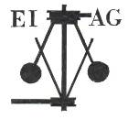
Essex Industrial Archaeology Group
Incorporating the Essex Mills Group

NEWSLETTER

Number 28 May 2019

Welcome to this month’s edition of the EIAG Newsletter. As usual set out below are the ESAH/EIAG visits of industrial interest, plus reports on talks and visits, and more details of IHF 2019. As you will notice from the heading, this now acknowledges the incorporation of the Essex Mills Group (EMG) into EIAG. We welcome former members of EMG who have joined EIAG and hope this bi-monthly newsletter is of interest to you. We would welcome items for the newsletter regarding the mills in Essex – opening times, special events, conservation projects and the like – as we want to promote the heritage of milling and the mills as much as possible.

We hope you enjoy reading this edition and if you have any comments on the Newsletter generally or specific items in it, or wish to make a contribution to the next Newsletter, please contact us via our email address - essexiag@gmail.com.

Programme of ESAH/EIAG visits 2019

The programme of visits in 2019 includes the following of industrial, maritime and transport interest:

Colliers Brick and Tile Works. Wednesday 21st August 2019, 10:30 am. Church Lane, Marks Tey, CO6 1LN. Brick making by hand using traditional methods - £5.00

Stow Maries Airfield. Saturday 14th September 2019, 10:00 am. Hackmans Lane, Purleigh, CM3 6RN. Tour and history of the site. £12.00 including traditional cream tea.

Industrial Heritage Fair 2019. Saturday 5th October 2019, 10:00 am – 4:00 pm. Sandford Mill, Chelmsford, CM2 6NY. Society and museum stalls and five short talks. Free admission. Light refreshments available all day. More details to follow in future newsletters.

EIAG Annual Meeting. Saturday 9th November 2019, 2:00 pm. Chelmsford Museum. AGM followed by a talk by Jim Lewis on the industries of the Lea Valley – Free for members, £2.00 for non-members.

For full details and to book places on these visits please contact the Hon. Secretary, Howard Brooks, via email, which is preferred, at Howard000brooks@gmail.com or by post to 13 Greenacres, Mile End, Colchester, CO4 5DX.

More on Boreham from Peter Jones

Following on from the article about Boreham railway station in the last newsletter…. Prior to more gravel extraction in the 1990s part of the site was excavated and revealed a remarkable piece of industrial archaeology.

The circular feature, an 18 metre wide ring ditch, contains the remains of a windmill mound of 12th or 13th century origin. Apart from being the earliest windmill found in the county the find is even more remarkable because windmills only made their appearance in England towards the end of the 12th century.

The windmill was located in the corner of a ditched enclosure that can also been seen in the photograph. Before the site was excavated aerial photography had revealed the presence of the ditches but it had been assumed they were of prehistoric origin. Ultimately it would take a proper excavation to reveal the true nature of the site. The vehicles at the top of the picture are the excavators waiting to strip the site.

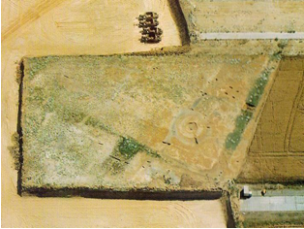

Below is the entry for the Boreham windmill from the Essex CC Comparative Survey No.19, ‘Windmills in Essex’ which is available on the EIAG website. – Ed.

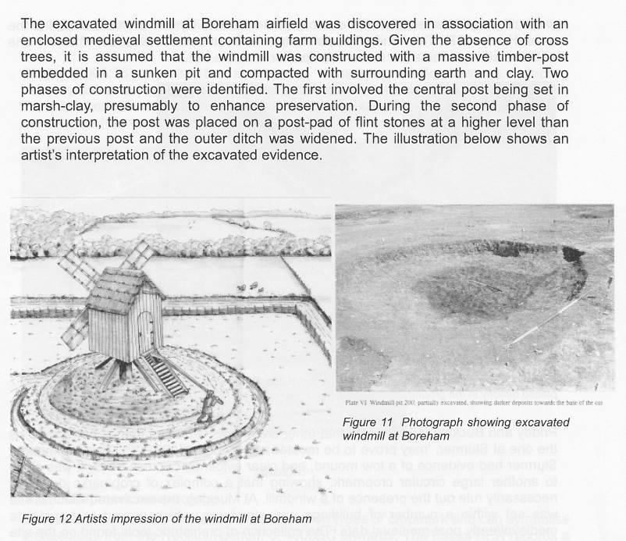

ESAH Morant Lecture, Saturday 9 March 2019, Queen’s Hall, Halstead

Speaker: John Miners, Chairman of Halstead History Society, Textile Consultant, Former Courtaulds employee

Topic: Textiles in East Anglia and Samuel Courtauld

John is well known in the Halstead district by anyone interested in History and Courtaulds. Long time ago he decided to work at Courtaulds rather than go to college because Courtaulds was across the narrow road from where he lived and so there would be no being late from commuting. He was still late for work!

His talk looked at the history of textiles in East Anglia including Halstead & Courtaulds. Following is a brief summary.

Linen was being woven in East Anglia in the Bronze Age. By the 9th Century this had moved on to wool and continued as a major economy for England through to the 19th Century. By the 11th Century there were trading links with mainland Europe due to the closeness to the North Sea.

Manufacturing involved the processing of raw wool through to cloth. The wool trade of East Anglia was split into Worsteds in Norfolk and part of Suffolk and Woollens in Essex and parts of Suffolk. Worsted cloth needed no more than dyeing after production whereas woollens needed fulling. Bays were brought in by Protestant Dutch refugees.
- Spinning was carried out in homes in towns and surrounding villages. 1 weaver needed 7 spinners.
- Weaving was done on a fairly basic loom with a treadle to operate the shafts for the warp threads whilst the weaver passed the shuttle by hand for the weft thread.
- Fulling and Finishing consisted of soaking the cloth in water, beating it with wooden paddles and scrubbing with Fuller’s Earth to give good texture and start bleaching.
- Dyeing was done with a range of natural dyestuffs.
- Tentering involved stretching the cloth on a tenter frame with hooks and leaving it to dry.
- Brushing was done with teasels, these were specific teasels, not any old type.

Commercial Activities by the clothier started with the purchase of fleeces through to trading the completed cloth. From 1300s onwards cloth sales were in London. By 18th Century the use of machinery with textile manufacture in Yorkshire was detrimental to East Anglia, especially those who were unwilling to move with the times plus our rivers were not fast flowing enough for the machines. By 1800s the only woollen materials were bays with the last in Colchester closing in 1830.

Silk was brought over from the continent by Huguenot refugees. They started up in London however various Acts of Parliament made production too costly so they moved out over the country including East Anglia.

The Courtaulds were Huguenot refugees who worked in London as silversmiths. George Courtauld, 1761-1823 entered the silk industry as an apprentice and then set up his own business. 1785 he sold the business and moved to America, returning in 1793 with wife and children. After employment in Kent he moved to Pebmarsh to manage a silk throwing mill converted from a water powered corn mill. Silk throwing combines raw silk threads to form yarns.

Samuel Courtauld III, 1793-1881, started work with his father at the age of 14. They moved to Chapel Hill Braintree to covert a former flour mill into a silk throwing mill. After disagreements George returned to America and Samuel set up a small throwing mill in Bocking. In 1825 He agreed to convert the water corn mill in Halstead into a mill for throwing silk in conjunction with Stephen Beuzeville a Spitalfields silk crape manufacturer. In 1828 he set up partnership with his younger brother George, 1802–1861 along with his cousin and brother-in-law, Peter Taylor. The business expanded out of county as well as in county with steam mills being built.

The Courtauld family were active in the building dwellings for workers in Halstead and Bocking. Samuel Courtauld III, when asked for what he wished to be remembered, said, “that he built good cottages!” They also contributed buildings such as the cottage hospital in Halstead and the Working Men’s Hall in Bocking.

Mourning Crape was an important textile in Victorian Britain. Initially the yarn was made in the mill and then handwoven in homes. In Halstead mill power looms were installed first in 1828 with numbers of looms increasing. By 1896 Courtaulds were exporting more crape than was used at home. Crape went out of fashion, production declined with closure in 1940. As crape declined so coloured silks took over. Multipurpose looms came into action to weave light silk textiles along with silk and wool mixtures.

Samuel Courtauld III dominated his family and firm. He showed paranoia tendencies fluctuating between euphoria and autocratic behaviour. His attitude was benevolent despotism where he was concerned about his workers but was also ruthless with any insubordination. He had been involved in the abolition of church rates and believer of religious freedom, being himself a Unitarian. He attempted political involvement but was not successful. In 1854 he bought Gosfield Hall and then extended his estate with a London house and a yacht. By 1881 he was worth £70,000, currently £55M using RPI or £298M using average earnings. His only child died and the bulk of his estate was bequeathed to two adopted children.

John was ready to take many questions from the audience. He then invited us to look at a range of textiles to help explain what had been made in the local mills. In addition the adjacent museum was then open for people to explore and find out more about the entrancing local history of textiles.
Jane Giffould

The Cutlers of Thaxted

At the meeting of the Saffron Walden Historical Society on 24th April, Richard Till gave a talk on the Cutlers of Thaxted 1350 – 1420. Here is a brief summary of his talk, but if you want to read more, the cutlers are mentioned in Richard’s article ‘Crisis and Change in Thaxted Manor 1350 – 1500’ in the ESAH Transactions Vol. 8, 2017, pp 96-103 (the latest edition recently circulated). Richard’s essay on ‘The Cutlers of Thaxted 1350 – 1420’ was published in The Local Historian Vol. 48, No.4, October 2018, pp 319-332 –
https://www.balh.org.uk/publications/local-historian/the-local-historian-volume-48-number-4-october-2018

Thaxted was a major manufacturer and supplier to the London market of cutlery from the mid-C14th for about 100 years. There was some cutler presence in the late C13th, but the main growth was from the early C14th. In 1381 the Poll Tax record shows there were 79 cutlers, 4 sheathers, 11 smiths, 2 goldsmiths, 3 tanners and a pelter in the town – over a third of the male population. An industrial area was developed specialising in the trade in the east of the town centre, what is now Town Street, The Tanyard, Orange Street, Mill End and Park Street – along the course of the Cripsey Brook. There were no cutlers at Cutlers Green, but the land there was owned by cutlers. The cutlers came to Thaxted because Hugh de Audley, Lord of Thaxted between 1320 – 1340, offered economic and commercial advantages to stimulate trade in the town. Most cutlers were incomers having Flemish and French names – probably Huguenots.

Cutlers consisted of bladesmiths and hafters who made the constituent parts, the cutlers who put them together, and cutlers merchants. There were also those who made the sheaths and scabbards. The iron was imported, probably from Germany, via Ipswich, the steel via London, while the material for the handles was ivory from the Baltic (whales) and wood from the Colchester area. Wood for charcoal fuel was also local. The main product was domestic knives, daggers and some swords all of which were much in demand.

Of the Master Cutlers, John Kent was one of the most significant. He owned a range of premises and workshops in the Sheepcote Lane area and adjacent to Kent’s Bridge over the Cripsey Brook, which was named after him. Next to his property in Sheepcote Lane was a hall which was almost certainly the first guildhall of the cutlers.

Details of the archaeological excavations by the Colchester Archaeological Trust in Weaverhead and Orange Street can be found on their website at:
https://www.thecolchesterarchaeologist.co.uk/?p=19877

Tony Crosby

ESAH Visit to Burnham-on-Crouch Museum

On Saturday 18th May a couple of dozen ESAH members visited the Burnham on Crouch Museum. We were first given a talk: a brief history of Burnham from prehistoric times to the twentieth century! Shark teeth fossils, artefacts from a Bronze Age burial site and a hoard of weaponry from the Bronze Age discovered in 2010 are all to be seen in the museum. Evidence of Roman activity includes the survival of ‘red hills’, such as that at Burnham Wick Farm. This was where salt water was collected in clay-lined pits and heated to cause the water to evaporate leaving salt crystals.

However, fishing, particularly oyster fishing, became a major industry of the town from the 1500s. This stimulated coastal trading with oysters, and other produce such as hay, being taken by barge to the London markets, a major return cargo being muck from London used to fertilise the fields of the Dengie. Along the Town Quay is evidence of the jetties where the barges were moored, and cranes used in the loading and un-loading of the cargo. Apparently the only surviving oyster pit is under the quayside fish and chip shop. Boat-building also grew into a major industry and in fact the museum is housed in the former boat building premises of Tucker Brown and Co. Other boat building firms included R J Prior & Son, William King, Newell Petticrow Ltd and William Stebbings, but all these gradually became concentrated on yacht building. Now the only surviving firm of Prior’s is undertaking just repairs. The railway arrived in 1889 (the Southminster Branch) and the other major industry of the town followed: Mildmay Ironworks, now demolished and the site re-developed, the most notable of its products being cast iron piano frames.

Such a large number of industries attracted workers and they had to be accommodated. As well as the large houses of the town built for the oyster merchants and barge owners, there are also artisans’ cottages and a unique terrace of workers’ housing. In 1891 Granville Terrace was constructed, a terrace of 24 white, weather-boarded cottages. The museum has displays of pre-history, farming, fishing and oysters, boat building and the Mildmay Ironworks.
Tony Crosby
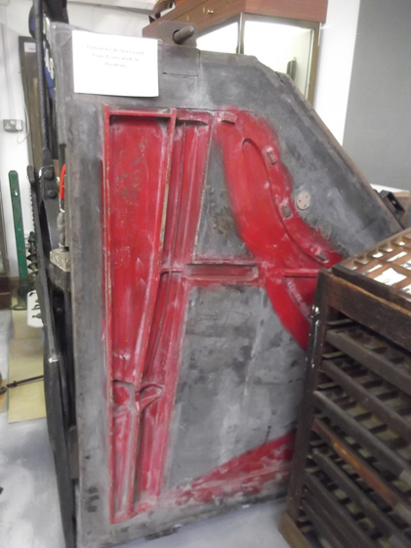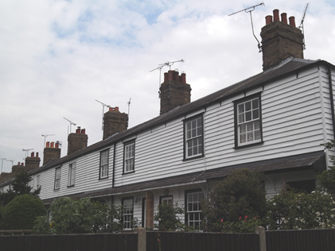

Cast for cast iron piano frame Just part of the terrace of 24 cottages in Granville
from the Mildmay Ironworks Terrace

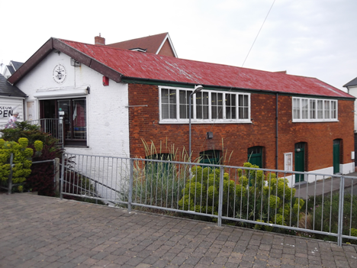 Burnham on Crouch Museum

Anniversaries in 2019
- 200th anniversary of the death of James Watt
- 250th anniversary of Watt’s patent to use a separate condenser in a steam engine
- 200th anniversary of the birth of Sir Joseph Bazalgette, the deviser of London’s sewage system
- 200th anniversary of the birth of Sir Horace Jones, architect and designer of Tower Bridge
- 150 years since the completion of Tower Bridge
- 250th anniversary of the birth of Sir Marc Brunel
- 150 years since the first trains used Brunel’s Thames Tunnel

Association for Industrial Archaeology

In the Summer 2019 edition of Industrial Archaeology News (no. 189) it is reported that ‘The AIA supported the Halstead 21st Century Group in their objection to the outline application for the Halstead Air Raid Shelters. This is a group of 16 WW2 Shelters which form a rare group and are an important survival both because of their number and for their association with Courtaulds.’

