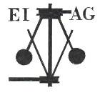
Essex Industrial Archaeology Group
Incorporating the Essex Mills Group

NEWSLETTER

Number 29 July 2019

Welcome to this month’s edition of the EIAG Newsletter. As usual set out below are the ESAH/EIAG visits of industrial interest, more details of IHF 2019, other events in Essex and beyond, articles about Essex industrial sites in national journals, good news about the wooden lighter ‘Susan’ and notice of a new book on Colchester Trams
We hope you enjoy reading this edition and if you have any comments on the Newsletter generally or specific items in it, or wish to make a contribution to the next Newsletter, please contact us via our email address - essexiag@gmail.com. We would particularly welcome contributions regarding the mills in Essex – opening times, special events, conservation projects and the like – as we want to promote the heritage of milling and the mills as much as possible.

Programme of ESAH/EIAG visits 2019

The programme of visits in 2019 includes the following of industrial, maritime and transport interest:

Colliers Brick and Tile Works. Wednesday 21st August 2019, 10:30 am. Church Lane, Marks Tey, CO6 1LN. Brick making by hand using traditional methods - £5.00

Stow Maries Airfield. Saturday 14th September 2019, 10:00 am. Hackmans Lane, Purleigh, CM3 6RN. Tour and history of the site. £12.00 including traditional cream tea.

Industrial Heritage Fair 2019. Saturday 5th October 2019, 10:00 am – 4:00 pm. Sandford Mill, Chelmsford, CM2 6NY. Society and museum stalls and five short talks. Free admission. Light refreshments available all day. More details to follow in future newsletters.

EIAG Annual Meeting. Saturday 9th November 2019, 2:00 pm. Chelmsford Museum. AGM followed by a talk by Jim Lewis on the industries of the Lea Valley – Free for members, £2.00 for non-members.

For full details and to book places on these visits please contact the Hon. Secretary, Howard Brooks, via email, which is preferred, at Howard000brooks@gmail.com or by post to 13 Greenacres, Mile End, Colchester, CO4 5DX.

Industrial Heritage Fair 2019

Saturday 5th October 2019 from 10 am to 4 pm
at Sandford Mill, Chelmsford, CM2 6NY

Celebrating the County’s rich and diverse industrial history

We already have approaching 20 organisations who have booked display stands at the Fair, including the Essex Fire Museum, the Essex Police Museum, Bata Heritage Centre, Upminster Windmill, Beeleigh Steam Mill, Chelmsford Civic Society, Balkerne Tower Trust/British Water Tower Appreciation Society, Basildon Heritage and Halstead C21st Group.

A series of talks will take place during the day, as follows:

11:30 David Hewett – Chelmer & Blackwater Navigation
12:00 Mike Bardell – Crittall flat-roofed houses in Braintree
12:30 Anthony McQuiggan – Water supply industry in Chelmsford
1:00 Peter Marriage – Steam roller milling
1:30 Tim Wander - The centenary of British broadcasting and the birth of the BBC

The fair will be opened at 10:30 by Deputy Mayor, Cllr Janette Potter, who will be accompanied by the Deputy Mayor’s Escort, Mrs Gillian Smith.

Free admission, ample free parking and light refreshments available

For further details email: essexiag@gmail.com

Excellent Essex by Coach: Some Structures and Stories

The Twentieth Century Society is running the above event on Saturday 19 October 2019

This tour will be led by Gillian Darley (President of the Twentieth Century Society), whose books include ‘Villages of Vision’ (which includes a number of Essex villages such as Silver End and Bata at East Tilbury) and ‘Factory’ (an architectural book tracing the history of the modern factory). Gillian’s book, ‘Excellent Essex’ is due to be published on 17th September 2019.

The day begins at Basildon, a first-wave New Town planned under the powers of the New Towns Act 1946 to decentralise London’s ‘overspill’ population, sited on land compulsorily purchased from the ‘plotlanders’, ad hoc settlers from east London who arrived from the early 1900s onwards. Led by Basildon Development Corporation, with Basil Spence as consultant, Basildon was designated in January 1949 and inaugurated thirteen years later in 1962. Brooke House, a residential tower, marks the centre. We jump on a coach to Burnham-on-Crouch’s Royal Corinthian Yacht Club, a grade II* listed building designed by Joseph Emberton for Britain's contribution to the International Exhibition of Modern Architecture held at the MoMA in New York City in 1932.

Following lunch at the Yacht Club we travel to East Tilbury’s Bata Estate, built in the 1930s to house workers of the Bata Shoe Factory, part of what became a global enterprise, centred around planned villages modelled on the modernist parent settlement at Zlin. Designed by Czech architects Frantisek Lydie Gahura and Vladimir Karfik, the Bata village contains numerous grade II buildings. With Conservation Area protection, some recent housing additions follow the same idiom. Finally, we travel to the Labworth Café at Canvey Island. Built by Ove Arup with Christiani & Nielsen (1932-33), the circular café was a pioneering modernist building, a design by a very young Arup. Due to its vulnerable situation on the shoreline, it was adapted and incorporated within the flood defences. A coach will take participants back to Basildon railway station for their return journey.

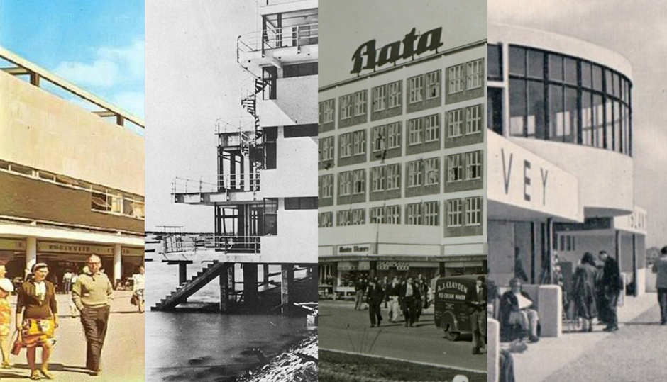

Full details are on the C20 website at: https://secure.c20society.org.uk/Default.aspx?tabid=62&EventId=654

Waltham Abbey Royal Gunpowder Mills

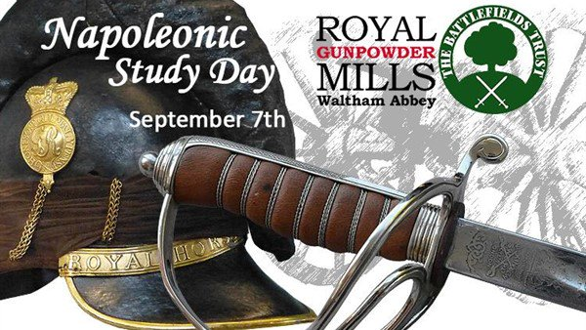
Waltham Abbey Royal Gunpowder Mills will be exploring firepower on land and sea during the Napoleonic period with acknowledged experts and live firing demonstrations by re-enactment groups. Places cost just £40 which includes delegate’s packs, refreshments and lunch plus all the guides and site tours. This is a unique opportunity to learn from acknowledged experts at the Royal Gunpowder Mills, within the home of gunpowder production that played a very important role during the Napoleonic Wars. Although covering our subject in depth, this day will be equally interesting and informative to those with a general interest in local or military history. You won’t need any specialist knowledge, just an enquiring mind and a desire to get hands-on with history.

Full details on their website at: https://www.royalgunpowdermills.com/Event/tsd2019

European Route of Industrial Heritage (ERIH)

EIAG is a member of ERIH and hence is notified of all ERIH activities. The next ERIH UK meeting will be held at Port Sunlight, Wirral on Thursday 19th September 2019. Port Sunlight is an ERIH Anchor Point. The village was founded by 'Soap King' William Hesketh Lever in 1888 to house Lever's 'Sunlight Soap' factory workers. There will be an opportunity during the day to hear about the fascinating history of this planned industrial community.
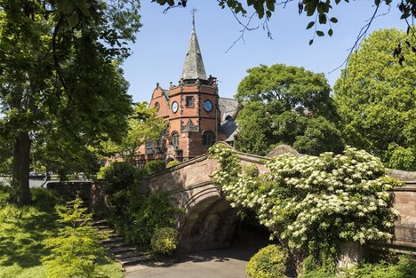
The main focus of the programme will be presentations and discussion about the future of ERIH in the UK - including, raising ERIH's profile; coordinating ERIH activity in the UK; examples of good practice from other countries; the impact of Brexit.

The ERIH 2019 Annual Conference will be held in Berlin on 16th-18th October and is on the topic `Industrial Heritage Tourism: It`s All in the Mix`, full details being available on the ERIH website: https://www.erih.net/

THE SUSAN TRUST

We are pleased to be able to report that The ‘Susan’ Trust has been awarded a grant of £20,000 towards a £65,506 project to restore the 1953 wooden lighter ‘Susan’ on the Chelmer & Blackwater Navigation. This is one of eight grant awards made this year by the Association for Industrial Archaeology from their Restoration Grants scheme.

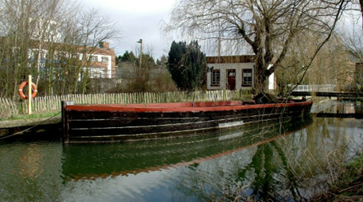

SUSAN AT SANDFORD MILL IN 2008

Susan is listed on the National Register of Historic Ships. More details can be found on their website at: http://www.susantrust.btck.co.uk/

Association for Industrial Archaeology

Industrial Archaeology Review (the AIA’s journal which EIAG receives as an affiliated society and is deposited in the ESAH library) Vol. 41, No. 1 was published in May. It contains (pages 31-44) a very interesting article exploring the findings of the archaeological investigations undertaken at the Eastern Counties Railway’s Stratford locomotive and carriage works in Angel Lane, Newham, east London. The investigations revealed an early engine roundhouse and associated structures, constructed in accordance with a design by Robert Stephenson, and walls and in situ floor surfaces of terraced housing built for the workers. Built in 1840 it is an early example of a railway roundhouse and the first in London. The Stratford roundhouse is compared to a number of other examples from around England and makes an excellent read for all those interested in railway locomotive depots

ARCHIVE – The quarterly journal for British industrial and transport history

Issue 102 of this excellent journal contains an article on the Corringham Light Railway, one of the three light railways of Essex, along with the Elsenham and Thaxted, and the Kelvendon, Tiptree and Tollesbury Pier Light Railways. Built originally by Kynoch Ltd, the explosives manufacturers, the railway was opened in 1901. It was sold along with the works and company village in 1919 to Cory Brothers, the coal shipping firm, but eventually became part of the oil processing industry when the site was sold to the Vacuum Oil Co. in 1950. The railway was closed in 1952, but the site remained in the oil industry.

The definitive history of the railway and the industries it served is Peter Kay’s The Corringham Light Railway – A New History (including Kynoch’s Works, Kynochtown/Corytown, and the Oil Industry), 2008

ARCHIVE is published by the Lightmoor Press, annual subscription is £34, although individual copies can be bought at the original issue price, in the case of Issue 102 this is £7.50. See their website at http://lightmoor.co.uk/category.php?page=1&section=IndArchive

Colchester Corporation Tramways Peter Jones

The first years of the 20th century were a golden age for trams. At its peak there were 14,000 tramcars running in the British Isles on 181 tramway systems, two thirds run by municipal undertakings. By this time Colchester was a busy and expanding town and with the railway station a mile from the town and cabs and coaches costing between 6d and a shilling a mile, there was a desperate need for public transport.

There had been proposals in the past to build a horse tramway to connect Colchester’s North Station with the town and St Botolph’s (now Colchester Town) with the army barracks but nothing was done. There was also an attempt in the 1880s to build a steam tramway from North Station to the town but the company went bankrupt after about half a mile had been completed.

The council debated what to do, they considered running their own bus company but felt that the petrol buses of the day were not reliable enough. Trackless cars that would become known as trolleybuses were gaining favour as a more flexible alternative to trams. Colchester Corporation applied for an Act of Parliament to open a trolleybus system in the town but this was rejected on a legal technicality. Had this been passed Colchester would have had ‘the oldest recorded trolleybus system in Britain’.

Eventually the Corporation decided on a conventional tramway system. The authorising Act of Parliament was passed in 1903 and the contract for the construction awarded to JG White and Company specialists in this field. Work started in January 1904 and with 200 men Whites completed 5½ miles of route and 11 miles of overhead line plant. The reason for the difference was that a lot of the route was single track but still required line for both directions. The lines ran from North Station to the High Street, out to Lexden and down the High Street to East Gates and the Hythe.

The system was passed by the Board of Trade Inspector and the grand opening set for 28th July 1904. In the pouring rain the Mayoress, Mrs Gertrude Barrett drove the first tram out to Lexden, down to North Station and then back to the Town Hall where the VIP guests enjoyed a celebratory lunch.

The trams in Colchester ran for 25 years and were very well patronised during WW1. But they were never modernised, maintenance was severely neglected during the war and by the middle 1920s they were showing their age and, by all accounts, very uncomfortable to ride on. The internal combustion engine had proved itself during the war and now Colchester Corporation decided to replace its trams with buses, which they did over an 18 month period. The very last Colchester tram ran on 10th December 1929.

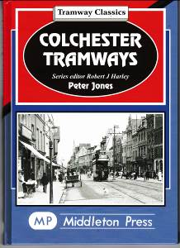
I appreciate that this is a very brief summary of Colchester Trams but I have recently written a book that has a more detailed account and 120 photographs. Published by Middleton Press these books usually retail at £18.95 but if there is any EIAG member out there who would like at copy for £17.50 (including P&P) please send a cheque payable to P.Jones to 19 Heathfields, Eight Ash Green, Colchester, CO6 3QP

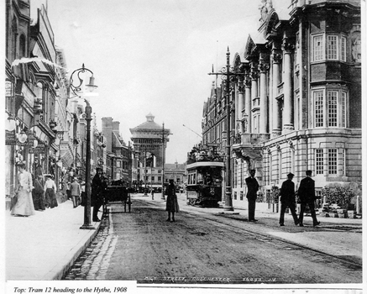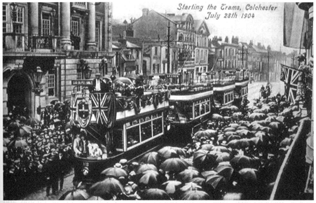

Tram heading to the Hythe 1908 The opening day, 28 July 1904

