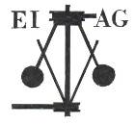
Essex Industrial Archaeology Group
Incorporating the Essex Mills Group

NEWSLETTER

Number 30 September 2019

Welcome to this month’s edition of the EIAG Newsletter which includes the latest details of the organisations attending the Industrial Heritage Fair, the talks programme and canal boat trips. One of the stands will be the Epping & Ongar Railway and they have contributed further details of the history of that line for this newsletter. There is a report on the EIAG/ESAH visit to Collier’s brick works last month and a report on progress with various of the county’s windmills. Marking the 50th anniversary of the moon landing, there is a short piece on the Marconi link to that famous event.

We hope you enjoy reading this edition and if you have any comments on the Newsletter generally or specific items in it, or wish to make a contribution to the next Newsletter, please contact us via our email address - essexiag@gmail.com. We would particularly welcome contributions regarding the mills in Essex – opening times, special events, conservation projects and the like – as we want to promote the heritage of milling and the mills as much as possible.

Programme of ESAH/EIAG visits 2019

The final two EIAG events of the year are;

Industrial Heritage Fair 2019. Saturday 5th October 2019, 10:00 am – 4:00 pm. Sandford Mill, Chelmsford, CM2 6NY. Society and museum stalls and five short talks. Free admission. Light refreshments available all day.

EIAG Annual Meeting. Saturday 9th November 2019, 2:00 pm. Chelmsford Museum. AGM followed by a talk by Jim Lewis on the industries of the Lea Valley – Free for members, £2.00 for non-members.

For full details and to book places on these visits please contact the Hon. Secretary, Howard Brooks, via email, which is preferred, at Howard000brooks@gmail.com or by post to 13 Greenacres, Mile End, Colchester, CO4 5DX.

Details of next year’s visits will appear in this Newsletter as soon as they are available.

Industrial Heritage Fair 2019

Saturday 5th October 2019 from 10 am to 4 pm
at Sandford Mill, Chelmsford, CM2 6NY

Celebrating the County’s rich and diverse industrial history

We have 25 organisations who have booked display stands at the Fair, including the Essex Police Museum, Bata Heritage Centre, Upminster Windmill, Beeleigh Steam Mill, Chelmsford Civic Society, Balkerne Tower Trust/British Water Tower Appreciation Society, Great Dunmow Maltings, Basildon Heritage, Halstead 21st Century Group, Chelmer & Blackwater Navigation, Epping & Ongar Railway and Wethersfield Aerodrome Museum.

A series of talks will take place during the day, as follows:

11:30 David Hewett – Chelmer & Blackwater Navigation
12:00 Mike Bardell – Crittall flat-roofed houses in Braintree
12:30 Anthony McQuiggan – Water supply industry in Chelmsford
1:00 Peter Marriage – History of Marriages – Millers of Chelmsford
1:30 Tim Wander - The centenary of British broadcasting and the birth of the BBC

There will also be canal boat trips on the Chelmer & Blackwater Navigation – there will be a charge of £5 per adult, £4 per child and £15 for a family of 4

The fair will be opened at 10:30 by Deputy Mayor, Cllr Janette Potter, who will be accompanied by the Deputy Mayor’s Escort, Mrs Gillian Smith.

Free admission, ample free parking and light refreshments available

For further details email: essexiag@gmail.com

One of the groups attending the Fair is the Epping & Ongar Heritage Railway:

Essex Heritage – Epping Ongar Railway
From the 1840s and 1850s railway building began to expand with lots of lines radiating from major centres in Britain. London was no exception with lots of networks being built out of the capital in all directions. There were several companies building their individual lines and networks. Essex saw an expansion eastward from London in many directions by different companies.
The Eastern Counties Railway had already constructed a line to Loughton from London’s Fenchurch Street and in 1858 another company called Epping Railways Company wanted to construct a line from Loughton via Epping and Ongar toward Dunmow. They received parliamentary sanction in 1859. Ironically Eastern Counties were not happy and built a line between Braintree and Bishop Stortford passing through Dunmow thereby making Epping Railways Company’s proposal to reach Dunmow not viable. Therefore the line only reached Ongar and not progressing any further. Eastern Counties took over Epping Railway Company and in turn merged with Eastern Union Railway to form the Great Eastern Railway.
The Epping Ongar branch remained out on a limb as a single track while the line from Loughton to Epping was double tracked. This part of the network came under GER in 1865 then was brought into the Big Four as part of the London North Eastern Railway from 1923. The LNER lasted till 1948 when, as the Big Four, it was brought into Nationalisation as British Railways. One of the exceptions was the line from Stratford to Loughton, Epping and Ongar and the line from Ilford to Hainault and Woodford which fell under the management of London Transport’s Underground Network. The link from Ilford to Newbury Park was severed in favour of a link from Leytonstone via Gants Hill. This expansion of the LU network had been delayed because of WW2.
Jumping ahead to 1994, the Epping to Ongar branch closed to underground traffic as the line was not considered economically viable in its single track form. This made the line a good candidate for preservation, eventually to become a heritage railway with steam, diesel powered locomotion, vintage rolling stock and uniquely run with a numbered heritage bus service number 339 reflecting red and green London Transport buses that would ply their trade deep into Essex territory.
The full story of the Epping Ongar Railway is available in a book titled ONGAR 150 which can be bought at our stand at the Fair on 5th October at the special price of £5. It normally sells for £7.95.
Eddie Veckranges
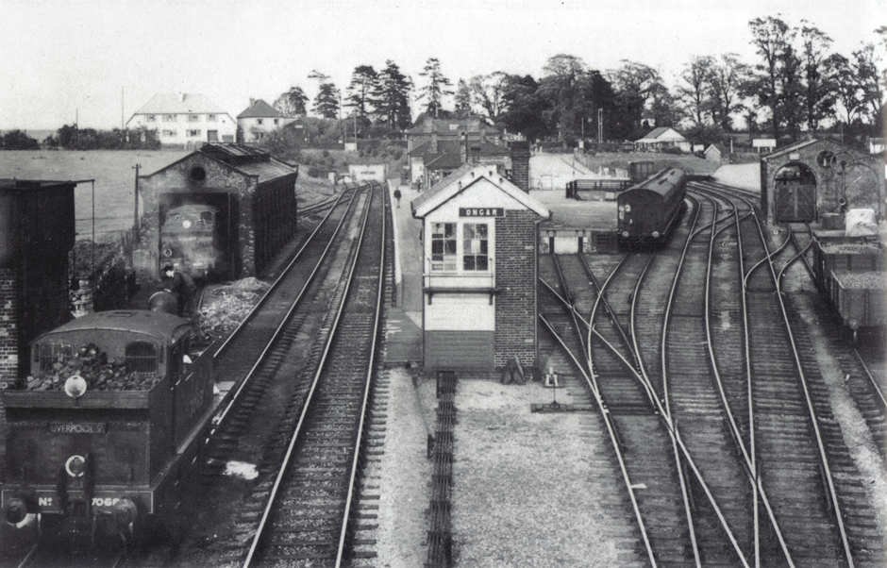

Ongar Station 1938

News of Windmills around Essex

Mountnessing:

Mill ground for the first time in about 20 years last month. We are going to do some fine tuning with the machinery to enable it to grind slightly better. Had some very successful open days this year, with over 100 visitors on each of the last 2 open days. I have recently set up a Facebook page where we have received 330 likes in a month and have reached over 7000 people with the posts. Still in discussions about the future ownership of the mill.

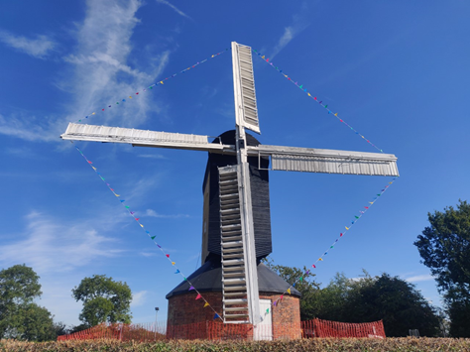
The inside of the roundhouse will be painted by volunteers over the winter. New lighting was recently installed. I did some minor repairs to the ladder steps last week. The windshaft has been cleaned and recoated in red oxide metal primer. Minor adjustments to the brake were done too allowing it to turn a lot easier. The buck can now turn with ease after extensive greasing with animal fat. We are going to make sure it is turned 360° both ways once a month to stop it from settling. The shutters in the ends of the sails will be removed for the winter in the next month.

Stock:

I helped at a few open days this year. A repair to the shutter bar was carried out by the ECC Millwright, and the sails were painted in the bare areas. The sails were then able to be turned by wind for the first time in 3-4 years. I will go over in the next months and try to get it milling. Everything is complete and in good condition so will hopefully be successful. Repairs to the winding gear are needed and will hopefully be carried out by James, Paul and myself this autumn/winter.

Aythorpe Roding:

The sails have been stripped back and rebuilt. The new 2 timber stocks have been shaped and are currently being treated and painted. They are replacing a rotten timber one and a fabricated steel one. The mill has been turning to wind after Paul rebuilt the fan frame 18 months back. It is planned to have the mill repainted in the next 12 months.

Thaxted:

After an inspection with Paul and myself last year, a major restoration has been started. It is now on the Heritage at Risk register and funding is being applied for to sort the issues with the brickwork. The cap will be removed and repaired, the sails slightly remodelled to work better and it will be reinstated with stock clamps. Currently closed to the public. The shutters were removed last summer for safety.

Stansted:

Repairs to the brickwork are being undertaken this year. Lots of the bricks have become crumbly and loose. A few areas have been identified for initial repairs which are being done by an excellent heritage brickwork specialist.

I am not directly involved with Finchingfield or Bocking, though Bocking has been repainted this year and I believe they are fundraising for a new sail. I haven't been to Ashdon though I know they have been open this year. We will take the sail cloths down for the winter soon. Tim Whiting repaired and repainted the sails at Rayleigh last year and also removed the rotten fanstage from Terling.

Cameron Southcott

Visit to W. H. Collier Brick Works

On Wednesday 21st August members gathered at William H. Colliers’ brickworks in Marks Tey for a tour of one of only two remaining working brickworks in Essex, where they have been making bricks since 1863.

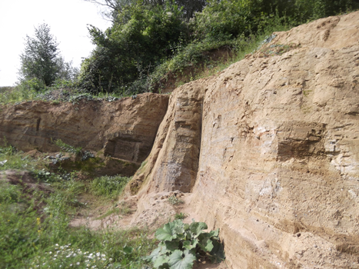
The tour started with a walk down to the clay quarries where we heard about the geology of the site and why, due to the bands of gravel and sand in some of the clay deposits, they had to be careful about where they dug out the clay each year. Apparently there is only 15 years of known usable clay deposits remaining on the site. Walking back to the buildings we passed a mound of clay that had been dug out earlier in the year and was weathering in preparation for use.

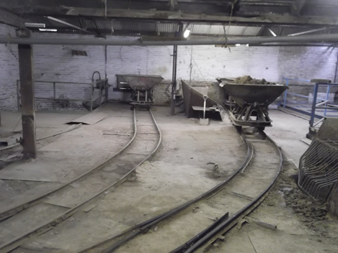
We then were taken on a tour around the buildings following through the process of brick making. This began with the areas where the clay was mixed with water and then sand to produce the usable mixture of clay. It was here that we encountered for the first time the internal narrow gauge tracks and wagons used to transport the clay around the building. From here we walked through the fascinating room where the many and various shaped moulds for the bricks and other items are stored. It looked very disorganised but were re-assured that the staff knew where to find the moulds they required!

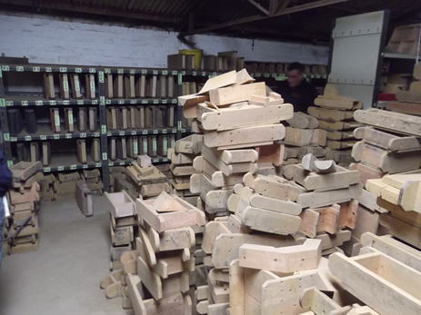

Moving on we came to the heart of the process and watched two brick makers forming hand-made bricks three at a time using a standard mould like those just seen in the store. These were stacked on trolleys which again were moved around on the internal tracks to be stored before kilning. A Moving Hood Kiln has been used since 2005 for the firing process. This is situated in a separate shed building and we were able to watch it being loaded by fork-lift truck – a very modern setting and process for this traditional hand-made product!

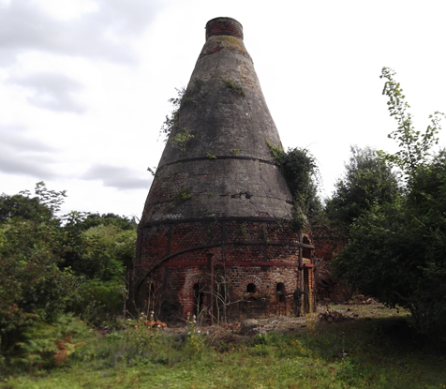
Finally we were taken to see the remains of two traditional up-draught bottle kilns: one is complete and is Listed Grade II, the other has lost its top two-thirds.

Tony Crosby

Marconi and Apollo 11
Alan Hartley-Smith drew the Editor’s attention to the following from the Moonlandings Memories website (https://moonlandingmemories.com/), which celebrates the 50th anniversary of the first moon landing, posted by Wing Commander John Brown OBE:

“In August 1965, the Manager of Marconi’s Radar Division received a call from the Managing Director of Cable & Wireless saying an urgent requirement had arisen to provide a Satellite Communication Station on Ascension Island, in under a year. It was to provide key communication facilities in support of the Apollo man-on-the moon project. We had just three weeks to submit our bid; I was made responsible for the co-ordination and production of our tender. After a period of intense scrutiny we discovered our bid had won. A special Project Team was set up to co-ordinate the design and production areas involved. After installation and testing on Ascension Island, handover was achieved on time, and was passing data to Andover, Maine. When Apollo 11 lifted off and successfully achieved its mission, all Marconi employees watching the television transmission felt enormous pride that their Ascension Island Station had played its part. Marconi received the Queen’s Award for outstanding achievement and technical innovation.”

Essex 2020: A Year of Science and Creativity

This is a year-long, county-wide celebration of Science, Technology, Engineering, Arts and Mathematics (STEAM) in Essex, including a celebration of 100 years since Marconi broadcast Dame Nellie Melba from Chelmsford and revolutionised the way we communicate. A website has been set up to advertise events - http://www.essexfuture.org.uk/essex-2020 - still obviously in its early stages of development, but do keep watching that space over the coming months and we will try to highlight events in this newsletter.

