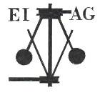
Essex Industrial Archaeology Group

NEWSLETTER

Number 32 January 2020

Welcome to this first edition of the
Essex Industrial Archaeology Group’s (EIAG) Newsletter for 2020.

2020 promises to be a very exciting year in Essex, not only because of the various EIAG/ESAH visits in this year’s programme, but also because of all that is happening across Essex throughout the year to mark various centenaries. The ESAH/EIAG programme is below, and the events so far arranged for Essex 2020 are also listed. As there will be further events added throughout the year, do watch out for them in future Newsletters. There is also news of progress at the Mills Archive with cataloguing and digitising archives relating to Essex mills, and a request for help in identifying planning applications for developments on former industrial sites.

If you have any comments on the Newsletter generally or specific items in it, or wish to make a contribution to the next Newsletter, please contact us via our email address - essexiag@gmail.com.

Programme of ESAH/EIAG visits 2020

The programme of visits in 2020 includes the following of industrial, maritime and transport interest. Booking forms will be emailed to all members early next month, so book early to avoid disappointment!

Annual Morant Lecture, Saturday 25th April 2020, Chelmsford Museum. Tim Wander will deliver a lecture to celebrate the 100th Anniversary of Marconi’s first radio transmission.

Warner’s Textile Archive, Braintree, Friday 22nd May 2020. Guided tour of the collection of textiles.

Epping – Ongar Railway, Saturday 22nd August 2020. Talk on the history of the line, a tour of the engine sheds, and a trip on a steam train from North Weald to Ongar.

EIAG Annual Meeting. Saturday 14th November 2020, 2:00 pm. Chelmsford Museum. AGM followed by a talk by Dr Catherine Pearson on the Frederick Roberts Archive of Industrial History – Free for members, £2.00 for non-members.

ESSEX 2020

A year-long, county-wide celebration of Science, Technology, Engineering, Arts and Mathematics, and the celebration of four centenaries:

400 years since The Mayflower left Harwich for the New World;
300 years since the building of the Naze Tower, Walton on the Naze;
200 years since The Beagle took Darwin from the East of England to the Galapagos; and
100 years since Dame Nellie Melba’s radio broadcast from Marconi’s New Street factory.

Marconi Events

Yes, 2020 is the 100th anniversary of Dame Nellie Melba’s radio broadcast from Marconi’s New Street factory. This was the first ever professional public entertainment broadcast in the UK and ultimately led to the formation of the BBC in 1922. Hence ‘Chelmsford Birthplace of Radio’ (or should that be ‘wireless’?)
.
The project will show through talks, exhibitions and drama, how Marconi’s pioneering work at the turn of the century has significant relevance to our modern age, of which broadcast entertainment is but one beneficiary, enabling future cosmic discoveries and the continuing growth of earth bound, ‘wireless’ inter-connectivity through mobile ‘phones’ and the ‘Internet of Things’!

Events so far arranged include:

Play

Monday 15th-19th June 2020 at 7.30:
Power behind the Microphone at Civic Theatre – written by Tim Wander, author and historian. Civic Theatre, Chelmsford, 01245 606505.

Lectures

Tuesday 31st March 2020 at Anglia Ruskin University 7.30
Professor Danielle George MBE, FIET – Marconi and the Invisible Universe - FREE
To book: https://www.eventbrite.co.uk/e/marconi-and-the-invisible-universe-tickets-85610680851

Friday 22nd May 2020 at Anglia Ruskin University 7.30
Dr Elizabeth Bruton – Two Wireless Ages: From Marconi’s Wireless Telegraphy to the Internet of Things - FREE
To book:https://www.eventbrite.co.uk/e/from-marconis-wireless-telegraphy-to-the-internet-of-things-iot-tickets-85611429089

Wednesday 10th June 2020 at Anglia Ruskin University 7.30
Tim Wander, author and historian, museum curator
Dame Nellie Sings! A night that changed the World - FREE
The story of the first radio broadcast experiments from the Marconi Chelmsford New Street Works and Melba’s famous concert on 15th June 1920
To book: https://www.eventbrite.co.uk/e/dame-nellie-sings-a-night-that-changed-the-world-tickets-85612177327

Tuesday 16th June 2020 at Baptist Church, Victoria Road CM1 1LN, 2.00
Alan Hartley-Smith, Display and Data-handling Systems Engineer in Radar Research Division
A World without Marconi –entry £6

Monday 22nd June at Baptist Church, Victoria Road, Chelmsford CM1 1LN, 7.30
Writtle and the Birth of British Radio Broadcasting – entry £6
Tim Wander, author and historian and museum curator
The story of radio station 2MT, its amazing leader Peter Eckersley, who became Britain’s first radio broadcaster and the first Chief Engineer of the new BBC.

Sunday 7th June Exhibition at Hylands House – Marconi – past, present and future 10.00-16.00
Leonardo from Basildon (a former Marconi Company) will be presenting at this exhibition in partnership with Chelmsford Civic Society including Tim Wander, author and historian, and Paul Green with his extensive range of vintage radios. FREE entry

Special Marconi Walks

TUESDAY 19TH MAY at 10:30 AM
THURSDAY 11TH JUNE at 10:30 AM
FRIDAY 11th SEPTEMBER at 10.30 AM (Heritage Open DAYS)
(Meet outside the Woolpack PH, Mildmay Road, Chelmsford)

A tour from the first Marconi factory to the second, finishing at the famous Marconi 1912 building. These are special events to celebrate 100 years since Dame Nellie Melba sang from Chelmsford to reach across Europe.
When the young Mr Marconi used radio waves for practical signalling without wires in 1896 he led us into the era of practical electronics, including not only radio but television, radar and space communication.
It may be claimed that Marconi's choice of a disused warehouse in Hall Street to be the birthplace of the world's radio industry makes Chelmsford the starting point of the Electronic Age. Why not come on this walk and hear more about this famous man and the way he changed our world.

The walk lasts around 90 minutes and has a capacity of up 30 places.
The price for the guided walk is £5 per person (children under 18 half price).
Bookings can be made by calling Alan on 07779 931401 or Email cityhistorywalks@gmail.com
Website www.chelmsfordhistorywalks.uk

Other Events
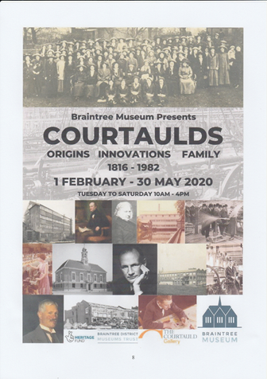

Courtaulds – Origins, Innovations, Family 1816 – 1982,

Braintree Museum,

1st February – 30th May

see poster in EIAG Newsletter No. 31 for more details.

Essex Record Office Conference - Back to the future: the impact of science across Essex

Tickets: £30 including a buffet lunch and refreshments

Location: Essex Record Office, Wharf Road, Chelmsford, CM2 6YT

Over the centuries science has had a massive impact on the residents of Essex. Join us for a day of talks celebrating some of the everyday developments in technology that have transformed lives in the past and how we live today.

With talks looking at everything from the basics such as water purification and supply, brewing, gas and cloth manufacture, to the cutting edge of fibre optic technology and advancement in archaeological techniques. This will be a day full of interest and a celebration of science and scientific advance across the county.

This one day conference is positively brimming with no less than 6 speakers talking on 7 different subjects.
- Peter Wynn will be talking about gas manufacture and water purification;
- Zoe Outram will discuss the science of archaeology;
- David Crease will talk about the science of brewing;
- Ian Vance will look at the development of fibre optics at STL in Harlow;
- John Miners will explore the science of cloth manufacture, and;
- Tony Crosby will wrap up with a whistle-stop tour of the industrial archaeology of Chelmsford
Over the next few weeks we will be introducing some of our speakers and their topics in a little more detail right here on our blog.

Saturday 7th March, 9.30am-4.00pm Book a place

(Registration opens at 9.30 with the first talk starting at 10.20)

Friends of Chelmsford Museum

present THE ANNUAL MUSEUM LECTURE at the Cramphorn Theatre, Chelmsford
on Tuesday 24th March 2020, at 7.45 p.m

Chelmsford’s Industrial Past Revealed - A guide to the sites and the people:

An illustrated talk by Tony Crosby

Friends of Chelmsford Museums Members £6.00 Non Members £8.00

In 1987 Stanley Wood devised and wrote a Chelmsford Industrial trail pinpointing the importance of the county town’s industries, describing the places involved and the people who made them possible. In 2018 Tony Crosby and Dave Buckley revised and updated it and Tony now brings the trail to life in the Annual Museum Lecture.

To keep up-to-date with all events throughout the county visit: https://www.essex2020.com/about-essex-2020/
The Mills Archive

As reported in the November Newsletter (No. 31), EIAG with ESAH have granted the Mills Archive £1,000 to fund their work on the Rex Wailes and Vincent Pargeter archives. As a condition of the grant, the Mills Archive are providing regular reports on progress with this project and here is one received earlier this month:

Three cataloguing volunteers continue to digitise some of the pictures in Rex’s collection - use the following link to view them on our catalogue: https://bit.ly/2pC3kYY.

We have found some stunning images that tell all kinds of stories. The image below shows Went’s Mill, Peldon, the Mill House after the Colchester Earthquake, 1884. Given to Rex Wailes in 1956 by Mrs E Went. The school boy with the black armband was her husband. His father had died shortly before and his brother (next to him) was running the business.

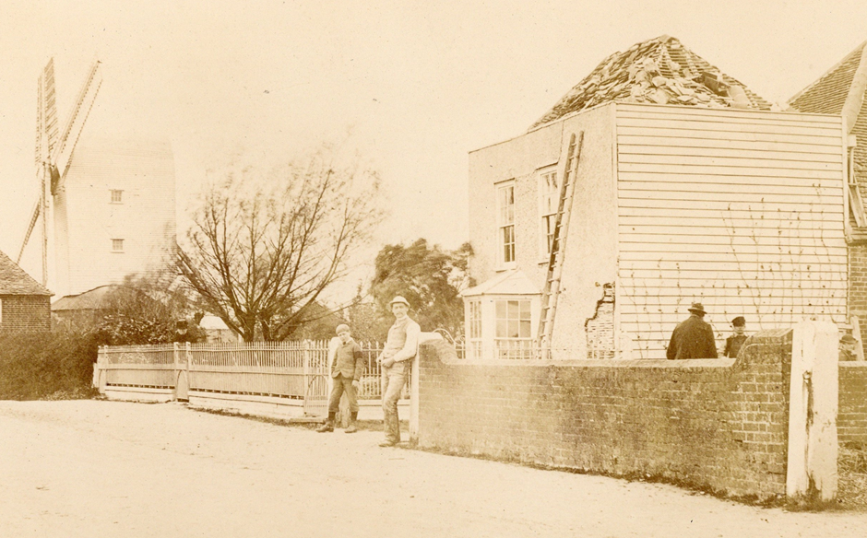

The following files have been recently added to the catalogue:

- Individual files on Rayleigh Windmill; Great Chishill Mill; Greenstead Green Mill, Halstead; Gardner’s Mill, Hatfield Peverel; Moreton Post Mill; St Osyth Mill; Broxted post mill
- Manuscript of "Toothill The Story of an Essex Windmill" by Paul Baker
- Correspondence re. Rex Wailes’ Essex Mills paper
- Large file of survey notes on Essex mills.

I have been truly amazed and touched by the response that people and groups like the Essex Society for Archaeology & History have made since we launched the fundraising appeal in the autumn. Thanks to your group’s generous support, we have already received almost £15,000, and we continue to receive expressions of support.
You are also one of the first to find out that we have been successful in winning a £10,000 grant from the National Manuscripts Conservation Trust to conserve some of the most badly damaged drawings in the collection. Again, this would not have been possible without your support, which helped to demonstrate the need and value of Rex’s material.

Ms Elizabeth Bartram,
Director of Programmes & Development, The Mills Archive Trust.

More information on the Rex Wailes Archive and the Alan and Glenys Crocker collection, which includes items on Waltham Abbey Royal Gunpowder Mills, can be found by following this link: https://mailchi.mp/6ef843bdc8b1/silk-mills-windmills-and-gunpowder-mills

Davey Paxman and the Romney, Hythe and Dymchurch Railway

Issue 104, December 2019 of ARCHIVE, The Quarterly Journal for British Industrial and Transport History, featured an article on the Romney, Hythe and Dymchurch Railway. The article includes details of seven locomotives built for the railway by Davey Paxman of Colchester between 1925 and 1927. Two of these locos, No.7 Typhoon and No.8 Hurricane, are featured on the post card below:

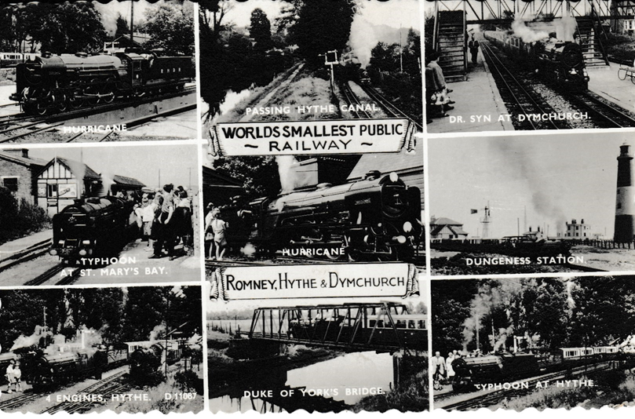
(Tony Crosby Collection)

Planning Applications

EIAG does make comments on planning applications which affect former industrial buildings but only when we hear about them, as it would be too great a task to monitor all applications made across all the Essex District Councils. Examples include the Britvic Clock Tower in Chelmsford (demolished despite our comments) and the Courtauld Air Raid Shelters in Halstead (planning application denied). If you hear of a development proposal in your area which will have a negative impact on a former industrial building, please let us know so that we can consider making comments and representations as appropriate. Email us on essexiag@gmail.com

