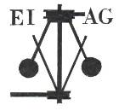
Essex Industrial Archaeology Group

NEWSLETTER

Number 33 March 2020

Welcome to this month’s edition of the EIAG Newsletter. We hope that you all are keeping well and safe during this unprecedented period of lock-down. In order to provide you with a little distraction by way of some industrial interest and keep in touch with you all, the Newsletter will continue to be produced every other month, albeit a lot slimmer than usual. Do get in touch with us with items of news of industrial interest, recommendations of books you have read or TV programmes you have seen, such as Great Welsh Canal Adventures, 7:30 on Tuesdays on BBC4. If you wish to make a contribution to the next Newsletter, please contact us via our email address - essexiag@gmail.com.

Programme of ESAH/EIAG visits 2020

Obviously the programme of visits for this year is already being subject to cancellations and more may follow. We will try to keep you up to date via this Newsletter or one-off emails. The following of industrial, maritime and transport interest much later this year hopefully will happen. Fuller details and booking forms were circulated with the ESAH Newsletter earlier this month.

The Annual Morant Lecture on Saturday 25th April 2020, and the visit to the Warner’s Textile Archive, Braintree, Friday 22nd May 2020 have already been cancelled.

Epping – Ongar Railway, Saturday 22nd August 2020. Talk on the history of the line, a tour of the engine sheds, and a trip on a steam train from North Weald to Ongar. £25 including Fish & Chip lunch.

EIAG Annual Meeting. Saturday 14th November 2020, 2:00 pm. Chelmsford Museum. AGM followed by a talk by Dr Catherine Pearson on the Frederick Roberts Archive of Industrial History – Free for members, £2.00 for non-members.

Planning Applications

EIAG does make comments on planning applications which affect former industrial buildings but only when we hear about them, as it would be too great a task to monitor all applications made across all the Essex District Councils. Examples include the Britvic Clock Tower in Chelmsford (demolished despite our comments) and the Courtauld Air Raid Shelters in Halstead (planning application denied). If you hear of a development proposal in your area which will have a negative impact on a former industrial building, please let us know so that we can consider making comments and representations as appropriate. Email us on essexiag@gmail.com
ESSEX 2020

A year-long, county-wide celebration of Science, Technology, Engineering, Arts and Mathematics, and the celebration of four centenaries.

The Essex Record Office Conference - Back to the future: the impact of science across Essex, was held on Saturday 7th March as planned, but due to the current restrictions other planned events, as set out in Newsletter 32 in January, are being cancelled, so please check before you book or go along to the event. The Chelmsford Museum Annual Lecture, for instance, due to be held on 24th March was cancelled. Please do visit the Essex 2020 website at: https://www.essex2020.com/events/ for the latest news.

East of England Regional Industrial Archaeology Conference

EERIAC 2020 is due to take place on Saturday 6th June 2020. The venue is:

The Pye Building
The Cambridge Museum of Technology
Cheddars Lane
Cambridge
CB5 8LD
Registration is from 09:00. There will be two lectures in the morning:
- The Pye Group of Companies
- The Cambridge Instrument Company
Followed in the afternoon by Boat Trips on the Cam with an IA commentary, or Tours of the Museum.
For more information please contact: robin.chandler@btinternet.com
Visit the Museum website for more details of what is to be seen at the museum: https://www.museumoftechnology.com/
When we hear of further news about this event we will let you know.

Davey Paxman and the Romney, Hythe and Dymchurch Railway

In the previous edition of this Newsletter we alerted you to an article in ARCHIVE, The Quarterly Journal for British Industrial and Transport History, on the Romney, Hythe and Dymchurch Railway. The article included details of seven locomotives built for the railway by Davey Paxman of Colchester between 1925 and 1927. Issue 105, March 2020 of ARCHIVE features Part 2 of this article, which again contains some excellent photos of the Davey Paxman locos.

Subscriptions to or the purchase of individual issues of ARCHIVE can be made from the Lightmoor Press website at: http://lightmoor.co.uk/category.php?section=IndArchive

Tindal Street, Chelmsford

To interpret Chelmsford’s history and enhance the appearance of Tindal Street in Chelmsford, five information boards have recently been installed along the blank side wall of High Chelmer. The boards provide information on the origins of Tindall Street, its public houses, the development of High Chelmer and the history of the Shire Hall and Tindal Square.

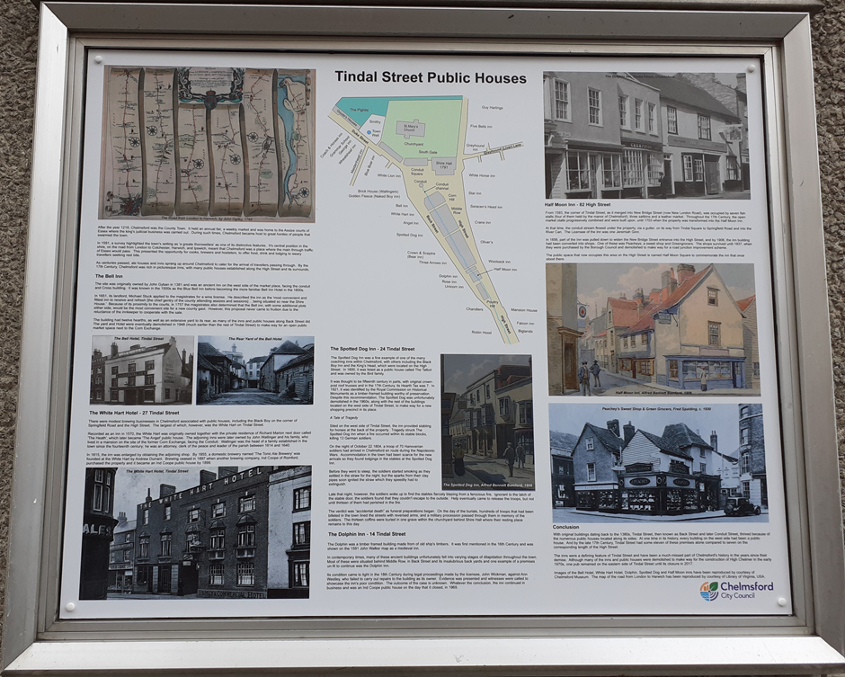

Photo: Tony Crosby

Balkerne Tower Trust – ‘Jumbo’

Following the rejection by the National Lottery Heritage Fund (NLHF) of a grant application by North Essex Heritage (NEH) for the restoration and development of Jumbo, NEH intends to commission a new study on the condition of Jumbo before submitting a revised NLHF application later this year. Meanwhile, to enhance public interest in the tower, NEH held a series of events called ‘Jumbo Summer’ including a series of talks and the production of two locally produced videos about Jumbo which can be seen by following this link:
https://colchesterbpt.co.uk/2019/10/06/jumbo-summer-films/

The Grade II Listed Balkerne Hill pumping station which once supplied Jumbo with water has been restored by Anglian Water but faces ongoing threats from vandals. Meanwhile the fate of the Rowhedge Pump House hangs in the balance.

Brian Light
Little Laver Windmill
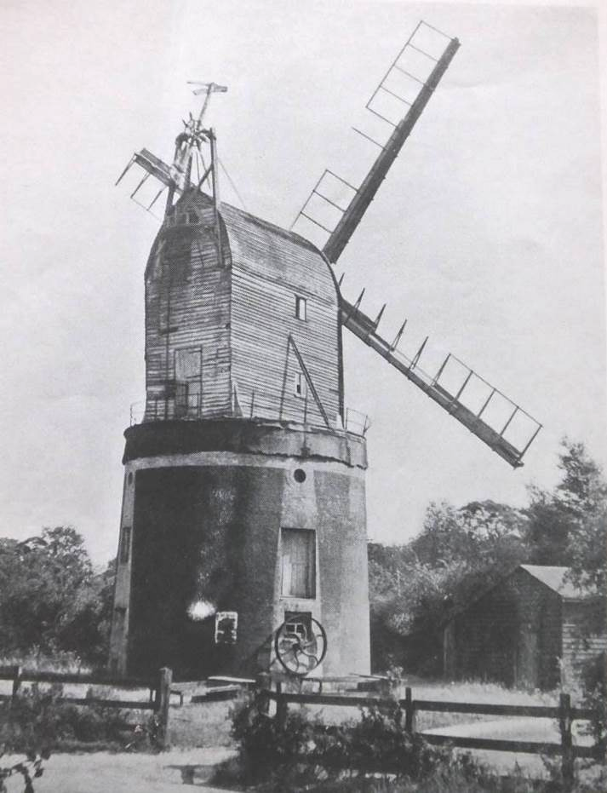
This very unusual windmill was demolished in 1963 but had an interesting life from at least 1579 when a Peter Hardy was miller. It was bought by William Roast of Margaret Roding, a miller in 1759. It continued in the family for some 140 years. In the middle of the 19th century the post mill was jacked up and a tapering brick tower about 24 feet high built under converting it into a composite post and tower mill. The brick tower has three floors and was said to have been built to increase storage capacity. This was said to give an additional storage of 200 quarters above the normal. It has been suggested that the compelling reason for the massive change was a defective main post that was made redundant by the conversion to operate as a tower mill. It continued milling until 1930 and survived to demolition in 1963. As the photo shows it also had steam, connected in 1898, driving a pair of stones in the first floor of the tower.
It came to light while perusing early editions of Essex Countryside and a letter by a P H Lovell of Pinner, Middlesex in Issue No.4 published in Summer 1953. Some extra information has been taken from Kenneth Farries, Essex Windmills, Millers & Millwrights published in 1985. It is interesting to note that Farries uses a picture of Little Laver as the frontpiece of Volume Four.
Elphin Watkin
Bata Heritage Centre

The planned Open Day on Saturday 25th April has been cancelled. However, there is an Open Day on Wednesday 8th July which is still in the diary, but dependent on the situation at the time. We will keep you posted as to whether this takes place or not.

That’s all for March unfortunately, but hopefully two months on the May Newsletter will have more positive news and events to look forward to. In the meantime do please consider sending in items for the Newsletter to essexiag@gmail.com

