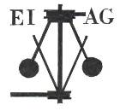
Essex Industrial Archaeology Group
Incorporating the Essex Mills Group

NEWSLETTER

Number 34 May 2020

Welcome to this month’s edition of the EIAG Newsletter. We hope that you all are keeping well and safe during this unprecedented period of lock-down. In order to provide you with a little distraction by way of some industrial interest and to keep in touch with you all, the Newsletter will continue to be produced every other month. Do get in touch with us with items of news of industrial interest, recommendations of books you have read, or TV programmes you have seen, such as The Architecture the Railways Built, 8:00pm on Tuesdays on the channel ‘Yesterday’. If you wish to make a contribution to the next Newsletter, please contact us via our email address - essexiag@gmail.com.

This month, along with bad news of cancelled or postponed events, we do have some good news, such as that from Chelmsford Civic Society and the Mills Archive. We also revisit a couple of features from a few years ago regarding lesser known industries and workers’ housing, and introduce a new feature – a Puzzle Page!

Programme of ESAH/EIAG visits 2020

Obviously the programme of visits for this year has already been subject to cancellations, as reported in the March Newsletter, and more may follow. We will try to keep you up to date via this Newsletter or one-off emails. The following of industrial, maritime and transport interest later this year hopefully will happen. Fuller details and booking forms were circulated with the ESAH Newsletter in March.

Epping – Ongar Railway, Saturday 22nd August 2020. Talk on the history of the line, a tour of the engine sheds, and a trip on a steam train from North Weald to Ongar. £25 including Fish & Chip lunch. - CANCELLED

EIAG Annual Meeting. Saturday 14th November 2020, 2:00 pm. Chelmsford Museum. AGM followed by a talk by Dr Catherine Pearson on the Frederick Roberts Archive of Industrial History – Free for members, £2.00 for non-members.

EIAG Committee has agreed to plan to hold a fourth Industrial Heritage Fair in early October 2021. Hopefully this will be able to go ahead and details as they are agreed will be in future Newsletters – fingers crossed!

East of England Regional Industrial Archaeology Conference
EERIAC 2020 was due to take place on Saturday 6th June 2020 at The Cambridge Museum of Technology. Due to the current situation this has now been postponed until 2021, with the date, venue and programme of the day to be confirmed nearer the time.

ESSEX 2020

A year-long, county-wide celebration of Science, Technology, Engineering, Arts and Mathematics.

Due to the current restrictions many planned events, as set out in Newsletter 32 in January, have been cancelled, so please check before you book or go along to the event. Please do visit the Essex 2020 website at: https://www.essex2020.com/events/ for the latest news, but here is the latest better news from the Chelmsford Civic Society

“As you will imagine the events that have been organised in June for the Marconi Centenary have now been cancelled because of Covid-19 but we are hoping to set up a live link with Tim Wander, author and historian, for his planned events on 10th and 22nd June - link details to follow soon, or check with www.chelmsfordcivicsociety.co.uk.

For your interest, this is the link to the original printed programme of events if you do not have a hard copy https://online.flippingbook.com/view/883349/

In the meantime, details of Tim's latest book 'From Marconi to Melba' can be viewed at www.chelmsford2020.co.uk and the limited edition book is now ready to order. Some of the unseen previous photos have been professionally tinted which certainly brings the book to life.

Here is message from Tim W - https://youtu.be/4MF5tQ6dVVM

In addition, the Hylands Marconi Exhibition has now been postponed to 1st November 2020.”

Dick Nunn's Bridge Coggeshall

In 1892 Henry ‘Dick’ Nunn a Coggeshall blacksmith made and erected a wrought iron footbridge over the River Blackwater in the village. Now Essex Highways, who are nominally the bridge's owners, deem it to be irreparable and are planning to replace it. However this footbridge is very special to the heritage of the village, its history and its current inhabitants, and they are seeking to be assured that every effort is made to investigate ways to repair and restore the bridge before consideration is given to replacement. To sign the petition for Essex Highways to restore the bridge, click the link here: https://www.change.org/p/essex-highway-s-department-save-dick-nunn-s-bridge.

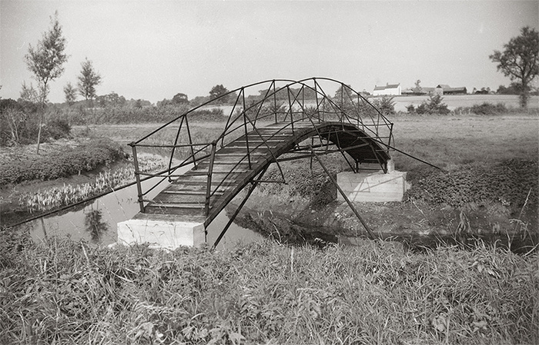
For more information on Dick Nunn and the bridge see the Coggeshall History website at: https://www.coggeshallhistory.com/dick-nunns-bridge
(Image from Coggeshall History)

Coggeshall History members have recently found and cleared the remains of Dick Nunn’s forge complete with bellows and hearth, as shown in photo below.

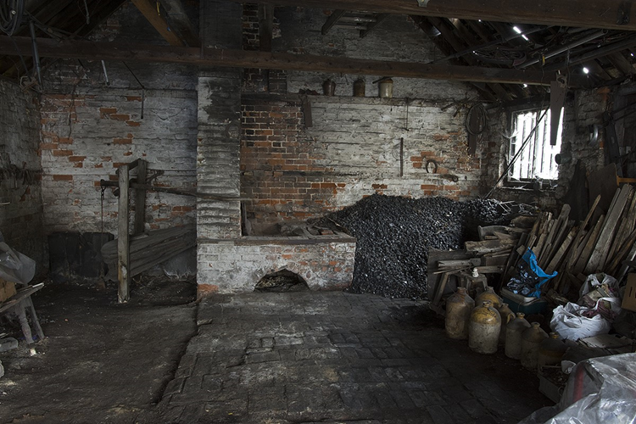

Dick Nunn’s forge complete with bellows and hearth
(Image from Coggeshall History / Trevor Disley)

‘Eat Natural’ Factory, Halstead

Not my usual viewing choice to watch Greg Wallace, but reading that the episode of ‘Inside the Factory’ on 5th May was to be based at a cereal bar factory in Essex I had to watch it! It was a fascinating insight into the manufacturing process in a set of modern factory sheds – no great architecture but a good example of process recording if you can put up with Greg’s presentation. It is of course available on iPlayer at: https://www.bbc.co.uk/iplayer/episode/m000hy3b/inside-the-factory-series-5-10-cereal-bars

Is this the industrial heritage of the future!?

Industrial Heritage Sector: Adaptations in Light of Covid-19

Dr Michael Nevell, AIA Chairman and Industrial Heritage Support Officer for England, wrote recently for Historic England’s Heritage Online Debate:

The wider Industrial Heritage and Industrial Archaeology sector has been severely hit by the Covid-19 health crisis. All the 600 plus industrial sites preserved as heritage attractions in England have been closed, most full-time staff furloughed, all local meetings and events of the 100 plus industrial heritage and industrial archaeology societies and groups in England cancelled, universities are closed, and professional archaeology fieldwork as part of the developer-funded world is mostly suspended.

These are worrying times and the financial viability of many heritage attractions and archaeology units, large and small, is in danger of being undermined. As the Association for Independent Museums has highlighted, the local voluntary sector, and in particular industrial heritage and industrial archaeology groups, societies and smaller industrial museums who rely on membership and visitor income, are likely to be under pressure as a result of a loss of income and members. Some grants are available from a number of bodies to support the sector, including The Arts Council, the National Lottery Heritage Fund and Historic England. The Government’s business loan support scheme should be accessible for professional archaeology units, whilst a variety of organisations are providing help, support and advice.

It is, though, very easy just to focus on the immediate damage being done by the economic paralysis. The crisis has also led to innovation, or perhaps has accelerated change, within the industrial heritage and wider archaeology sectors.

The Council for British Archaeology has partnered with the University of Lincoln to launch Dig School, 20 free archaeology-themed workshops to help teachers and home-schooling families inspire children to explore archaeology and local history from their laptops and tablets. Both the Association for Industrial Archaeology (AIA) and Society for Post-Medieval Archaeology (SPMA) are looking at expanding further their online presence. SPMA held their first twitter conference in April, whilst the AIA is promoting its new research funding stream as well as continuing its support for the sector through its conservation grants scheme with a new round of funding available for 2020.

Regional groups such as the Cumbrian Industrial Heritage Society have responded by increasing their online presence through expanding their website pages. Educational charities such as the Workers’ Educational Association though only functioning online, have distance learning courses including heritage topics due to be available later in the spring. Transport heritage societies were quick off the mark – railway trusts such as the Severn Valley Railway, launching online funding appeals within a few days of the lockdown beginning.

Focussing on industrial sites preserved as heritage attractions, the Industrial Heritage Support Project has been acting as an information hub since the Covid-19 crisis began continuing to build on nearly a decade of support for the sector. The Industrial Heritage Support Officer (IHSO) is hosted by the Ironbridge Gorge Museum Trust and funded by Historic England. Regular updates are provided through the project’s Facebook pages, Twitter posts (@IHSOEngland) and through the projects’ two websites: Industrial Heritage Support and Industrial Heritage Networks.

As the industrial heritage sector looks to recover from the pandemic the IHSO project’s Steering Group will be helping in focusing on the needs of the sector and how these can be aided. The IHSO project will also be re-activating the regional Industrial Heritage Support Networks once conditions improve, and extending these to the remaining areas in England not so far covered. Information exchange and remote networking will be key to helping spread best practice as the industrial heritage sector begins to recover from the impact of the pandemic.

Further help and advice for industrial sites preserved as heritage attractions is available by contacting the Industrial Heritage Support Officer - mike.nevell@ironbridge.org.uk.

Lesser Known Industries and Workers’ Housing

Kirkaldy’s Marine Engineering Works, Burnt Mill, Harlow.
Plus Workers’ Housing at Burnt Mill Village

The water mill on the River Stort close to what is now Harlow Town Station was originally known as Netteswell Mill, which dates back to C13th, although there was probably a pre-Conquest mill on the site. Later in the C16th it became known as Burnt Mill and gave this area of what is now Harlow its name, and that of the original railway station on the Great Eastern Railway line from London Liverpool Street to Cambridge. The mill was still producing flour in 1881, but in 1885 John Kirkaldy Ltd., marine engineers of Limehouse, London, bought the site, had some buildings demolished and some adapted for use as the factory where plant for converting salt water to fresh water on board ship was produced. During the First World War the factory produced munitions and there were about 300 workers - men and women - on site, but after the war business declined and the factory closed in 1932. Part of the works, including the foundry, was demolished as part of the development of Harlow New Town, and especially the Burnt Mill Station to Harlow Town Station re-development, in the 1960s. However, one two-storey, brick building survives and is used by Essex Outdoors Harlow as a centre for specialist climbing and paddle-sport.

The building of Burnt Mill Village began soon after Kirkaldy’s arrived at Burnt Mill. It consisted to two streets, Spring Street and The Avenue, which were to the south of the station. To the north west of the station in Station Road were three pairs of semi-detached houses known as ‘Works Villas’. In addition to over 50 houses there was a Post Office and General Store, a butcher’s shop, a reading room and a Methodist Church. According to the 1891 census the population of the village was 155, 36 of the men working at Kirkaldy’s. Unfortunately the whole village was swept away as part of the development of Harlow New Town.

Reference: The Life and Death of Burnt Mill Village, Edited by Hazel Lake

Tony Crosby

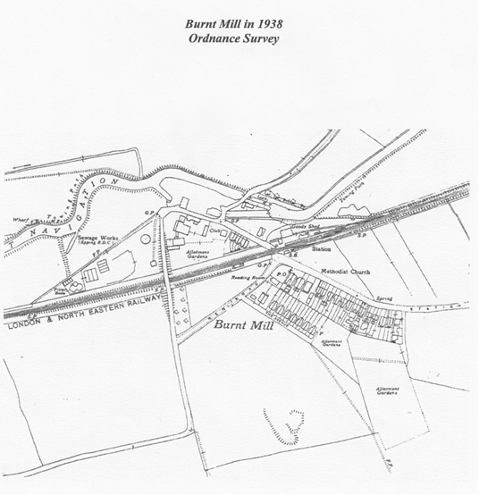
PUZZLE PAGE

Can anyone identify the object in the foreground please? It was mainly constructed with wood and made by Rippers Limited, joinery manufacturers of Castle and Sible Hedingham. One of the men in the photograph is Samson Schooling who was a carpenter employed by Rippers, whose joinery works was adjacent to Castle and Sible Hedingham Railway Station. In the background is the signal box, which stood on the platform and the main railway line was behind the signal box. In front of the signal box is a railway wagon standing on the goods siding and it appears the mystery item is just about to be loaded onto the wagon. If you recognise the object will you please email Adrian Corder-Birch on: adrian@corder-birch.co.uk or: essexiag@gmail.com
Thank you.
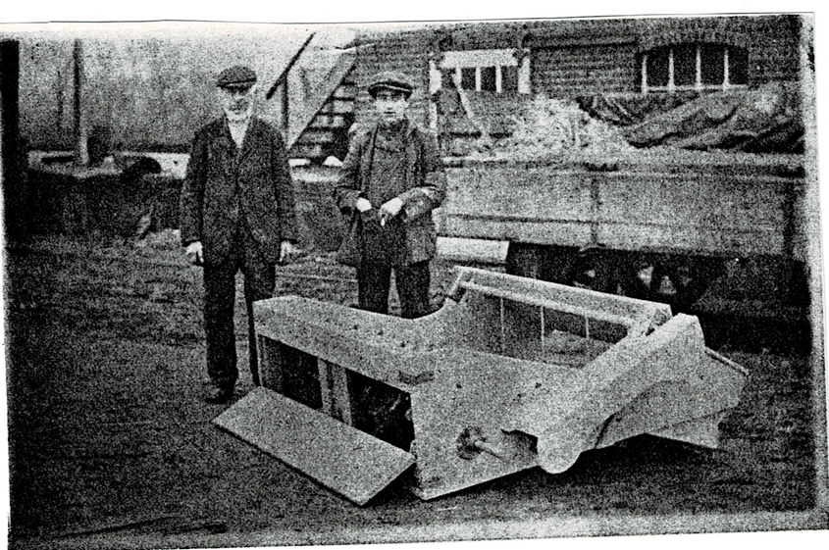

Where is / was this?
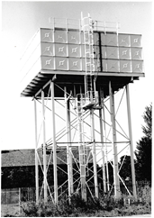
Like many of you I am sure, during this period of lock-down, along with gardening, spring cleaning (!) and DIY-ing, I have been sorting through my book shelves including my photos. Amongst the many I took when researching Essex’s Public Water Supply industry is this photo of a steel-framed water tower – but where is / was it? I can’t remember and did not make a note of it at the time! A village in the Braintree area, I think, possibly associated with one of the airfields? So, over to you all - any suggestions /answers please to essexiag@gmail.com
Tony Crosby

If you have photos of artefacts, buildings or sites which you cannot identify and with which you need help, then do send them to us at essexiag@gmail.com and we will include them in future newsletters and hopefully find answers for you.
Essex Mills

Earlier this month it should have been National Mills weekend but for obvious reasons it was cancelled. However Essex CC through their Explore Essex What’s On newsletter still took the opportunity to promote the county’s important heritage of wind, water and steam mills. The County Council owns and manages the five mills illustrated below, which are under normal circumstances are open to the public.

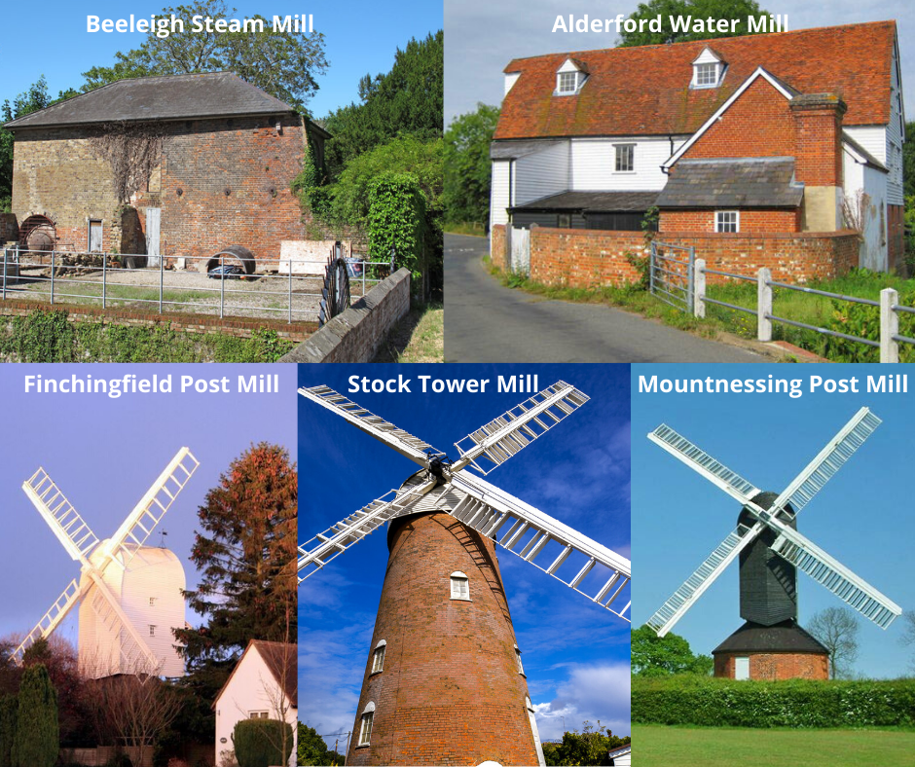
Alderford Water Mill used to mill corn but switched to producing animal feed during WW2. It is one of the best-preserved water mills in Essex, containing most of the original machinery.
The Weatherboard Water Mill at Beeleigh, which housed 2 water wheels driving 10 stones, was destroyed by fire in 1875 but the Steam Mill survived and the building now houses a rare Wentworth beam engine, elephant boiler and circular all-iron steam mill dating from 1845.
Finchingfield Post Mill is the oldest mill in Essex, built around 1756. Finchingfield used to be home to 7 mills, this one is the last mill standing! The mill's four sails could be rotated to catch the wind, driving a pair of millstones. A tail pole was used to turn the mill.
Mountnessing Post Mill, built in 1807, is in full working order and although it stopped operating in 1933, it still occasionally mills flour!
Stock Tower Mill was a wind powered corn mill. The mill used wind power up until around 1930, then ran for a further six years using an internal combustion engine.
The Mills Archive - Rex Wailes Collection Update

Nathanael Hodge has provided this update on progress with the cataloguing and digitisation of the Rex Wailes Collection, towards which EIAG gave a grant as the collection includes many Essex mills:

“Since the Rex Wailes collection arrived at the Mills Archive we haven’t been standing still. Staff and volunteers have been hard at work sorting, cataloguing and uncovering some of the gems of the collection. Bearing the brunt of much of this work has been the Archive’s most long-standing volunteer, Guy Boocock. Guy’s spreadsheet listing already runs to over 600 entries – when complete, it will be available for the public to search on our online catalogue.
But we didn’t want to wait for that before making some of the collection available online. So at the same time, other volunteers have been working through Rex’s photographs. Many have already been digitised and can be viewed on our online catalogue: https://catalogue.millsarchive.org/images-3. (Scroll down in the box at the top of the page to find ‘Photographs of Essex Windmills’.)
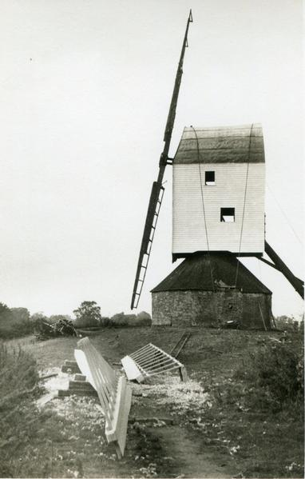
Much of the collection is in a poor condition due to having been stored for many years in sheds at the bottom of Rex’s garden before rescue by Alan Stoyel. A grant from the National Manuscripts Conservation Trust will help fund conservation work on some of the most damaged large drawings. The appeal to help conserve the collection has resulted in the amount raised so far to have reached £15,000. This will go a long way in preserving this collection for future generations to enjoy.”

Mountnessing post mill with sails on the ground
(Photo from the Rex Wailes Collection)

Guy Boocock also wrote:

“Since Rex Wailes’ collection arrived at the Archive in July 2019, work has begun on the 38 boxes, organising the material between mill-related items and industrial archaeology. The industrial archaeology material comes from Rex’s involvement in the Industrial Monuments Survey during the 1960s and 1970s and includes material on breweries, beam engines and pumping stations, canals and railways, and iron and steel works, to name a few. I created a spreadsheet of the industrial archaeology material which has since been uploaded to the catalogue for the public to view. The next mammoth task is to organise all of his mill material into categories and then sift through the enormous miscellaneous mill material and place it into those categories. While it may seem like we are deconstructing Rex’s collection, and in some ways we are, most of it was not organised in any particular way, with many loose items of research and correspondence found in the boxes. This necessitates me having to strip down the contents and create new files or place them into existing files on particular topics. These will all be added to the catalogue in a similar vein to the industrial archaeology material, whilst other material will be catalogued in greater detail in the coming months.”

