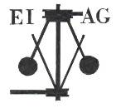
Essex Industrial Archaeology Group
Incorporating the Essex Mills Group

NEWSLETTER

Number 35 July 2020

Welcome to this month’s edition of the EIAG Newsletter. We hope that you all are keeping well and safe as we emerge from lock-down. Hopefully you are now able to get out and about to visit museums and heritage sites as they re-open, or just walk around the many historic towns and villages of Essex. This month we are looking forward as sites announce that they are re-opening, to planned events which will hopefully take place in the Autumn, and even look forward to 2021 which is European Year of Rail! We look back to the early days of Essex windmills, at one good news outcome of Covid-19 from The Traditional Cornmillers Guild, but bad news from Paxman’s of Colchester.

If you wish to comment on or make a contribution to the next Newsletter, please contact us via our email address - essexiag@gmail.com.

ESAH/EIAG Programme 2020

Obviously the programme of visits for this year has already been cancelled. We are still hoping that the EIAG Annual Meeting will be able to go ahead, perhaps with a change of venue where social distancing is easier, but as soon as we know one way or the other we will let you all know by email.

EIAG Annual Meeting. Saturday 14th November 2020, 2:00 pm, venue to be arranged. AGM followed by a talk by Dr Catherine Pearson on the Frederick Roberts Archive of Industrial History – Free for members, £2.00 for non-members.

EIAG Committee has agreed to plan to hold a fourth Industrial Heritage Fair in early October 2021. Hopefully this will be able to go ahead and details as they are agreed will be in future Newsletters – fingers crossed!

ESSEX 2020

A year-long, county-wide celebration of Science, Technology, Engineering, Arts and Mathematics.

Due to the current restrictions many planned events, as set out in Newsletter 32 in January, have been cancelled, but the Hylands Marconi Exhibition has now been postponed to 1st November 2020.

Marconi's Legacy – Past ideas inspiring future solutions

This special day is one of a series of events planned to celebrate Essex 2020: a Year of Science and Creativity.

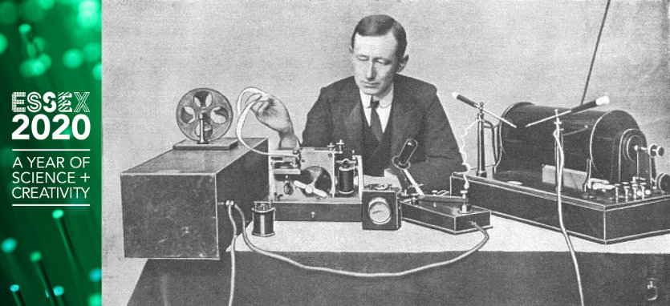

Embark on a journey! Start at the birth of Marconi; follow through his life's work and on to the company he gave his name to. 2020 is the 100th anniversary of Dame Nellie Melba's radio broadcast from Marconi's New Street factory and much has changed since then. Take a look at some of the modern technologies that were set in motion by Marconi's pioneering work.

This FREE exhibition will give a great blend of old and new, intended to inspire pride in Essex's past, and confidence in its future.

Leonardo from Basildon (a former Marconi Company) will be presenting at this exhibition in partnership with CSES and Chelmsford Civic Society.

FREE entry

Bata Heritage Centre News

A short newsletter was issued by the Bata Heritage Centre for June. All events up until July have been cancelled, but:

“There is some good news though! We are now planning to host a 2-centre Open Day on Saturday 17 October. The owners of the former factory site have confirmed that we can use the ground floor area of Building 13 (the old administration building) but more details will follow once the outlook for all of us is clearer.

Given these continuing issues we cannot currently have a presence in East Tilbury library to greet visitors. As I said before should any of you, or visitors to the library, want to make contact with us then please view our website (http://www.bataheritagecentre.org.uk/) - my contact details are on the front page as is our email address of brrcatbatamemories@hotmail.com.

If needed we could consider arranging a “one to one” online discussion/meeting with one or more of our volunteers using the Zoom software or perhaps Facebook’s messenger.”

Mike Tarbard, Chairman – Bata Heritage Centre


2021 European Year of Rail
2021 will be the European Year of Railways... ...but railway heritage is under threat in all countries.

2021 will be the European Year of Railways. Railways can provide sustainable transport today and tomorrow, as they did so in the past. Much is at risk, though, railways and tramways, both their buildings and infrastructure, and the rolling stock, which are all an important of our industrial and transport heritage are threatened. Old railway lines are decommissioned; stations, signal boxes and workshops are decaying into ruins or being demolished - while they could easily be redeveloped as a form of sustainability. Written-off rolling stock is stored in poor conditions or ends up in railway cemeteries. Disused iron railway bridges rust or are demolished and sold for scrap value. But old railway lines can be transformed into Greenways, quiet and ecologically sound cycle paths and footpaths. Tourist railways, run by volunteers, are threatened by the loss of income due to COVID-19, while they are a tourist attraction in rural areas.

For more information see the EFAITH website at:
http://www.industrialheritage.eu/2021/European-Year-Rail/

Essex Heritage Railways to Re-open

Looking at the local railway heritage, the three Essex heritage railways have been closed since lock-down began in March – but steam and diesel hauled trains are returning to the tracks.

The East Anglian Railway Museum (EARM) at Chappel and Wakes Colne re-opened on Friday 17th July and will be open on Fridays, Saturdays and Sundays only. Details in their website at: https://www.earm.co.uk/

The Epping and Ongar Railway (EOR) at Ongar and North Weald will be open on Fridays, Saturdays, Sundays and Bank Holiday Monday in August. Details on their website at: https://www.eorailway.co.uk/

The Colne Valley Railway Has announced a limited re-opening from Sunday 26th July. Details on their website at: https://www.colnevalleyrailway.co.uk/

Both the EARM and EOR have appeals for donations on their websites as obviously they will be in financial difficulties with no income for the last four months and only limited income for the rest of the season, so please do support our local railway heritage.

The Audley End Miniature Railway is planning to re-open from 6th September. Details again on their website at: https://www.audley-end-railway.co.uk/

Chappel Viaduct featured on TV

Last month we mentioned a new TV series being shown on the Yesterday Channel called The Architecture the Railways Built. The programme broadcast on Tuesday 23rd June at 8:00 pm featured the viaduct at Chappel and Wakes Colne. As well as describing the building of the railway and its viaduct, the presenter also discussed the local production of the bricks which were required for its construction. A third element was an interview with Adrian Gascoyne of ECC Place Services regarding the World War Two defences built under and around the viaduct. The programme can be watched on UKTVPlay. Further details of the WW2 Trail (a project managed by our own Paul Gilman) can be found here: https://www.tendringcoastalheritage.org.uk/wp-content/uploads/2018/07/Chappel_Leaflet_FINAL.pdf

Ship Dock for Darwin’s HMS Beagle at Paglesham

The remains of a rare 19th century dock, built to accommodate HMS Beagle when it was serving as a Coastguard Watch Vessel in Essex, is now protected as a nationally important site. The submerged mud berth on the River Roach near Paglesham has been designated as a Scheduled Ancient Monument by the Department for Digital, Culture, Media and Sport on the advice of Historic England.

HMS Beagle was first launched in May 1820 from Woolwich Dockyard on the River Thames and is most famous for being the vessel on which Charles Darwin made the observations necessary to develop his theory of natural selection. Following three far-flung exploratory voyages the Beagle was refitted as a static watch vessel for the Essex Coastguard in 1845 serving to curb smuggling until it was sold for scrap in 1870.

In 2019 Historic England commissioned Wessex Archaeology to investigate the Paglesham mudflats in Rochford thought to be the last resting place of the Beagle, ahead of the bicentenary of the vessel’s launch in May 2020. Maritime archaeologists confirmed the location of the mud dock and a brick slope or ‘hard’ using geophysical surveys and an aerial survey by drone.

The Rochford mud dock - a specifically cut mooring place in which a vessel rests on the bottom at low tide - was constructed sometime after 1847. Despite what was probably once a common feature on England’s major waterways, particularly in the absence of designed dockyards, the locations of purpose built mud docks are not well known. Only five mud docks are recorded in England. Mud berths included the need for shoring to stabilise the sides, and wooden stocks to support the ship. The sloped brick hard extended alongside the dock and ship’s side allowing people access down the foreshore to low water.

Further details can be found on the Historic England website at: https://historicengland.org.uk/whats-new/news/rare-19th-century-ship-dock-protected//?utm_medium=email&utm_source=newsletter&utm_campaign=news

Paxman’s of Colchester

It has been recently announced that Paxman’s of Colchester is to close. Engine manufacturing MAN Energy Solutions has announced plans to shut their facility off Hythe Hill, Colchester. Formerly Paxman Diesels, work has been undertaken at the site for more than 150 years: the business was taken over by German-based firm MAN in 2010. Ship engines had been exported all over the world, but bosses say the coronavirus crisis has led to the decision to close down. For more information on the history of this business see: https://www.paxmanhistory.org.uk/
Flour Milling in a Time of Coronavirus
By the Traditional Cornmillers Guild

First it was toilet rolls, then it was tinned tomatoes. Now, with everyone at home, bored and wanting to bake, it’s flour and yeast. Not that there’s a shortage of flour, but the big roller mills are largely geared up to making bulk deliveries to bakeries, caterers and food manufacturers. So that leaves small traditional mills to produce and pack shopping-basket sized bags of flour.

The Traditional Cornmillers Guild represents some 35 wind and water mills around the UK. All must mill on horizontal millstones and be primarily driven by wind or water. They vary considerably in normal output and ways of working. Some are, already, quite large-scale flour producers, milling about 300 tonnes of grain per year. They provide a living for the miller, who can also be the owner of the mill. Other mills are owned by local authorities, bodies such as the National Trust, and local charitable trusts, run entirely by volunteers.

In these mills there is a wide variation in the balance between being heritage visitor attractions, and commercial flour producers, but in the past couple of months, they have one thing in common: there is no visiting of these mills to marvel at their historic machinery. A few have closed altogether (although routine safety maintenance will be vital – especially for windmills). The rest have devoted themselves exclusively to a greatly increased level of flour production.

Holgate Windmill in York (run by a community charitable trust) was to have celebrated its 250th anniversary this year and was hoping to attract a record number of visitors to its many commemorative events. All of a sudden, everything is on hold (until we are 251 years-old!) and small teams of three volunteer millers are going in three or four times a week to mill about five times as much flour as usual. The Saturday shop sells out, and local stockists are putting in frequent wholesale orders for our wholemeal wheat and spelt flour.

Other Guild mills are also working flat out to satisfy an extraordinary demand: at Heatherslaw in Northumberland and Worsbrough in Barnsley (two ancient watermills) the sudden rise in demand meant dramatically increasing flour production by as much as 500%. However, the mill shops are eerily quiet, donations are non-existent and the cafés are shut up as no visitors are allowed on site. And the pattern is replicated all over the country.

There’s been enormous interest from the media, both local and national, in this phenomenon. There have been radio interviews and local and national TV and newspaper features. These have raised the profile of traditional mills and shown that an ancient industry has huge modern relevance: not least by highlighting the green credentials of wind and water-powered machinery. Another outcome is that many more people are experiencing the flavour and quality of stone-ground wholemeal flour, as well as learning to bake bread, cakes and pastries. We hope, when this is all over, we will discover that we have recruited many converts to the joys of healthy, additive-free, wholemeal flour. That increased custom will, in turn, help to preserve these wonderful examples of our industrial heritage.

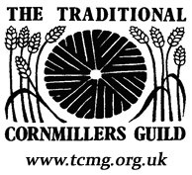
References to Early Essex Windmills

The earliest authentic reference to any windmill is to one at Bury St Edmunds in 1191 (chronicles of Joscelin de Brakelond).
There was a windmill at Henham mentioned in 1203 (molendin de vento) (Essex Finds vol I, p 29).
There were windmills at Belchamp St Paul’s, Runwell and Wickham St Paul’s in 1222 (Hale, Doomsday of St Paul’s, pp. 28,33,69).
There was a windmill at Takeley in the middle of the thirteenth century. (Harl, 480 g, f.107).
In 1243, Mabel, Abbess of Barking, complained that William and Geoffrey Dunn had erected a windmill in Barking to the injury of her mills in the same town, and William and Geoffrey admitted that they ought not to erect any wind or watermill in the manor or appurtenances.(Essex Fines vol I p 144).
In 1252, the Prior of Stoke received a yearly rent of 20s, from the windmill of Thomas de Bayeux at Toppesfield and from land abutting thereon. (Essex Fines vol I p 189).
In 1262 the windmill standing in the field called Melnfeld in Havering was excepted from a grant of Richard de Havering to Geoffrey fitzPeter of Romford. (Hornchurch Priory Documents, no’s 57, 59, pp, 23, 24)
There was also a windmill in Boreham before 1309, for twice (in 1309 and 1375) we find mention of Wymmellefeld or Wyndmellefeld. (Cat, Ancient Deeds, vol 5, pp 200, 210; A 11575, 11876. In 1375, this is also called simply Mellfeld ibid, A. 11874, p, 210).
In an inquisition on the death of Alice de Bello Monte in 1314, windmills are mentioned at Elmdon and Rayleigh. (Cal. Inq, post mortem, vol 5, no 507, p 282).
A windmill at Boking is mentioned in the Court Rolls for 1405. Usually the reference is simply to a “mill”. (Essex Review vol 39, p, 84).
In addition to the Windmill and Watermill mentioned at Barking in 1243, there was also at least one Horsemill, for in 1248 a boy was killed there quadam rota molendini at equos.(Assize Roll 232, m. 9d).
Cooksmill Green in Writtle owes its name to a windmill built by Richard Coc(us) on a plot of land at Armswick before 1274.( Rotuli Hundredorum vol I p, 161b).
By a deed of c.1240, William de Rumford granted to William de la Markedich a windmill standing in Suthfeld in Havering. A windmill in Hornchurch was leased in 1494 to William Fryth by the Warden and Fellows of the College of St Mary Winton in Oxford (New College). (Hornchurch Priory Documents, no’s 406, 309, pp, 96, 72).
A windmill called Newemyll in Havering is mentioned in 1396. (Cat. Ancient Deeds, C.2385.).
According to Shawcross, there was also a windmill in the Manor of Marks in Havering in 1479. (History of Dagenham, p 307).
In 1245, Richard de Munfitchet was ordered to allow William de Wauton to take timber from his wood of Muleshum as far a necessary for the construction of a windmill, the timber to be taken without doing injury to the Kings Forest of Essex. (Cal. Close Rolls.)
Two mills, ‘one at wind and one at water’ were part of the land in Finchingfield granted to Hugh Dyve in 1235. (Essex Fines vol i p 202).
Guy de Rochford had a windmill in Berden in 1273. (Newcourt Repertorium vol 2 p 54).
The dower assigned in 1300 to Margaret, widow of Gilbert Urii, included one third of two parts of a toll of a windmill in Wickford, the toll being extended at 13s 4d, (Cal. Close Rolls.)
Sir Guy de Rochford held a windmill in Rochford of John de Burgh in 1274, Richard de Suthchurch had one in Southchurch in 1267 and one in Prittlewell in1294, Phillip Perdrix one in Great Sutton in 1313 and William Combe one in Little Stambridge in 1333. (Trans, Southend Antiq Soc, vol I, pp, 62, 63, 168. That at Sutton, is, perhaps identical with the windmill, worth 20s per annum, mentioned in an extent of 1328 of the Sutton lands of the Knights Templars [Cott. MS. Nero E v I f 105]).
There were windmills at Rainham in 1248 (Assize Roll, 232 M 3d.) Milton in Prittlewell in 1309 (Trans Southend Antiq Soc, vol 2 p 13) Lawling in 1310 (Ex inf. Dr J F Nichols.). Gibcrack in Purleigh in 1323 along with a watermill. (Morant, Hist. Essex vol I p, 345) Helion Bumpstead in 1349. (Newcourt Repertorium vol 2 p 108) and at Colchester in 1406 (E.A.T vol 14 p88.).
In 1330 the tithes of two windmills and one watermill at Aveley were reserved to the vicar by the Abbot of Lesnes, the tithes of three watermills and certain other mills (probably windmills) to the vicar of Chigwell in 1374, whilst the tithes of all mills in Saffron Walden, ‘Windmell, Watermell, Horsemell or Fullynmell’, were reserved to the Abbot of Walden in 1444. (Newcourt Repertorium, vol 2, pp, 21, 140, 624).
The moiety of a windmill in Bulphan was included in a grant by Edward Bray to Charles Wilford and John Wolfe in 1654. (Add. Ch. 15616).
Occasionally we learn of the existence of windmills from place name forms. Windmills must have existed at Kelvedon in 1294 (Wyndemullhull), (Essex Review vol. 19 p. 147),
Near Moor Hall, Harlow, before 1350 (Wyndmylfeld) (Add Roll, 55185)
At Arkesden before 1387 (Wyndemelnessot, Oldwyndemelnessot) (Walden Cartulary)
And at Great Dunmow before 1527 (Wynmell Strete) (Scott, Antiquities of Great Dunmow p. 116).
From Essex Archaeological Society Transactions vol xx pt. 1&2 (1930/31) – Percy H Beaney
Paul Sainsbury

Puzzle Page

Last month we introduced this Puzzle Page feature and began with a request from Adrian Corder-Birch for help to identify a wooden object made by Rippers Limited, and a request from Tony Crosby to identify the location of a metal-framed water tower. Adrian received a suggestion from Paul Sainsbury that the wooden object was associated with potato harvesting which Adrian is now researching further. Two people very quickly identified the water tower as being that at Great Saling, which is extant; so many thanks to Mike Bardell and Elphin Watkin for their quick replies.

Tony still has a couple of public water supply sites he wishes to identify, so your help, please, would be much appreciated. Both are water pumping stations, but which are / were they? (Apologies for the quality!)

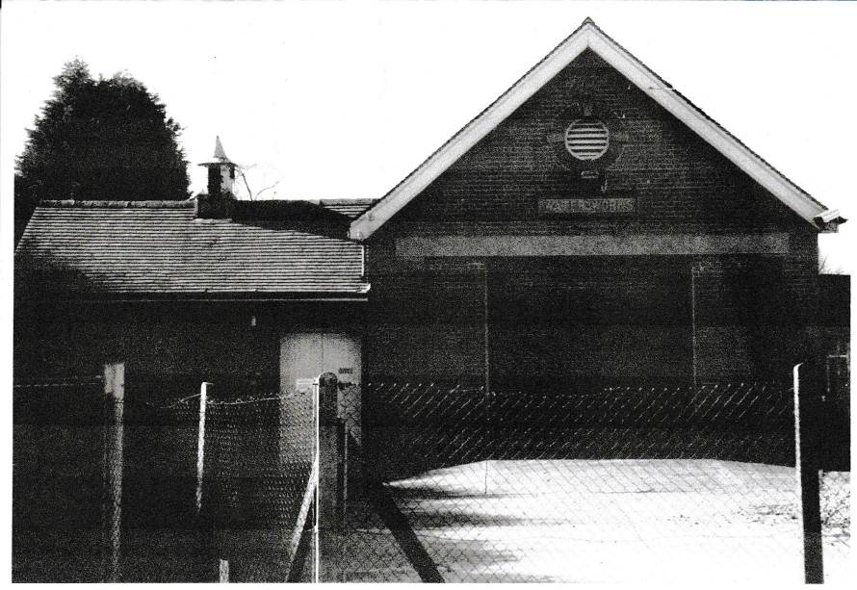

Number 1 – the plaque above the door says ‘WATER WORKS’

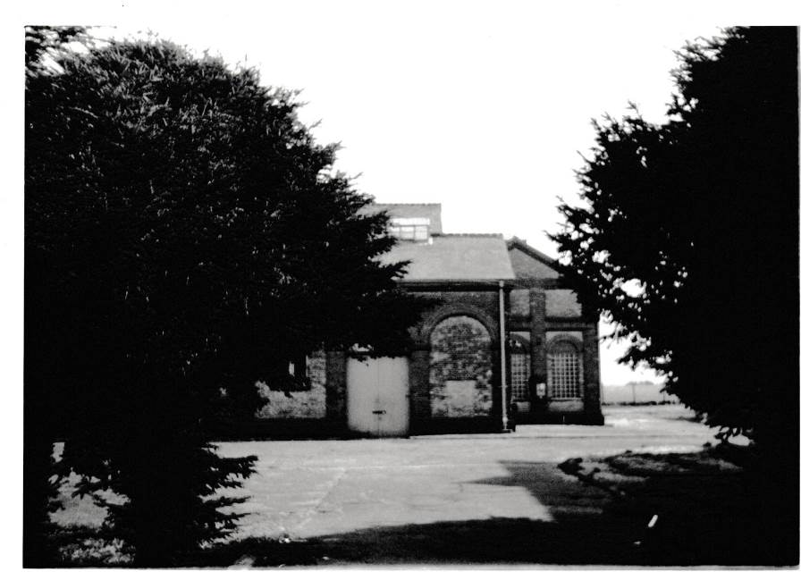

Number 2

If you have photos of artefacts, buildings or sites which you cannot identify and with which you need help, then do send them to us at essexiag@gmail.com and we will include them in future newsletters and hopefully find answers for you.

