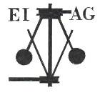
Essex Industrial Archaeology Group
Incorporating the Essex Mills Group

NEWSLETTER

Number 36 September 2020

Welcome to this month’s edition of the EIAG Newsletter which includes notice of the cancellation of the EIAG Annual Meeting, but also good news of museum re-openings. Plus there is a mixed bag of articles on mills, terraced housing, plaques and interpretation boards, I. K. Brunel, and EKCO radios made in Southend-on-Sea.

We hope you enjoy reading this edition and if you have any comments on the Newsletter generally or specific items in it, or wish to make a contribution to the next Newsletter, please contact us via our email address - essexiag@gmail.com.

EIAG Annual Meeting 14th November 2020, 2:00 pm

CANCELLED!

Considering the recent in rises in the number of Covid-19 infections in the community and the recent announcement restricting gatherings to six people, it has been decided to cancel this year’s Annual Meeting. I will circulate, in November, by email a report on activities over the last year (very little!), plans we have for 2021 (crystal ball welcome, please!) and membership of the Committee for the coming year.

Tony Crosby, EIAG Chairman

COLNE VALLEY RAILWAY Open again

The Colne Valley Railway at Yeldham Road, Castle Hedingham is open again although there are some changes due to Covid regulations. They limit the number of family groups on the train and have implemented one way systems in some areas. They have hand sanitising stations around the site and a cleaner in every operation day to help keep you safe. They are giving diesel train rides every Sunday until the end of October. Further information can be found on their website: www.colnevalleyrailway.co.uk or by email to: colnevalleyrailway@googlemail.com or calling 01787 461174

As mentioned in the July Newsletter (No.35) the Epping & Ongar Railway and the East Anglian Railway Museum are also open again.

The Bata Heritage Centre open day planned for October 17th has been cancelled.

Braintree District Museum Open again

Braintree District Museum re-opened its doors at the beginning of September and the Courtaulds – Origins - Innovations - Family 1816 – 1982 exhibition is still showing (see the website at: https://www.braintreemuseum.co.uk/ ).

As the title suggests this exhibition starts by looking back into the history of the Courtauld family from when Augustine, a Huguenot, arrived in London in the C17th up to the mid-C20th. It then traces the history of the textile business from the early C19th to 1982 and highlights the many buildings and facilities which the family have funded for the benefit of their workforce and the local community generally. There are also displays recounting the contribution of the some of the women of the family. An excellent, informative exhibition well worth visiting.

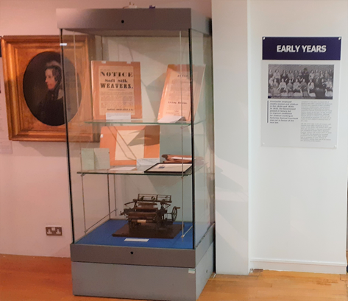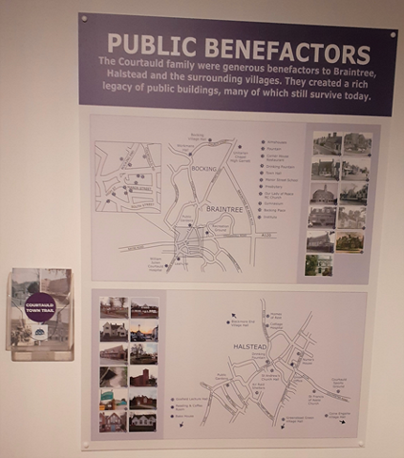
(Photos: Tony Crosby)

Chelmsford Blue Plaques and Interpretation Boards

In the March 2020 edition of this newsletter (No. 33) we highlighted the information boards which had been recently erected along Tindal Street in Chelmsford. Two Blue Plaques and a two more interpretation boards have recently been added to mark other aspects of the City’s history and particularly its industrial history.

On the Nat West bank building at 4 High Street a Blue Plaque has been erected celebrating Frederick Spalding Senior and Junior, pioneers of photography in Chelmsford. The Spalding Collection of photographs is held in the Essex Record Office and includes many photos of historic industrial sites.
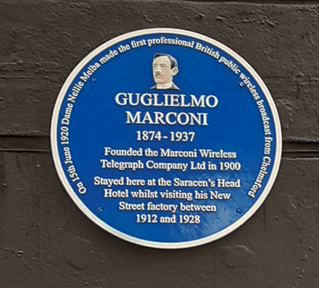
Next door on the wall of the former Saracen’s Head Hotel is a new Blue Plaque recording the fact that Marconi stayed at the Hotel while visiting his New Street Factory between 1912 and 1928.
The City Council have also recently published a ‘City Centre Scavenger Hunt’ - a route to discover 12 of the blue plaques which commemorate and help identify famous people, places and events that have shaped the city's history. This can be found here:
https://www.chelmsford.gov.uk/_resources/assets/inline/full/0/4587409.pdf
(Photo: Tony Crosby)
In editions 22, 23 & 24 of this Newsletter we reported on the history of Chelmsford Gas Works and the recent demolition of the two remaining gas holders. National Grid has now erected two interpretation boards along the footpath between the Essex Record Office and the City Centre near the boundary fence of the current gas installations.

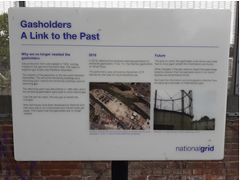
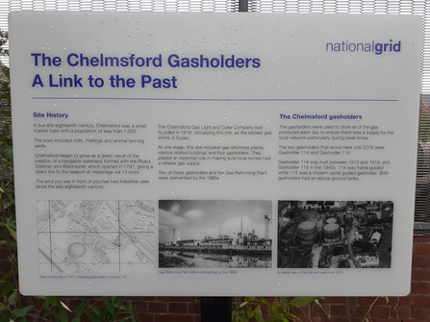

(Photos: Tony Crosby)

Puzzle Page

No luck with the identification of the photos of water works sites in the last edition. Hopefully more luck with the following:

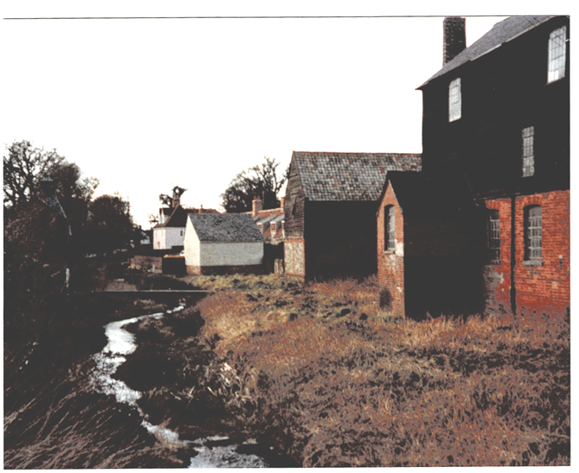
This is from Adrian Corder-Birch’s collection and he thinks it is probably of a site in north Essex. Judging by the metal framed windows the building on the right would appear to be industrial in nature, maybe associated with water power or the use of water in the process which took place there, as it is built by a stream. Any answers to our usual email address, please:
essexiag@gmail.com
ISAMBARD KINGDOM BRUNEL (1806-1859) AND ESSEX
In 2003 Isambard Kingdom Brunel was voted the second ‘Greatest Briton’ by BBC TV viewers. He was a well-known engineer, designing railways, bridges, tunnels, locomotives and three great ships. Much of his work was in the west of the United Kingdom and he even had some contracts abroad.

However it is not generally known that he had contracts in Essex. One was in 1830, the year described as the lowest point of his career; when he got one job, draining Tollesbury Marshes. The marshes along this part of the Essex coast were preserved from the encroachment of high tides by embankments called sea walls and outside these were the saltings on which cattle grazed during low tides.

Phillip Bennett of Tollesbury Lodge was a landowner whose property included Old Hall Marshes and wanted his land drained, so required a skilled engineer. In 1830 he commissioned Isambard Kingdom Brunel to construct a new syphon. This syphon, located in a field later known as Syphon Piece on the 1840 tithe map, consisted of two pipes of 8 and 10 inches diameter positioned over the sea wall. The drainage work involved installing a pumping engine, which was constructed by Maudsley, Sons and Field, engineers of Lambeth. They carried out significant work for Isambard and his father Sir Marc Brunel, in connection with designing and building engines. It is known that the work was carried out to Bennett’s satisfaction. Incidentally, it took Bennett and Brunel three stage coaches to make the journey from London to Tollesbury, with changes at Chelmsford and Kelvedon.

Brunel was associated with building a bridge over the River Lea in Chingford in 1832, which may have been his earliest bridge, being three years before he designed and built bridges for the Great Western Railway (GWR). Although many of his documents and plans survive, there is not a complete catalogue of all his work and records are incomplete between the completion of the Thames Tunnel in 1828 and the start of his work for the GWR in 1835. As he was active in Essex in 1830 and 1832, did he carry out any other work in the county between 1828 and 1835 or indeed at any other time?

Peter Bruff, who built Chappel Viaduct, debated the cost benefits of brick compared with timber with Brunel, when he was the GWR’s chief engineer. This followed a lecture at the Institution of Civil Engineers, when Brunel was strongly in favour of using timber, but Bruff opted for brick, which in the long term reduced maintenance costs. The well-known brick viaduct, which is listed, was completed in 1849.

Any further information about the work of Brunel in Essex will be of interest.
Adrian Corder-Birch

The English Windmill

This film by Martin Taylor describes the evolution and operation of windmills in England from their first appearance in the C13th up to the time when they were superseded by steam and later electric power. It continues with an account of the restoration of surviving mills. Post mills, smock mills and tower mills are all described and the improvements by Andrew Meikle, John Smeaton and John Rennie are explained. The part played by Rex Wailes and the SPAB in the survival of these often magnificent structures is recounted and there are numerous interviews with current millers, millwrights and others with specialist knowledge. Showing working examples throughout the country, this film captures the essence and grace of the English Windmill and looks forward to the next stage of green energy production. The complete film (98mins) may be downloaded at https://www.thedigitalpublishingcenter.com.

There is a trailer available at:
https://www.youtube.com/watch?v=JaBf5TadX3o&feature=youtu.be

(From the Association for Industrial Archaeology’s (AIA) IA News, No. 194, Autumn 2020)

Essex Journal

Hopefully you all subscribe to the excellent Essex Journal (EJ), the publishing of which will be taken over by ESAH in January 2021. If you don’t already, then you are missing out on some excellent articles regarding Essex archaeology and history, such as those highlighted below. Annual subscription for two issues per year is only £10; to subscribe visit: www.essexjournal.co.uk/sunscribe.

In the Spring 2020 issue, Vol 55, No. 1, there are two articles of industrial interest.

The first is entitled Black Notley Watermill, its millers and their associations other Essex mills, by Adrian Corder-Birch. Written partly as a tribute to, and to thank the former Essex Mills Group for their work over the years, in it Adrian outlines the history of mills in Black Notley, their ownership and describes the most recent mill which was demolished in 1939. He then moves on to discuss over half a dozen of the millers who worked at Black Notley and other mills in the county.

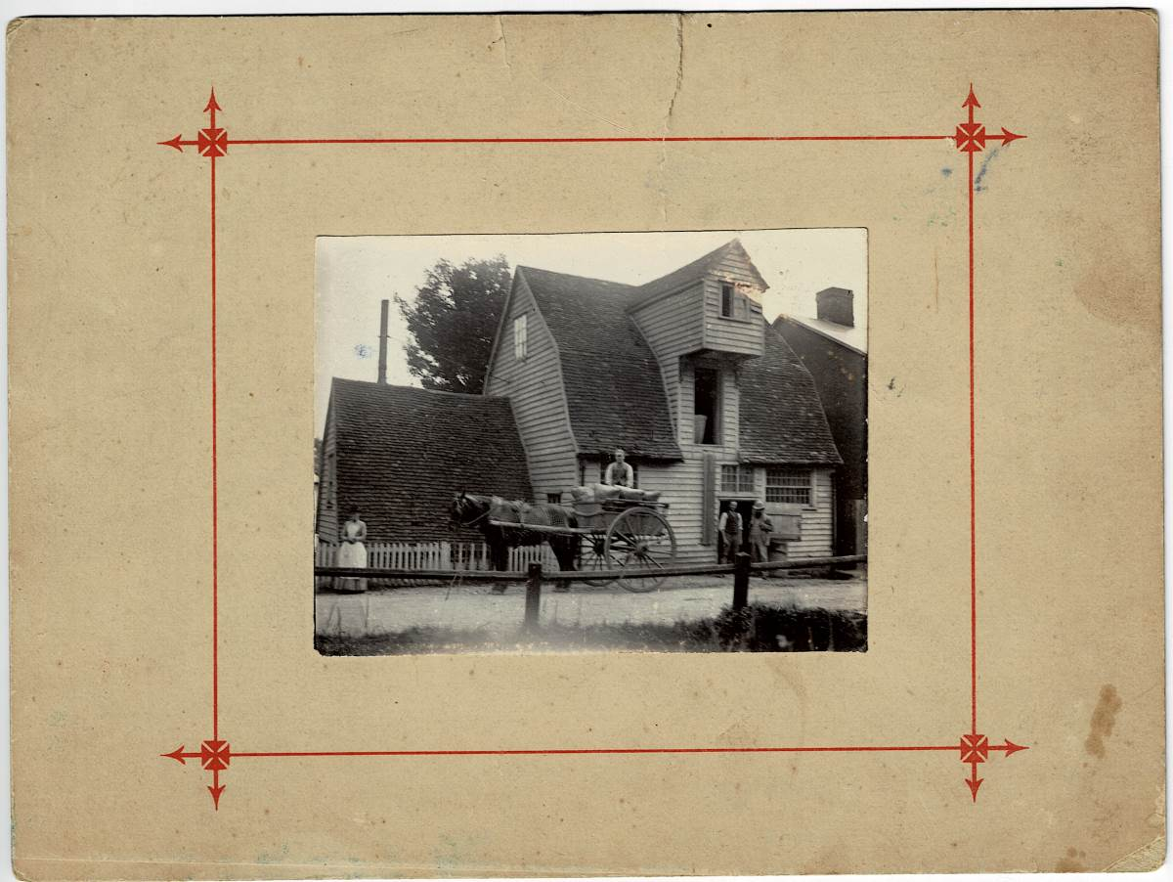

Black Notley Watermill (Adrian Corder-Birch collection)

The second article to highlight is by Ken Newman and is entitled Terraced Housing in the Landscape. Ken begins by discussing the background context of terraced housing in the “industrial north” and then ”London’s Victorian terraces”, before looking at the terraces in more rural areas, especially Essex. Here he highlights estate housing for staff, the terraces in the large villages and market towns for those employed in local industries, almshouses, and the grand terraces of the sea-side resorts amongst others. Ken ends by examining some of the more recent terraces built by developers on the many new housing developments springing up all over the county.

Industrial Housing

Following on from Ken Newman’s article in EJ referred to above, it seems timely to highlight some of the terraces of industrial housing which have been identified since the ECC survey of Industrial Housing completed in 2006. In the January 2017 edition of this newsletter (No. 14) mention was made of the extant terraces in Marconi Road and Bishop Road, Chelmsford built by Marconi’s in the early C20th; Marconi Bungalows in North Weald; and the houses built for the staff of Rochford’s Nurseries on Stansted Mountfitchet. In the May 2020 edition (No. 34) mention was made of the Burnt Mill Village built for staff of Kirkaldy’s engineering works in Harlow, which were demolished when the New Town was developed in the 1960s.

While researching for the up-dating and revision of the Chelmsford Industrial Trail 2018, the authors identified three examples of workers’ housing not previously recorded. These are:

10 – 15 Hall Street, Chelmsford. These are the only survivors of the houses built by John Hall in 1858 to provide accommodation for the workers of his new silk mill on the corner of Hall Street and Mildmay Road. He also built the manager’s house opposite the workers’ houses and next to the mill, which survives today as Alfred Cottage. The mill building became Marconi’s first radio factory and survives today as commercial premises.

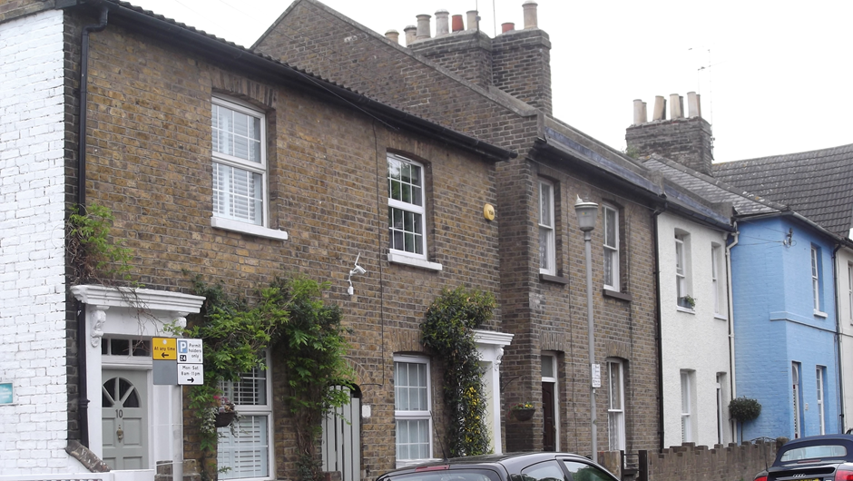

- – 15 Hall Street, Chelmsford (Photo: Tony Crosby)
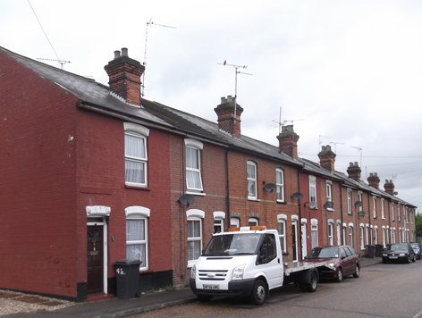
23 – 33 and 43 – 69 (Crompton Terrace) Crompton Street, Chelmsford. Built in the late C19th alongside Crompton’s second Arc Works in Writtle Road for the workers at the factory.

Crompton Terrace, 43 – 69 Crompton Street, Chelmsford

(Photo: Tony Crosby)

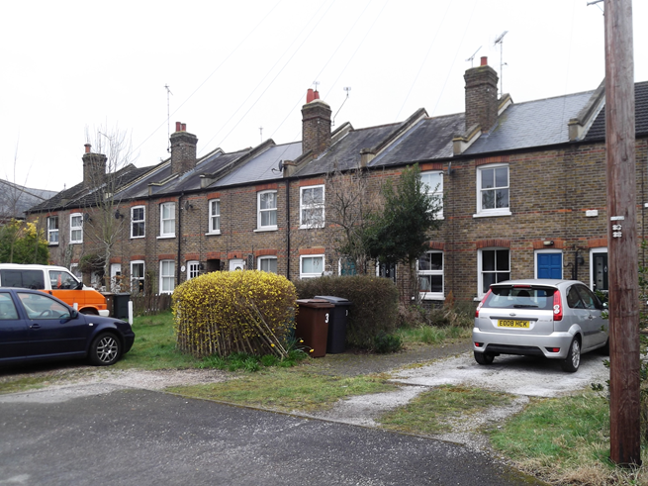
1 – 10 Jubilee Terrace, Coopers Row, Chelmsford. Probably built around 1897 and named in honour of the Queen’s Diamond Jubilee that year, by Christy & Norris for the staff of their iron works on Broomfield Road. These represent the only surviving evidence of the iron works which has been completely demolished and re- developed.

(Photo: Tony Crosby)

Art Deco by the sea

The Sainsbury Centre for Visual Arts at the University of East Anglia in Norwich recently showed an exhibition entitled Art Deco by the sea. This major exhibition explored how the Art Deco style shaped the modern seaside during the 1920s and 30s. In a new age of mass tourism, new coastal resorts were built and existing resorts modernised using the Deco style while the networks of transport – by road, rail, sea and air – met the needs of the modern traveller.

The show celebrated iconic examples of seaside architecture, from hotels and apartment blocks, to piers, cinemas and lidos, and revealed how Art Deco became the key style for pleasure, leisure and entertainment. Through some 130 works including paintings, posters, brochures, drawings, photographs, fashion, furniture, ceramics and textiles, the exhibition explored the sports, activities and amusements of the seaside between the wars.

Essex featured highly in the exhibition with examples such as the Art Deco housing estate in Frinton-on-Sea, Clacton’s Century Cinema, the Silver End company village, the Royal Corinthian Yacht Club at Burnham on Crouch and displays of seaside fashion from Southend Museum. There was also a section on industries at the seaside which featured E.K. Cole Ltd, radio manufacturers of Southend-on-Sea.
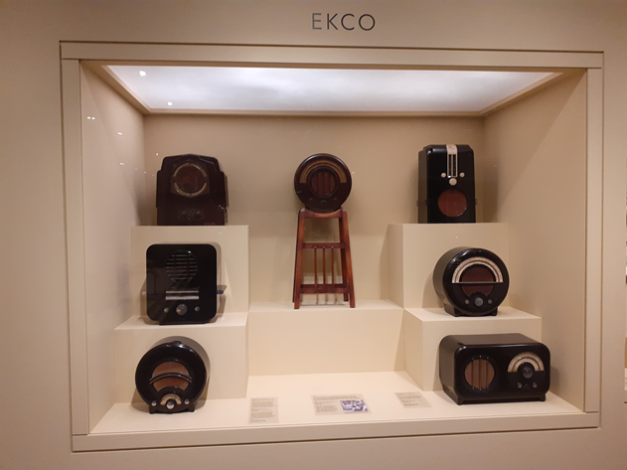
EKCO became one of the most innovative electronics manufacturers in the world in the 1930s. Established by E.K. Cole in his home town of Southend-on-Sea in 1926, the company combined new technology with stylish design. EKCO popularised the use of moulded Bakerlite plastic to house the radios instead of wood, the cabinets being produced in new local factories.

EKCO display at the exhibition.
(Photo: Tony Crosby)

STOP PRESS!

Chain Home Transmitter Tower at Great Baddow, Listed Grade II

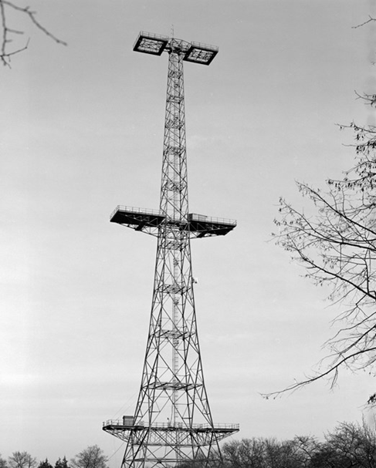
The Chain Home Transmitter Tower at Great Baddow has recently been Listed Grade II by Historic England. It is the only complete Chain Home transmitter tower surviving in the British Isles and one of only five surviving from the earliest radar network that was in use during the Battle of Britain. The tower was originally erected at RAF Canewdon in south-east Essex in 1937 and was relocated to Great Baddow in 1956.

The Marconi Company scientists and engineers at the Great Baddow laboratories designed the transmitter aerials for the Chain Home system. The Royal Air Force and Royal Navy were also based at Great Baddow carrying out radio technology research which, when used in aircraft, ships and mobile equipment, could be used to identify the source of enemy agents’ radio transmissions.

The tower’s relocation to the Marconi Company research site at Great Baddow in 1956 enabled it to play an important role in defence research and communications during the Cold War, particularly the development of the radio guidance system for the British ‘Blue Streak’ intercontinental ballistic missile.

(Photo: Historic England)

