
Essex Industrial Archaeology Group

NEWSLETTER

Number 37 November 2020

Welcome to this edition of the Essex Industrial Archaeology Group’s (EIAG) Newsletter.

As 2020 comes to a close we hope that you are all well, have manged to avoid Covid 19, and were able to get out & about, a little at least, in the summer to appreciate the County’s history and heritage. As has been said so many times it has caused the past year to be very different and not as planned: all ESAH/EAIG events had to be cancelled, as did most of those planned to celebrate Marconi 100 and other major anniversaries in Essex this year. However, there is some good news to report here from Coggeshall and Colchester, and if the pharmaceutical industry does achieve its aim of producing a vaccine, hopefully we can look forward to events taking place next year. The programme of visits is still being put together, but we will let you know as soon as it is finalised. This edition also contains more on the work of IKB in Essex, a railway monument at risk and the 2020 Annual report.

If you have any comments on the Newsletter generally or specific items in it, or wish to make a contribution to the next Newsletter, please contact us via our email address - essexiag@gmail.com.

2021 events

We are planning another Industrial Heritage Fair for early October 2021.

Our Annual Meeting is booked for Saturday 13th November 2021 at Christ Church, New London Road, Chelmsford at 2:00 pm. Dr Catherine Pearson, who was booked for this year’s Meeting, has agreed to present on 'The Frederick Roberts archive of industrial history - Marconi & Hoffmann’.

GOOD NEWS 1:

Dick Nunn’s Bridge, Coggeshall

In the May 2020 edition of this Newsletter (no. 34) we reported on the fact that Dick Nunn’s Bridge in Coggeshall, built in 1897 and of great local significance, was at risk of being replaced and that there was a petition to have it repaired and restored. EIAG were supportive of the petition and duly signed it. We now have the pleasure in reporting that following a successful application for national listing, Historic England have listed the bridge at Grade II. In the light of that listing, and recognising the bridge’s historical importance, last month Essex Highways announced that they will repair and restore the bridge and have dropped plans to replace it.

GOOD NEWS 2:

THE BALKERNE TOWER TRUST - JUMBO

The latest news from Brian Light, Chairman of the BTT:

The We are Colchester (WAC) group has submitted a bid to the Government’s Town Fund for £25 million for various projects to improve Colchester. Included in this bid is £1 million for phase one of the restoration of Jumbo. This is based on the scheme put forward by North Essex Heritage and includes a cafe and restaurant at the base of Jumbo, and mixed uses for the tank including heritage interpretation.
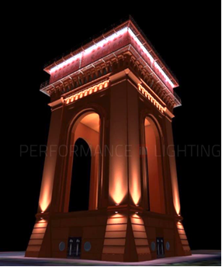
Also included in the bid is £80,000 for illuminating Jumbo at night. BTT had submitted this scheme when the WAC board invited ideas. Then it was reported that, aside from the bid for £25 million, £1 million has already been allocated to revamp the Balkerne Gate area and St Nicholas Square. As it is obvious that illuminating Jumbo would go hand in glove with the Balkerne Gate revamp, BTT sent an urgent email to WAC pointing this out. The end result was that illuminating Jumbo is included in phase two of the bid.

The outcome of the bid will be known in February 2021 … so fingers crossed!

Brian Light
Chairman
http://www.savejumbo.org.uk/

A computer generated image of an illuminated Jumbo.

ISAMBARD KINGDOM BRUNEL (1806-1859) AND ESSEX

I am pleased to report that my article about Brunel (IKB) and Essex, which appeared in our September 2020 Newsletter No. 36, inspired one of our members to contact me with further information. I am very grateful to Graham Thorne of Great Totham for sending a copy of the following booklet:

Isambard Kingdom Brunel and the Tollesbury Syphons – A background to the man the place and the project, by Eric Peacock, 1997

This booklet has clarified some points and added new information. Apparently IKB installed his syphon next to an existing one, but both were troublesome, so he advised the acquisition of a good pump to connect both syphons. (A syphon is a tube which lifts liquid up and over an obstacle, which in this case was marsh water over the sea wall. The flow could only start when the tube was full and the inlet and outlet was therefore probably controlled by valves or sluices). The creek which contained the outlet stream is still known as Syphon Creek.

Unfortunately, it is still not known who installed the first syphon or why IKB was chosen to inspect it and provide a second syphon, with shortly afterwards a pump. When the massive engineering projects, with which he was associated, are considered, the Tollesbury Syphon must have been one of his smallest contracts.
Graham also sent some photos including the brick base of an old wind-driven water pump, which later replaced the syphons. Other photos show the possible remains of a structure where pipes and the pump may have been unloaded and possibly part of the site of a syphon, but further investigation is required.

Unfortunately, the recent television programme on Channel 5 titled, ‘Brunel: Building of Great Britain’, did not mention the Tollesbury Syphons, but nevertheless it was an excellent account of Brunel’s life, his family and many of his other engineering projects.

I am grateful to Graham for the booklet, photos and further information and I hope that we shall learn more about the work of Brunel in Essex in the future.

Adrian Corder-Birch

A territorial claim to parts of Essex and Suffolk

Six miles off the Essex coast is the former Roughs Tower, one of many sea forts built during the Second World War. In 1966 it was claimed by a former pirate radio operator, renamed Sealand and declared an independent principality, being three nautical miles outside UK territorial waters. However in 1987, in accordance with new international laws, the UK extended its marine border to 12 nautical miles, bringing Sealand inside its national territorial envelope. Sealand responded in the same way, and claimed that, as a result, it owned Felixstowe, Harwich and ‘the nice parts’ of Clacton-on-Sea. In the words of The Guardian reporter, ‘an unspoken stalemate remains.’

Michael Leach Source: The Guardian, 15/6/2020.

Historic structure at risk

The timber trestle viaduct at Wickham Bishops, the only survivor in England of what was a common feature of the Victorian railway system, has recently been added to the at risk register due to serious deterioration of its structure. It was repaired in 1995/6 by Essex County Council, but has received no maintenance over the last 25 years.

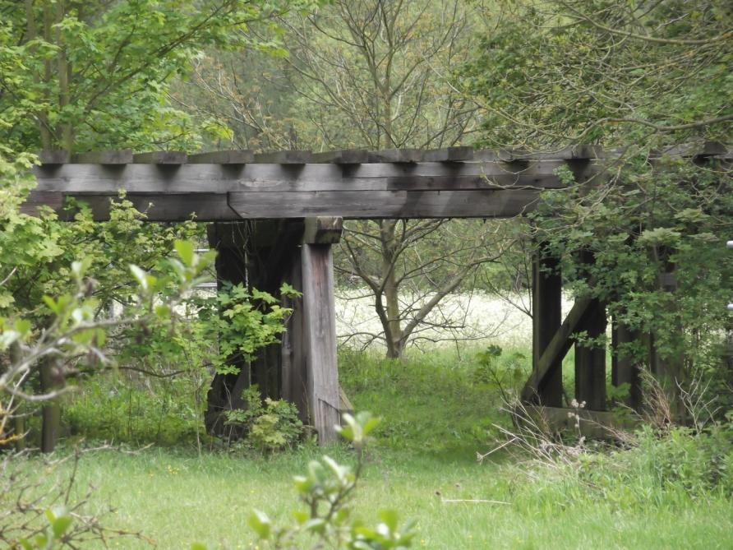
This type of structure was once common on the Victorian railway system, being quick to build and relatively cheap. The Wickham Bishops example carried the line from Braintree and Witham to Maldon East over two separate streams, the River Blackwater and a mill leat. It was operational from 1848 and, though originally double tracked, it was singled in the mid 1850s. At the same time, the viaduct was narrowed and split into two sections, linked by an embankment. The line was closed to passengers in 1964, and to goods traffic two years later, after which the track was lifted and the stations and railway land sold off.

The viaduct now serves no useful function, other than as the sole survivor of a once common type of railway structure. It will be a serious challenge to provide for its preservation in these straitened times.

Michael Leach Sources: Newsletter of Great Eastern Railway Society, Summer 2020 (& various online sites)
(Photo: Tony Crosby)

Chain Tower at Great Baddow

This 109 m (358 ft) high tower has recently been listed Grade II. It was originally erected at RAF Canewdon as part of the world’s first defensive radar network, and performed a vital role in providing early warning of attacking aircraft during the Second World War. It was dismantled and re-erected on the Marconi Company’s research site at Great Baddow in 1956 during the Cold War, for use in defence research and communication. It was particularly important for the development of the radio guidance system used in Britain’s intercontinental ballistic missile, Blue Streak. Long redundant, it now has a somewhat more secure future.
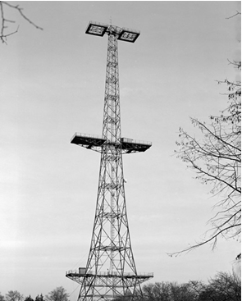
There are parallels with the Shukhov radio tower in Moscow, designed by the inventor of hyperboloid structures, and erected outside the city in 1920. Higher than the chain towers at 148.5 m, this iconic structure is in the form of an elegantly tapered cylinder. No longer serving any useful purpose, it was scheduled for demolition in 2014, but after considerable protest it was served with a preservation order by Moscow City Council in the same year. Nothing further has happened since then, illustrating the considerable problems surrounding the preservation of those structures or buildings which cannot be adapted for an alternative use. It is to be hoped that the structure of the Great Baddow tower was galvanised, or the maintenance costs will be considerable.

Michael Leach

(Photo: Historic England)
English Windmill – error

In the September edition of this Newsletter (no.36) we reported on the film by Martin Taylor entitled The English Windmill. The report included a link which would allow those interested to order a CD or download of the film, but unfortunately the link was incomplete and so did not work! I am grateful to our member Alan Hartley-Smith for pointing out this error. The full link is as follows: https://www.thedigitalpublishingcenter.com/70/ew/79/the-english-windmill-1

Annual Report November 2020

As we had to cancel this year’s Annual Meeting, a short Annual Report which would usually be presented at the Meeting is included below:

Essex Industrial Archaeology Group
Incorporating the Essex Mills Group

Annual Report November 2020

As this year’s EIAG Annual Meeting had to be cancelled, your Committee decided to compile and circulate to members an annual report covering those items which would have been addressed at the Meeting.

Review of 2020

Obviously the Covid-19 situation has severely curtailed activity this year. All visits planned for the 2020 programme had to be cancelled, along with most of the events planned as part of the Marconi 100th anniversary celebrations. Proposed work with our partners at Essex CC Place Services has had to be postponed to a future date and the annual Mills Weekend was also cancelled. Finally, work on producing a booklet on Essex mills open to the public has also been severely curtailed.

However, as a Committee we did our business in April and July by email, and the October Committee meeting was held via Zoom. We have continued to produce our bi-monthly Newsletters in order to maintain some contact as normal with members and provide some interest for them during these restricted times.

Plans under consideration for 2021
- We have agreed to put back a year to 2022 the production of an information booklet on the mills open to the public in Essex. We have an agreed template for the publication and will use 2021 to collect the information required from the various mills. If any members with a particular interest in mills generally or a specific wind or water mill would be interested in helping with this initiative please do contact us via usual email address: essexiag@gmail.com

- It has been agreed that EIAG will plan to hold a fourth Industrial Heritage Fair in early October 2021. We have visited the East Anglian Railway Museum to check out the facilities there, which would seem to suit our needs, but some negotiations of the arrangement are required to ensure a cost effective use of that venue. If any members are interested in joining the Committee to help with organising this event, please do contact us via usual email address: essexiag@gmail.com
- A full programme of visits and talks is being compiled and will be sent to members when finalised.
- The Annual Meeting will be held on Saturday 13th November 2021 at 2:00 pm, at Christ Church, New London Road, Chelmsford. The speaker will be Dr Catherine Pearson - 'The Frederick Roberts archive of industrial history - Marconi & Hoffmann’

Committee

Current members of your Committee have agreed to continue for a further year and they are listed below. New Committee members would be very welcome to join us to share in overseeing the work of the Group and taking it forward, ensuring that the Committee can continue to provide events for its members now and into the future. 2021 will hopefully be a busy year, especially if we are able to hold another Industrial Heritage Fair, so new Committee members would be welcome to help us ensure such events are a great success. Succession planning is vital to the sustainability of any organisation, but especially those dependent on volunteers. Committee meets four times a year for a couple of hours, although much work is done outside of the meetings by individuals and small groups, much of it by email. If you are interested in joining the Committee please contact us at essexiag@gmail.com.

- Chairman – Tony Crosby
- Vice–Chairman – Adrian Corder-Birch
- Secretary – Paul Gilman
- Membership – Jane Giffould
- Programme – Paul Sainsbury
- Essex Mills – Bob Sier
- Other members:
  - Dave Buckley
  - Elphin Watkin

Tony Crosby
Chairman EIAG
November 2020

Merry Christmas and a Happy & Healthy New Year to all our members.

