
Essex Industrial Archaeology Group

NEWSLETTER

Number 38 January 2021

Welcome to this first edition of the
Essex Industrial Archaeology Group’s (EIAG) Newsletter for 2021.

It is with pleasure that EIAG is in a position to be able to continue to welcome all members to this first edition for 2021 and wish you all a Happy and Healthy New Year. 2020 promised to be a very exciting year in Essex, especially as it was the year of many major anniversaries, including the centenary of the first ever professional public entertainment broadcast in the UK from Marconi’s New Street factory. However, as we all now know too well, the year turned out to be very different with most planned events having to be postponed or cancelled altogether. This year, though, despite the present situation, holds greater hope for a brighter time with the Covid vaccine roll-out promising that planned events will take place this time. So far only a few visits and events have been planned, but others will be added to the programme, so do watch your Newsletters for these additions. As well as the visits programme, this edition brings news – both good and not so good – of various industrial sites at risk. Bearing this in mind we make another request for help in identifying planning applications for developments on former industrial sites. There are also items on ERIH, a new Blue Plaque in Chelmsford, and Upminster’s Lost Brickworks.

If you have any comments on the Newsletter generally or specific items in it, or wish to make a contribution to the next Newsletter, please contact us via our email address - essexiag@gmail.com.

Programme of ESAH/EIAG visits 2021

The programme of visits in 2021 is, as already mentioned, still being planned but the programme already includes the following of industrial, maritime and transport interest. Booking details are in your ESAH Programme membership card, but details of all events and availability are available from Howard Brooks (Hon Secretary) at howard000brooks@gmail.com

‘Clock, beer and bad water – a walk along Stoneham Street, Coggeshall, to be led by local historian Trevor Disley. Wednesday 14th April 2021. Further details to be confirmed.
(Coggeshall has a fascinating industrial history covering textile manufacture, malting and brewing, and the production of Isinglass for use in the brewing process.)

EIAG Annual Meeting. Saturday 13th November 2021, 2:00 pm. Chelmsford Museum. AGM followed by a talk by Dr Catherine Pearson on the Frederick Roberts Archive of Industrial History – Free for members, £2.00 for non-members.

Another Asset Lost?

To commemorate the Millennium the Colchester Engineering Society commissioned an exhibition to celebrate 200 years of Colchester engineering featuring numerous products built in the town. It is currently located in the Museum of Rural Life in Stowmarket. Unfortunately the museum has recently asked for the exhibition to be removed as soon as possible because they need the space. This will not be easy because the display occupies around 1200 square feet and contains some very large and weighty exhibits such as a full size cross section of an 18 cylinder Deltic diesel engine.
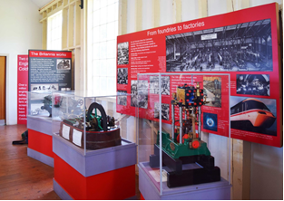
What to do with it? That is the question. Ideally it should be in Colchester. With Paxman having a large presence in the display and coupled with the impending closure of the factory in Colchester, it would seem only right that it should return to the town. But where to put it? The Castle Museum does not have the space or the money to do anything. There was speculation that a building in the Paxman factory might be set aside. That will depend on what the company want to do with the site and with it being located over a mile from the town centre it is a bit off the tourist trail.
Part of the display in Stowmarket

The future for the exhibition does not look promising. Will this be another lost chance to capitalise on Colchester’s heritage? Unfortunately Colchester Council has for years had a very poor track record when it comes to promoting the town’s heritage. Quite a few interesting buildings in the town centre close to public transport links and car parks that would have made excellent visitor attractions have been lost. St Mary’s hospital and former workhouse (now flats), in the town centre next to a large car park would have made a wonderful Jorvik type museum. They closed the historic Tudor house where William Gilberd the Elizabethan physicist lived, well known for his pioneering work in electricity. The house had been left to the town and housed the clock museum. The council closed the museum and leased the building as a café. The adjacent church with its 1000 year old Saxon tower once housed a social history museum but now stands empty.

A couple of years ago there were moves to try to acquire an army building from the barracks to establish a military museum that came to nothing. The unique Roman Circus had a lot of problems establishing itself as an attraction and why do the direction signs to it from the High Street stop when you are only halfway there? There was a proposal, on the site of the old bus station, to build a culture centre that included exhibition space and meeting rooms. That too was ideally placed on bus routes and near a large car park. However the plan fell through and there are now moves to build blocks of student flats robbing the town of another central accessible site. Nearby is the shell of an old theatre lately used as a bus garage but never the less a large space with potential as was the site of the recently demolished tram shed (now flats), Meanwhile the Jumbo water tower has been slowly deteriorating for the last 30 years. The old Essex County Hospital is being turned into flats. The old Odeon Cinema, a listed building that has been empty for several years, is suffering from serious neglect and there is now talk of demolition.

The Roman period is exceptionally well covered in Colchester’s excellent Castle museum but later history, particularly the modern period, is not. The Castle simply does not have the space to show off all it does have. Now unfortunately money to do anything is going to be in even shorter supply as we face the greatest financial crisis since the South Sea Bubble burst.

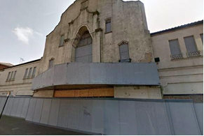
Meanwhile, we do have the unloved and underused First Site art gallery that would, even in the short term, make an ideal place for a Colchester engineering exhibition. I just wish that Colchester could make more of its past in the way that Chester and York do.

The derelict Odeon Cinema

By Peter Jones

Nunn's Bridge, Coggeshall, Essex

In the November edition we reported that Dick Nunn’s Bridge had been Listed Grade II by Historic England. The BBC News website (https://www.bbc.co.uk/news/uk-england-55310369) reported on the new Listings by Historic England and with reference to Nunn’s Bridge quoted as follows:

“Grade II listed Nunn's Bridge is a "simple but elegant" wrought iron footbridge spanning the River Blackwater.
“Erected in 1892 by social activist Henry Dick Nunn, it has been described as "unique in its design, craftsmanship and installation" and replaced a wooden crossing that was washed away.
“Mr Nunn was a campaigner for the welfare of people and animals, and an early advocate of rights of way in the countryside.”

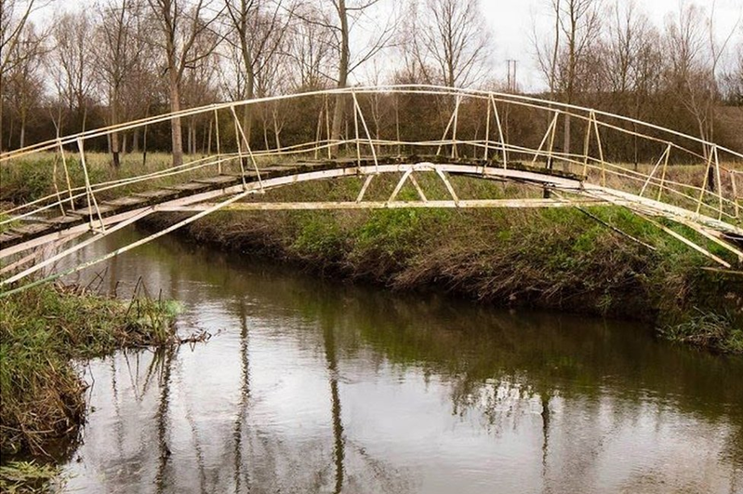
Photo credit: Historic England

Boxted Bridge

It has come to our notice that another historic bridge in Essex is at risk of replacement by the Highways Department, that across the River Stour in Wick Road, Boxted.

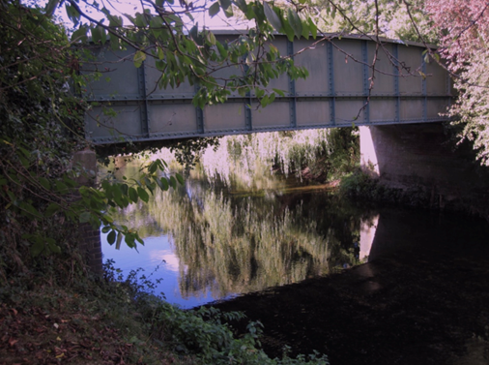
Boxted bridge is a steel girder bridge built over the River Stour in North Essex. Essex Records Office archives reveal that it replaced an earlier wooden bridge, built after 1835, which had fallen into disrepair. On 14th November 1896 The Bury Free Press announced that ‘the tender of Mr George Double of Ipswich was accepted for the sum of £927 to build Boxted bridge by Essex and West Suffolk County Councils’ and on the 28th April 1897 The Evening Star reported that ‘The Boxted Bridge, which has been built by Mr George Double of Ipswich is now completed and opened for traffic, so that the road to Nayland is once more available.’ Interestingly the bridge at Wormingford was also built by the same contractor.

Having been neglected for years it was assessed as being of ‘insufficient capacity to adequately sustain the loading imposed by the highway it carries within the acceptable limits of an adequate factor of safety’. Following an options appraisal, the preferred action is for a ‘Full bridge reconstruction on widened footprint incorporating highway alignment and junction improvements’. A petition to save the bridge has been started. Full details of the bridge’s history, significance and a link to the petition can be found on the Boxted Village Website at: https://boxted.org.uk/2020/11/10/bridge/.

Historic England - Heritage at Risk Register

Historic England published the most recent Heritage at Risk Register (HAR) in October 2020. The Register identifies sites most 'at risk' of being lost as a result of neglect, decay or inappropriate development. In Essex there are 65 sites registered as being ‘at risk’. Of the 14 Conservation Areas on the register two are Silver End and East Tilbury, both company model villages built by Crittall’s and Bata’s respectively. Of the 25 ‘buildings and structures’ on the register, the vast majority are industrial and transport sites including various wind and water mills, two cinemas, the Wickham Bishops timber trestle railway viaduct (see EIAG newsletter no. 37 for Michael Leach’s item on this viaduct), ‘Jumbo water tower in Colchester, Thorpe-le-Soken station and maltings, and the Dovercourt lighthouses and causeway.

To see all the Essex sites on the HAR Register go to the Historic England website at: https://historicengland.org.uk/advice/heritage-at-risk/search-register/
then click on ‘Explore the Heritage at Risk 2020 Map’ to search for sites on the map.

The Regional Heritage at Risk Register for the East of England can be accessed by clicking on the link to Regional Registers on the same page, where you will find details of all the Essex sites.
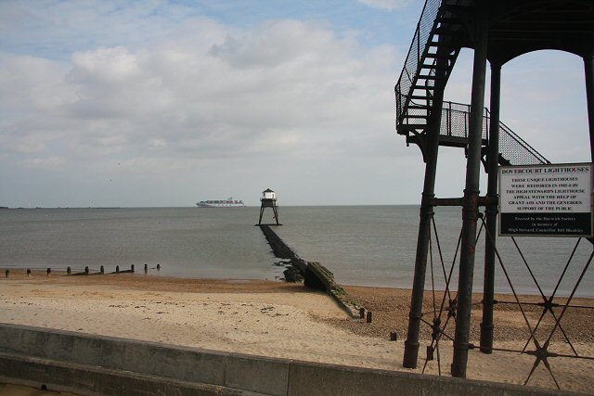

Dovercourt lighthouses and causeway

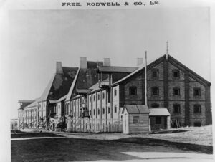
Thorpe-le-Soken maltings 1890

Planning Applications

As will be seen from the items above, although there have been successes in achieving the preservation of some historic sites in Essex, many of the County’s important heritage sites remain at risk. EIAG does make comments on planning applications and other development proposals which affect former industrial and transport sites, but we can only do so when we hear about them, as it would be too great a task to monitor all applications made across all the Essex District Councils. If you hear of a development proposal in your area which will have a negative impact on a former industrial or transport related building or site, please let us know so that we can consider making comments and representations as appropriate. Email us on essexiag@gmail.com

European Route of Industrial Heritage (ERIH)

Last month Jonathan Lloyd, the UK Co-ordinator for ERIH, circulated his review for 2020, which was understandably short as, in line with many other heritage organisations, most planned events had to be postponed or cancelled altogether. However, on a more positive note he was able to outline changes which will impact on how ERIH in the UK will be co-ordinated, as quoted below:

“From the beginning of 2021 there will be changes in the way that ERIH activity in the UK and Ireland will be coordinated. I will be retiring from my role as ERIH National Representative for the UK and Ireland at the end of December having undertaken the role since 2012 when I took over from David de Haan. Rather than having one person covering the whole of the UK and Ireland we have opted to have separate representatives in England, Scotland and Wales and a representative in Northern Ireland and Ireland. The new contacts will be:

England: Dr Mike Nevell
Mike is Industrial Heritage Support Officer, employed by Historic England and working from Ironbridge Gorge Museum Trust. I have worked closely with Mike in his IHSO role and also his predecessors and there is strong synergy between his work, particularly in relation to the Industrial Heritage Networks in England (www.industrialheritagenetworks.com), and the work of ERIH.
Email: mike.nevell@ironbridge.org.uk

Scotland: Mark Watson
Mark is Deputy Head of Industrial Heritage at Historic Environment Scotland and has been associated with ERIH for a long time. A number of Historic Environment Scotland sites are members of the ERIH network.
Email: mark.watson@HES.scot

Wales: John Rodger
John has been involved with ERIH since its inception over 20 years ago and is currently an ERIH Board Member. John has also been active in strengthening ERIH's presence in Wales.
Email: john.a.rodger@btinternet.com

Northern Ireland and Ireland: To be agreed

ERIH is a very special organisation. It has achieved much in terms of raising the profile of industrial heritage tourism and providing a support network for industrial heritage sites and attractions. ERIH is well regarded by the European Commission and national heritage bodies and its relevance and contribution were recognised when it was certified as a Cultural Route of the Council of Europe in 2019. For its members, ERIH offers a European profile and access to activities and events that share good practice and experience. For those sites that are already members of ERIH, I encourage you to be active in your membership so that you enjoy the full benefits of being part of ERIH - promote your membership on your website and in promotional literature so that more and more people recognise the logo and become more aware of ERIH and what it does. For those sites that are not yet members, do look on the website at the benefits that membership can bring.”

EIAG is a member of ERIH, and the ERIH website can be accessed here: https://www.erih.net/

Blue Plaque unveiled for Marconi factory worker for contributions to the war effort

A Chelmsford woman whose efforts contributed to the Royal Navy’s code breaking in World War II has been recognised with a blue plaque. Florence Attridge worked at the Marconi wireless factory in Chelmsford and received a British Empire Medal for her contributions to the war effort.

A plaque to commemorate her life has been unveiled at 14 Andrews Place, Chelmsford. Chelmsford City Council, in collaboration with Chelmer Housing Partnership (CHP), unveiled the plaque at the property, which was Florence’s home between 1969 and 1975.
Born in 1901 and raised within the city, Florence Attridge joined her father in working for the prestigious Marconi company shortly after the end of World War I. During her employment, Florence witnessed the first wireless radio transmission made by Guglielmo Marconi in 1920. Her role involved making key radio components, including the coils, transformers and inductors.
During World War II, Florence had progressed to the head of the coil winding shop, overseeing a team of women. She worked within the K3 Section, part of the Naval Intelligence code breaking section, who developed the British Type 3 Mark II radio made by the company with specialist miniature components and issued to spies, Special Forces and resistance groups during the war. After the war ended, in 1946 Florence Attridge was awarded the British Empire Medal (civil division) for her contribution to the war effort.
Peter Turrall MBE, from the Marconi Veterans Association, said “The Marconi Veterans Association is pleased that ex Marconi Chelmsford employee Florence Attridge is being honoured with a blue plaque in the city. This plaque commemorates her work at the New Street Factory during the last war where she was engaged in preparation of secret communication equipment for the UK Government.”

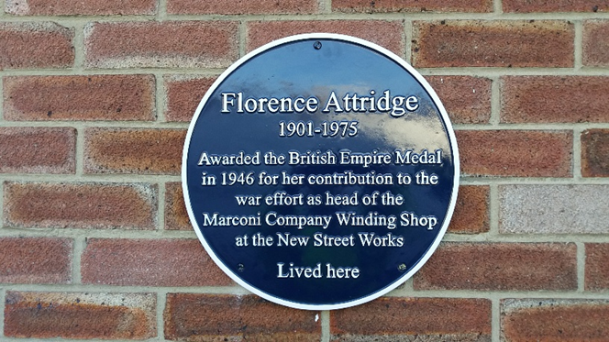
Information and photo from Chelmsford City Council press release.

Brickmaking in Upminster

Tony Benton, who just over seven years ago launched his Upminster History Website (https://upminsterhistory.net/2013/12/21/welcome/), contacted EIAG to inform us that he had recently revised his article on Upminster’s Lost Brickworks. This revision was prompted by discovering that The Clothmakers’ Company archives provides evidence that there was an active brick making site in Upminster at Stony Hills Farm from 1576, if not earlier. Tony’s web article can be accessed here: https://www.upminsterhistory.net/2018/04/26/upminsters-lost-brickworks/. This very detailed article is well worth a read and is illustrated with archive photos and four informative maps.

Grateful thanks to Tony for sharing this with us.

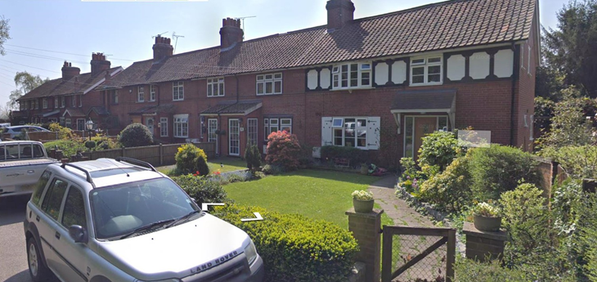

We learn from Tony’s article that a James Brown took over the lease on the brickworks in 1885 and ‘Brown completely revolutionised the Upminster operation. … He extended the brick workings with excavations in a large field south of Bird Lane, and adding a second kiln known as “The Shaft”. Bricks still warm from the local kiln were used to build the Plain Tile and Pantile cottages in Bird Lane to house his workers.’ Tony concludes ‘Nowadays the site either side of Birds Lane remains undeveloped with little identifiable hints of its former history.’ However, both the ten Pantile Cottages and the four Plain Tile Cottages survive, the photo above being of the Pantile Cottages in Bird Lane, Upminster. This is yet another example of workers’ houses surviving long after the industry with which they were associated has disappeared, and as the only surviving evidence of that industry.

Industrial Archaeology News (IA News)

IA News is the quarterly Newsletter of the Association for Industrial Archaeology (AIA) of which EIAG is an Affiliated Society. As such we receive five copies of IA News each quarter, one of which is deposited in the ESAH Library. The other four are circulated to members who have requested copies. There are currently three such members, so there is one copy each quarter which can be made available to an EIAG member upon request. If you would like to receive a copy regularly please contact us on our usual email address – essexiag@gmail.com – first come first served!

