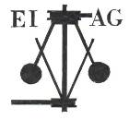
Essex Industrial Archaeology Group
Incorporating the Essex Mills Group

NEWSLETTER

Number 40 May 2021

Welcome to this month’s edition of the EIAG Newsletter. We hope that you all have kept well and safe during the current period of lock-down, are receiving your vaccinations, and are now looking forward to getting out and about for days out seeing Essex’s history and heritage, and planning to meet people in person rather than on a computer screen! Below you will find details of two events so far planned for this year, our next on-line Zoom talk and our Annual Meeting. There is a follow-up article on James Brown’s brickworks, Roy & Penny Berry’s Obituary, and a couple of TV programmes to catch up on, if you have missed them!

Programme of ESAH/EIAG events 2021

Obviously the programme of visits for this year has already been subject to cancellations, but as current restrictions continue to be lifted new events will be arranged and we will keep you up to date on details via this Newsletter or one-off emails.

Online talk via Zoom - The Past, Present & Future of Stow Maries Great War
Aerodrome, by Roger Smith. Wednesday 9th June 2021, 7.00 – 8.00 pm. Further details below (last page).

EIAG Annual Meeting. Saturday 13th November 2021, 2:00 pm. at Christ Church, London Road, Chelmsford. AGM followed by a talk by Dr Catherine Pearson on the Frederick Roberts Archive of Industrial History – Free for members, £2.00 for non-members.

EIAG Committee has agreed to plan to hold a fourth Industrial Heritage Fair in early Autumn 2022. Hopefully this will be able to go ahead and details, as they are agreed, will be in future Newsletters – fingers crossed!

James Brown Bricks

This is a follow on from Tony Benton’s update on James Brown’s brickworks and worker’s cottages at Upminster in the January Newsletter (no. 38). I would like to draw attention to James Brown’s catalogue illustrating the numerous specials and decorated bricks produced. A good selection of these and the wooden moulds can be seen in the display at the Upminster Barn museum.

The catalogue consists of 77 plates illustrating brick ornament and its application. These range from individual bricks and panels to complete facades and examples of historic brickwork together with a comprehensive price list. James Brown acknowledges that he is indebted to Mr. George Sherrin, Architect for the drawings. Although Sherrin had a London office he lived at The Gate House, Station Road, Ingatestone that he designed himself. His commissions were diverse and widely spread. They ranged from the Southend Kursaal to Spitalfields Market reconstruction, the dome at Brompton Oratory and Roman Catholic churches to Metropolitan Railway Stations and many domestic commissions. A number of Essex commissions were undertaken for Samuel Courtauld & Co which included the worker’s housing in Halstead and Braintree, Workmen’s club in Bocking and the Cottage Hospital in Halstead.

Of particular interest is the extremely complete example of worker’s housing built by Samuel Courtauld & Co in conjunction with the Halstead silk factory. This long range, aligned NW-SE was designed in Queen Anne movement style and comprised of 2 semi detached manager’s residences at the NW end, workman’s hall at the SE and ten terraced properties between. They are built in Flemish brick bond with curvilinear gables, sunflower brick panels, moulded brick friezes and string courses between storeys and typical panelled chimneys as illustrated in the catalogue. Sited along The Causeway, parallel to the river they create a picturesque scene with the white weatherboarded mill.

The 1883 Causeway buildings are now grade II listed but at the time received much attention with a perspective sketch being exhibited at the Royal Academy and drawings published in the British Architect. They were described as ‘this spirited little drawing and plan, with the large view render a pretty complete idea of this pleasingly-designed row of cottages. The wing in the nearer portion of the view is a coffee-hall for the workmen.’

Original drawings of the commission can be found in the Essex Record Office (D/UH Pb 2/40) These show well-appointed houses with heated parlour and living room with back scullery, coal store and wc which were rented out to the workers at £10 per annum.

I was fortunate whilst researching the Causeway houses for listing to correspond with and meet Mr. Philip Coverdale, grandson of George Sherrin. He recounted how his mother claimed another connection to Halstead in that her father had designed the logo for the top of Portway’s famous Tortoise stove. Unfortunately, this is a claim that I have yet to verify.

References:
The Brickworks of Upminster and Cranham by John Drury published in Havering History Review No. 13 1992
A neglected Essex Architect by Kenneth Langford. Essex Countryside no. 324, vol. 32 January 1984 p.22 & 23

By Brenda Watkin

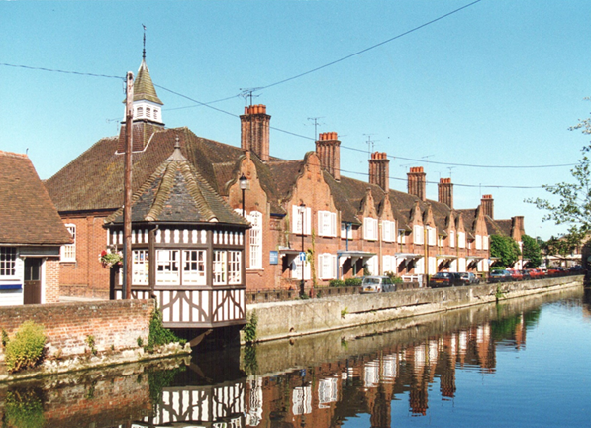
Courtauld workers’ housing,
The Causeway, Halstead

Obituary - Roy & Penny Berry.

Penny, died March 2021, a northern lass who eventually made her home in Essex.
She produced a book on bricks when the opportunity arose to write and study on something that interested her while at the North Essex School of Art & Design at the Colchester Institute. It is beautifully illustrated with line drawings, screen and lino prints to illustrate the various stages of brick manufacture through to the end buildings. Production was limited to fifty copies that were produced to an exceptionally high quality with hard covers and slip case.

She was a prolific artist whose exhibitions were filled with many subjects and some still relating to her northern upbringing such as a scene with a pigeon loft and Granny’s kitchen range. There have been regular exhibitions of Penny’s work over many years. She served as a long-term church warden at Middleton Parish Church and was always searching for the correct and effective ways of repairing the building.

Along with Roy she was a founding member of the Essex Mills Group and both became committee members shortly after its formation in 1985. They were still on the committee when the Mills Group was incorporated into the Industrial Archaeology Group of the Essex Society for Archaeology and History.

Roy had been interested in mills from about the age of six. He trained as an engineer and retired from teaching at the Colchester Institute in 1988. He had joined the Suffolk Mills Group prior to the Essex Group being formed. He was friendly with Mike Organ the then owner of Ramsey mill saying they are having a meeting in Coggeshall about forming an Essex Group but don’t have many ‘windmillers’. Since then until his death in 2020 he was either editor of the newsletter, chairman or vice-chairman or sometimes all three and produced many articles, arranged visits, walks and tours of other mills. He finally retired as newsletter editor at issue 50 in March 2002 and celebrated with one of his other specialities when he rode his 54 year old motorcycle to a VMCC meet in Shropshire.

After Roy’s retirement from teaching he joined the Essex County Council Historic Buildings and Conservation section in January 1989 with the job title of ‘Mills Visits Supervisor’. His comment ‘what a lovely retirement job and to be able to work with the County Millwright Vincent Pargeter.’ Possibly at this time the Mills Group and County became so entwined in Roy’s life that both benefited.

Most likely the last time that members of ESAH may have seen them was at Hill Farm Gestingthorpe where by chance they were visiting to see a print exhibition and it was the 2018 AGM of ESAH.
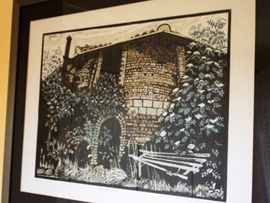
Elphin Watkin

Penny’s sketch of a brick kiln at Collier’s brickworks, Marks Tey
Essex’s Industrial Heritage on National Television

The industrial and transport heritage of Essex has been highlighted in two popular national TV series recently.

Firstly, Tim Dunn’s The Architecture the Railways Built, which is shown on the Yesterday channel, Series 2, Episode 8 featured Southend-on-Sea pier and its railway. It is available to watch on the catch-up app UKTV Play

Secondly in Michael Portillo’s Great British Railway Journeys, Series 12, episode 7 shown on BBC2, Michael travelled from Colchester to Chadwell Heath visiting Abberton Reservoir, Wilkin & Sons jam factory in Tiptree, and Marconi’s Hut at Sandford Mill, where he was joined by Tim Wander, who is known to many of us as a Marconi history expert. This is available to watch on BBC iPlayer.

7th International Virtual Early Railways Conference
10-13 June 2021

Bookings are now invited for delegates to participate in this virtual conference.

The conference, conducted in English, will be in a similar format to the successful Early Railways and Early Main Line Railways Conferences. Topics will cover the earliest waggonway systems through to the main line and industrial systems, throughout the world, in the development era up to the 1870s.

The charge for participating in the conference, which will cover the costs of the event and the exclusive use of the YouTube on-line recordings will be:

• £50 per delegate.*
• £25 per delegate for students in full time courses.*

TO BOOK YOUR PLACE AT THE VIRTUAL CONFERENCE PLEASE VISIT the early railways conference website or email: er7bookings@rchs.org.uk

Coffee/lunch/tea breaks will be provided to allow for both physical needs and screen time restraint.

Lockdown Industrial Heritage Vandalism is Rare – Fortunately

In 2020 trespass and vandalism was reported on a number of heritage railway sites, including the Bowes Railway, Churnet Valley Railway, Peak Rail, and Swanage Railway. In 2021 reports of vandalism on industrial heritage sites during the third lock down encompassed the destruction of information boards at the South Tynedale Railway, and trespass by members of the public on preserved railway lines, including the South Devon Railway and Tanfield Railway.

Linear industrial monuments such as canals and railways are difficult sites to police and to increase security along. But smaller sites, especially those largely volunteer-run, are also vulnerable to such attacks. The Avoncroft vandalism is a type well known in the museum sector over many years, though thankfully rare, and has promoted a positive response from members of the public and museum supporters: 'Outpouring of support' for vandalised Avoncroft Museum - BBC News . Other types of vandalism include metal theft - with fluctuations in commodity prices coinciding in the last decade with rises and falls in metal theft on a variety of industrial heritage sites from railways to stationary steam engine sites.

Historic England have been reporting and supporting strategies to combat Heritage Crime for over a decade. They have been working with local police forces, judges, local authorities, and a variety of heritage partners to provide advice and guidance on how to prevent and report a variety of heritage crimes. For more details on prevention and reporting follow this link: Heritage Crime | Historic England.

In one unfortunate sense, the vandalism at Avoncroft Museum is a sign of a return to normal, unwelcome, trends

Mike Nevell – Industrial Heritage Support Officer

https://industrialheritagesupport.com/the-industrial-heritage-support-officer/

New book due for publication in June

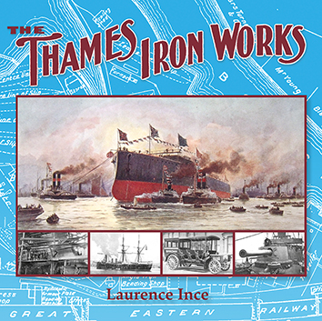

The Thames Iron Works has its origins in the shipbuilding partnership of Charles Mare and Thomas Ditchburn. The partnership started to build ships in 1837 at Deptford but soon moved to occupy land on the Orchard House side of Bow Creek which fed into the River Thames. During the 1840s Ditchburn & Mare’s yard was one of the largest builders of iron ships in Britain. The ships built at the yard were praised for their strength and design. In 1847 Thomas Ditchburn left the partnership and Mare continued to build ships and developed land on the opposite bank of Bow Creek for shipbuilding. The yard was taken over by a group of businessmen in 1855 when it became known as the Thames Iron Works and continued to build a large number of commercial and naval ships until its closure in 1912. The story of the Thames Iron Works is closely associated with the Hills family who for over forty years helped guide the yard to success and fame. This volume contains a complete history of the firm starting in 1837 with extensive lists of the ships, bridges, motor vehicles and lifeboats produced by the Thames Iron Works.

Due mid-June ISBN: 9781911038900
Price £18.00 + £4.00 p&p from Lightmoor Press - https://lightmoor.co.uk/
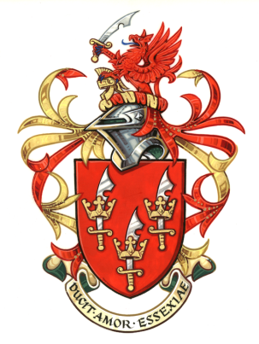
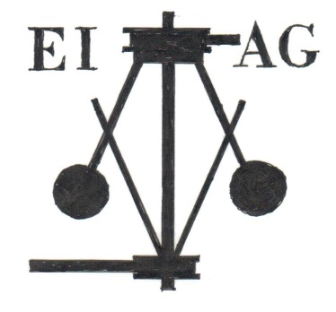
ESSEX INDUSTRIAL ARCHAEOLOGY GROUP
incorporating the Essex Mills Group
A Sub-Group of the Essex Society for Archaeology and History

The Past, Present & Future of Stow Maries Great War Aerodrome

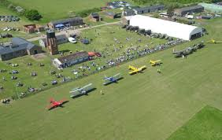

A talk by Roger Smith

9th June 2021 at 7.00pm via Zoom

To book please email jgiffould@aol.com

Zoom link will be sent on 8th June

At Roger’s request a donation is being made by EIAG to Blood Cancer UK in lieu of a speaker’s fee.

You may also wish to make a donation to that charity in appreciation of Roger’s presentation - https://bloodcancer.org.uk/get-involved/ways-give/donate/

