
Essex Industrial Archaeology Group
Incorporating the Essex Mills Group

NEWSLETTER

Number 41 July 2021

Welcome to this edition of the EIAG Newsletter. We hope that you all are keeping well and are able to have a taste of some freedom to explore our historic county. This edition contains news of the former gas works in Braintree, the risk presented to former railway bridges, a 200th anniversary, repair work on Stansted Mountfitchet windmill and the new ESAH Website.

If you wish to comment on or make a contribution to the next Newsletter, please contact us via our email address - essexiag@gmail.com.

ESAH/EIAG Programme 2021

Obviously the programme of visits for this year has already been cancelled. We are still hoping that the EIAG Annual Meeting will be able to go ahead, details below, but if there are any changes to these plans we will let you all know through this Newsletter and/or by email.

EIAG Annual Meeting. Saturday 13th November 2021, 2:00 pm. at Christ Church, London Road, Chelmsford. AGM followed by a talk by Dr Catherine Pearson on the Frederick Roberts Archive of Industrial History – Free for members, £2.00 for non-members.

EIAG Committee has agreed to plan to hold a fourth Industrial Heritage Fair in early Autumn 2022. Hopefully this will be able to go ahead and details as they are agreed will be in future Newsletters – fingers crossed!

ESAH website and EIAG pages

The new Essex Society for Archaeology and History (ESAH) website was launched at its AGM on 26 June 2021 and it can be accessed at https://www.esah1852.org.uk/

EIAG has its own dedicated pages which can be accessed by clicking on the EIAG link in the middle of the top banner of the ESAH home page. There at present you will find back copies of the EIAG Newsletter; Essex CC surveys of industrial monuments; future events of both ESAH/EIAG and other Essex organisations; and the Group’s Terms of Reference. It is planned to also include a section on the Essex Mills Group, publications, and links to other organisations. These pages will be regularly up-dated so do keep visiting the website to find out up-to-date information and resources.

If there are any items you would like to suggest for the website, please email us at the usual address.

The end of gas holders in Braintree – Mike Bardell

The first mention of gas, for lighting, in Braintree can be found in the Lighting and Watching Inspectors’ Minute Book of May 1834. The gas works were in New Street (NGR TL757229), now Tesco car park, but fumes were always a nuisance until Braintree & Bocking Gas Company voluntarily removed to, what was then, an out of town site in Manor Street (NGR TL765229). This was conveniently closer to the railway goods yard at its 1848 site.

As far as we know Braintree gas holders were all the telescoping, water-sealed type, comprising a deep tank of water to provide a seal, and a closed vessel (the lift) that rose above the water as the gas volume increased. The earlier ones were column-guided while the two most modern ones were frameless, where each lift was guided by the one below.

On this 1951 OS Map I have added the position of earlier, smaller gas holders; precise dating is difficult. Coal arrived by rail even closer to the gas works in 1869 but no trace of a siding from the new goods yard, just visible in the map southwest corner, has been identified.
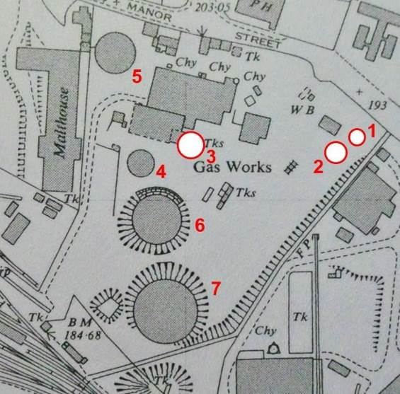
Numbers 1, 2 and 3 are shown on a large scale site plan of 1873 and can be identified from it as column-guided. The smallest was almost certainly moved from New Street.

By 1876 1 and 2 had gone, 3 remained, supported by 4 and by 1922, as demand increased, 3 was replaced by 5 which I can remember. It too was column-guided.

By 1946 4 and 5 had been augmented by 6 but by 1964 4 had gone and 7 had been added. 5 had been removed by 1976 leaving just 6 and 7.

In terms of lifts, 5 and 6 had two, and 7 three.
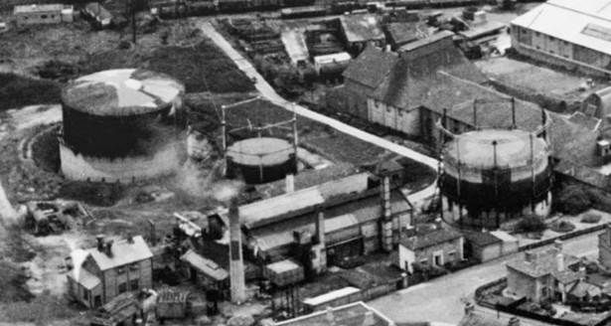
(Right) Numbers 6, 4 and 5 from the north-east in 1946.

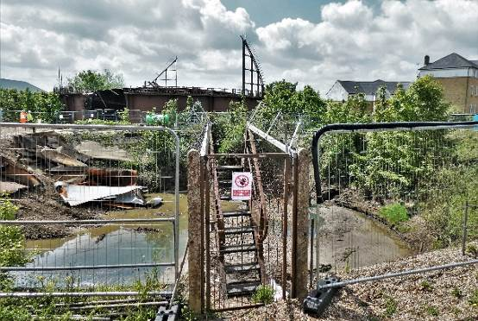

(Left) The end of 7 and just the steps of 6 remain.

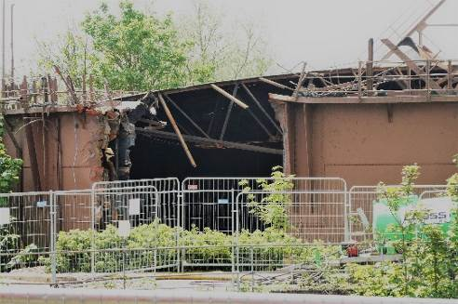

(Right) Close up of 7.

Historical Railways Estate
In 2013 Highways England became responsible for the inspection and maintenance of some 3,200 historical railway structures across England, Scotland and Wales – the Historical Railways Estate (HRE). The Estate consists of railway structures on former lines from tunnels to bridges and viaducts crossing roads, most dating back to the 19th century. While there is a recognition of the wider social value of these structures, HRE’s main role involves repair and strengthening of structures for safety reasons, which may include demolition, or partial or full infilling. Infilling is where material, such as crushed rock, is placed underneath an old railway bridge to make sure it is fully supported and could be removed if a viable new use is identified. Such action should only be taken when HRE have checked with the local authority to see if they wish to take on the structure for a viable new use, perhaps for a new walking or cycling route. As of summer 2021 HRE have reported that they are enabling the re-use of 22 structures; six abutments and 9 bridges are identified for removal and 69 bridges for infilling.

Early this year concerns were beginning to be expressed about the proposed demolitions and infilling. New Civil Engineer reported that according to the HRE Group – an alliance of engineers, active travel campaigners and greenway developers – 135 structures were at risk, assets already used by walkers, some earmarked as potential walking and cycling routes, and others which had been identified as eligible for the Dept. of Transport’s ‘Restoring your Railways’ fund, which aims to reopen local rail lines closed under the 1960s Beeching cuts. A map of 135 disused railway structures under threat of demolition or infilling by Highways England has been produced and can be accessed by following the link: 135 structures are currently at risk of demolition or infilling.

Railnews also expressed concern, headlining that Highways England were ‘finishing off what Beeching started’! The serious concerns again were that such actions would potentially prevent future railway re-openings, and block heritage trails used by walkers and cyclists. An initial appraisal however has revealed that 19 structures (14%) are already proposed for reuse, 22 (17%) have identified potential for future reuse, 54 (40%) have no obstructions to reuse and 39 (29%) have no realistic value.
A campaign to prevent Highways England taking a wrecking ball to England's great railway heritage has been launched. The issue has been taken up by Historic England, The Victorian Society and SAVE Britain’s Heritage, whilst several MPs are lobbying the Department for Transport on behalf of constituents.

One such recent infilling has raised major concerns about the impact of this policy. Great Musgrave bridge in Cumbria spanned a five-mile section of trackbed which the Eden Valley and Stainmore railways hope to restore. Their plans have, however been thrown into doubt after Highways England compacted aggregate around the structure and filled the arch with concrete. Only its parapets are now visible.
See: https://www.theconstructionindex.co.uk/news/view/highways-england-accused-of-rail-heritage-vandalism

These concerns are beginning to be addressed in some instances, however, and the potential of former historic railway assets is being recognised. One tunnel initially earmarked for infilling was the Queensbury Tunnel in West Yorkshire, but it does have proposed reuses as either the route of the proposed Bradford-Halifax Greenway or the West Yorkshire Mass Transit System. In April, Herefordshire Council rejected Highways England’s planning applications to infill two disused railway bridges. The council ruled that infilling Gough Bridge and Hurstley Bridge in Kinnersley would “lead to the irreversible harm to the fabric and significance of the bridge and its visual contribution the historic landscape character”. In May it was reported that Highways England has confirmed plans to restore a mid-19th century rail bridge in Horspath, South Oxfordshire, after it was named by HRE Group as one of the structures at risk of demolition by the roads operator.

In Essex six bridges are on the list for potential infilling as follows:

- Debden Road, Saffron Walden – INFILL – ‘No Realistic Value’ – ‘Development both sides’. – On former Saffron Walden branch line. - Group value with Station building, Railway Tavern and weighbridge.
- Hovis (or Purls Hill), Sible Hedingham – INFILL – ‘No obstructions to re-use’ – ‘Alignment clear to both sides’. – On former Colne Valley & Halstead line.
- Old House Farm, Acorn, Wakes Colne – INFILL – ‘No obstructions to re-use’ – ‘Alignment clear to both sides’. – On former Colne Valley & Halstead line.
- Parkeston Road, Parkeston – INFILL - ‘No Realistic Value’ – ‘Development blocks alignment on east side’. – On route of former line into Harwich before Parkeston diversion.
- Stow Maries Halt – INFILL - ‘No obstructions to re-use’ – ‘Bridge on Church Lane. Formation clear East and West side’. – On former Woodham Ferrers to Maldon branch line so recorded in Survey Report (available on the new website).
- Norton Hall, St Stephen's Road – INFILL - ‘No Realistic Value’ – ‘Bridge is on St Stephens Road. North side is partially blocked by residential garden to a private property. South is clearer’. - On former Woodham Ferrers to Maldon branch line so recorded in Survey Report.
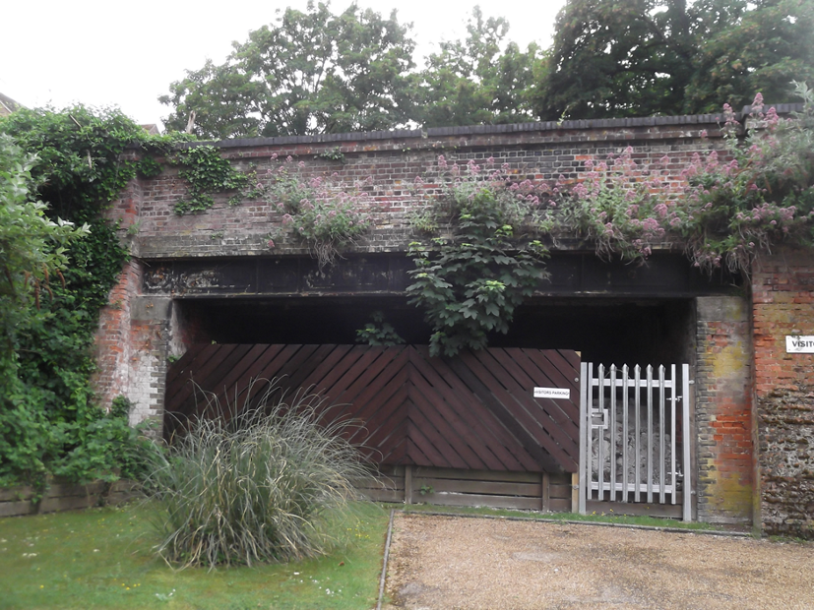
Debden Road bridge, Saffron Walden, Essex, at the western end of the former station yard, built 1864. Identified as of 'no realistic value' as the land either side has been developed for housing and hence it is ear-marked for infilling.

Photo: Tony Crosby

John Rennie Snr., 1761 - 1821

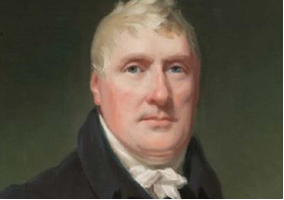
This year marks the 200th anniversary of the death of the engineer, John Rennie Snr. He was responsible for major projects across the UK such as the Pembroke Royal Dockyard and the East India Dock, London, and also designed many bridges throughout the UK including London Bridge. In Essex he was responsible for the High and Low Lighthouses at Harwich and he was Chief Engineer to the Chelmer & Blackwater Navigation.

Image credit: Institution of Civil Engineers

Harwich’s original lighthouses were timber ones but were replaced in 1818 under the supervision of Rennie. Low Lighthouse is a 45 feet high, ten-sided brick tower, while High Lighthouse is a 90 feet high, nine-sided brick tower. They are 150 yards apart and were leading lights working as a pair with one light positioned above the other as seen from the sea so a vessel knew it was on the correct course. Both were taken over by Trinity House in 1836, but became redundant in 1836 due to the changing course of the channels, although High Lighthouse continued to be used as a landmark. Low Lighthouse is now the Maritime Museum run by the Harwich Society, while High Lighthouse is a private residence with a private Wireless Museum.

Below left is Low lighthouse and right is High Lighthouse
(Tony Crosby)

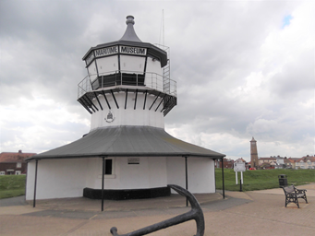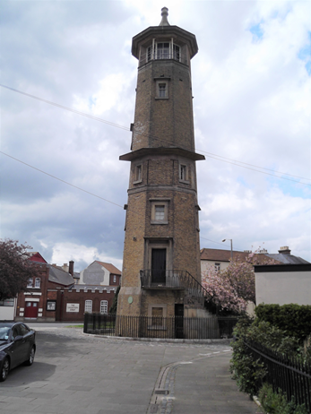

The Chelmer and Blackwater Navigation was constructed between 1793 and 1797, Rennie being the Chief Engineer. It was built to link Chelmsford to the port of Malden, but following objections it took a different course to reach the sea at Heybridge Basin.

The Institution of Civil Engineers’ Archive Panel and Panel for the History of Engineering Works have announced a project to commemorate this anniversary and are seeking contributions to both print and on-line publications aimed at the general public, focussing on Rennie’s life and work.

Stansted Mountfitchet Windmill Repairs

Stansted Mountfitchet is privileged to have a Grade II* five storey brick tower mill built in 1787 by Joseph Lindsell. It is also a Scheduled Ancient Monument. With the windmill Lindsell also built a malthouse, mill house, granary and bake house. Nothing remains of the granary or malthouse; the mill house became a Roman Catholic Church and is now a private house as is the former bake house.

In 1807 the Mill was put up for auction, bought by Mr Chaplin for £1135. Mr. Chaplin leased the Mill to several millers but as the running of the Mill was of course dependent on the weather, especially the wind, not many were successful. The Mill was ultimately leased to Charles and Edward Hicks of Stansted who worked it for the next 70 years. It last worked, crushing oats, in 1910.
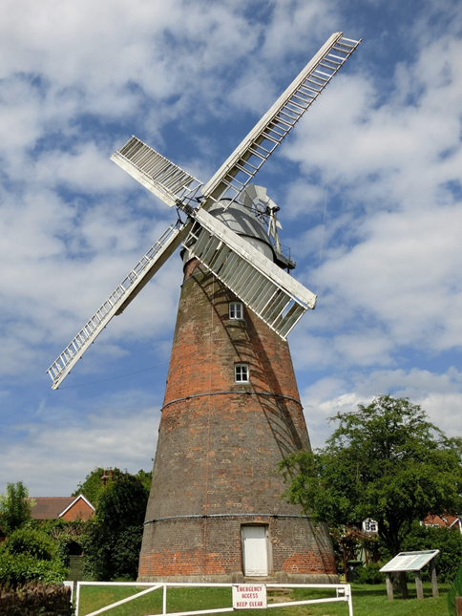
James Blyth, later the first Lord Blyth of Stansted Mountfitchet, bought the Mill in 1887. His son, the second Lord Blyth, organised extensive repairs, restoring it to a sound state. Then in 1935 it was “conveyed for the benefit of the inhabitants of Stansted”. Today the Parish Council are joint trustees.

During WWII the Mill was used by the Boy Scouts as their headquarters; they left in 1963. The Mill was opened to the public for the first time in 1964. It was floodlit in 1977 to commemorate the Queen’s Silver Jubilee.

In April this year the good weather and easing of lockdown allowed the Stansted Millers to complete the latest round of repairs to the Mill. Millwright Paul Kemp and engineer Steve Mansfield, fixed the Mill’s striking mechanism that controls the shutters which rotate the four white sails. The sails are now operated from ground level.

(Text by Janice McDonald, photo by Ken McDonald)

STOP PRESS

Welsh slate landscape gains World Heritage status

An area famed for its slate industry has joined Egypt's Pyramids, India's Taj Mahal and the Grand Canyon to become a Unesco World Heritage Site. The slate landscape of north-west Wales has become the UK's 32nd site on the prestigious list after the World Heritage Committee approved the UK bid.

It comes after Liverpool lost its World Heritage status earlier in July when the Unesco committee meeting in China ruled development threatened the value of its waterfront.

