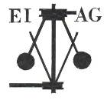
Essex Industrial Archaeology Group
Incorporating the Essex Mills Group

NEWSLETTER

Number 42 September 2021

Welcome to this month’s edition of the EIAG Newsletter which includes Colchester Gas Works, two new books (Christmas is coming!), a village visit, and news of the next online talk and our Annual Meeting.

We hope you enjoy reading this edition and if you have any comments on the Newsletter generally or specific items in it, or wish to make a contribution to the next Newsletter, please contact us via our email address - essexiag@gmail.com.

EIAG Annual Meeting Saturday 13th November 2021, 2:00 pm

We intend to go ahead with this year’s EIAG Annual Meeting, whether that be an actual in-person meeting or online via Zoom.
Our speaker will be Dr Catherine Pearson on the
‘Frederick Roberts Archive of Industrial History’.
If we can meet in person the venue will be Christ Church, London Road, Chelmsford. The usual AGM business will precede the speaker. The meeting is free for members, £2.00 for non-members. We will contact you by a separate email to confirm whether this event is ‘live’ or online, so put the date in your diaries as it will go ahead one way or the other.

EIAG Committee has agreed to plan to hold a fourth Industrial Heritage Fair in early Autumn 2022. Hopefully this will be able to go ahead and details as they are agreed will be in future Newsletters – fingers crossed!

Eddystone Lighthouse

Yes, we know it is not in Essex! However, the first Eddystone Lighthouse, in the English Channel off Plymouth, was built in 1698 by Henry Winstanley, artist, engineer and merchant, after losing two of his ships on the Eddystone Rocks. He was born in Saffron Walden and initially worked at Audley End House. He died while working on the project during the Great Storm of 1703. The story of the Eddystone Lighthouse recently featured in the Channel 5 programme ‘Lighthouses: Building the Impossible’ presented by Rob Bell on Friday 17th September. Trinity House at Harwich also featured.

If you are interested in this story of a famous Essex man, you can watch it on the catch-up channel, My5 TV - https://www.my5.tv/lighthouses-building-the-impossible
Colchester Gasworks By Peter Jones

Continuing the Gasworks theme from the last EIAG newsletter, the Friends of Colchester Museum recently purchased a picture of Colchester Gasworks painted by Colchester born artist Henry Collins (1910-1994). He had a connection with the Gasworks as his father worked there, as noted in pencil on the back of the picture.

Gas was produced on the site at the Hythe for over 130 years with the works finally closing in the early 1970s. The picture shows the works in 1951 looking north towards Hythe Hill with St Leonard’s Church clearly visible in the distance. All the Gasworks buildings are long gone and houses now block the view from where the picture was painted.

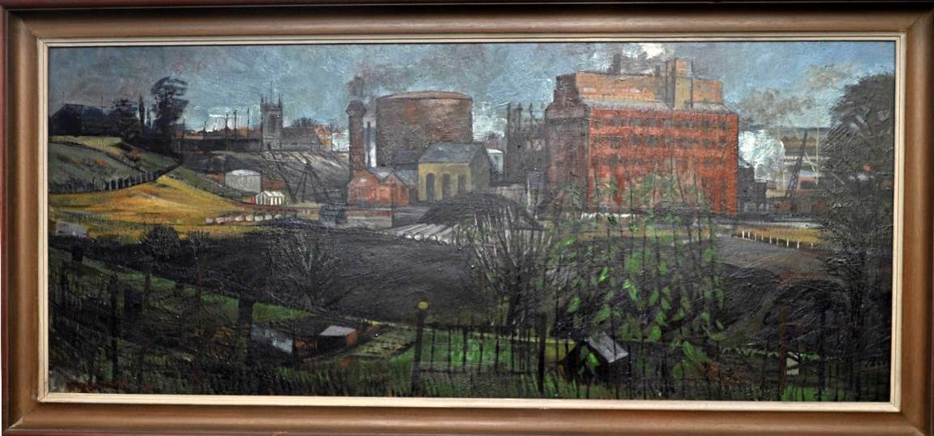

Henry Collins and wife and fellow artist Joyce Pallot were also responsible for designing a series of concrete murals decorating the pedestrian underpasses beneath Southway in Colchester as well as a larger design on the outer wall of the Sainsbury’s town centre store in Priory Walk. Their work was not confined to Colchester, the murals first became popular during the 1951 Festival of Britain and it is thought that between them they produced around a thousand, some of which can still be seen in Bexhill, Newcastle, Southampton and Stockport as well as Colchester.

Footnote.

Also on the back of the picture is a label stating that the picture was shown at

Ingot Industrial Britain Exhibition

Sponsored by the RTSC group of companies.

So far I have been unable to discover anything about this exhibition, which was presumably in the 1950s. If anyone can throw any light on this I would be very pleased to hear from you. My email is jonesjp@outlook.com.

Two new books – ideal Christmas presents!

SLOW BUT SURE - A History of the Portway Family and the Tortoise Foundry at Halstead
by Adrian Corder-Birch, will be published in October.

This book is a history of the Portway family and their industrial interests mainly in Halstead, Essex. Charles Portway was initially an ironmonger with a large shop in Halstead High Street and a warehouse in Chapel Street. In 1886 a branch shop was established in Sudbury, Suffolk.
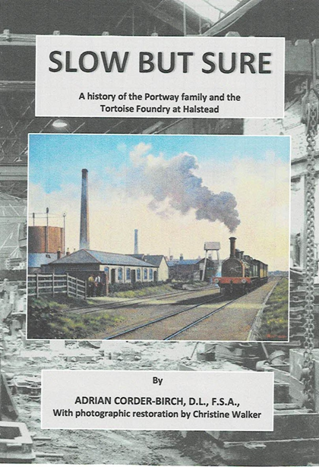
From 1869 to 1878 Charles Portway was a partner of T. H. P. Dennis & Co., of Chelmsford and in 1876 they were joined by Col. R. E. B. Crompton, who established the well-known electrical engineering company of R. E. Crompton & Co., later Crompton Parkinson Limited, which was taken over by the Hawker-Siddeley Group in 1968. Another partner of T.H.P. Dennis & Co. was Charles Portway’s nephew, Frank Fawkes, who joined Col. Crompton and in 1907 the partnership was incorporated as Crompton and F. A. Fawkes Limited.

In 1877 Charles Portway patented the Tortoise Stove, which became famous worldwide. He was joined by his son, Harry Portway and in 1882 they established the Tortoise Foundry and Stove Works, which was conveniently located adjacent to the Colne Valley and Halstead Railway and had its own siding. The book is of particular interest to railway historians, with two Court actions between Portway & Son and the Railway Company being fully researched and recorded.

Following the death of Charles Portway in 1909, the businesses were continued by Harry Portway and later by Col. Cedric Portway and Madeline Franklin. In 1938 two companies, Charles Portway and Son Limited and The Tortoise Foundry Company Limited were incorporated and continued production until 1975. Charles Portway & Son Limited specialised in manufacturing stoves, ovens, ranges, fireplaces, boilers and all heating and cooking apparatus. The Tortoise Foundry Company Limited carried out general foundry work and forged brass and iron castings for the engineering industry. The book also includes details of successor companies, which operated until 2004.

The numerous employees of the shops, the foundry and other businesses are provided together with details of the prominent part, which members of the Portway family have taken, in many Halstead and other organisations, including military service and education.

The early history of the foundry, its previous owners and some of the work carried out by them is included, such as bridge construction and castings for wind & water mills. Among previous owners were members of the Greenwood family one of whom established Halstead Gas Works and was later a director of the Colne Valley and Halstead Railway.

Copies of the book will be available from 11th October 2021 from: Adrian Corder-Birch, Rustlings, Howe Drive, Halstead CO9 2QL – email: acb@corderbirch.co.uk price £14.95 plus £3.25 postage – cheques in English pounds sterling payable to Adrian Corder-Birch please.

The Mistley, Thorpe & Walton Railway
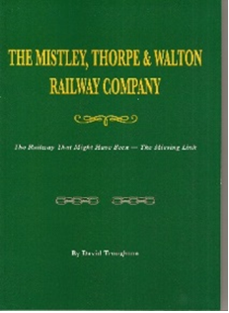
150 years ago in NE Essex a line was conceived to run some 12 miles from Mistley on the rail network, to the coastal village of Walton.

The prospect of expanding trade had not escaped the unwelcome attention of competing and predatory railway companies. The stage was thus set for intrigue, mischief and manipulation. At the outset little could the promoters contemplate quite the challenges to be met in the following years, finally resulting in the lines abandonment.

An ambitious line was sought by Act of Parliament in 1865 to run some 12 miles between Manningtree and Bures, along the bank of the river Stour, however, it was to meet the same fate.

Research over many years has now been collated in 146 A4 pages, comprising over 80 plans, 50 photographs, detailed schedules, extracts from ordnance survey maps, and a forensic examination of evidence. Printed in high quality by The Amadeus Press, it has received “very good” reviews in the railway press, and it will be of particular local interest.

Priced at £19.00 including p&p, from the author, David Troughton at 26 The Cobbles, Delamere Park, Cuddington, Cheshire CW8 2XH. Cheques payable to “D Troughton”.

A Short Sortie to Ashdon Village

Taking advantage of the lifting of restrictions and the late summer sunshine, Pat and I visited, for the first time, earlier this month, Ashdon village situated some 4 miles northeast of Saffron Walden. A quintessential English agricultural village, population just under 900, with its 14th century church, medieval Guildhall, and small museum (unfortunately closed), it provided a number of interesting features of agriculture-linked industry.

Although closed, the museum has a few exhibits outside, including what I believe is an oil cake breaker which, as will be seen from the photo below, was made by Bentall & Co., agricultural implement manufacturers of Heybridge.
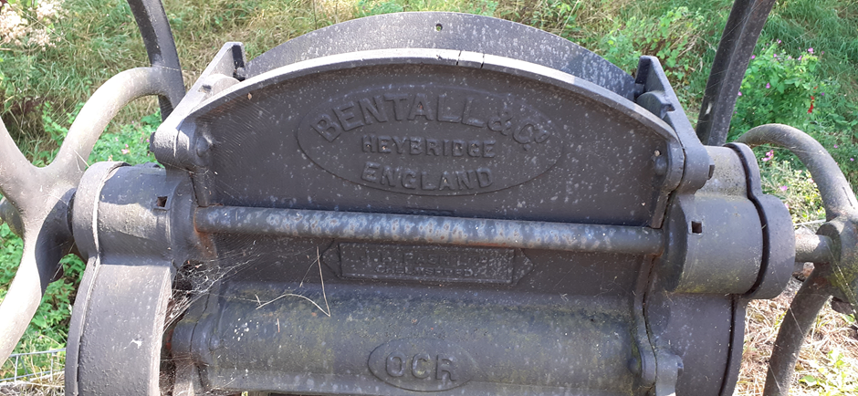 .
The main historic industrial monument in the village is Bragg’s Mill, a Grade II Listed post mill built in 1757 by William Haylock. The brick roundhouse was added sometime after 1813. William Bragg operated it until 1912 when commercial operation ceased. Despite various repairs over the years, urgent action was needed to save the mill and in 1999 a charitable company was formed with the object of restoring and maintaining the mill. It opened in 2016 as a working mill able to mill grain again for the first time in 104 years.
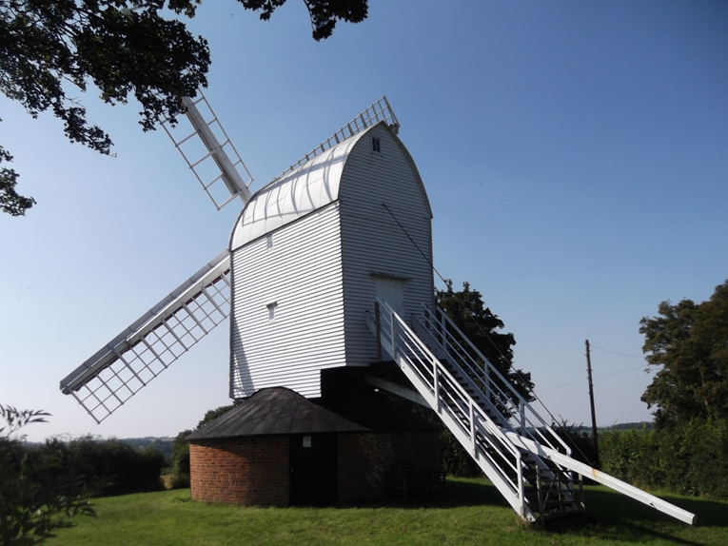

Bragg’s Mill, post mill Ashdon

The railway arrived in the village in 1866 with the full opening of the Saffron Walden Branch which ran from a junction with the Cambridge main line at Audley End to Bartlow where it joined the Shelford – Sudbury line. Initially there was no station or halt at Ashdon, but, after many campaigns by villagers, Ashdon Halt, a request stop, was finally opened by the Great Eastern Railway on 14 August 1911. Prior to that the nearest station was at Bartlow, two miles further down the line. A mile stone in Ashdon’s main street, Church Hill, informed potential rail users of the length of walk to access the station (photo below). The branch line closed on 7 September 1964.
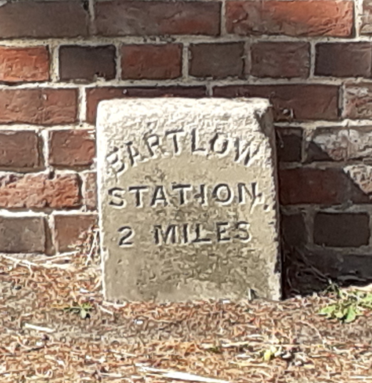
Mile stone indicating the distance Ashdon residents had to walk to Bartlow Station before the Halt at Ashdon was provided.

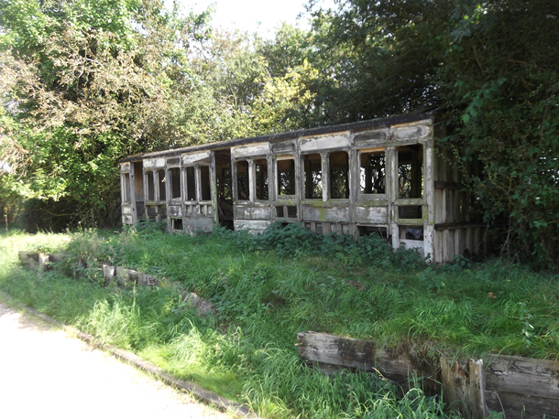
All that remains of the Ashdon Halt. The platform was constructed of raised earth and clinker with sleeper frontage to the track and sleeper edging. An old GER carriage body was mounted on the platform in 1916 to act as the waiting room.

Finally, I also spotted another road drain cover manufactured by the Maldon Ironworks.

Text and photos by Tony Crosby

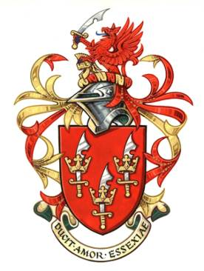
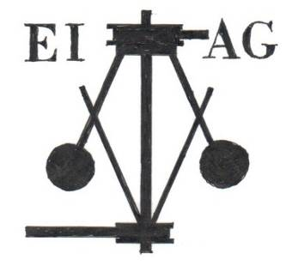
ESSEX INDUSTRIAL ARCHAEOLOGY GROUP
incorporating the Essex Mills Group
A Sub-Group of the Essex Society for Archaeology and History

The Iron Bridge
Conservation & Repairs
and some other Industrial Monuments
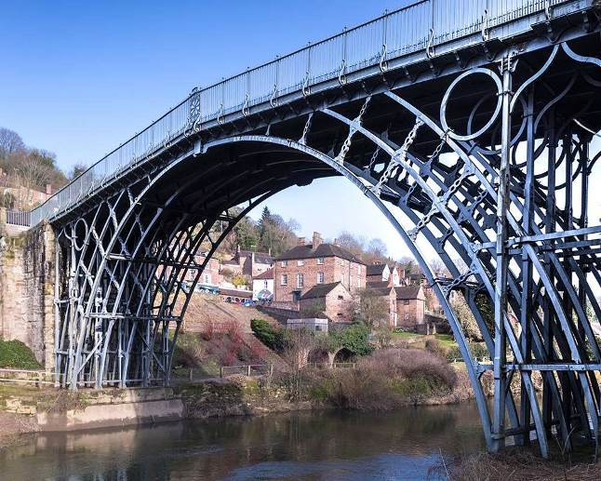

A talk by Ed Morton
Ed Morton is the Managing Director of The Morton Partnership, a company almost entirely involved with conservation, repairs and reuse of historic buildings and structures throughout the country and abroad. Ed is appointed Engineer to various Cathedrals, and has over 30 years’ experience, including many Industrial Monuments and sites from the recent repairs of the Ironbridge, and locally to Wickham Bishop’s Timber Trestle Viaduct, the Double Timber Treadwheel Crane in Harwich.

27th October 2021 at 7.00pm via Zoom

To book please email jgiffould@aol.com

Zoom link will be sent on 26th October

