Essex Industrial Archaeology Group
(Incorporating The Essex Mills Group)

NEWSLETTER

Number 44 April 2022

Welcome to this edition of the
Essex Industrial Archaeology Group’s (EIAG) Newsletter

This edition contains an obituary to David Alderton; articles on the Jaywick Miniature Railway; the Birth of British Radio Broadcasting; ERIH; and an up-date on former railway bridges at risk. As well as events organised by ESAH (in the box below) we would also draw your attention to National Mills Weekend on 7th and 8th May; Tim Wander’s lecture on the Centenary of British Radio Broadcasting on May 17th (flyer below) and the EERIAC conference at Woodbridge in Suffolk on 11th June, details of which were circulated to members earlier this month.

If you have any comments on the Newsletter generally or specific items in it, or wish to make a contribution to the next Newsletter, please contact us via our email address - essexiag@gmail.com.
Contributions for the Newsletter should be sent by the end of the month prior to publication (i.e. by end of March, June, September and December), please.

Programme of EIAG events 2022

The ESAH programme of visits and events for 2022 is now organised and will be circulated to members very soon. It includes:

Warners Textile Archive, Braintree. Wednesday 14th September 2022, 10:00 am. Tour of the museum and archive, plus tea/coffee. £20

Industrial Heritage Fair 2022. Saturday 1st October 2022, venue is Silver End Village Hall from 10:00 am to 4:00 pm. As usual there will be various exhibition stands from industrial sites, museums and societies; three talks, two of which will be on Crittall’s and Silver End history; access to the Silver End Heritage Centre; and guided walks around the Crittall company village of Silver End.

EIAG Annual Meeting. Saturday 12th November 2022. Venue and other details still to be arranged

Jaywick Miniature Railway

Reading Issue 113 of Archive (The Quarterly Journal for British Industrial and Transport History), there was a short article on the New Brighton Miniature Railway. It grabbed my attention as, being a Liverpudlian, I probably travelled on it as a small child. However, what has it to do with Essex, you are probably asking? Opened in 1947 and closed in 1965, ‘the track and some equipment came from a closed 18-inch gauge line at Jaywick Sands, near Clacton in Essex.’ This latter line I had not come across before, hence some online research was required!

The Jaywick Miniature Railway (JMR) was planned and built by the Stedman family who were developing the estates at Jaywick and wanted to be able to transport prospective home buyers to the estate from Clacton. It was opened in 1936, built to 18-inch gauge to accommodate the second hand locomotive, a scaled down miniature version of a Great Northern Railway Stirling Single 4-2-2, purchased from the Fairbourne Miniature Railway in North Wales. Three coaches were bought new and in 1938/9 a second locomotive, a scaled down version of a vertical boiler Sentinel, was built on site. This latter locomotive did not have a very long working life as the outbreak of war lead to the closure of the line. There was a failed attempt to re-open the line after the war, after which the Sentinel and three coaches were sold to the New Brighton Miniature Railway.

A full history of the line can be found in Lawson Little’s book ‘A Single to the Seashore’.

Tony Crosby
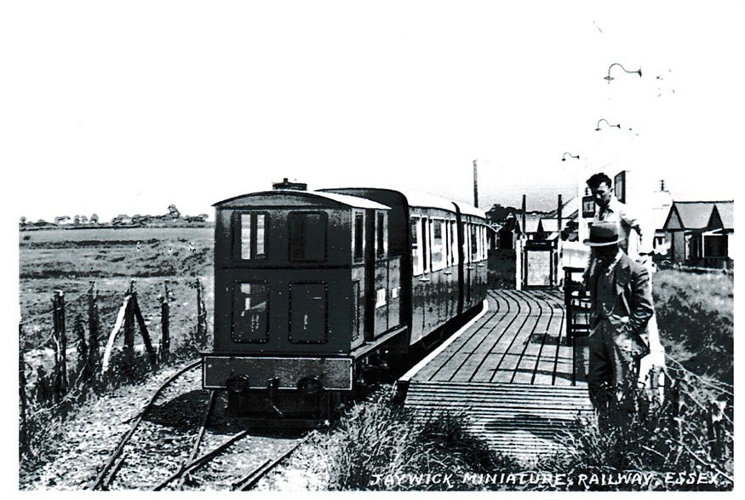
The Sentinel locomotive with its train at Jaywick Sands station in 1939 showing the wooden platform, bench, and lamps for evening operations. (Tony Crosby Collection)

Historic Railway Bridges at Risk – An up-date

In Newsletter 41, July 2021, I reported on the potential risk to 135 former railway tunnels, bridges and viaducts, part of the Historical Railways Estate, which Highways England were proposing to demolish, or partially or fully infill, for safety reasons. This list included six former railway bridges in Essex. Such was the outcry that followed these proposals that the programme was paused and the Government ordered a review of the whole programme, the outcome of the review being reported in New Civil Engineer (NCE) in March.

The review was carried out by Sustrans and concluded that 50 out of 75 structures earmarked for demolition or infilling had potential use as part of the National Cycle Network (NCN) or as local cycling and walking routes. The study was mainly desk based and did not involve any structural assessments, which are recommended as the next step to determine the structural condition, alongside planning permission and consents required, ecology and community support. This assessment was a pilot but the methodology developed for these priority structures could be scaled up to assess the other 3,000 Historical Railways Estate structures in due course.

The report splits the 75 structures into 4 categories, as follows:

- Structures deemed useful for the National Cycle Network - 11
- Structures deemed useful for local projects (with plans already mooted) - 15
- Structures deemed useful for local schemes (but don’t have plans in place) - 24
- Structures deemed not useful for active travel routes – 25. (This does not necessarily mean that they will be demolished or infilled as the Sustrans review did not consider other possible uses for the routes, such as reinstatement of historic railway lines.)
Of the Essex bridges:

- Parkeston is in Category 1
- Stow Maries and Norton Hall are in Category 2
- Hovis (or Purls Hill) is in Category 3 and
- Debden Road and Old House Farm are in Category 4

Also on this new list are two bridges in Essex not on the original list, those at Painters Bridge (does anyone know where this one is, please?) and Cold Norton Halt / Latchingdon Road (both Category 3)

For the full report in NCE including a list of the bridges in each category, search New Civil Engineer 50 rail bridges.

Tony Crosby

The Birth of British Radio Broadcasting in Essex

It is almost impossible today to imagine a world without radio and its sister medium television, but on the eve of the First World War, when the science of radio was perhaps less than twenty years old, the ether crackled with countless radio signals, but all of them were the monotonous clatter of Morse code. The Great War of 1914-18 saw wireless used in many ways and the requirement for reliable communications and reporting, especially upon the fall of artillery shells, meant that the development of radio equipment and valve design moved at an unprecedented rate. Within two years the science of radio speech transmission developed to the point were by 1918 robust, reliable and portable equipment allowed ground to air and even air to air communication.

The 'War to End All Wars' brought a tremendous cost in suffering, death and waste, but as usual, war always spurs the advance of technology. This rapid technical development in hardware was met by an equal number of young men both fascinated by, and now well trained in, the new art of wireless communication. By the armistice of 1918, radio had been transformed from an inventor’s plaything, into a faithful workhorse. The same war that had driven the technology, science and engineering to develop the equipment would now make it possible for the general public to ‘listen in’ as massive quantities of war surplus equipment were freely available. Also tens of thousands of young men came home to this new world having either been trained in, or having seen wireless communication and radio systems being used at sea, or in the trenches and skies of Northern France. The social structure of the world had also been torn apart by a World War and the new world was ready to listen, hungry for instant news especially as the world was also under the grip of the Spanish flu – a pandemic that would kill over 70 million people.

In the commercial world, at first the powerful Marconi Company was still convinced that Morse code was the most reliable form of communication between ships and between ship and shore. There was a widely held belief that speech transmission, known then as telephony, had no real place in the evermore crowded ether. So it was that a group of young engineers, born into the Victorian age, fresh from Military service during the war and working for the very formal and huge Company that Marconi had built, took their stride into history. As the new decade dawned, the time was simply right for radio broadcasting to occur.

In Britain the first broadcasts were, in the great tradition of radio, complete accidents. Two Marconi engineers, H.J. Round and W.T. Ditcham, who ran the high power experimental station at the Marconi Works in Chelmsford first brought entertainment to the airwaves. Their transmitter tests soon became far more than telephony experiments, their regular evenings of music and news, including the famous concert by Dame Nellie Melba, became true firsts in the history of radio. The great lady herself, Dame Nellie Melba, when at the Marconi New Street Works in Chelmsford, in 1920, for her historic broadcast was shown the huge 450 ft. high twin masts towering over the factory and the town. It was explained to her that from the top her voice would be heard throughout the world. Her answer is now radio folklore, “Young Man, if you think I’m going to climb up there you are very much mistaken”. The lady sang and was heard throughout Europe, but in November 1920 the Post Master General decided that Britain was not ready for broadcasting and he closed the station down due to severe interference.

Then it started again in a small Essex village called Writtle, when on the 14th February 1922, popularly known as St Valentine’s Day, a weak and static laden radio signal crackled out from an old army hut on the edge of a partly flooded muddy field in a small Essex village. The new art of radio broadcasting had come back to Essex and Britain had gained her first official voice. So it is a small village in Essex that, beyond all others, claims to be the birthplace of British broadcasting, due to its innovations and regularity of service. It faithfully appeared on the air every Tuesday for half an hour, at eight o'clock in the evening for almost a year. The village is called Writtle, the radio station that ran there was known by its radio call sign of 2MT, and it made history.

The new art of broadcasting had come to Essex, and Britain had gained her first official voice, but station 2MT was so much more than an experimental radio station. The whole thing was conceived and run by the irrepressible Captain Peter Pendleton Eckersley. A brilliant engineer, ‘PPE’ and the 2MT team offered its listeners impromptu comedy sketches, the first ever broadcast radio play, dedicated children’s five minute spots, impersonations, guest artistes, burlesque entertainments and even parodies of grand opera. Nothing like it had been heard before - it was a new type of entertainment and it made history. With the power behind the microphone being Marconi engineer Captain Peter Eckersley, Britain’s first ‘DJ’ brought an amazing light-hearted spirit and comic skill to the new art of radio broadcasting. His sheer joie de vivre bubbled across the ether and he was not only the first, but also talked to his listeners as if they were in the room with him - and his listeners, estimated at over 20,000 people loved him and the station. Peter's love of 'sound effects' would find him playing records pivoted at some other point than their centre, inventing wireless noises, banging half-filled milk bottles, inventing new characters and always sing bad songs, very badly....this was essentially a Goon show some 40 years early.

From their chaotic planning meetings in the Cock and Bell Pub and then having to push the pub piano down the narrow muddy lane on a wheel barrow it was clear from the outset that 2MT was something different. In fact it was so different and so successful that the young Writtle radio engineers work led directly to the formation of the famous London radio station ‘2LO’ and then the within the year British Broadcasting Company. Peter Eckersley quickly became the BBC’s first Chief Engineer, and he took most of the Writtle pioneers with him to build the National Broadcasting service from the ground up.

Today, as we mark the centenary of the Birth of British Broadcasting it is perhaps a little humbling to think that our entire modern age of media, broadcasting and even the internet started in a small hut in Writtle. It all came about because some young engineers had the audacity, humour and technical skill to invent the art and science of radio broadcasting as we know it, and that one man walked in front of a microphone and soon became the power behind the microphone…….. Hello CQ, Hello CQ! This is two, Emma Toc Writtle calling!

Tim Wander

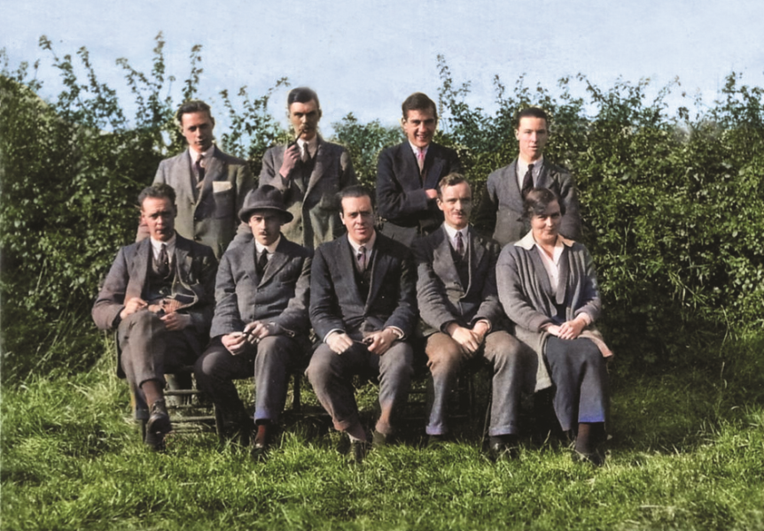
Left - Peter Eckersley and the 2MT team at Writtle

(All photos from the Alan Hartley-Smith Collection)

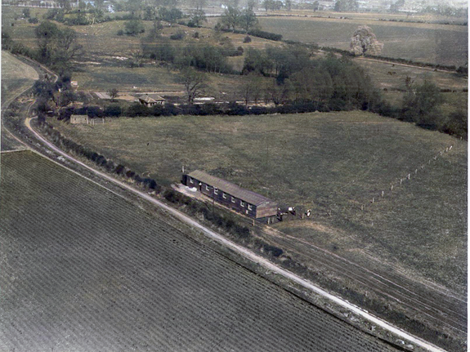
Left - The Writtle Hut

Below - The Writtle Team beside the Hut

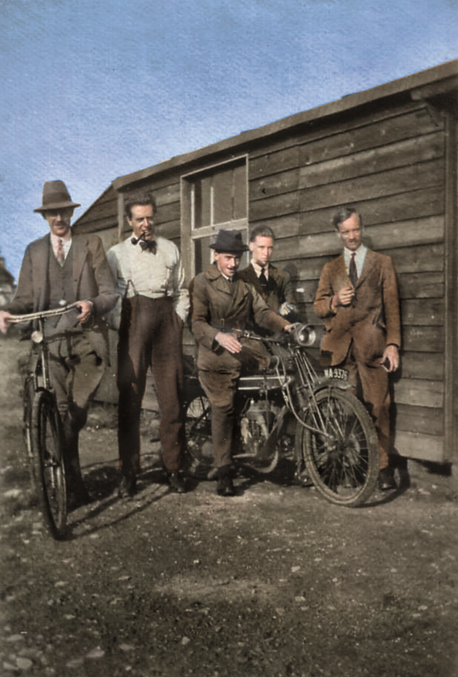

To mark the centenary of the birth of British Broadcasting Writtle Parish Council and Heritage Writtle have arranged a number of events in May starting with Tim Wander’s lecture on 17th May – see flyer below:
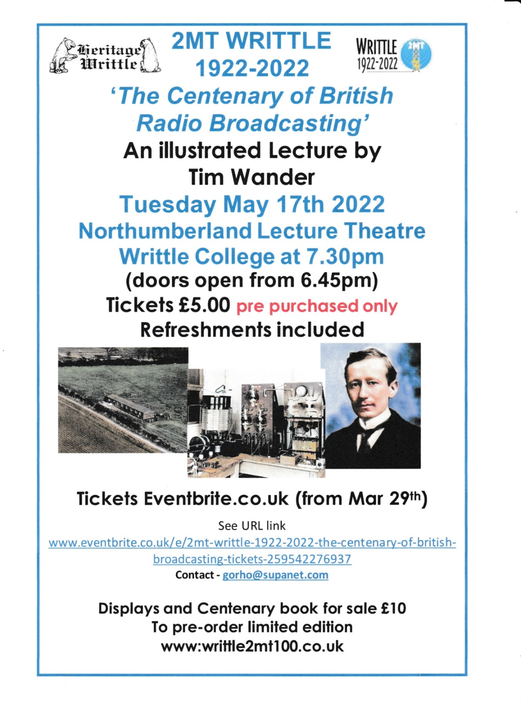
This will be followed by various events on Saturday 21st and Sunday 22nd May in Writtle village including an exhibition, demonstrations, and a Writtle Wireless Walk. Full details can be found on the Writtle Parish Council website under ‘Other Village Events’ at - https://writtle-pc.gov.uk/village-diary/other-village-events/

David Alderton 1935 – 2022 – Obituary
David was an historian, teacher and lecturer who had a life-long interest in steam railways, canals and industrial archaeology. He was a founder member of the Association for Industrial Archaeology (AIA) in 1973 and served on the AIA Council in a number of roles including Chairman, Secretary, and Conference Organiser. His associations with Essex can be traced back to 1980 when he and John Booker wrote The Batsford Guide to the Industrial Archaeology of East Anglia. At the time he was Senior Lecturer in History at Keswick Hall College of Education in Norwich where he encouraged some of his students to study industrial sites. David wrote the sections on Norfolk, Suffolk and Cambridge, while John Booker contributed the section on Essex. Soon after he moved from Suffolk to Essex he offered to organise an AIA Annual Conference in Essex as he recognised the variety and importance of the heritage of the County’s industrial past. At the time there was no dedicated industrial archaeology society in Essex to help with this task, so most of the work fell on David himself, with the help of some local AIA members. The conference which took place in 2012 was a great success, owing a great deal to David’s knowledge, experience and organisational skills, and it directly resulted in the formation of EIAG, of which David was a member from the start. David will be greatly missed in the industrial archaeology world, but his achievements will continue as a lasting legacy to his contribution to the discipline.
Tony Crosby
EUROPEAN ROUTE OF INDUSTRIAL HERITAGE (ERIH) UPDATE
The following update is based upon information in the March 2022 ERIH Newsletter. The various items illustrate how ERIH is playing a successful role in raising the profile of industrial heritage in Europe.
ERIH SOLIDARITY WITH THE PEOPLE OF UKRAINE: The Russian assault upon Ukraine is a flagrant violation of international law which strongly contradicts the common European values that are the foundation of the ERIH network, being a Cultural Route of the Council of Europe. ERIH strongly condemns the destructive war and joins the overwhelming majority of the global community in calling for immediate peace negotiations. In solidarity with Ukraine, the descriptions of Russian sites on the ERIH website have been removed until further notice.
EU FUNDING SCHEME “CREATIVE EUROPE: An application for a three-year Creative Europe Networks grant to promote ERIH networking has been successful. This provides 80 percent EU funding for network projects from January 2022 until December 2024, with ERIH contributing the remaining 20 percent. ERIH's focus is on the implications of the "European Green Deal" for industrial heritage as well as the sector's sustainability in the wake of the effects of the pandemic. The new project period is divided into six work packages designed to develop established formats and implement new ones.
A project management group (PMG) has been constituted which relies on active member participation. Invitations for ERIH members to get involved will be issued for projects such as WORK-it-OUT, ERIH on TOUR (successor to Twinning of Sites), Linking Europe and others. Lobbying for industrial heritage at EU level will also continue to be important. As a Cultural Route of the Council of Europe ERIH will share its experience as well as maintain and expand its contacts with various other expert groups, in the European Heritage Alliance 3.3 network and in other relevant programmes.
ERIH work packages 2022-24 involving education and professional training, as well as knowledge transfer, will continue to be top priorities. The European Academy of Industrial Heritage is going to propose lectures at further universities (germany@erih.net gladly accepts suggestions and applications via email). These activities will particularly target the younger generation.
The Industrial Heritage Barometer will remain an integral part of ERIH. There will be a call from the Ruhr Regional Association for participation in this year's online survey and the more sites that take part the more meaningful will be the results.
An upgrade is scheduled for both internal and external ERIH communications. This applies in particular to the use of social media, which will be extended to include additional channels and content.
COMPARISON OF CULTURAL ROUTE ONLINE COMMUNICAN: How the Cultural Routes of the Council of Europe deliver content, information and services on their respective websites is the basis for a study conducted by four researchers from UNESCO and two universities in Switzerland and Finland. The results were presented at a University Network for Cultural Routes Studies workshop held in December. The study identified 47 indicators for comparison between 34 websites and assigned them to six categories, including "information about the route", "news, events, projects" and "tourism".
The ERIH website scored 33 out of the 47 indicators putting it, with the “Liberation Route Europe”, in joint first place out of the 34 websites studied. The researchers state that both top-ranking websites "were among the last routes to be certified (both in 2019), and are characterised by a strong network of members at different levels (public and private organisations, corporate members and individuals) ... [They] provide constantly updated and easy-to-find information about current activities and future events and about how to take part in their organisation. These websites also constitute a tool for users to create a personal experience of the route, thanks to interactive maps and audio-guides, educational materials and travel packages that can be bought on the website. "
ERIH NETWORK: In the past year two new Anchor Points have been added to the ERIH network, the Grand Hornu World Heritage Site in Belgium and the Fortuna ore mine in Germany. There is also a new Regional Route the "TECHNOTRASA (Technical Route - Rough Beauty) which links eight sites in the Czech Republic's Moravian-Silesian coal and steel region, including the two ERIH Anchor Points Dolni Vitkovice and Michal Mine.
WEBSITE CONTENT: The ERIH website continues to grow with the following additions:
Descriptions of 100 more sites bringing the total number of industrial heritage sites presented online to over 2100.
Biographies of 45 more people who contributed to shaping the age of industrialisation.
Revision of the industrial history of 6 countries and new industrial history profiles on Kazakhstan, Monaco, San Marino and Vatican City. The website now features articles on all 51 countries that are partly or entirely considered part of Europe from a political, cultural or geographical view point.
Another important upgrade relates to the link lists. The Service/Links section now includes the entry "XTRA: Industrial Heritage for Kids". Anyone looking for specific sites explaining and presenting industrial heritage in a child-friendly way, will find a growing selection of links here. Comments and suggestions can be sent to webmaster@erih.net, especially with regard to websites that make educational and training opportunities available for download.
ERIH PUBLICATIONS: There is a new edition of the ERIH brochure "European Industrial Heritage. The International Story". This provides inspiration for ERIH sites as to how they can illustrate and explain the European context of industrialisation. Like the ERIH Theme Routes it outlines the history of individual industries as an exciting European narrative providing an incentive for a more in-depth approach to the topic. Copies are available on requested from the ERIH head office.
ERIH CALENDER DATES: Dates to note are:
The ERIH dance event "WORK it OUT" scheduled for 11th September 2022.
The ERIH General Assembly, along with the Annual Conference (both hybrid) will take place from 19-22nd October 2022. The venue is Esch-sur-Alzette (European Capital of Culture 2022) in Luxembourg.
Dave Buckley
Discovering Essex Wind and Water Mills
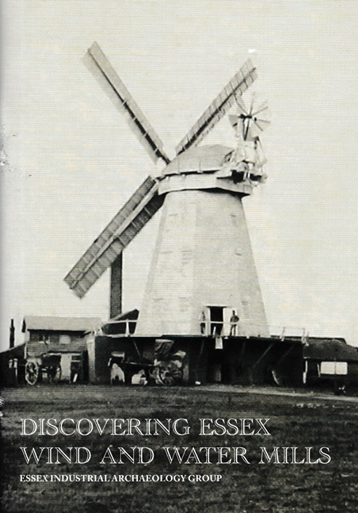
Now that EIAG has incorporated the former Essex Mills Group, we decided to continue with that Group’s aim of promoting the milling history and heritage of the County. This was felt to be particularly necessary at this time considering the fact that many mills have been closed to the public over the last two years due to Covid restrictions. Many are desperately in need of funds from paying visitors to be able to maintain the mills as visitor attractions.
Therefore, EIAG have earlier this month published a booklet – Discovering Essex Wind and Water Mills. This is a detailed guide to the 13 wind and water mills which are normally open to the public with a brief history of each, opening times, location and facilities. The booklet also has captioned diagrams of a wind and a water mill; a list of mills with new uses with public access; and lists of Listed mills in the County.
All ESAH/EIAG members will be receiving a copy of the booklet. Further copies can be obtained from the mills featured or by emailing us at essexiag@gmail.com.

National Mills Weekend
This year's National Mills Weekend, organised by SPAB (the Society for the Protection of Ancient Buildings), will take place on 7th & 8th May 2022. The theme for the first in-person event since 2019 will be ‘New Life for Old Mills’, celebrating the repair of wind and watermills for future generations to enjoy.
The National Mills Weekend will take place at wind and watermills across the UK and online on YouTube and SPAB Mills Section social media channels. The SPAB Mills Section is inviting everyone to share images of their own mill repair project on their social media channels. Let SPAB know about recent and historic repairs to your mill that has helped to make it possible for people to see, appreciate, and enjoy today. Also SPAB would like to know if your mill has been affected by recent storms or if you are planning to open your mill to the public during this year’s National Mills Weekend for the first time since the coronavirus pandemic. For more information on how to take part in the SPAB National Mills Weekend you can find an information and support pack here and a poster that can be customized and displayed in your mill here

