Essex Industrial Archaeology Group
(Incorporating The Essex Mills Group)

NEWSLETTER

Number 45 July 2022

Welcome to this edition of the
Essex Industrial Archaeology Group’s (EIAG) Newsletter

This edition contains two excellent reports by our Membership Secretary, Jane Giffould, one on the ESAH visit to Boxted Airfield and the other on this year’s EERIAC event in Suffolk. Also there is an up-date on the Jaywick Miniature Railway plus information on one of the bridges at risk mentioned in the April edition: Painters Bridge. Arrangements for the Annual Meeting on 12th November are now available (see box below) and last but by no means least, more details of what will be on offer at the Industrial Heritage Fair on 1st October.

If you have any comments on the Newsletter generally or specific items in it, or wish to make a contribution to the next Newsletter, please contact us via our email address - essexiag@gmail.com.

Contributions for the Newsletter should be sent by the end of the month prior to publication (i.e. by end of March, June, September and December), please.

Programme of EIAG events 2022

The ESAH programme of visits and events for 2022 is now organised. It includes:

Warners Textile Archive, Braintree. Wednesday 14th September 2022, 10:00 am. Tour of the museum and archive, plus tea/coffee. £20

Industrial Heritage Fair 2022. Saturday 1st October 2022, venue is Silver End Village Hall from 10:00 am to 4:00 pm. As usual there will be various exhibition stands from industrial sites, museums and societies; three talks; and guided walks around the Crittall company village of Silver End. More details are below.

EIAG Annual Meeting. Saturday 12th November 2022, 2:00 – 4:00 pm, at Chelmsford Museum, Oaklands Park, Chelmsford. The business of the Annual Meeting will be followed by an illustrated talk by Bob Sier on the History of Essex Tide Mills. Free to members, £2 for non-members.

ESAH Boxted Airfield visit

https://www.boxted-airfield.com/home

80 years ago the East of England, with Essex in particular, was considered the aircraft carrier of Britain due to the vast number of military airfields constructed on relatively flat farmland. They were inhabited by RAF and USAAF with the aim of protecting Britain and giving back like for like to Germany. It was only a short hop for our aircraft over to Germany. We were also naturally available for raids from the continent.

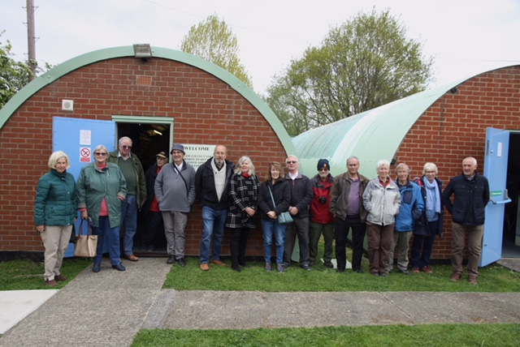
Boxted, north of Colchester, N51 55 E000 53, was one of those airfields that supported the aviation industry in WW2. It has had a varied history since being built by the Americans in 1943 on former orchards. Now it is inactive but does support an active museum, keen to show what was going on all those years ago, lest we forget. It is to this museum that ESAH, including quite a few EIAG members, paid a visit on 27 April 2022.
ESAH by the Nissen huts, 2022

We were welcomed with tea and cake in the first Nissen hut. Whilst consuming this we listened to an interesting talk on the history of the airfield. Being an aviation enthusiast I was naturally most interested in the technical details. We learnt about the different aircraft that had been through. The first ones were the Martin B26 Marauders. Essex had so many of these aircraft that it was nicknamed Marauder county. These were followed by P51b Mustangs and then P47Thunderbolts. The Americans left in October 1945 and the airfield was taken over by the RAF. In 1947 it was decommissioned as a military airfield. After that it had a varied history including air cadets, crop spraying and gliding. In the early 2000s there was a yearly open day fly in with a wide range of activities.

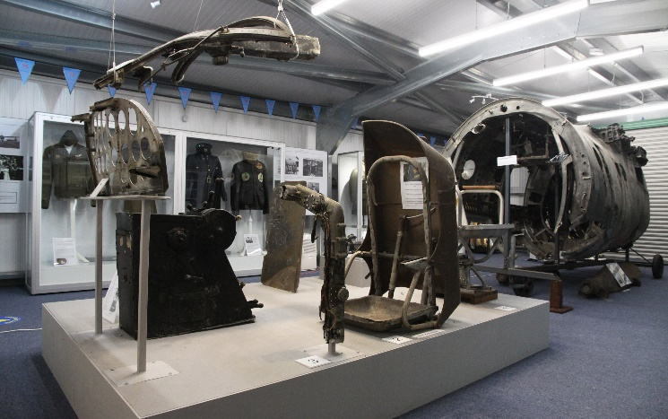
Outside we looked at the expanse of the airfield. I half closed my eyes and could see the squadrons of 16 aircraft with the total ranging to between 80 and 90 aircraft on the field. Beside the inactive aircraft would be the techie guys doing the maintenance, all done outside irrespective of weather. Then pilots would be out and into their aircraft, ready for taxi and take off on to their next mission.

The second Nissen hut contained displays and videos. Plenty to look at.

The third building behind one and two contained ‘Mr Shorty’. Mr Shorty is a selection of parts including a section of fuselage of a Marauder. This Marauder had a very busy time in WW2 and then moved around a range of museums and storage. It is now on loan to Boxted from Marks Hall. Together with Mr Shorty are a number of uniforms of the squadrons who had been based in Boxted.
Mr Shorty

On-going training and practice is an integral part of flying whether military, commercial or leisure. The Link trainer, pictured here, was a precursor to flight sims. It provided an enclosed space with basic controls for flying on instruments only and for night flying training and practice. It is named after Ed Link, who, after leaving school in 1929, could not afford to fly and so invented this flight sim. I did suggest they could get it working again as people would pay to have a go!
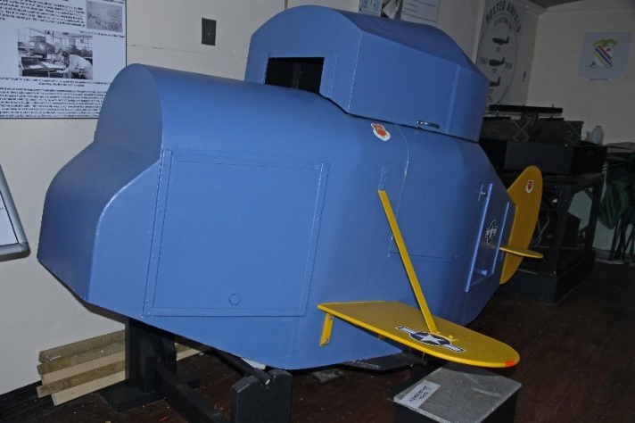
An excellent visit. Thank you to Boxted Friends. The airfield museum is open to visitors on the last Sunday of the month and can take pre-arranged groups at other times. Find out more from their website.

An aside: Why is it called Boxted airfield when it is next to Langham? Answer, there is already a Langham airfield in Norfolk and one does not want to confuse the pilots!

Jane Giffould
The Link trainer

Jaywick Miniature Railway

Following my article in April’s Newsletter No. 44 on the Jaywick Miniature Railway (JMR), I undertook further research, especially to learn about what happened to the locos and coaches following the closure of the JMR. The following is the outcome of those researches:

The Jaywick Miniature Railway was planned and built by the Stedman family who were developing the residential Jaywick Sands Estate and wanted to be able to transport prospective home buyers to the estate from Clacton. It was opened in 1936, being built to 18-inch gauge to accommodate the second hand scaled down version of a Great Northern Railway Stirling Single 4-2-2, purchased from the Fairbourne Miniature Railway in North Wales. Built to a design from W.G.Bagnalls Ltd., it was eventually given the name ‘Century’. Three coaches were bought new from Caffyn’s of Eastbourne which, with a 4-wheel flat wagon used during track maintenance, completed the rolling stock.

‘Century’ was used on its own for three seasons and was beginning to have running problems. Therefore, in the 1938/9 closed season a second locomotive, a scaled down version of the 4-wheel vertical boiler design developed by Sentinel of Shrewsbury, was built on site, ‘Century’ being kept as a stand-by. The Sentinel did not have a very long working life as the outbreak of war lead to the closure of the line. There was a failed attempt to re-open the line after the war, after which the Sentinel and the three coaches were sold to the New Brighton Miniature Railway.

‘Century’ was also sold separately in 1946, following which it had a number of owners before being restored to working order by 1970, but rarely steamed. In the 1980s it joined the collection at what is now the World of Country Life Museum, Exmouth, where it remains on static display.

The Sentinel was rebuilt is 1948 by the New Brighton Miniature Railway, giving it a more conventional steam loco appearance, having a dummy boiler with all attachments, side tanks and a rear bunker. It too has had a chequered history since the closure of the New Brighton line, as a ‘kit of parts’ which were purchased by the Ashover Light Railway Society in 2013/4 where it remains awaiting full restoration. The Sentinel loco as it was built and used on the JMR is the subject of the photo in Newsletter No. 44.

The three coaches were sold to the Ravenglass and Eskdale Railway in 1965, being reduced to reserve stock by 1970. After further moves, in 1978 they were at the Gloddfa Ganol Museum and three more moves later were at Windmill Farm in Lancashire by 1997.

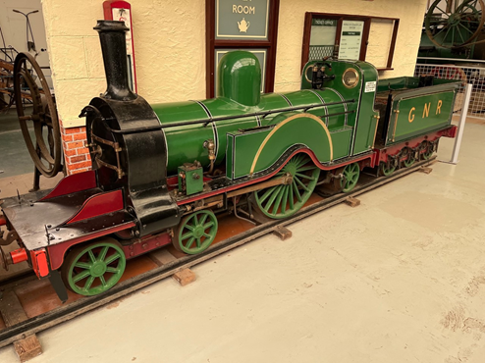
The Sterling Single in its restored state as a GNR loco on static display at the World of Country Life Museum, Exmouth.

(Photo courtesy of the World of Country Life Museum.)

Reference: ‘A Single to the Seashore’. by Lawson Little, 2003, Narrow Gauge Railway Society

Tony Crosby

Painters Bridge

In April’s Newsletter No. 44 in my article on Historic Railway Bridges at Risk I mentioned Painters Bridge and asked for help to locate it. Many thanks to EIAG member Graham Thorne who sent the following information:

Bridge 2122, Overbridge, Butlers Lane, alias Painters Bridge, GR 564399, red brick, three segmental arches, (three rings) skew.

Armed with this very helpful information I visited it last month and took the photo below:

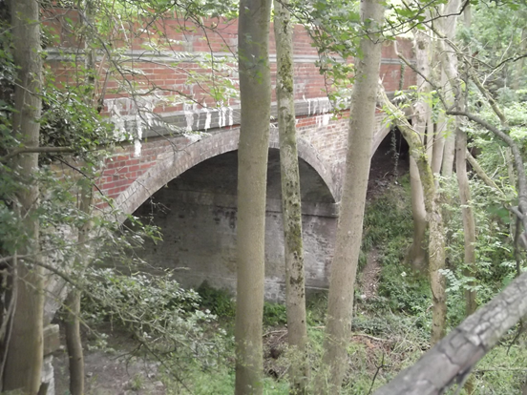
As can be seen it spans a very deep, wide cutting which runs from the Ashdon Road in north-east Saffron Walden to the village of Ashdon itself. On some maps the track bed is marked as a path and showing it has the potential as a walking and cycle path from Saffron Walden to Ashdon.

(Photo Tony Crosby Collection)

Tony Crosby

EERIAC at Woodbridge, Suffolk

East of England Regional Industrial Archaeology Conference, known as EERIAC is held once a year in June round the different East of England counties. Cambridge was last year, Suffolk was this year and Essex is next year. Each one picks a topic from its county that could be of interest to others. Generally they consist of some talks followed by a visit. The ones I have attended have all been very interesting and informative. There have been complaints about them being too far away, that will be a problem for anything in the East of England, it is a big area and will invariably be too far for some people. Plus some of the more interesting sites are away from the general routes.

This year on Saturday 11 June 2022 we met up at Woodbridge Community Hall in Suffolk. The morning’s talks were of the last century looking at ‘The History of Radar at Bawdsey’, followed by ‘RAF Martlesham Heath’. Lunch time gave us a chance to chat and explore Woodbridge. The afternoon took us further back in time to look at the reconstruction of a Saxon burial ship and a guided tour of a Tide mill.

The History of Radar at Bawdsey
RADAR, RAdio Detection And Ranging, was an idea mooted in 1935 as a way of using Radio waves to Detect aircraft. Now Radar has become part of our lives in that it is used to detect not just aircraft but also in terrain surveillance and weather forecasting. The term ‘below someone’s radar’ is common parlance indicating unlikely to be detected.

Bawdsey has an interesting history starting with the radar team moving into Bawdsey Manor Estate in 1936 with Bawdsey becoming an RAF base, but without runways or aircraft, through to the final lowering of the RAF Ensign in March 1991. Work was intensive throughout WW2 involving use, research, development and training for Radar. There was a large contingent of female operators as part of the workforce. Bawdsey became part of a chain of radar towers round Britain to defend the country with Bawdsey becoming an RAF base, but without runways or aircraft. Development of the detection capabilities enabled detection of ships as well as aircraft. During the 50s far more accurate radar was developed as part of the Cold War defences. In 1963 it was a base for Bloodhound surface-to-air missiles.

The site is now run by the Bawdsey Radar Trust. It is open to visitors and appreciates people becoming Friends. Detail can be found on the website: https://www.bawdseyradar.org.uk/

RAF Martlesham Heath
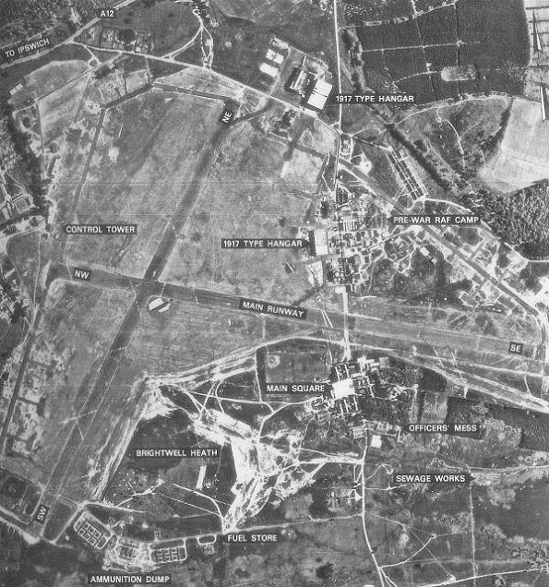
WW2 meant that Martlesham Heath was an easy option for attack and so the testing and evaluation moved west to Boscombe Down. Martlesham Heath joined the other airfields in the east as being part of the aircraft carrier for Britain. First the RAF and then the USAAF were stationed there during the war. The heavy aircraft, such as the P47 Thunderbolt and the P51 Mustang, needed construction of a hard runway.

Martlesham Heath started its main work on 16 January 1917. It was not just an airfield but was base for The Aeroplane Experimental Unit, Royal Flying Corps. However the first landing was the Bristol Scout fighter, a flying boat, in 1916. The site has been described as ‘The Cradle of British Aviation’ as it became a centre for testing and evaluation aircraft, military and civilian. In the 30s aircraft were available for use by Bawdsey when they needed to test their Radar equipment.

After the war RAF Martlesham Heath reverted to research and development including The Blind Landing Unit and the Bomb Ballistics Unit. 1958 – 1961 The Battle of Britain Flight was based here. In 1963 Martlesham Heath was closed.

The airfield maybe closed and turned into housing estates but its memory continues with a museum in the former control tower and the Martlesham Heath Aviation Society. Find out more from their website: http://www.mhas.org.uk/

Saxon Ship Longshed

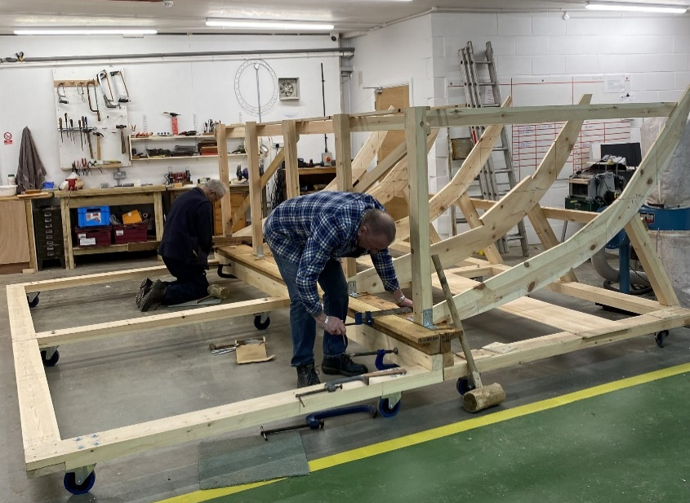
Moving back in time to the 7th Century we saw the recreation of an Anglo-Saxon king’s burial ship. The aim is to build it the way it was originally built using the same materials and method. It starts with a model, using more modern methods to get an idea of what the end product will be like and what problems might arise. Oak is the favoured wood, with the trees, that have to be the correct shape, cleaved manually the same way as before and then converted into suitable planks for the ship. There was a complete new vocabulary to go with the boat building: ribands, underloute, scarfs, butts, butt-strap, strake, clinker, rabbet. We saw how the oars were held which made going backwards difficult. We noted the fairly flat bottom of the ship so that it can navigate rivers. Plenty of learning. It was interesting to see how a growing tree becomes a boat.

Outside we looked at the slipway down to the river Deben and at a pre-constructed boat that is used on the river. We thought of how the ship/boat building industry goes back so far in time and how the vessels constructed depended on the environment in which they were used and the type of use.

Visitors are welcome at the Saxon ship Longshed. Look them up on their website: https://saxonship.org/

Woodbridge Tide Mill Museum

Our final activity was a visit to Woodbridge Tide Mill Museum, near to the Longshed. Looking at the map Woodbridge appears to be some way inland and so one might query a Tide Mill. However a closer view shows the River Deben which is tidal at least up to Woodbridge. A tide mill has been there for around 850 years. The current one was built, just about all wood in 1793. In 1850 various cogs in the machinery were replaced with cast iron. The tidal range is about 4 metres. This fills the mill pond through a one-way valve. The miller then waits for low tide to do the milling to ensure the largest head of water. He can control the flow of the water to turn the machinery. This is all well explained in the video on the web-site.

The visit started with a video showing the workings of the mill. We then did a tour round. This included seeing the sluice opened and watching the machinery turning although this time there was no grinding done. On querying the mill pond size we found out that originally it had been much larger, but that area is now a car park! To get the grain up to the top floor for the grain chutes we were shown the hoist, run by the water mechanism. We learnt that the flour can be ground into varying sizes by various adjustments. To test the flour the miller rubs it between thumb and fingers, hence the phrase ‘by rule of thumb’.
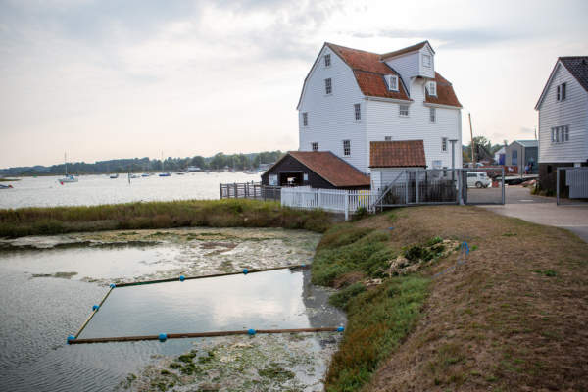
This Tide Mill is well worth a visit, see if you can do it on an actual milling day. Check the website: https://woodbridgetidemill.org.uk/

Thank you to Suffolk for an excellent and informative Industrial Archaeology day.

Essex will be running EERIAC next year. An initial thought was Stow Maries, but then I am slightly biased especially if I could fly in! Another thought is Chelmsford which has so much including our Chelmsford Industrial Trail and Marconi. It would be great if EIAG members were to help with ideas on what Essex can offer. As I am the EERIAC Essex rep, please contact me directly with your ideas on jgiffould@aol.com .

Jane Giffould

Industrial Heritage Fair 2022

This year’s IHF, the first since the very successful event held at Sandford Mill, Chelmsford, in 2019 and, therefore, a year late for obvious reasons, is being held in the Village Hall at Silver End. This is an eminently appropriate venue for an event organised by EIAG, Silver End being the company village constructed by the Crittall metal window business for its employees. This model village built in the 1920s consisted of high quality housing, many built in the International Modernist style, a range of community facilities such as the village hall, schools, shops and places of worship, as well as a factory.

At the event visitors will be able to learn about many of the heritage of Essex industries from the displays and stands representing leading industrial heritage sites. There will be two guided walks around the village in the morning (bookable on arrival at reception), and in the afternoon there will be three short talks (open to all), one on the history of Silver End, one on the architecture of the houses and other buildings of the village, and the third, by way of comparison and contrast, will look at the Bata shoe factory and company village at East Tilbury.

Admission to the Fair in the Village Hall is free, so do come along for what will be an informative and enjoyable event learning about the industrial history of Essex.
The Birth of British Radio Broadcasting in Essex - Correction

In Newsletter No. 44 at the end of the above article by Tim Wander, I wrongly credited the photos to Alan Hartley-Smith whereas in fact they are from Tim Wander’s Collection – sorry Tim! – Ed.

News in Brief

All Party Parliamentary Group on Industrial Heritage:

The APPG on Industrial Heritage held its first in-person meeting since before the COVID pandemic in May 2022 under new Chair, Stephanie Peacock, MP for Barnsley. The first part of the meeting was taken up by AGM business. This was followed by three presentations:

- Mile Oglethorpe (Head of Industrial Heritage at Historic Scotland) set the scene by talking about successes in preserving the industrial heritage, especially World Heritage Sites, but also losses of important industrial heritage assets and those still at risk. He emphasised the importance to the Climate Change agenda of re-using historic buildings as opposed to their demolition – the environmental benefits of preservation.
- Lianna Francis-Kelly (historic England) presented the Mills of the North Project case study, again emphasising the economic, environmental and social benefits of the adaptive re-use of former industrial buildings.
- Finally, Alistair Godfrey (Historic England) briefly described the restoration and adaptive re-use of the Shrewsbury Flaxmill Maltings.

A series of themed meetings are planned for 2022 around the subject of ‘the role of industrial heritage in regeneration and place-shaping’.

Tony Crosby

Lost Railways of Essex

On July 13th Essex CC Place Services held a mini-conference on the Lost Railways of Essex, the venue, very appropriately, being the East Anglia Railway Museum on the Colne Valley Line at Chappel and Wakes Colne.

Tim Murphy began by talking about the line that was lost before it was built! – the proposed Mistley, Thorpe and Walton Railway, the surviving major evidence of which is one bridge built in 1864 to carry the B1352 over the line. Tim then described the routes of the two branch lines to Maldon and their surviving structures, the most important of which is the timber trestle viaduct at Wickham Bishops which is a Scheduled Monument owned by Essex CC, but currently at risk.

Tony Crosby then described the history and surviving structures of the Bishop’s Stortford, Dunmow and Braintree Branch, the track bed of which is now the Flitch Way; the Saffron Walden Branch (on which is Painters Bridge mentioned above); and the Elsenham & Thaxted Light Railway. The engine shed, water tower and station building at Thaxted all survive, the engine shed being the only surviving engine shed in Essex.

