Essex Industrial Archaeology Group
(Incorporating The Essex Mills Group)

NEWSLETTER

Number 52 April 2024

Welcome to this edition of the Essex Industrial Archaeology Group’s (EIAG) Newsletter

In this edition we have a paper by Committee member Peter Wynn on Colchester’s first gas works; news of a number of up-coming events including EERIAC 2024 in Norwich, this year’s Industrial Heritage Fair, the ESAH Symposium, and much more.

If you have any comments on the Newsletter generally or specific items in it, or wish to make a contribution to the next Newsletter, please contact us via our email address - essexiag@gmail.com.

Contributions for the Newsletter should be sent by the end of the month prior to publication (i.e. by end of March, June, September and December), please. Please submit text as a Word document and photos as separate files such as jpgs.

Programme of ESAH / EIAG events 2024

Saturday 11th May, 11:00am. Walking tour of Harwich, £10. Includes several historic sites: Christopher Jones’ house, the treadwheel crane, and the town gaol. Please note: this tour may not be suitable for those with mobility issues.

Monday 29th August, Time TBC. Guided tour of the Bata factory in East Tilbury. £5 The Bata Heritage Centre presents the history of the British Bata Shoe Co Ltd., and its fascinating industrial and architectural heritage.

Saturday 14th September, 10:00 – 4:00. Industrial Heritage Fair, Grange Barn, Coggeshall. See poster below, full details of the event will be in the Newsletter and on the ESAH/EIAG website as they are finalised. No need to book, attendance free!

Saturday 2nd November, 10am-4pm. Annual Archaeology & History Symposium, £10. Includes lunch and tea/coffee. At Roman Circus House, Colchester. There will be a post-medieval and industrial theme to this year’s programme. Speakers include: Andrew Phillips, Peter Jones, and Tim Murphy - Plus EIAG AGM at lunch time!

Please email/write to the Excursions Secretary to book (howard000brooks@gmail.com). Payment: Online as before. Let us know if you require account details. Please give event reference and number of bookings (e.g. HAR 2). Alternatively: send a cheque to Hon Sec's Colchester address.
PLEASE NOTE: If you pay online you must tell us otherwise we won't be expecting you.
Colchester’s First Gasworks
by Peter Wynn

Colchester’s first gasworks was established in 1817 by Harris and Firman at the rear of their chemist’s shop in the High Street which was initially used to light their own and neighbouring shops. It has been incorrectly recorded that it had been established as a coal gas plant. However unlike Chelmsford, whose gasworks were opened two years later, Harris and Firman’s gas was initially manufactured from oil, rather than coal. In those early days there was a battle between proponents of the two technologies and skirmishes at Bristol provide us with information on Harris and Firman’s business.

A public meeting was held at Bristol in February 1823 to discuss a proposed oil gas company that would compete with the existing coal gas one there. A letter from Mr George Firman, stated to be the proprietor of the Colchester establishment, was read: “We have had four years’ experience with the oil-gas, and certainly it possesses many very superior advantages over the coal-gas. The capital required is much smaller; the pipes are never injured by its use; the light is vastly superior; it never tarnishes metallic substances, and may be used in the most confined rooms, without smell or inconvenience. One ton of Greenland or cod-oil will produce about 21,000 feet [presumably cubic feet] of gas. The average consumption of our burners is about a foot and a half per hour; and, by judicious management, a company may make it a lucrative concern.” As the Colchester works opened in 1817 and the letter referred to four years’ experience, it would appear to have been written in about 1821.

However it was also reported at the Bristol meeting that in August 1822 the Colchester concern had started to mix coal gas with that produced from oil and that from November that year only coal gas was supplied. Mr Taylor who was one of those proposing to establish the Bristol oil gas company responded by saying that “at that town he and his colleague did not act as engineers, but that the parties interested had made use of a very rude and imperfect apparatus, which they continued patching and pasting up, and spending more money on than for which they could purchase a new one; in their success or failure he and his colleague were alike uninterested – the managers at this place [Colchester] had, he understood, recourse to mingling of the gases, which however, as they professed to manufacture from oil only, they were desirous of keeping out of sight.”

This was followed by a letter to the press from a correspondent who had subsequently been in touch with Messrs Firman. This quoted Firman as saying “We have the highest opinion of Messrs. Taylor & Martineau, but they are incorrect in stating that our reasons for changing our plan arose from the defective nature of our Apparatus, as this we could have remedied at less expense than altering our Works for Coal Gas.” The reason for the change was not stated, but may have been economic as the correspondent also noted Firman as saying “We flatter ourselves, from our experience and the difficulties we have had to contend with, that we know as much about the manufacture of Oil Gas as any man in the kingdom; and on many accounts we are still its advocates. But as a business of pounds, shillings, and pence, we must fall in with the results of the experiments you were so polite to send us, though not to the extent there exhibited. Our produce of Gas from a gallon of oil depended on several practical circumstances: I should say our average was 90 feet.”

By 1825 the gasworks had been moved from Colchester High Street to a new location just outside the Town Wall in what would become St Peter’s Street.

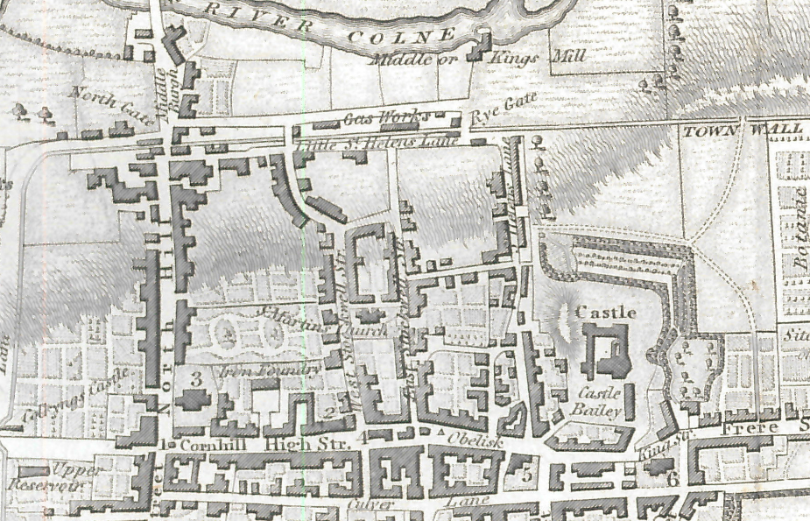
Location of Colchester Gasworks 1825
From Cromwell History and Description of the Town and Ancient Borough of Colchester
EERIAC 2024 – Programme & booking form
Norwich, Norfolk

Saturday, 8th June 2024

The Vernon Castle Room,
Norwich & Norfolk Millennium Library,
The Forum, Millennium Plain, Norwich, Norfolk NR2 1TF

Programme
09:30 Set up of displays by NIAS and others
10:00 Registration, tea and coffee
10:20 Welcome by Philip Tolley, NIAS Chairman. Notices/programme for the day
10:30 Talk 1: Norwich’s Industrial Past. Speaker: Dr Mary Fewster
11:15 Break: Tea, coffee and biscuits. View displays
11:45 Talk 2: Arthur Collins, Norwich City Engineer. Speaker: Matt Williams
12:30 EERIAC AGM
12:45 Clear away displays
13:00 Vacate room; Lunch
14:00 Re-assemble in front of City Hall for walk and visit
16:00 Close
Booking form for EERIAC 2024 – Saturday, 8th June 2024
Please book …………. places at £12.00 per person. Total £………
Name ……………………………………… email/phone…………………………………..
Address…………..…………………………………………………………………………….
I agree to my personal information being used only for the purposes of the organisation of this event and advising me of future events (please tick) □
Please indicate if you are a member of:
Cambridge IAS □ : Essex IAG □ : Suffolk IAS □ : Norfolk IAS □
Please advise when booking if display space is required: yes/no

Preferred payment method: Copy form and email to joneshines85@gmail.com. Pay by bank transfer to: Sort code: 30-96-17; Account No. 40789168
Title: East of England Region Industrial Archaeology Conference; Ref: EERIAC24 /Surname
Alternatively, detach and send this form with cheque to: EERIAC, Hines Farm, Earl Stonham, Stowmarket, Suffolk, IP14 5HQ

Getting there
Rail: The railway station is 0.7 miles from the Forum. Walk or catch a No 5B, 8, 14 or 33 bus to Castle Meadow. (look for the castle on your left!)
Park & Ride:
Thickthorn: Best for those arriving via the A11. Alight at Castle Meadow (Stand CA)
Harford: Best for those arriving via the A140. Alight at Castle Meadow (Stand CB)
Buses depart every 20 mins. Driver pays £3.00, each additional passenger pays £1.00
Car Parks:
Barn Road 0.5 mile, over 5hrs – £6.50
Westwick St. 0.5 mile, over 5 hrs - £6.50
St Andrews 0.3 mile, over 5 hrs - £10.00
Chantry Place 0.1 mile, 6 – 8 hrs - £17.50
The Forum Car parking is available and disabled access is very good but costs £2.20 per hour

A few of the lunch eating options – all within 250m of the Forum:

In the Forum: Bar Marzano Restaurants M&S
Pizza Express Jarrold’s
Cote Brasserie
Cafes Starbucks Bill’s
Caffe Nero Bella Italia
Costa Coffee
Subway Chantry Place Gourmet Burger
Greggs Wagamama
The Real Greek
Pubs The Bell – JD Wetherspoons ASK Italian
The Lamb

There are a number of eating places on the market in front of City Hall.

Note: Personal information is stored in password-protected form held only by the EERIAC treasurer, and is used purely for purposes connected with the organisation of the event and for informing attendees about future conferences.

Historic England Adds Interactive Map to its Historic Manufactured Gas Webpages

Historic England has added an interactive map to its Historic Gas Industry webpages. The new feature allows researchers to search for manufactured gas sites in England from the 19th and 20th centuries and to view summary details about each site. This new feature expands the resources already available for those wishing to research the local manufacture of gas, which already includes a detailed overview report on the history of the manufactured gas industry in England, a heritage assets guide, and advice on recording such sites. The new interactive map shows the location of hundreds of sites including listed gasworks buildings and gasholders, non-designated surviving gasworks buildings and gasholders, possible surviving structures related to the industry, sites with only below ground evidence, and sites only known from map evidence. The map also has links to the relevant Aerofilms Collection of aerial photographs where these show these gas industry sites, a database which is held by Historic England. To view the interactive map, follow this link:
https://historicengland.org.uk/research/current/discover-and-understand/industry-andinfrastructure/manufactured-gas-industry/

The Railway in Halstead

A date for your diaries is this walk on Wednesday 16 October 2024, at 11.00

The walk will follow the railway as it was in Halstead before 1963 and will look at its history and effect on the town - squabbles and all. It will be led by Malcolm Root, President of Halstead and District Local History Society.

It will probably start and end in the Butler Road car park opposite the Locomotive public house – full details will be in the next Newsletter.

EIAG attendance at other Societies’ events

Last year EIAG took the advantage of offers to exhibit at events organised by other Societies and organisations in Essex. By doing so we were able to raise the profile of the Group; hopefully recruit new members; and highlight the county’s industrial past. Our exhibit includes displays on industries and sites (these are being re-vamped ready for this year’s season of openings), leaflets and application forms for membership of ESAH and EIAG, and publications for sale. To exhibit in this way requires members to set up and staff our stand and so far this responsibility has fallen on Committee members (the number of whom diminished last year). If we are to continue to exhibit and support other societies’ events we need the help of EIAG members to staff the stand. So this is a plea from Committee to all members – firstly if you know of an up-coming event near you at which it would be appropriate for EIAG to have a stand please let us know by emailing essexiag@gmail.com. Most importantly please let us know if you would be willing to staff the EIAG stand, for at least a few hours, on the day of any event in order to ensure EIAG presence and some support for the Group and its Committee.

Ian P. Peaty – Brewer and Author

It was with much sadness that only recently it came to my notice that Ian P. Peaty died late last year. Ian was born in Hampshire and following service in the Black Watch, he worked in the brewing industry at Ind Coope in Romford. His many interests included steam railways and these two industries were the focus of much of his writing. In 1985 he brought them together in the publication of Brewery Railways which included chapters on Ind Coope at Romford and Mistley Maltings. In 1997 his book You Brew Good Ale: A History of Small-Scale Brewing was published, which featured the estate brewhouses of such Essex locations as Audley End House, Ingatestone Hall, Berden and Prittlewell Priories and Warley Hospital. However before that, in 1992, the Brewery History Society (on which Ian served a term as Chairman) published his extensive survey of Essex Breweries – The Malting & Hop Industries of the County – a most-go-to reference book for anyone with an interest in the history of brewing in Essex. I had the great pleasure of his company and advice when producing the Essex CC Comparative Survey of Essex Breweries in 2002 (which can be accessed on the EIAG Reports Page of the ESAH website). He also found time to serve as a Trustee of Great Dunmow Maltings!

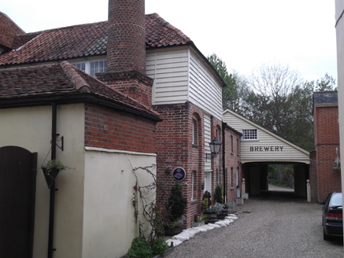
Ian settled in Coggeshall in the very sympathetically restored former Bridge House Brewery of William Gardner (photo above).

As the Industrial Heritage Fair this year is being held in Coggeshall, those of you who will be attending will be interested in his paper on the Get Beer. Drink Beer website on Beer In Essex: Four Coggeshall Pubs.
https://masonjust.blogspot.com/2015/08/beer-in-essex-four-coggeshall-pubs.html
Text & Photo – Tony Crosby

ERIH Young Professionals Network (ERIH YP)

Many societies, museums etc. are currently facing an aging volunteer brigade with few younger people joining them to ensure a future for their organisation. The Association for Industrial Archaeology (AIA), for instance, has recently successfully introduced a Young Members Board (YMB) - https://industrial-archaeology.org/young-members.

The European Route of Industrial Heritage (ERIH) last year established an ERIH Young Professionals Network (ERIH YP) and held their first information event in January 2024. The YP Network is about participating in discussions about sustainability, climate change, working conditions, employment accessibility and more within the realm of Industrial Heritage. Young peoples’ unique perspectives and innovative ideas are needed to shaping our shared future.
Whether you’re a student, volunteer, apprentice, trainee, PhD candidate or someone within the first five years of their career, everyone is welcome from the diverse disciplines important to industrial heritage – such as Architecture and Urban Planning, Cultural Studies and History, Historic Preservation, Industrial Archaeology, Culture and Tourism Management, Sustainability and Communication Studies and related fields. If you or any of your colleagues wants to be part of our network or wants to stay up to date on our activities, you can sign up here with your name and email: https://docs.google.com/forms/d/e/1FAIpQLSdbsOz5Rq8rktLOCdYHVC23l33JtAdJxt14XfNHqAV3UcdMBw/viewform?pli=1
How can you help?
To make the ERIH YP Network truly thrive, we now do need your help to spread the word. Imagine the impact we can make collectively! Here are a few easy ways you can contribute. Please:
- encourage your young team members to attend our upcoming events and become active participants.
- forward this information to industrial heritage colleagues working with or at universities, museums and sites with people new to the field of industrial heritage.

Together, let's build a legacy that future generations will be proud of. If you have any questions or ideas to enhance our network, please feel free to reach out: young-professionals@erih.net
Thank you for your support and for being a crucial part of our industrial heritage journey. More news coming soon!

Bassir, A. (2018) Historic Building Recording of gasholders at the former Colchester Gasworks Hythe Quay, Colchester Museum of London Archaeology.
Bristol Mercury 8 February 1823.
Bristol Mercury 10 February 1823.
Bristol Mirror 15 March 1823.
Cromwell, T. (1825) History and Description of the Town and Ancient Borough of Colchester Vol 2 pp.306-307.

