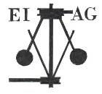
Essex Industrial Archaeology Group
(Incorporating The Essex Mills Group)

NEWSLETTER

Number 56 April 2025

Happy New Year and Welcome to this edition of the
Essex Industrial Archaeology Group’s (EIAG) Newsletter

In this edition we are pleased to reproduce, with the permission of the author, an article by Paula Readman, first published in Practical Family History Magazine in April 2005, of her childhood memories growing up in Moulsham Mill, Chelmsford. This is followed by an article on the find by Peter Marriage of a cast-iron boiler door manufactured by Crompton & Fawkes. There are details of two imminent events: the 2025 East of England Region Industrial Archaeology Conference which will be held in Cambridgeshire on 7th June; and the Festival of Essex Archaeology & Heritage which will be held on 24th July at Cressing Temple Barns. There is also the chance to visit the West Ham Pumping Station Engine House in Stratford E15. Finally, there is a report from the event to mark the 50th Anniversary of the publication of John Booker’s Essex and the Industrial Revolution; and one on the re-opening of Stansted windmill.

If you have any comments on the Newsletter generally or specific items in it, or wish to make a contribution to the next Newsletter, please contact us via our email address - essexiag@gmail.com.

Contributions for the Newsletter should be sent by the end of the month prior to publication (i.e. by end of March, June, September and December), please. Please submit text as a Word document and photos as separate files such as jpgs.

Programme of ESAH/EIAG events 2025

Date to be announced (sometime in the autumn, probably October!). EIAG Annual Meeting, extended to a half-day, afternoon meeting to include EIAG Business followed by Essex railway-themed talks to commemorate the 200th Anniversary of the opening of the Stockton – Darlington Railway

Looking forward to 2026 (!!!) we are still exploring whether to hold another, what would be our sixth, Industrial Heritage Fair. We are having difficulty finding a venue in the south of the county so may have to look for somewhere more central and accessible by public transport. We will keep you up-dated through your quarterly Newsletter

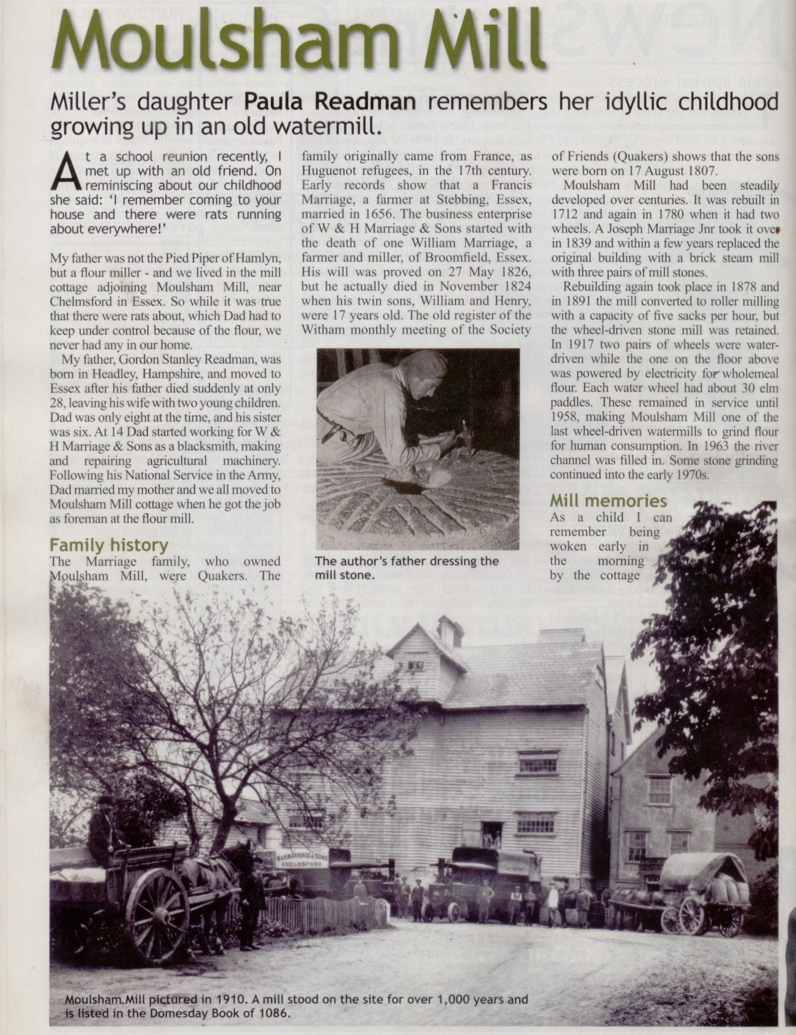
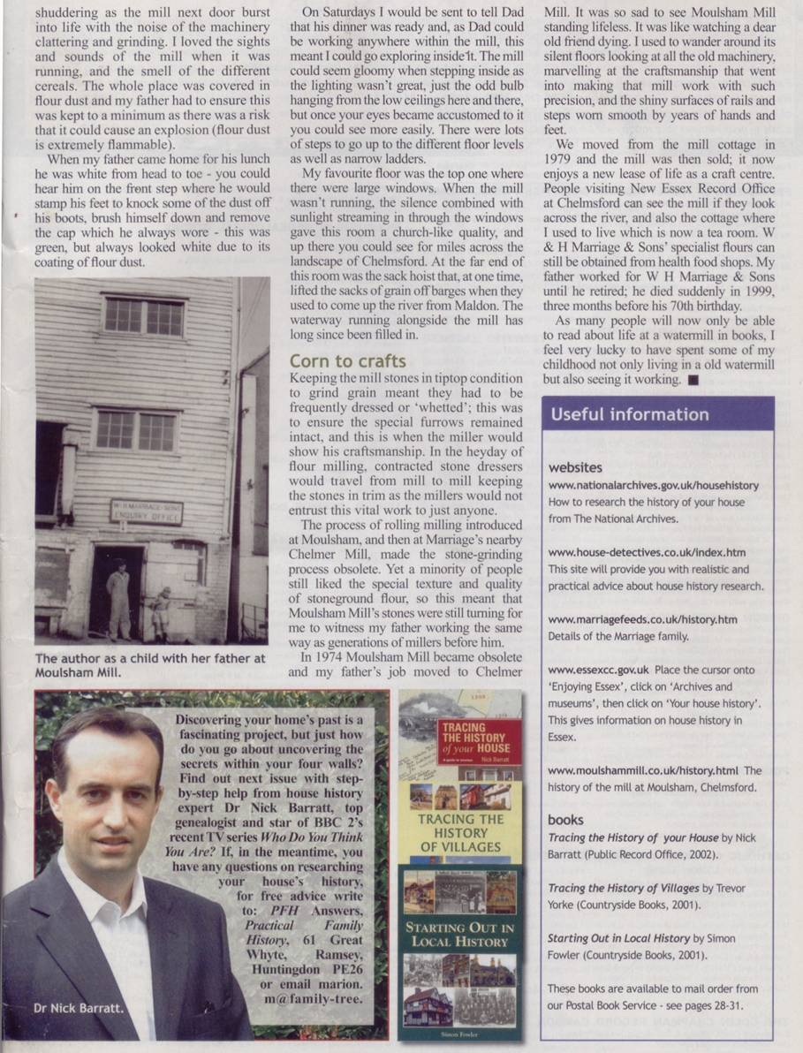

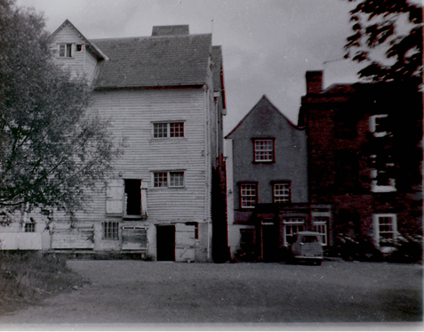

Left & below – two views of Moulsham Mill

Photos reproduced here with permission from Paula Readman
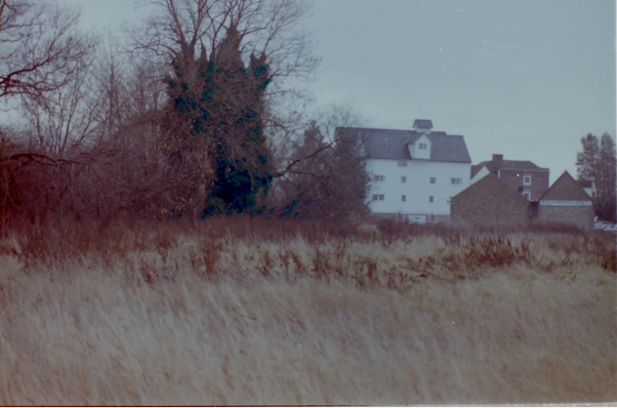

Below – Mr Whitehead dressing the millstone

Reproduced here with permission from Paula Readman

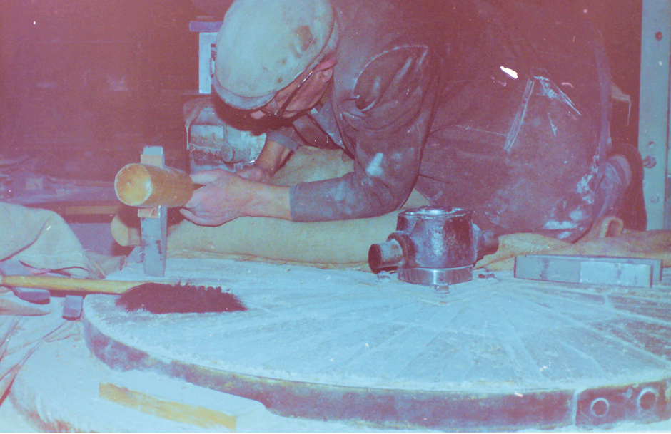

Crompton & Fawkes by Adrian Corder-Birch

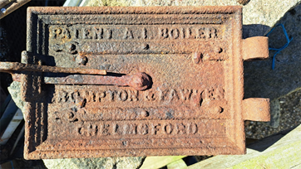
(Photo by kind permission of Peter Marriage)
The illustration above is of a rather corroded boiler door inscribed ‘CROMPTON & FAWKES, CHELMSFORD’. It was discovered by Peter Marriage, at Broomfield Mill, Mill Lane, Broomfield, who was keen to learn more about Crompton & Fawkes. He made an enquiry with Neil Wiffen who forwarded it to the Essex Industrial Archaeology Group. The door was found by Peter whilst building a new bungalow on the site of a greenhouse at Broomfield Mill. There were originally two adjoining green houses and a fern house. The fern house was mostly demolished during the Second World War to make way for a pill box, which was built in the remains of the structure. One greenhouse has been rebuilt, and the pill box is being retained as part of the bungalow. Three completely different greenhouse boilers were found but were all beyond use. Over four tonnes of cast iron were removed from the greenhouses and the door was found in the rubble that the boilers were buried under.
The boiler door is the only known iron casting remaining with the name ‘Crompton & Fawkes’. They were successors to T. H. P. Dennis & Co, who were ironmongers in Chelmsford during the mid-nineteenth century. In 1869 Thomas Hungate Preston Dennis (1831-1916) took Charles Portway (1828-1909), an ironmonger of Halstead, into partnership and they traded at Anchor Iron Works, Chelmsford as horticultural builders and manufacturers of valves, boilers and hot water apparatus, agricultural and general engineers. In 1876 Rookes Evelyn Bell Crompton (1845-1940) bought into the partnership. The following year Frank Attfield Fawkes (1849-1941), a relation of Charles Portway, also became a partner with responsibility for the horticultural side of the business. He was the author of several books including ‘Horticultural Buildings’ in 1881 and ‘Hot Water Heating on the Low-Pressure System’ 1882.
In 1878 Rookes Crompton founded R. E. Crompton & Company, electrical engineers at the Arc Electric Works, Anchor Street, which was next to the Anchor Iron Works of T.H.P. Dennis & Co of which Rookes Crompton was still a partner. The two buildings were interconnected, the two businesses shared a London Office and worked closely together. T.H.P. Dennis & Co supplied the metal work needed by R. E. Crompton & Co for lamps and other goods and the horticultural buildings supplied by T.H.P. Dennis & Co could have electric lighting installed by R. E. Crompton & Co.
From December 1884 the manufacturing iron works side of the business formerly T. H. P. Dennis & Co was known as Crompton & Fawkes of which Rookes Crompton continued as senior partner and responsible for the engineering side. In 1907 the partnership of Crompton & Fawkes was incorporated as Crompton and F. A. Fawkes Limited, but the company declined under new management, went into voluntary liquidation and had closed by 1912. In 1927 Crompton & Co. Limited merged with F. & A. Parkinson to form Crompton Parkinson Limited. Interestingly, Charles Portway and Son Limited and its associate company, The Tortoise Foundry Company Limited of Halstead manufactured a large variety of castings for the Crompton companies for several decades.
From the above brief outline the boiler door was probably manufactured during or between 1884 and 1907, which Peter Marriage confirms fits in with his knowledge of the site and its buildings.
In the book, ‘SLOW BUT SURE – a history of the Portway family and the Tortoise Foundry at Halstead’ a whole chapter is devoted to Crompton and Fawkes including photographs of each of them.
Copies of the book are available from: Adrian Corder-Birch, Rustlings, Howe Drive, Hedingham Road, Halstead CO9 2QL for £14.95 each plus £3.50 postage and packing.

50th Anniversary of John Booker’s book
Essex and the Industrial Revolution
Saturday 26th April saw over 60 people gather at the Essex Record Office to celebrate the 50th anniversary of the publication of John Booker’s Essex and the Industrial Revolution. The ERO staff managed to track down John who now lives in Exeter and persuade him to come back to Essex to address the event and so it begin with John describing the fascinating story of the genesis of his book. His interest in IA had begun when helping his father, Frank Booker, undertake field trips while researching for his book Industrial Archaeology of the Tamar Valley which was published in 1967 by David & Charles as one of their series of regional IA publications. (David St John Thomas was a friend of Frank’s). In 1969 John arrived in Essex to work as a Senior Assistant Archivist and proposed the use of the 5” x 4” stiff card pro-forma to survey and record IA sites in Essex – the Industrial Monuments Survey project. John enlisted the help of volunteers from local societies and the project was completed in 1971, but the question then was what to do with the information on the cards, and so his book was published in 1974. Although it did generate some negative reviews at the time, it remains an essential foundation and first go-to-book for many of us still researching Essex’s industrial past.
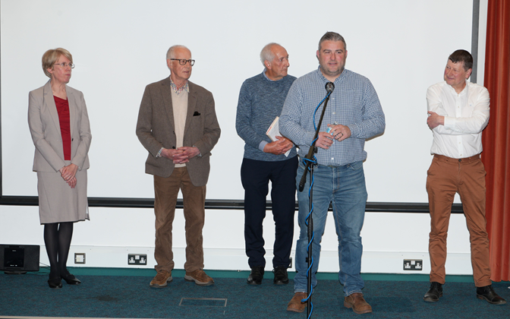
(Photo by kind permission of ERO)
L – R: Dr Catherine Pearson, John Booker, Tony Crosby, Tim Murphy & Shane Gould
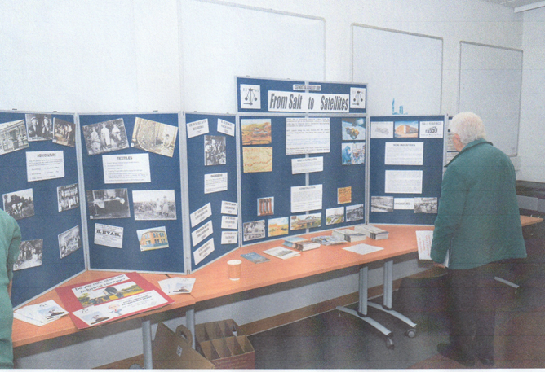
There then followed three more talks outlining some of the major periods of the continuing interest in former Essex industry. Firstly Dr Catherine Pearson from Anglia Ruskin University presented some of the material, photographs, documents and film, preserved in the Frederick Roberts Archive, mainly regarding Marconi and Hoffmann. Fred, along with Stanley Wood, was heavily involved with the short-lived Chelmsford Industrial Museum Society during the 1980s. Shane Gould, now Historic England’s lead on Industrial Heritage Strategy, then described the ECC Thematic Surveys of Industrial & Modern Monuments which begin in the mid-1990s. The resultant survey reports are available in the ERO and also many are on the EIAG website at https://www.esah1852.org.uk/eiag/reports. Finally Tim Murphy from ECC Place Services described some of the work being undertaken by ECC to preserve their wind and water mills, the timber trestle viaduct at Wickham Bishops, and Beaumont Quay.
Left: EIAG display at the John Booker event
(Photo by kind permission of ERO)

Report text by Tony Crosby


Festival of Essex Archaeology & Heritage 2025


ECC Place Services and Explore Essex are currently planning the Festival of Essex Archaeology & Heritage to be held at Cressing Temple Barns on Thursday 24th July 2025.
Organisations which have undertaken work in Essex, or are key stakeholders in the county’s historic environment and may have an interest in engaging with the wider public at an event such as this, have been contacted to express an interest in having a display, run activities and/or give talks on their area of interest. Both ESAH and EIAG are having displays at the Festival and an EIAG member will be giving a talk on Essex’s Industrial Archaeology & History.
This is the first year of the festival and the hope is that there will be many more to come. This will be a free day open to the public at the fantastic site at Cressing Temple Barns. It is aimed at anyone with an interest in the county’s historic environment. The event is purposely held in the school holidays, and to coincide with the Council for British Archaeology’s Festival of Archaeology, to ensure it is advertised and accessible to a wide demographic. Attendees may have a professional interest, or be visiting as a family day out. The hope to fill two barns with stands from a variety of exhibitors and there will be talks, tours and activities held throughout the day.
More details will be circulated to you as they are confirmed and will be advertised in Explore Essex
East of England Region Industrial Archaeology Conference

EERIAC 2025 – Programme & Booking Form

Cambridgeshire

Saturday 7th June 2025

Prickwillow Engine House Museum, Main Street, Prickwillow, Ely, CB7 4UN

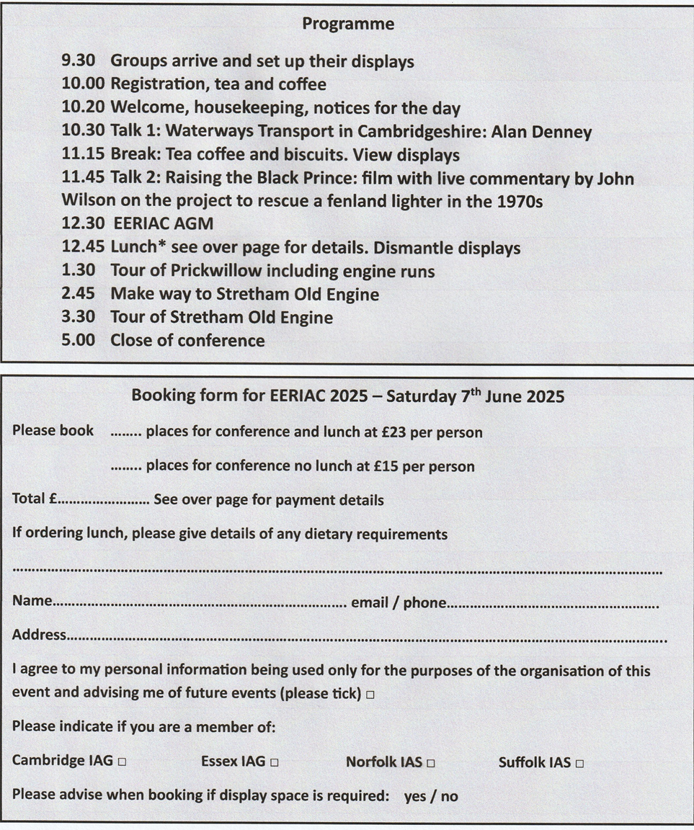
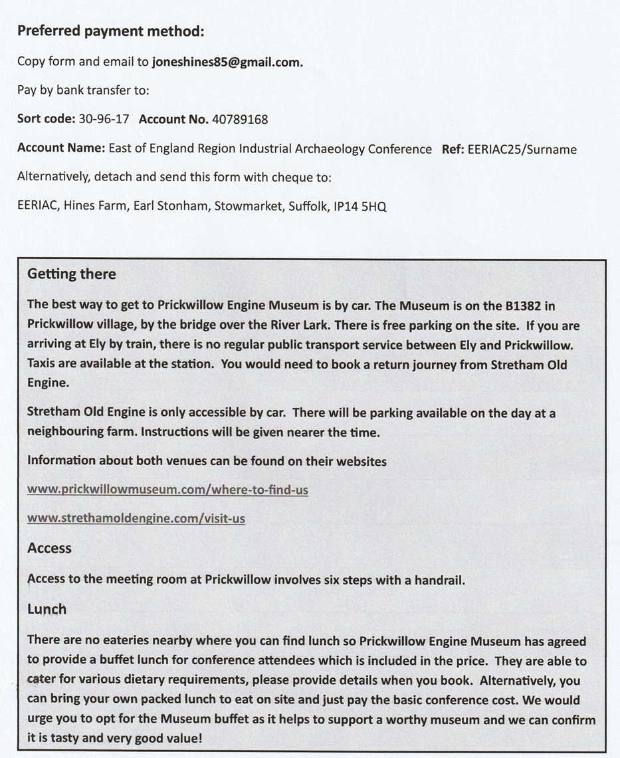

An exclusive opportunity to visit
West Ham Pumping Station Engine House, Abbey Road, Stratford, E15 2QT

An opportunity has arisen to have a small group visit to the West Ham Pumping Station Engine House later this year on a date to be arranged.

The famous and iconic Abbey Mills Pumping Station is preserved in Stratford, East London. Closely adjacent and much less well known is the former West Ham Pumping Station. This was completed in 1897 and equipped with Lilleshall Company (Engineers) beam engines to pump waste water from West Ham to the Northern Outfall sewers, part of Sir Joseph Bazelgette’s new London sewer system. The station was closed in 1972 and was Listed Grade II in 1984. The engine House contains two beam engines built by Lilleshall Co. in 1895 and installed in 1900. One reason for listed status was these fine examples of late 19th century steam technology.

The site was unoccupied until 2002 when the engineering training facility (Alpha BSE Training) took over the site to use as a training centre for local people as plumbers, electricians and gas engineers. Now the Lea Valley Heritage Alliance are planning to open the site to the public combining historic east London engineering with the training of engineers for the 21st Century.

If you would be in interested in visiting this site please email me at essexiag@gmail.com to express an interest and indicate what day(s) of the week would be best for you.

The Engine House is on Abbey Road Stratford and the nearest railway station is Abbey Road Station on the DLR which is just a few minutes’ walk from the Engine House. West Ham Station on the DLR and Underground Jubilee, District and Hammersmith & City lines is about 10 minutes’ walk from the Engine House.

See Historic England’s website for further information and photos of the engines:
https://historicengland.org.uk/listing/the-list/list-entry/1357997?section=comments-and-photos

Stansted Mountfitchet Windmill
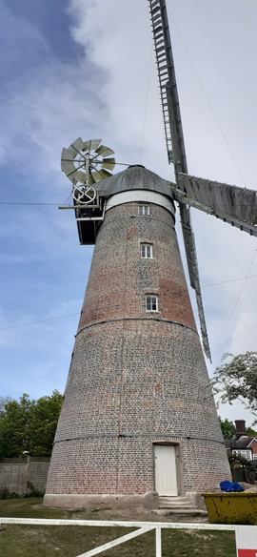
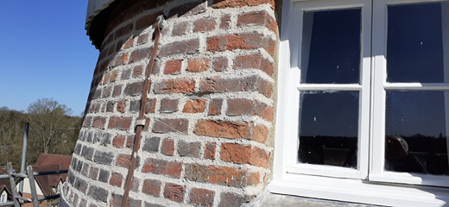

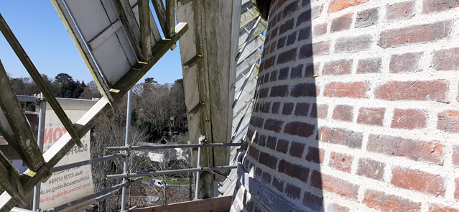

In Newsletter issue 54, October 2024, I reported on the restoration work being undertaken on the tower windmill in Stansted Mountfitchet. I said then that we hoped the work would be completed before Christmas – unfortunately weather and other issues intervened and it was only completed in early April! However this made sure we could re-open in time for Easter open days and the mill will now be open as usual for the summer season. Photos above show the mill in full view, with a couple of close-ups of the re-pointing.

Text & photos – Tony Crosby

