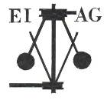
Essex Industrial Archaeology Group
(Incorporating The Essex Mills Group)

NEWSLETTER

Number 58 October 2025

Welcome to this edition of the Essex Industrial Archaeology Group’s (EIAG) Newsletter

In this edition we have reports on the EIAG Annual Meeting earlier this month; good and bad news about bridges; news from the Mills Archive; and a look forward to events for 2026.

If you have any comments on the Newsletter generally or specific items in it, or wish to make a contribution to the next Newsletter, please contact us via our email address - essexiag@gmail.com.

Contributions for the Newsletter should be sent by the end of the month prior to publication (i.e. by end of March, June, September and December), please. Please submit text as a Word document and photos as separate files such as jpegs.

Programme of ESAH / EIAG events 2026

The ESAH programme of visits and other events is still in the planning stage. Details of those visits with an industrial theme will also be announced in this newsletter.

It is unlikely that EIAG will be holding a further biennial Industrial Heritage Fair in 2026. We are having great difficulty finding a venue which meets all the criteria of industrial location, accessibility, facilities, etc. Also as Committee numbers are low at present we do not feel that we have capacity to undertake all the organisation involved - we do need new Committee members!

Possible alternative events could include a full day focused on Essex’s Mills – see article below.

Next year there will be a number of events with which EIAG could be involved and which would see us working jointly with other organisations in the County, but which are at the planning stage at the moment:

* Silver End Village Centenary celebrations
* Second ECC Festival of Archaeology & Heritage,
* ECC & ERO Archaeology Conference – Saturday 3rd October 2026 at the Essex Record Office


Essex Industrial Archaeology Group (EIAG) Annual Meeting

Following a brief session of EIAG business which included a look back over activity in 2025, a look forward to proposed events for 2026, the re-election of the six-person Committee and a plea for new members, we then were entertained by a short programme of talks on the theme of the impact of the development of railways in Essex. This was stimulated by this year being the 200th anniversary of the opening of the Stockton & Darlington Railway (S&DR).

The first speaker was EIAG member Peter Jones who spoke on:

Early Essex Railways

Peter started with a brief look at the development of horse- drawn waggonways, plateways and tramways for transporting coal from the mines to the coast in Northeast England before the opening of the S&DR. Examples he mentioned included the Lake Lock Tramroad near Wakefield opened in 1798 which transported coal from the mines to Aire & Calder Navigation, and the Oystermouth & Mumbles Railway of 1804 which carried passengers from 1807. He then traced the develoment of steam locomotives from Richard Trevithick’s Pen-y-darren loco of 1804 upto Locomotion No.1.

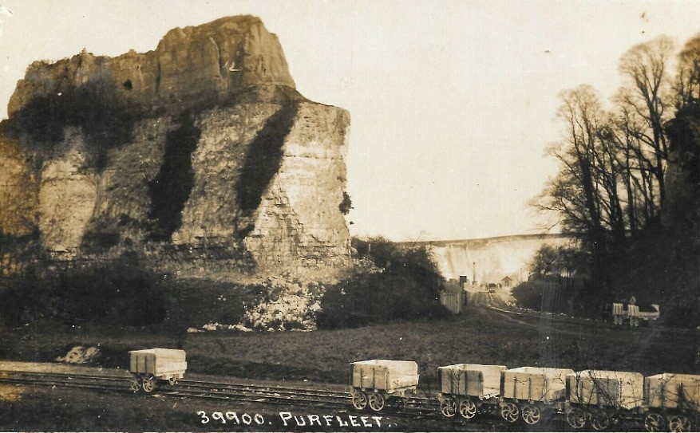
Moving on to Essex the first tramway was the Purfleet Quarry Tramway of 1805 and over the next two decades or so there were a number of proposals for railways in the County including a line from Islington to Wallasea Island and a line from London to Ipswich. However it was not until 1834 that the first main line railway, the Great Eastern Counties Railway, was launched, a line from London to Norwich and Great Yarmouth with a branch to Harwich. The Eastern Counties Railway Act was passed in 1836 and work on its construction began the next year, John Braithwaite being the engineer. There were problems with objections from local landowners such a Lord Petre of Ingatestone, but the first part of the line between Mile End and Romford opened in 1839 and the line was completed in stages by 1845.

The second talk was given by Martin Rose, entitled

The Railway Through Audley End

The route for a railway from London to Cambridge and Norwich and hence to the north had to cross the chalk escarpment which crossed diagonally north Essex. Such a route would need to find its way through one of the gaps in the chalk, one such being that created by the Stort and Cam (Granta) valleys between Newport and Great Chesterford. This meant that the line would have to run through Audley End and cross the land owned by Richard Griffin, the third Lord Braybrooke. Capability Brown had created a landscaped parkland in the mid 1700s which gave extensive views to the west from Audley End house. The first proposed route for the railway ran across the lawns of the estate interupting this view and (as the previous speaker had mentioned in relation to Lord Petre), Lord Braybrooke opposed the railway. The Saffron Walden businessmen wanted a railway connection however and other routes were proposed both to the east and further west from the house and estate. Lord Braybrooke realised that the railway would eventually come and needed to consider how he could minimise the impact on his estate and also make him some money. A route was finally agreed which ran through the western edge of the estate but through two tunnels and a deep cutting between Wendens Ambo and Littlebury, so that it could not be seen as part of the views from the house and estate.

Again the line was built in stages and had reached Newport by 1843, but to 5-foot gauge built by the Northern & Eastern Railway. In that year the N&ER merged with the Eastern Counties Railway, Robert Stephenson took over as engineer, changed the gauge to standard gauge (4’ 8.5”) and the line was opened in June 1845, over a year ahead of the original due date. Initially there were not enough engines to run the timetable, so more had to be ordered from Robert Stephenson & Co!

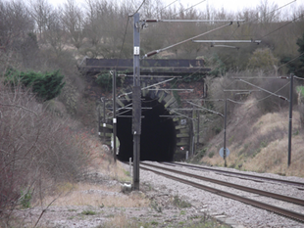
Lord Braybrooke achieved his objectives of minimal intrusion, compensation, but also the family logo on the tunnel portals and a grand station at Audley End (previously Wendens Ambo) with Porte Cochere.

Left: North portal of Littlebury Tunnel

(Photo: Tony Crosby)

Saffron Walden was eventually connected directly to the mainline with the opening of the former Saffron Wladen Branch in 1865 after the third Lord Barybrooke’s death.

(All full account of this episode in the development of the Cambridge line can be found in Martin’s book of the same title available from the Saffron Walden Tourist Information Office.)

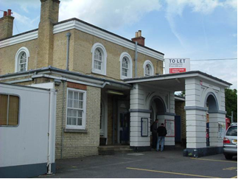
Left: Audley End Station entrance with Porte-Cochere

(Photo: Tony Crosby)

The third talk was given by Peter Wynn, entitled

The Railway Builders of Essex

Peter began by outlining the distinction between professional Engineers who surveyed, designed and supervised the construction of railways, and Contractors who carried out the construction. The engineer would appoint a Resident Engineer who would have day-to-day supervisory responsibility. Contractors would often have Sub-Contractors. This clear distinction was often blurred, including when the construction of rolling stock was also involved – as was highlighted by Martin in the previous talk.

The principle railway builders who Peter spoke of were:

Charles Vignoles who was one of two joint engineers for the Eastern Counties Railway (ECR)

John Braithwaite who was the other joint engineer with Vignoles on the ECR

Peter Bruff who was for a short period assistant to Braithwaite on the ECR. Also he worked with Joseph Locke on the Eastern Union Railway (EUR) and eventually took over from him as engineer. He became General Manager of the EUR and he was also engineer for the Colchester, Stour Valley, Sudbury & Halstead Railway. In 1854 the ECR took over the working of the EUR with Bruff responsible as engineer for the whole system. Bruff also worked in the public water supply industry, was involved with property development at Essex coastal resorts, and other railways such as the Tendering Hundred line.

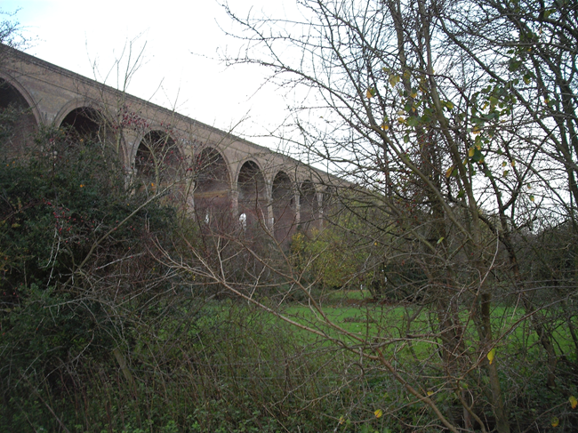
Left: Chappel viaduct on the Marks Tey to Sudbury Railway, built by Peter Bruff

(Photo: Peter Wynn)

Thomas Brassey who was main contractor for the EUR and worked in partnership with Samuel Morton Peto in constructing the London, Tilbury & Southend Railway. He, like Bruff, also worked in the public water supply industry in Essex.

Finally Alan White spoke to about

The Impact of the Railway on the Development of Southend

The London, Tilbury & Southend Railway (LT&SR) was opened to Southend, then just a small village, in 1855. A major part of its initial purpose was to give Londoners easy access to the Rosherville Gardens, the pleasure gardens in Gravesend on the Kent side of the Thames estuary. Passengers would alight at Tilbury to catch the ferry across to Gravesend. It would also then be possible for people to access the Kent coast from Southend using the crossing from Southend Pier which had been built in 1830. Brassey and Peto were the contractors constructing the line and both ran the line for a number of years.

Again the issue of landowners’ objections to the easiest route into the town from the west arose. The major landowner, Daniel Scratton, owned the seafront land on which it was planned to run the line and build the station near the pier. Also many of the town’s most affluent and influential citizens lived on Royal Terrace perched on the cliff overlooking the cliffside pleasure gardens and the station. Brassey and Peto had to eventually conceed to these objections and the route was diverted inland at Chalkwell to terminate about half a mile from the pier to the west of the High Street at what is Central Station, on land owned by Scratton!

Brassey and Peto also planned to develop a residential area of over 300 houses to be called Cliff Town, again on Scratton’s land,which it was hoped to stimulate further housing development. However, a only a few were built. The numbers of ‘excursionists’ from London did eventually increase such that affordable terrraced housing was built for the people needed to service these visiitors.

In the 1880s the LT&SR built its ‘short cut’ line into London from Pitsea via Barking and the Great Eastern Railway built the branch from Shenfield to Southend Victoria. Bote these lines stimulated the commuter traffic into the City of London. The coming of the railway to Southend facilitated a two-way flow of passenger traffic: initially excursionists coming from London annd then later commuters going to London.

(More detail of this subject can be found in Alan’s article in Essex Journal, Vol. 60, No.1, Spring 2025, Daniel Scratton and the Making of Southend, pages 16-21.)

Bridges

Peter Jones has been following the progress, or otherwise, with the repair and restoration of a number of historic bridges. Here is a summary of the newspaper clippings that he has kindly provided:

Boxted Bridge was built in 1897 and is located on Wick Road/Lower Farm Road near the junction of Sky Hall Hill in Boxted on the Essex/Suffolk border where it crosses the River Stour. An inspection in 2018 by the County Council identified that the bridge was displaying signs of distress including corrosion, delamination, deformation and cracking. The bridge was considered to be nearing the end of its natural lifespan. ECC’s preferred option is to replace the existing structure on a slightly widened footprint to allow for the safe movement of large vehicles such as emergency vehicles. The bridge was closed to traffic and pedestrians in 2023.
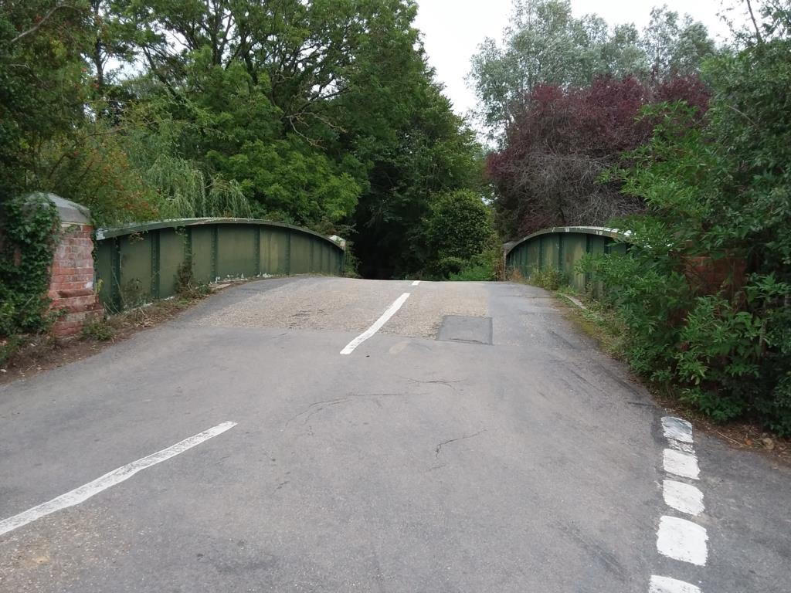
Local residents, and others including the local Canoe Club, are campaigning against the planned demolition and replacement of this historic structure. Their view is that the money spent by the Council on Inspections and Assessments could have been better spent on the repairs necessary to bring the current bridge back into use. A further test was undertaken in September, the outcome of which is awaited.

North Bridge, Colchester is Grade II Listed, was built in 1843 and widened in 1903 to accommodate tram traffic. Plans to renovate the cracking and peeling paintwork were submitted to the Council in January, approved in March and work began in July. The work involved stripping the existing failing paint, priming the metal and repainting. Colchester Civic Society have expressed their pleasure at the quality of the work.

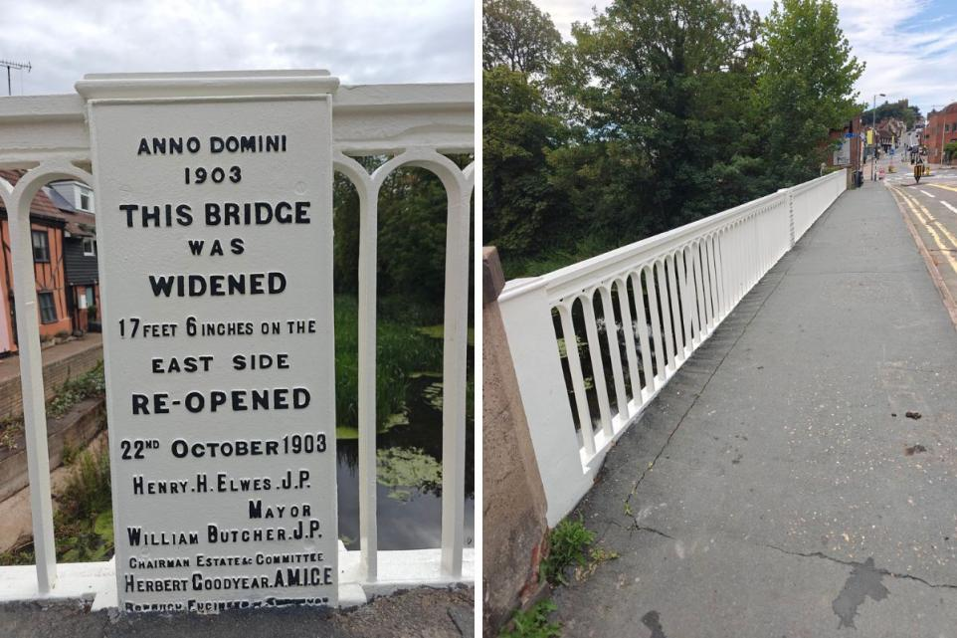

Middle Mill Bridge, Colchester had been inaccessible since 2023 when the weir it sits over collapsed resulting in one access route to the Castle Park being unuseable. Work to repair the bridge began in May and are now close to completion and the re-opening of this route to the park. The 900 year old weir is still to be repaired and discussions are continuing over the best way to fund and execute the necessry works.

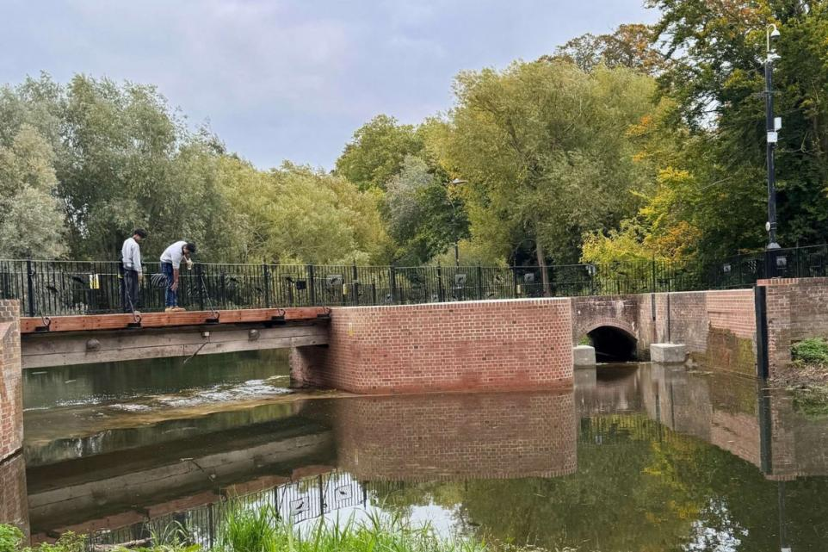

The Essex Mills Group

The Essex Mills Group (EMG) was inaugurated in 1985 for mill enthusiasts to preserve wind, water, tide and steam mills in Essex and to defend their future. The group arranged visits to mills, collected historical and technical information, together with illustrations of mills, and published regular newsletters. The Mills Group was active for about thirty years during which time much valuable work was carried out. This included nearly 70 newsletters containing significant information about the history of all types of mills in Essex. However, to ensure its continued work, in 2019 The Essex Mills Group was incorporated into The Essex Industrial Archaeology Group (EIAG), (a sub-group of The Essex Society for Archaeology and History (ESAH)) which has similar aims and will, therefore, ensure the Mills Group's work will be continued, especially the promotion of Essex's mills for the public to enjoy and learn about. On incorporation a small amount of residual money in the Mills Group’s accounts was transferred to ESAH and remains as a ring-fenced budget which is delegated to EIAG.

Since incorporating the Mills Group EIAG has made only limited progress with continuing to promote the aims of the former EMG. Through the quarterly EIAG Newsletter, news about mills, such as openings, activities, repair and restoration work, is published when this is brought to our attention. EIAG has made a donation to the Mills Archive (see item below) for their project to digitise their archive, and particularly the Rex Wailes Collection: Rex (1901 – 1986) was from Essex and worked on windmills including Essex examples. Most recently in 2022 EIAG published a booklet – Discovering Essex Wind and Water Mills – with the aim of promoting those mills which are open to the public and encouraging them to visit, especially following the long period of closure due to the pandemic.

EIAG Committee is now seeking how best to further the aims of the former EMG by writing to all those who were involved and benefitted from their membership of EMG and perhaps holding a consultation event in 2026 to find out what EIAG should be offering to the people involved with Essex mills. This may include:

- Opportunities for networking, sharing advice and information on good practice and latest news
- Promoting the mills to the public
- Meetings, talks and mutual visits
- Financial support and funding sources
- Networking with other Mills Groups, e.g. Midlands Wind & Water Mills Group
- Archiving historic documents and photos relating to Essex mills
- Other suggestions?

Funding Awarded for Millwrighting Collections

From the Mills Archive Newsletter?

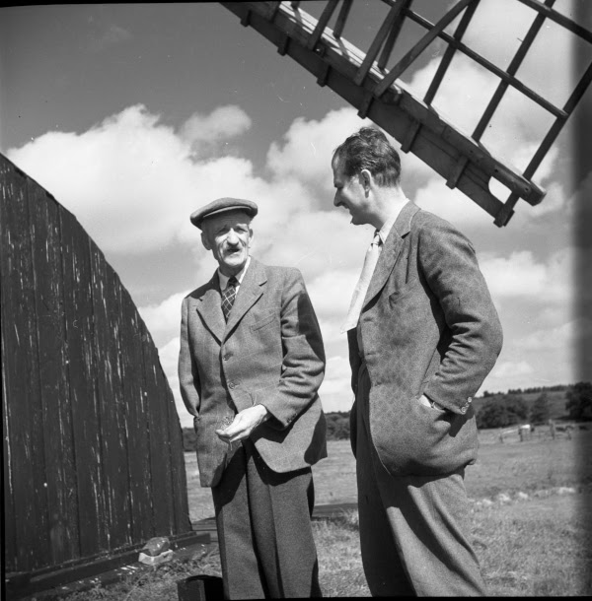

Rex Wailes with millwright Alfred James Thrower (1881-1962) at Herringfleet smock mill, Suffolk, September 1945, © The Mills Archive

The Mills Archive has received funding from the National Archives Archives Revealed programme to catalogue important millwrighting records, including those collected by Rex Wailes across the UK and beyond in the mid-20th century. The Mills Archive is a permanent repository for the documentary and photographic records of traditional and contemporary mills and milling, and mill-like structures that use traditional power sources. It is housed in an historic William and Mary building, Watlington House, in Reading.
Visit the Mills Archive website

Braintree Museum Exhibition
Art Deco and Beyond

Innovations & Design in Braintree 1925 – 1935

January – June 2026



