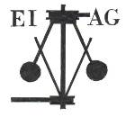
Essex Industrial Archaeology Group
(Incorporating The Essex Mills Group)

NEWSLETTER

Number 59 January 2026

Happy New Year and Welcome to this edition of the
Essex Industrial Archaeology Group’s (EIAG) Newsletter

In this edition we are, firstly, pleased to publish an article by Wendy Hibbitt of The Writtle Archives on Writtle’s Water Supply. This was first published in the Writtle Parish Newsletter and is re-printed here with their and Wendy’s kind permission. The second article is from Adrian Corder-Birch on the subject of the Maplestead Woodworks Ltd. Otherwise we are looking forward to a fascinating programme of events being planned by us and others for 2026.

If you have any comments on the Newsletter generally or specific items in it, or wish to make a contribution to the next Newsletter, please contact us via our email address - essexiag@gmail.com.

Contributions for the Newsletter should be sent by the end of the month prior to publication (i.e. by end of March, June, September and December), please. Please submit text as a Word document and photos as separate files such as jpgs.

Programme of ESAH / EIAG events 2026

The ESAH programme of visits and other events is still in the planning stage. Details of those visits with an industrial theme will also be announced in this newsletter. So far arranged is:

Wednesday 6th May – A walking tour of Mistley

Full details will be circulated when available, but hopefully it will include the many maltings in Mistley, the associated workers’ housing, quayside and railway station.

EIAG will not be holding a further biennial Industrial Heritage Fair in 2026. We have had great difficulty finding a venue which meets all the criteria of industrial location, accessibility, facilities, etc. Also, as Committee numbers are low at present we do not feel that we have capacity to undertake the entire organisation involved - we do need new Committee members!

See below for the possible alternative events which are being explored and planned. See p7 for a possible replacement for the Industrial Heritage Fair with the Company Housing in Essex.

Writtle’s Water Supply

By Wendy Hibbitt

Up to the early 1900’s Writtle village lacked amenities such as gas, electricity and water that we now take for granted. Imagine having to go to the local well to get a bucketful of not very clean water every time you were thirsty. There was no piped water or sewerage, and this was a serious health hazard.

In 1892 Dr. J C THRESH, Medical Officer of Health, gave a damning report on the wells and pumps in the village which supplied water. Of the 55 wells in the parish nine were pronounced good, four useable and six doubtful, while the remaining 36 were contaminated by sewage and were considered unsafe and totally unfit for household use. Luckily the public well in Pump Lane, the brewery tap in Bridge Street and Mr WOODHOUSE’s deep well at Longmeads, Oxney Green, were tested as good.

Dr THRESH wrote ‘There can be no question that a public supply of pure water is urgently required for the village and no time should be lost procuring such a supply together with a proper drainage system if Writtle is to maintain its character for healthiness. We have had our warning in the recent prevalence of ‘diphtheritic complaints’ and the many evil smells about the place; it is well not to wait until an epidemic of typhoid or cholera teaches us a sharp lesson.’

In 1894 a request for a Writtle Drainage and Water-Supply was put forward. The scheme was to borrow £2,750, the repayment of this sum with interest would require about £130 per annum for 30 years. In the meantime, the use of a water cart was approved. By 1896/7 difficulty was also noted in getting the soil cart for clearing out the cesspools, and earth buckets were not collected. In 1899 there was no water in the pump at Oxney Green and the parish pump on the Green was in a bad condition.

In July 1900 a protest was made about the large number of houses being built in the 1890s in Ongar Road without proper drainage causing danger to public health particularly in the summer months. For example in 1904, due to low levels of water in Oxney Green's public well, pure water was provided at a cost of 1/- per quarter.

The villagers' health had declined due to centuries of poverty, malnutrition, and unsanitary living conditions that led to disease. Many babies and infants died and often mothers did not survive childbirth especially when large families were involved. Typical village cottages were small and overcrowded with no drainage or water. Slops were disposed of in a deep hole or ‘bumby’, conveniently nearby, which was only emptied occasionally. Pail closets were common, and a public scavenger was appointed to empty them periodically. Infant deaths were particularly high in the winter months caused by respiratory diseases such as bronchitis, pneumonia and influenza often due to the cold and damp conditions, while in the summer, the dry dusty months when the water supply was low, there were deaths from fevers and gastro-intestinal diseases. With limited medical knowledge and no money to pay for the doctor or nurse the poor suffered the most.

According to the Essex Chronicle dated August 2, 1901, there were 26 new cases of diphtheria reported in Writtle since Dr Thresh’s last report, bringing the total number of cases to 30. There had been two deaths; Nora MILES, and a lad named EDWARDS both aged four.
However things were improving and by 1905 a water tower and filtering system were constructed at Oxney Green, along with sewers being connected. The water supply, however, was not considered safe for school children to drink until the following year.

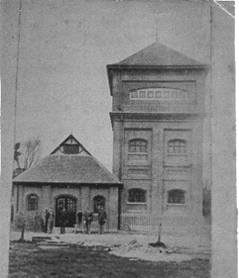
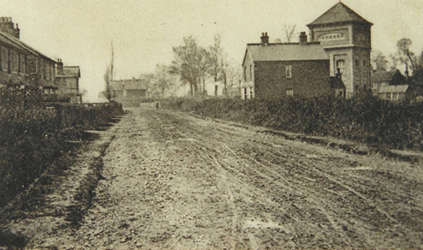
Above right - Water Tower 1905 Ongar Road Oxney Green

Above left - John REEVE, manager and engineer, and son outside the Water Tower in Oxney Green about 1920

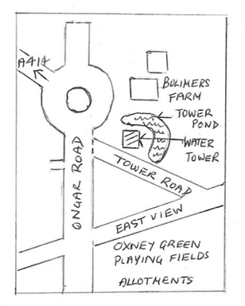
The parish minutes contained details of the Water Tower. It was constructed at the top of Oxney Green, known as Little Oxney Green, to stand 191 feet above the village's lowest point, and to provide a gravitational water supply to the new Arc Works (Cromptons Writtle Road), part of Writtle until 1902, the supply to be sufficient to serve any buildings between the village and the Arc Works. The nearby road was named Tower Road, and the pond behind the waterworks called Tower Pond is still there.

The water tower was replaced by a mains water supply in the 1930s and was demolished in the early 1960s.

Below - Arc Works of Crompton Parkinson c 1896

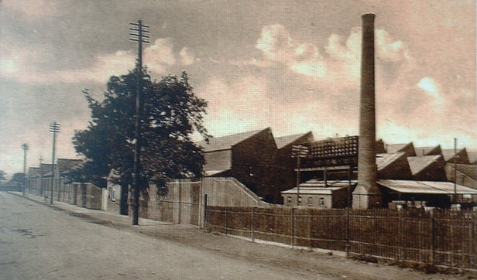

archivist@writtlearchives.org.uk
The Maplestead Hod and Maplestead Woodworks Limited

By Adrian Corder-Birch

The Essex Record Office recently received an enquiry about the ‘Maplestead Hod’, a container used when picking apples. The upper part was a curved open-ended thin wood cylinder (possibly willow?) with an attached lower cloth section, which was tied off and could be used to carefully deposit the picked fruit into a larger crate or container by untying the bottom of the material, so it acted as a soft funnel. There was a strap to go round the body/ shoulders of the user. It was believed that they were made by the Maplestead Woodworks in Little Maplestead during the post-war years. An archivist at the Record Office consulted me for more information about the Maplestead Hod and Maplestead Woodworks and I thought that readers of the EIAG Newsletter would be interested in the results of my research.

About 1926 a businessman who had been a Freeman of the City of London since 1901, Edward Lawrence Percy (1879-1942) of Deans Hall, Little Maplestead decided to open a small factory, known as Maplestead Woodworks, in one of his barns. His manager was a Mr. Anderson and the foreman for many years was Stanley Nichols. During the 1930s the railway goods van driver from Halstead Railway Station made a daily trip to collect products from Maplestead Woodworks, which in 1933 were described as fruit basket makers.

Edward Percy was born at Upper Holloway, Islington on 15th July 1879, a son of Thomas Callow Percy, a merchant, and Emma Percy. His main residence was 87 Linden Gardens, Kensington so presumably Deans Hall was a second home, but he was living at Deans Hall in 1939. He died at another home of his namely Coverdale, Sunninghill, in the Royal Borough of Windsor and Maidenhead on 11th April 1942 and was buried in St. Peter’s Churchyard, Frimley, Surrey. Edward Percy was the founder of E. & B. Percy Limited of Midland Match Works, Great Bridge, Staffordshire and by 1939 he was described as a retired match manufacturer and shipping merchant. Maplestead Woodworks started as a match factory, but this did not last long. It went over to making coloured spills and soft fruit baskets, apple picking buckets, fruit and apple boxes, all made from willow and poplar wood and proudly advertised as British made from British timber. The spills were dyed and multi-coloured including yellow, green, mauve and purple and used for lighting fires or cigarettes. They were 8 inches long with small bundles comprising about 130 spills and large bundles of about 225 spills. The wooden barrels for holding spills were also made and turned at the factory. About 30-40 local ladies and men from the surrounding villages worked here and they also had their own tree felling gang, which collected tree trunks from all over Essex and Suffolk. These included willows, which were not suitable for cricket bats, and poplars. The tree trunks were brought back to the works to be stripped of bark, sawn into thin strips and made into various products, which also included Christmas crackers, confectionery sticks and apple-picking buckets, which were called ‘Maplestead hods’.

The following advertisement appeared in The Essex Chronicle of 22nd November 1957 – “WILLOW TREES – We buy Willow Trees not good enough for bats, if not less than 44inch round. Good prices given. State quantity. Maplestead Woodworks Limited, Halstead.”

Maplestead Woodworks Limited continued until about 1963, when ownership changed to Samson Furniture, when good quality pine furniture was made at the factory. Samson furnishing manufacturers was still operating at Oak Road, Little Maplestead until 1975 or later.

Sources:

Information kindly supplied by Charles Soule of Great Maplestead and Peter Cook of Little Maplestead.
Kelly’s Directories of Essex, 1933& 1937
England and Wales Register 1939
People at Work in Halstead and District by Doreen Potts, 1993, pp. 90 & 100
Little Maplestead – A Millennium History, by Patricia Fletcher, 2000, pp. 119, 171, 204, 207

Events in 2026

Braintree Museum – Art Deco and Beyond

January – June 2026



Beaulieu Park Station
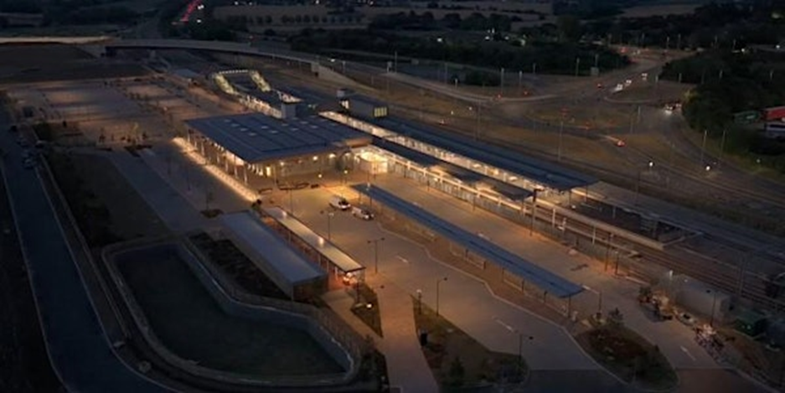
Tuesday 3rd March 2026, 10:40am – 12:00 noon
Venue: Essex Record Office

Overcoming the Challenges to build the first mainline Station on the Great Eastern Mainline in over 100 years
Speaker: Gary Macdonnell

The talk will provide a brief history of the Great Eastern Mainline and go through the financial and technical challenges of creating a new Mainline Railway Station. The talk will give some insight into how as its promotor Essex County Council engaged with various bodies to overcome the significant blockers to complete the project.

Gary Macdonnell is the Essex County Council lead on major Transport infrastructure programmes with a responsibility for working with funders from the public and private sector on major schemes. With over 20 years’ experience in delivering major infrastructure Gary has had a direct project management role on the new Beaulieu Park Station built on the Great Eastern and a unique perspective on this important new station.

Tickets: £6.50p Please book via ERO website at: https://www.essexrecordoffice.co.uk/whats-on/events

Silver End 100th Anniversary – Summer Fair
Saturday 20th June 2026

This year the Silver End Heritage Society and the Parish Council are commemorating the 100th Anniversary of the building of the first houses in the Silver End company village by Crittall’s for its workforce. There will be a number of events in the summer, the main one being the Summer Fair.


ECC Festival of Archaeology & Heritage

Such was the success of last year’s Festival of Archaeology & Heritage that the County Council Place Services are planning another on, provisionally:

Thursday 23rd July 2026 at Cressing Temple Barns

EIAG, along with the Essex Society for Archaeology and History (ESAH), will have a display stand as last year. We are also exploring with Place Services inviting some of the Industrial Heritage Fair exhibitors to have displays and grouping together these ‘industry-themed’ displays in one area.

Company Housing in Essex

As part of the Silver End 100th Anniversary commemorations, we are exploring with the Silver End Heritage Society using their Heritage Open Day on:

Sunday 13th September 2026 at Silver End Village Hall

To have an event which celebrates a number of industrial companies in Essex which built company housing for their workforces. Various history / heritage societies will be invited to have displays at this event and we are also exploring having a small number of talks on these companies and their housing developments.

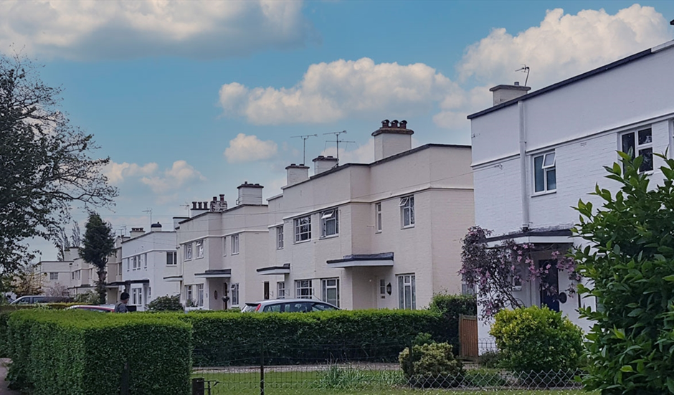

Look out in future EIAG Newsletters and emails for details of how the planning is progressing!

Essex Archaeology Conference:
Recent Research and Discoveries in Essex

Saturday 3rd October 2026 at the Essex Record Office

EIAG and ESAH are both supporting this major event and EIAG will be presenting a paper on recent developments in industrial archaeology and heritage

