
Essex Industrial Archaeology Group
(Incorporating The Essex Mills Group)

NEWSLETTER

Number 60 April 2026

Welcome to this the 60th Edition of the
Essex Industrial Archaeology Group’s (EIAG) Newsletter

In this edition we include a report on the Art Deco exhibition at Braintree Museum, the first major event of the year, which we have been promoting. Then we look forward to four events this summer and early autumn – important dates for your diaries! There are details of: the 2026 East of England Region Industrial Archaeology Conference which will be held in Elmswell, Suffolk on 6th June; the Festival of Essex Archaeology & Heritage which will be held on 23rd July at Cressing Temple Barns; Silver End Heritage Open Day & EIAG mini Industrial Heritage Fair on Sunday 13th September at Silver End Village Hall; and the Essex Archaeology Conference at the Essex Record Office on 3rd October. Finally we have an excellent article from Peter Wynn on L.P. Norman and Sons factory in Chelmsford .

If you have any comments on the Newsletter generally or specific items in it, or wish to make a contribution to the next Newsletter, please contact us via our email address - essexiag@gmail.com.

Contributions for the Newsletter should be sent by the end of the month prior to publication (i.e. by end of March, June, September and December), please. Please submit text as a Word document and photos as separate files such as jpgs.

Programme of ESAH/EIAG events 2026

Wednesday 6th May – Mistley tour: 2.00pm to 4.30 pm.

An introductory talk at Mistley Towers will be followed by a short walk to the Quay, and then to the nearby Swan Fountain (part of Richard Rigby's grand plan to make a spa at Mistley which never materialised). Across the road and over The Green we shall reach a good viewpoint to look up towards where Mistley Hall stood, the seat of the Rigby family. Finishing with tea and cake! Some walking is involved, and there are four fairly steep steps up into each of the Mistley Towers.

Booking as usual through Howard Brooks at howard000brooks@gmail.com

Details of the events mentioned above are in this and future Newsletters.

ART DECO and BEYOND – BRAINTREE MUSEUM


In early February I visited this excellent exhibition at Braintree Museum - this much anticipated event certainly did not fail to please!

It explores how Braintree paved the way in manufacturing innovations and textile design during the 1920s and 1930s. Featuring Crittalls and the centenary of their unique village of Silver End; Courtaulds, innovators of artificial silk; and esteemed textile manufacturers Warner & Sons.

As well as out-lining the history of Crittall’s itself, the impact of the company on house design in general, particularly window design of course, and on the town of Braintree are explored. They introduced the first modernist housing to Britain with the creation of the Clockhouse Way estate in 1919

Likewise in respect of Courtauld’s, the impact of the company on the town is explored, and special mention is made of Sir Stephen Courtauld. Although he did not join the family business, he was heavily involved in the arts and film making during the inter-war period, giving financial support to the Courtauld Galleries at the Fitzwilliam Museum in Cambridge. His philanthropic work extended to his final adopted home of Zimbabwe (formerly Southern Rhodesia).

The exhibition runs until 27th June and is highly recommended.

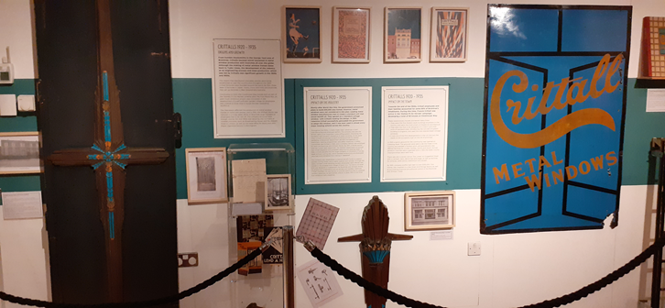
Part of the Crittall display featuring artefacts, archive documents and interpretation.
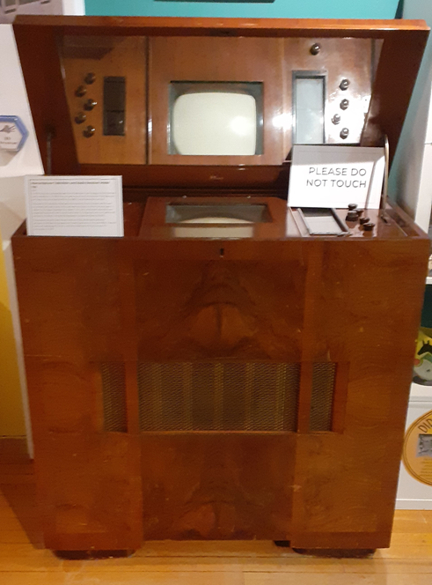
Also on display is this period piece of 1930s technological innovation – the Marconiphone Television and Radio Receiver Model 705 of 1937.

The accompanying interpretation label states:

“This early 705 television features a horizontal 10 inch screen which was mounted vertically due to the cathode ray tube. A mirror lid was used to reflect the image towards the viewer. The unit combined television and broadcast receivers with sound and vision. “

Text and photos: Tony Crosby

THE FESTIVAL OF ESSEX ARCHAEOLOGY AND HERITAGE

Last year Essex County Council's Place Services organised a Festival of Essex Archaeology and Heritage in July at Cressing Temple Barns. This was a great success – see the review in Newsletter No. 57 of July 2025 – such that Place Services are organising a similar event this year to be held on:

Thursday 23rd July 2026 from 10:00 – 5:00

at Cressing Temple Barns
Witham Road, Braintree, Cressing, Essex, CM77 8PD

A fantastic free and family-friendly festival for anyone with an interest in archaeology, history and the heritage of Essex – young and old.

Encounter some of the country’s leading experts and those involved in discovering, preserving and presenting the best of the county’s heritage. Meet experts and browse finds, enjoy children’s activities and re-enactments, talks, tours and so much more including food stands.

EIAG, along with the Essex Society for Archaeology and History (ESAH), will have a display stand as last year. We are also exploring with Place Services inviting some of the Industrial Heritage Fair exhibitors to have displays and grouping together these ‘industry-themed’ displays in one area.
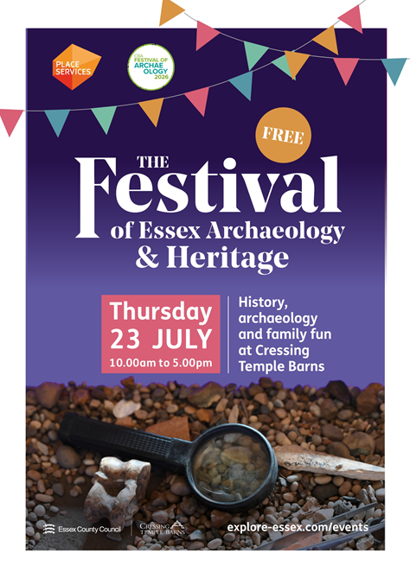
SILVER END HERITAGE SOCIETY + EIAG MINI INDUSTRIAL HERITAGE FAIR

As your EIAG Committee was having great difficulty identifying a suitable venue for a full Industrial Heritage Fair for this year and felt that the Group no longer has the capacity to organise one, we are partnering with the Silver End Heritage Society (SEHS) to hold a joint event on:
Sunday 13th September 2026 (times tbc)

at Silver End Village Hall
3 Broadway, Silver End, Witham CM8 3RQ

SEHS will be having a Heritage Open Day as part of their commemoration of the 100th Anniversary of the building of the first houses in the village by Crittall’s the metal window manufacturers. Taking the lead from the anniversary of the building of one of the world famous company villages here is Essex, EIAG are organising a “Company Housing” themed mini-Fair featuring other workers’ housing schemes developed in the County by local industrial companies. Planning is still in the early stages but we already have promises of displays on Bata’s East Tilbury village; Courtauld’s housing in Halstead and district: Hunt’s housing in Earls Colne; and Ripper’s housing in Sible Hedingham. There will be talks on Courtauld’s, Hunt’s and also Wilkin & Sons in Tiptree.

More details will be in the July edition of this Newsletter, but in the meantime “save the date” for what will be a fascinating event featuring a variety of Essex industries and the housing and facilities they built for their work-force.
ESSEX ARCHAEOLOGY CONFERENCE:
RECENT RESEARCH AND DISCOVERIES IN ESSEX

Saturday 3rd October 2026 (Full Day)
at the Essex Record Office
Wharf Rd, Chelmsford CM2 6YT

EIAG and ESAH are both supporting this major event and EIAG will be presenting a paper on recent developments in industrial archaeology and heritage
Full details of the day’s programme, cost, booking and refreshments can be found here:

https://www.placeservices.co.uk/media/dwwnbj2r/essex-archaeology-conference-2026.pdf

Earls Colne Heritage Museum

Earls Colne Heritage Museum has been awarded £241,000 by the National Lottery Heritage Fund.

The Earls Colne Heritage Museum is located inside a Grade II listed Victorian water tower on the site of the former Atlas Works, a 19th Century iron foundry. The Atlas Works closed in 1988 and was left derelict for more than a decade until it was bought by developers. At that time it was decided that the interior of the water tower be converted into the museum. The building was then run by volunteers before the lease expired in 2024 and Earls Colne Parish Council was unable to purchase it.

Chairman Gordon Brown said it had been 25 years since the museum first opened and NLHF grant the money would be used to purchase the building, renovate and modernise it. He said: "We're very grateful to National Lottery Heritage Fund for understanding the need, otherwise it would be a loss of the museum to the community which it had served for 20-plus years."

One of the main tasks will be turning "cluttered" artefacts and material into an improved experience for visitors, befitting the 21st Century. One example has been organising more than 100 years of newspaper cuttings which were presented to the museum in 25 volumes which have now been scanned, digitised and are keyword searchable.

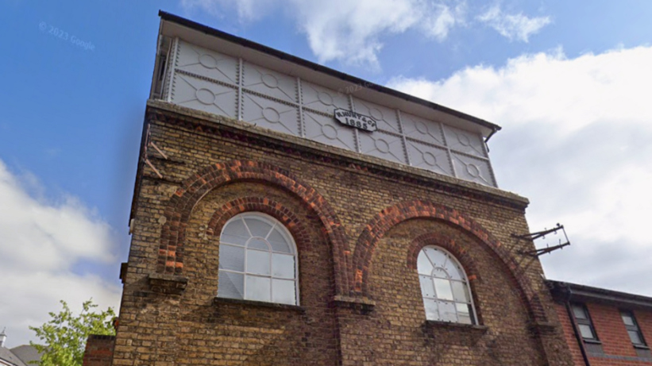
L.P. Foreman & Sons: a clarification and additional details

The following is the text from Chelmsford Industrial Trail for Foreman’s factory in Roxwell Road to the west of Chelmsford.

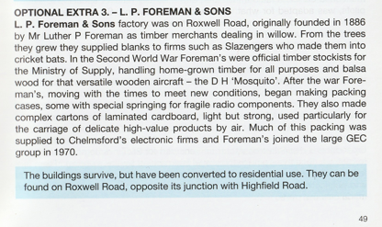
Figure 1
Text from Chelmsford Industrial Trail

An impression from this is that the Roxwell Road factory was founded in 1886. This was the date that Foreman’s gave for their establishment in some advertisements, but is not the date when they started at Chelmsford.

The 1891 census showed Luther P. Foreman as a builder living in Ashley near Newmarket. The 1901 census showed him as a building manager in Newmarket itself. His bankruptcy was reported in 1903 with the Official Receiver declaring that he must have known he was insolvent from 1895.

The earliest association I have been able to find of him being in Chelmsford was a newspaper advertisement which identified his address as being in Anchor Street (Figure 2, below).
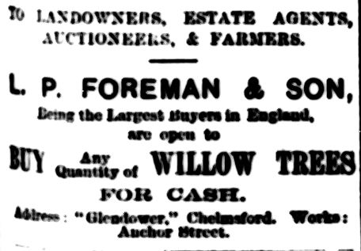

Figure 2
Essex Weekly News 23 October 1908

Similar advertisements were placed regularly thereafter.

In July 1909 his factory was offered for sale by auction (Figure 3, next page). This advertisement is useful in providing a more detailed identification of the premises.
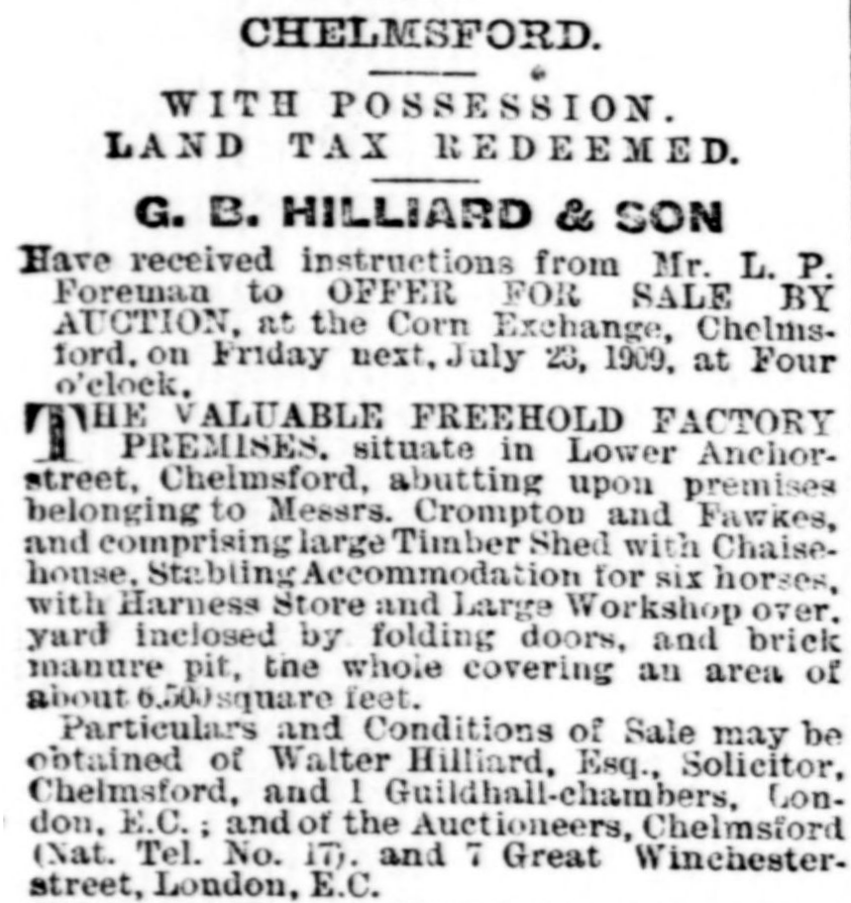
Figure3
Essex County Chronicle 16 July 1909

There were two other auctions of properties of significance to the Foreman story advertised by Hilliard on the same day: development plots at Hill Farm to the north of Roxwell Road and part of W. Beach & Son’s property to the south of Roxwell Road.

In the “Lloyd George Domesday Survey” of 1911 Foreman was identified as occupier of Hill Farm. Ownership was split: Foreman owned most of the land, having purchased it for £1417/10/0 in the 1909 sale, but Wells and Perry , the Chelmsford brewers, retained a frontage covering nearly four acres onto Roxwell Road. Two houses had been erected facing Roxwell Road: St. Fabians, owned by E Foreman (probably Luther’s wife, Elizabeth) and occupied by L.P. Foreman, and Villa Romsdal owned by W. Cowell. By December 1909 Hill Farm had replaced Anchor Street as the works address in Foreman’s advertisements with the office given as being at St. Fabians.

From July 1912 Foreman’s were operating from a new willow works to the south of Roxwell Road on land leased from the Beach family. Their advertisements were now indicating that the business had been established in 1886. The “Lloyd George Survey” showed that residential development of the Beach property to the south of Roxwell Road had started as shown in Figure 4 (next page). One wonders whether the purchasers were aware when they bought their plots that their neighbours would soon include Beach’s brickworks, a foundry and Foreman’s new willow works!
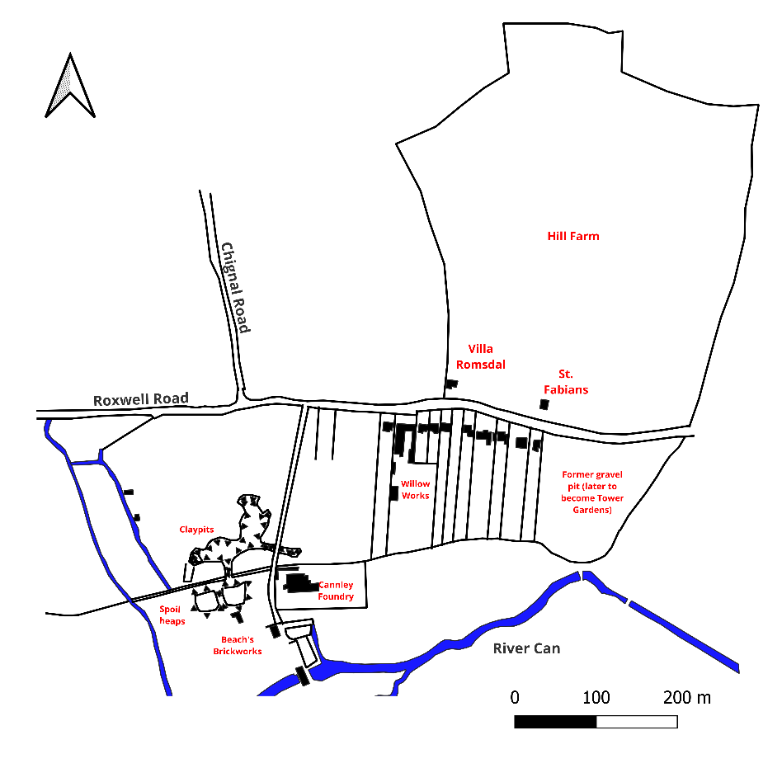
Figure 4
Foreman’s Roxwell Road Willow Works
(layout of brickworks from OS maps revised in 1919)

Researched and written by Peter Wynn

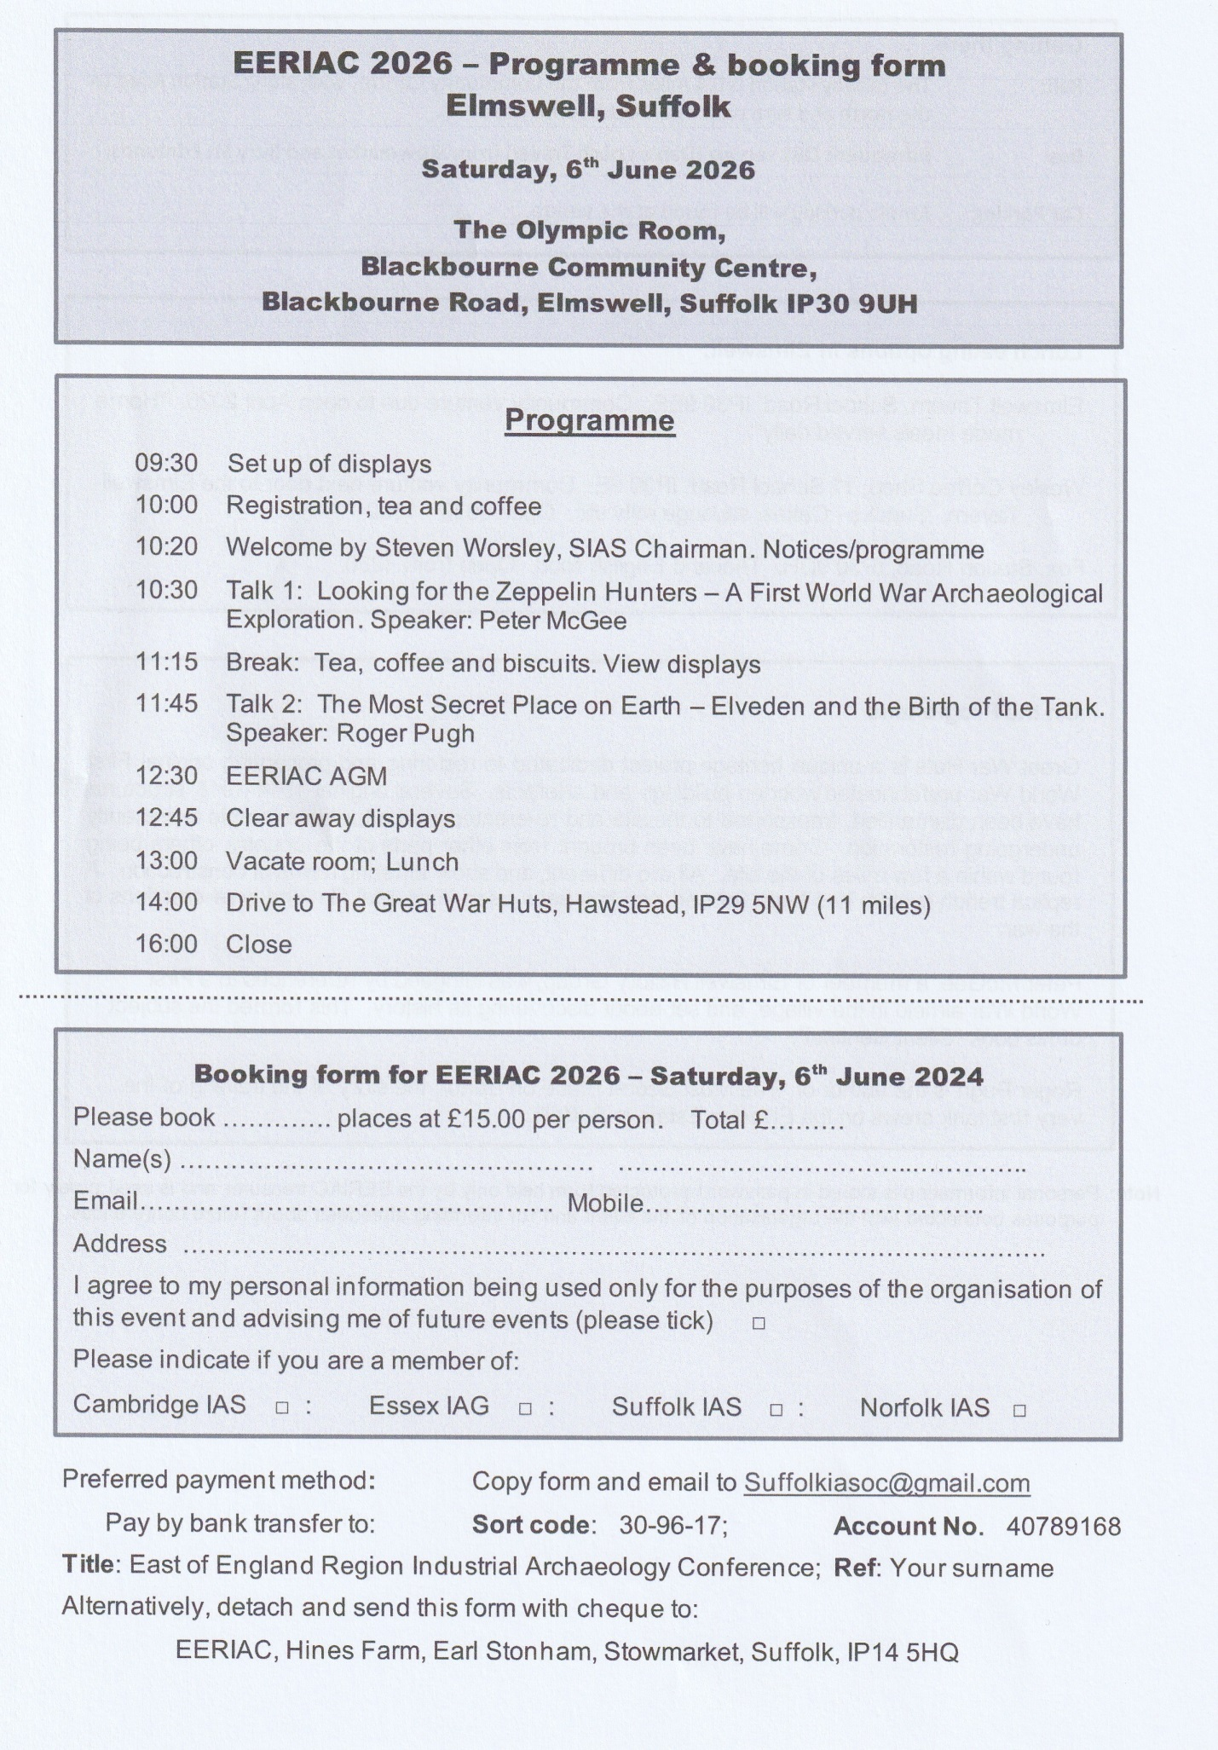
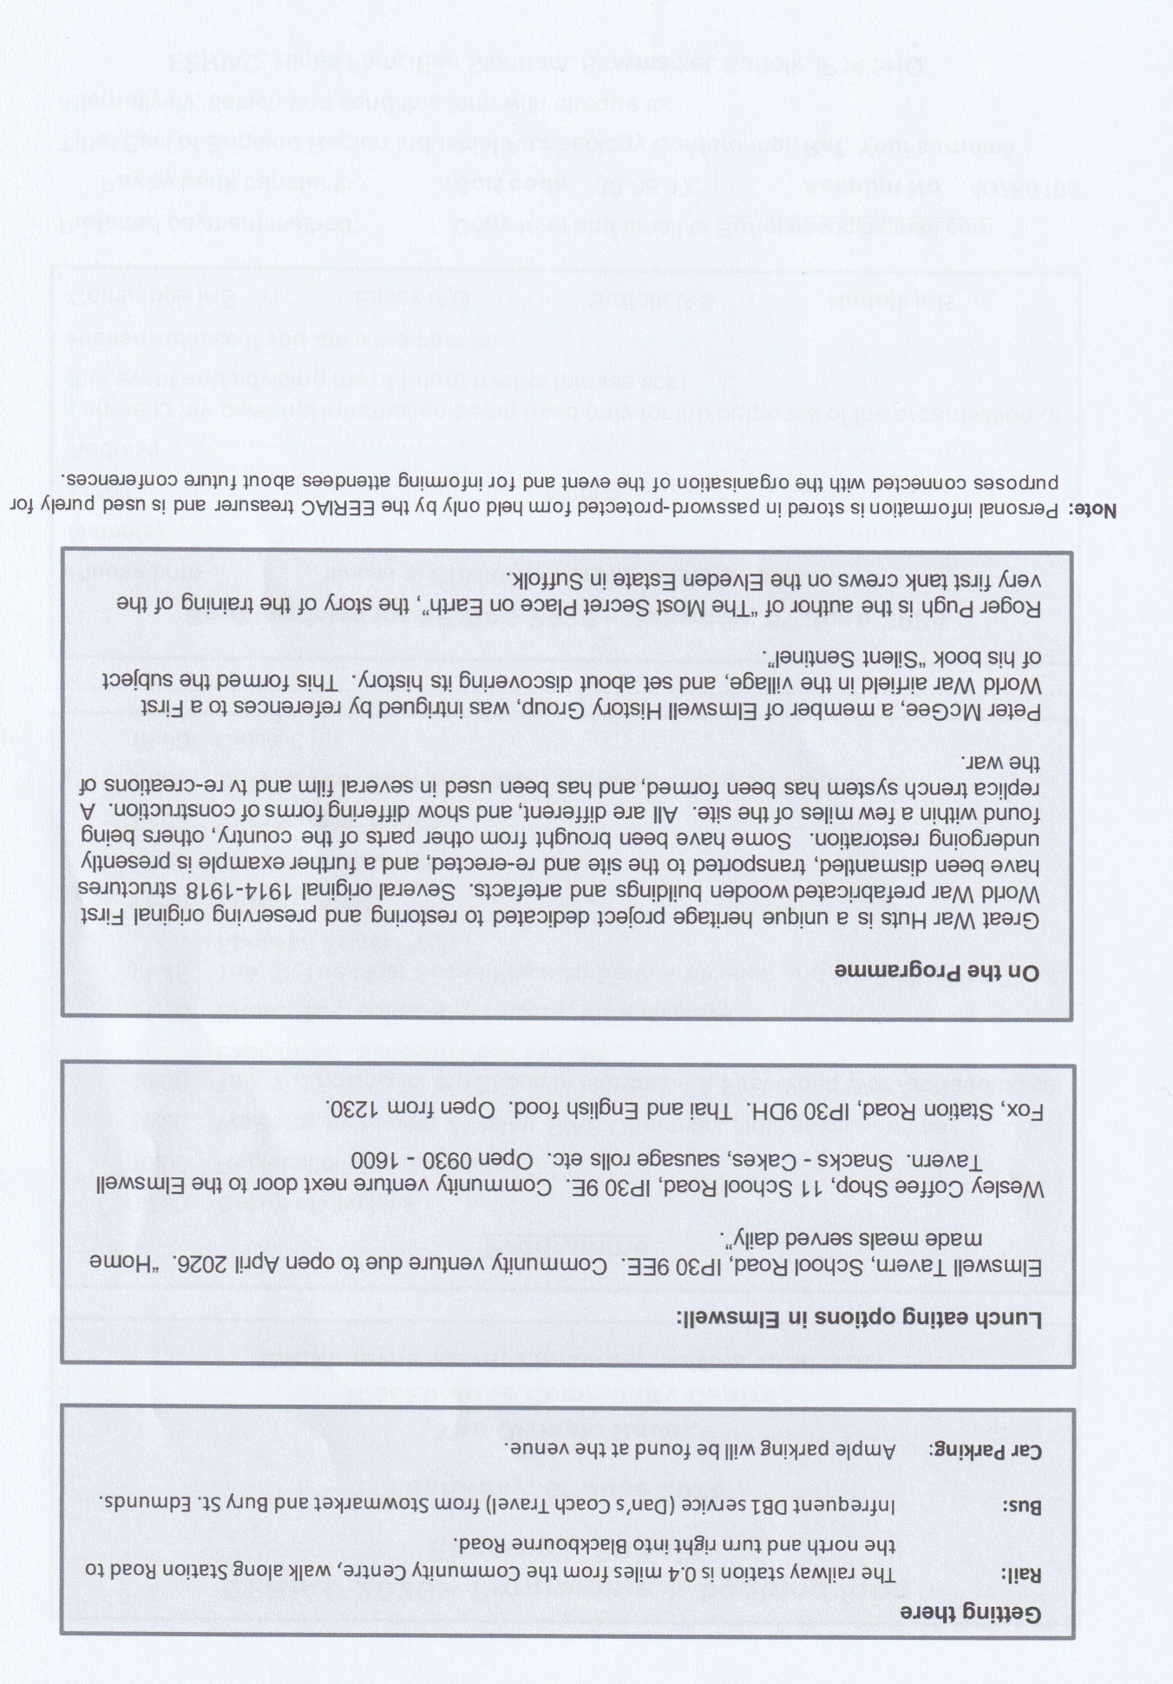

Cambridge Evening News 23 September 1903

