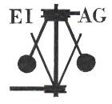
Essex Industrial Archaeology Group
(Incorporating The Essex Mills Group)

NEWSLETTER

Number 61 July 2026

Welcome to this edition of the Essex Industrial Archaeology Group’s (EIAG) Newsletter

Welcome to the July edition of our Newsletter. In this edition we have a report from the East of England Regional Industrial Archaeology Conference (EERIAC) held last month in Suffolk – thanks to Nick Ellis for his comprehensive report. We look forward to three events in the Autumn, report on the ECC Festival held earlier this month and have more good news about ‘Jumbo’, plus details of a new book on Essex windmills.

If you have any comments on the Newsletter generally or specific items in it, or wish to make a contribution to the next Newsletter, please contact us via our email address - essexiag@gmail.com.

Contributions for the Newsletter should be sent by the end of the month prior to publication (i.e. by end of March, June, September and December), please. Please submit text as a Word document and photos as separate files such as jpegs.

Programme of ESAH / EIAG events 2026

SILVER END HERITAGE SOCIETY + EIAG MINI INDUSTRIAL HERITAGE FAIR

Sunday 13th September 2026 (times tbc) at Silver End Village Hall, 3 Broadway, Silver End, Witham CM8 3RQ
Full details of the day’s programme are on page 5

ESSEX ARCHAEOLOGY CONFERENCE:
RECENT RESEARCH AND DISCOVERIES IN ESSEX

Saturday 3rd October 2026 at the Essex Record Office full details below

EIAG Annual Meeting – Saturday 7th November 2026, 2:00 – 4:00pm
at the Essex Record Office, Wharf Rd, Chelmsford CM2 6YT

A short time of EIAG business will be followed by a talk by a guest speaker on an aspect of Essex’s Industrial History - full details to follow.

East of England Regional Industrial Archaeology Conference 2026, run by Suffolk Industrial Archaeology Society at Elmswell, Suffolk.
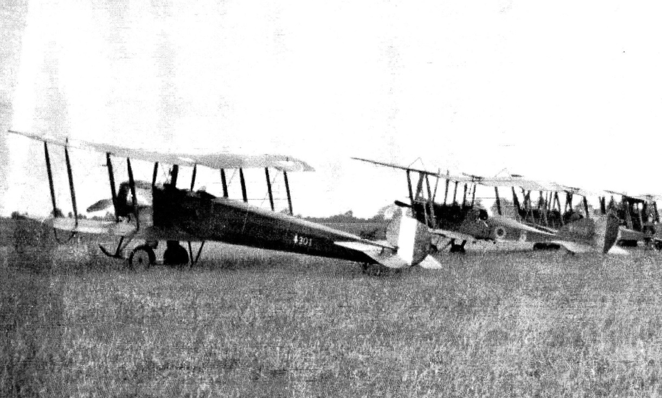

Picture from Elmswell History Society. 75 Sqdn Avro 504Ks in the summer of 1918.
On Saturday 6th June around 30 people, interested in Industrial Archaeology and including at least 2 pilots, from Norfolk, Suffolk and Essex met in Elmswell Community Centre for the annual meeting of the EERIAC. Unfortunately, only 3 people from Essex were present, possibly because the date of the meeting clashed with AGM of the ESAH.
The Agenda for the event did suggest that there would be displays but the only large display was from our own EIAG brought along by Jane Giffould. There were a few smaller displays of books.
Apart from the formal AGM matters those present heard from two excellent speakers. The first was Peter McGee, who had spent 10 years leading a local project on looking for the remains of a First World Airfield in Elmswell village, His group’s search was made more difficult by the fact the Second World War Airfield, Great Ashfield, had been built on the same site, followed by post war developments.
To put his talk into context Peter titled his talk “Looking for the Zeppelin Hunters” as the aircraft based at Elmswell initially sought out airships but towards the end of the war their attention was on the Gotha, and other, bombers used by the Germans. He did point out that towards the end of the war the Germans returned to using airships as they developed craft that could travel altitudes that the British planes could not reach. Peter’s talk covered a wide range from descriptions of the various archaeological techniques used through the group’s difficulties and successes. Their research took them to both archives in the UK as well as the USA and Canada. The talk concluded by a review of some of the finds. Following a brief Q&A session the interest raised by the ensuing good sales for his book on the subject, which was available to those attending at a 50% discount.
Like Peter, our second speaker had also written a book about his findings. However in this case the book had sold well and no copies were available. Your reviewer has a copy and to be honest expected the talk, by the author Roger Pugh, to just cover things that he had read in the comprehensive book. In the event it was an entertaining talk, entitled “The Most Secret Talk on Earth”. The subject of the speaker, Roger Pugh, was how the Elveden estate in Norfolk was used as the machine development and training ground for the first tanks to go into battle in September 1916. Roger covered both the selection of the area as a training ground as well as the measures taken to ensure the secrecy of this new wonder weapon. Although a historical rather than archaeological based talk Roger kept the audience interested with a wide range of observations regarding the history of the time, including reminding us that over 74,000 troops from India died during the conflict. This fact was relevant as the Indian Cavalry were used to guard the area.
The meeting then broke up and at 14:00 the WW1 theme was continued with a visit to the Great War Huts at Hawstead, Only around a dozen attendees made their way south to the Huts, where we were greeted by the co-Founder and Director David ‘Taff’ Gillingham.
Taff gave those present a talk about how his ownership of a company that supplied props to film and TV companies had developed firstly into the provision to a WW1 trench system for filming then onto the current collection of First World War wooden huts and associated militaria. The talk also covered the development of the huts during the conflict and was well illustrated by contemporary photographs by way of illustration.
We were than taken for a tour of three of the huts, however by this time it was raining heavily and thus we could not visit the trench system. The first hut was furnished as an Adjuncts Office, including a single cell for offenders. In each of the huts Taff outlined his vision of the development and how material should be presented.
The second hut contained some of the uniforms rented out to film companies, but the main interest was that it showed some of the construction methods of such huts. The final hut contained displays relating to the use to Gas in warfare through the years covering both the First World War and the expected use of gas in the Second World War.
The organisers are to be congratulated on arranging an interesting WW1 themed day and they cannot be blamed by the external noise created by a sports day for young people taking place on site,
References:
Forgotten Sentinel, Peter McGee pub: Elmswell History Group (see web site below)
The Most Secret Place On Earth, Roger Pugh, pub: Larks Press (only available second hand)
https://www.elmswell-history.org.uk/
https://www.greatwarhuts.org/
Nick Ellis

THE SECOND FESTIVAL OF ESSEX ARCHAEOLOGY AND HERITAGE

This event, organised by Essex County Council's Place Services, was held on Thursday 23rd July 2026 at Cressing Temple. Many heritage organisations from across the county were represented with stands and exhibitions distributed over the various buildings on the Cressing Temple site. Also several of the commercial archaeological units that are active in the county presented the results of recent excavations. There were a number of talks given during the day which proved very popular. The Essex Industrial Archaeology Group was represented by a stand in the Wheat Barn, manned by members of the group, adjacent to a stand from our parent body, the Essex Society for Archaeology and History.

On a very warm day during the current heat wave the event was a great success with about 1,400 people attending, about a 25% increase on last year’s Festival. Place Services reported good feedback from the public about the stands, exhibitions and talks. The knowledge and enthusiasm of the exhibitors was much appreciated.
In the view of the success of the festival, including the good feedback, Place Services are considering another festival in 2027.

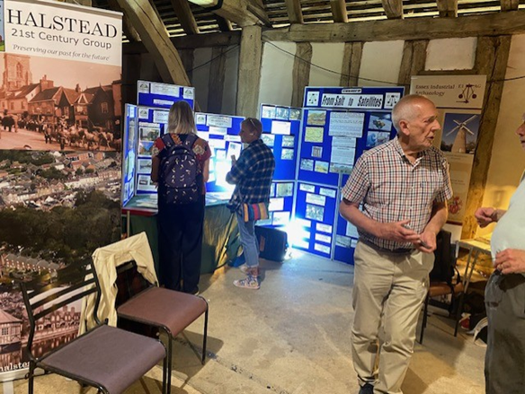

The EIAG display stand in the Wheat Barn at the Festival. Also adjacent was the H21C stand featuring a display focusing on the Courtauld factory, workers’ housing, community facilities and, of course, the Air Raid Shelters in Halstead. This will be one of the displays at the Silver End event on 13th September.

Photo credit: Howard Brooks

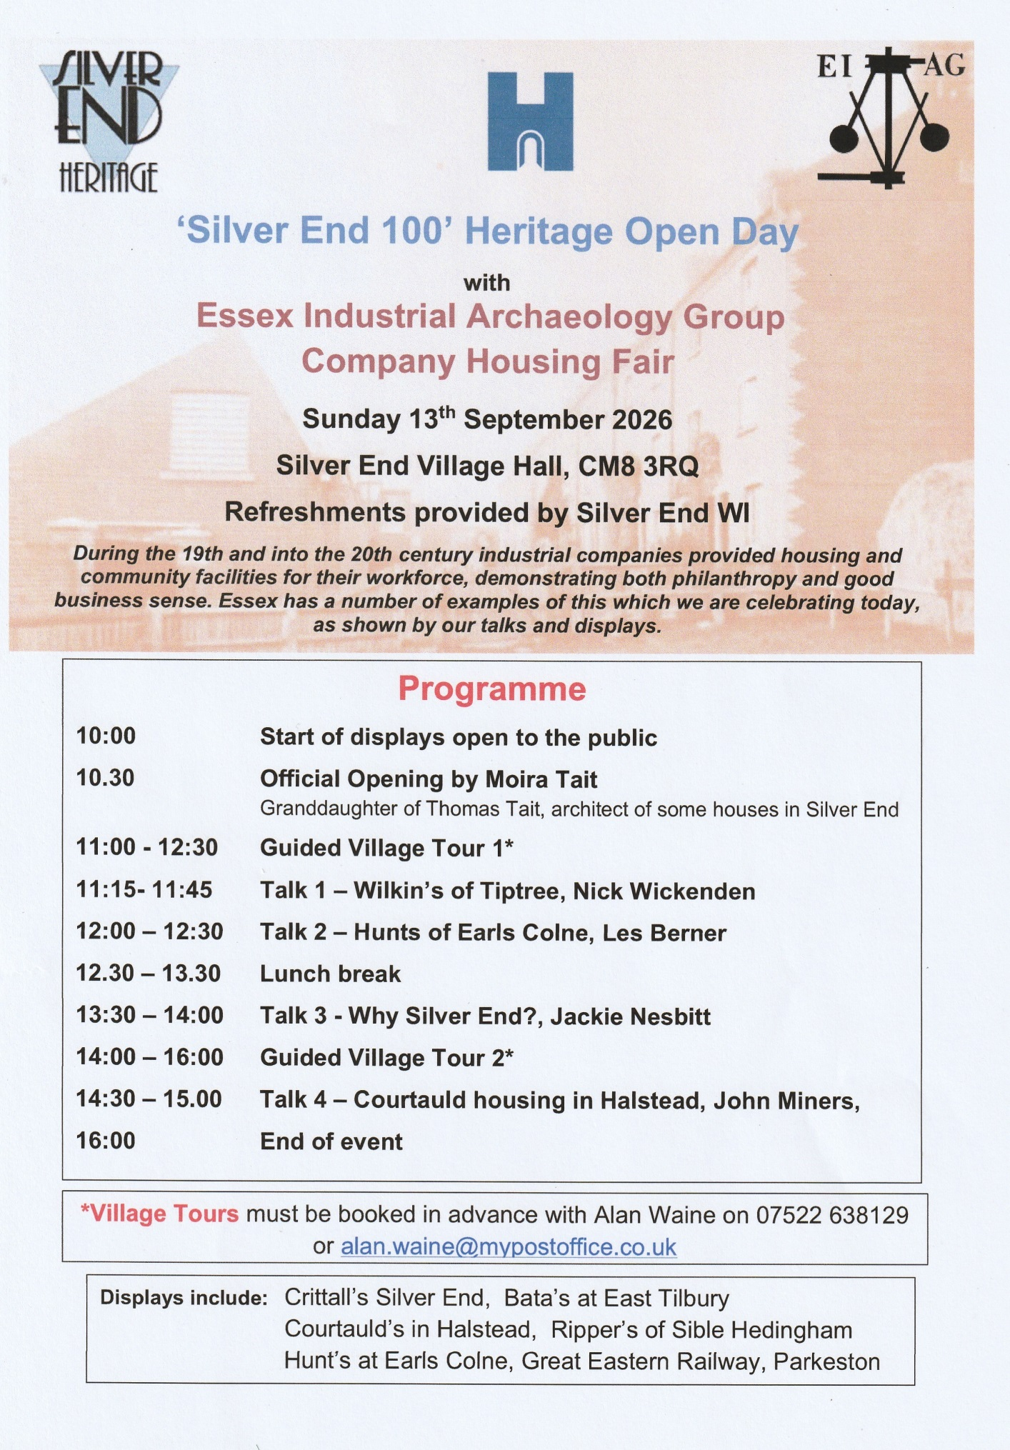
FAREWELL TO THE BALKERNE TOWER TRUST
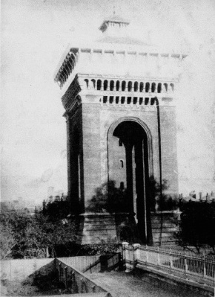
EIAG has received this email from Brian Light, Chairman of the BTT:

On 23rd July 2026, BTT is being wound up as a registered charity. This is because our main objective, saving Jumbo for the public benefit, has been achieved. As you know, North Essex Heritage has acquired Jumbo on a 150 year lease and their plans to make Jumbo a major heritage and events attraction are now well advanced.

BTT was formed in 2006, but was preceded by a campaign group called Save Jumbo for Colchester, which was active from 1998. So in total we campaigned for a public use for Jumbo, and against its predatory commercial development, for over a quarter of a century.

We would like to extend a hearty thanks to everyone who expressed their support over the years for what we were trying to do, also to the then Borough Council, the Civic Society and the Colchester and North Essex Building Preservation Trust for their financial support towards the Jumbo and Garrison water tower interpretation panels. A particularly warm thanks also to the many of you who donated generously towards our aborted attempt to bid for Jumbo at the 2014 auction, when Jumbo was sold by George Braithwaite and bought by Paul Flatman for a much deflated price.
Jumbo in 1884 showing original heavy guttering.

BTT has no remaining assets. The last of our funds were donated to North Essex Heritage’s Jumbo Project. North Essex Heritage is selling our remaining stock of Jumbo books and they may well publish a second edition in due course. They also have the Jumbo interpretation panel which will no doubt be updated as needed in the future.

Our website www.savejumbo.org.uk will be taken offline at the end of 2026, so there is still have time to explore its nooks and crannies for everything about our famous landmark, soon to be reborn as a unique heritage and events attraction worthy of its fascinating history.

Best wishes to you all. Brian Light, Chair

Association for Industrial Archaeology - Restoration Grants

It has recently been announced by the AIA that they have awarded North Essex Heritage a grant of £30,000 for the restoration of the Victorian cast-iron spiral staircase in Jumbo.

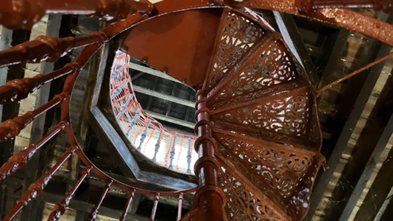
Internal photo of the cast-iron stairs (Jodie Halford/BBC)

New Publication – Windmills of Essex by Ian Yearsley

Ian had his first book published in 1994 and has since written 14 books on Essex history, other Essex inspired books, numerous articles and contributed to the Victorian County History of Southend. His latest book published in April this year explores the history of the milling industry of Essex and particularly, what was at its peak, over 200 windmills.

In the first chapter he outlines the history of windmill development in the county, describes the architecture of the three types of windmills and the machinery they housed, and summarises the usual process by which the grain is turned into flour. He names all the component parts of the milling machinery and their function, but it would have been helpful to have had example diagrams of the machinery to help the understanding of the process.

He then gives details of 23 surviving windmills, those open to the public (with website addresses so readers can find out when they are open) and those which have been converted to private use. The final main chapter covers many of the lost mills of the county, with detail of 20 of which there are “significant structural fabric remains”.

The book is illustrated with a colour map of the 23 surviving mills and is lavishly illustrated with both historic black & white photos and also current colour photos. It was heartening to note that the bibligraphy contains the EIAG booklet Discovering Essex Wind and Water Mills, the ECC survey Discover Essex Windmills, and the EIAG website is listed
The Windmills of Essex is published by Amberley Publishing,
ISBN 978 1 3981 2577 3, cost £15.99

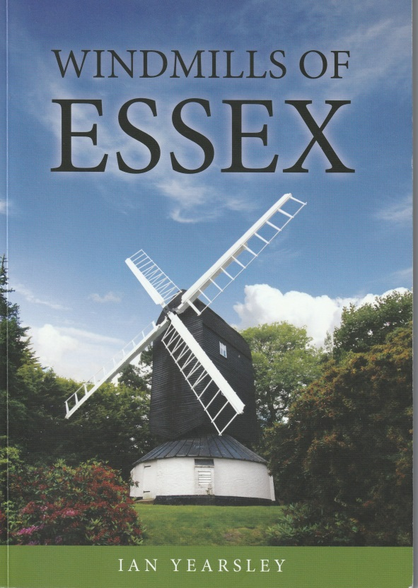

Essex Mills Group Meeting

While on the subject of Mills, the first meeting organised by EIAG to explore revitalising the former Essex Mills Group was held on 12th May at Mountnessing village hall and included a tour of Mountnessing Post Mill. Three ECC staff, including James Owden the County Millwrght, representing the five mills owned by the County Council attended, along with representatives of Friends Groups of three windmills and the owners of a water mill. A further meeting is in the planning stage to be held in the early Autumn.

ESSEX ARCHAEOLOGY CONFERENCE:
RECENT RESEARCH AND DISCOVERIES IN ESSEX

Saturday 3rd October 2026 (Full Day)
at the Essex Record Office, Wharf Rd, Chelmsford CM2 6YT

EIAG and ESAH are both supporting this major event and EIAG will be presenting a paper on recent developments in industrial archaeology and heritage

Full details of the day’s programme, cost, booking and refreshments can be found here:
https://www.placeservices.co.uk/media/dwwnbj2r/essex-archaeology-conference-2026.pdf

