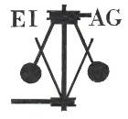
Essex Industrial Archaeology Group
(Incorporating The Essex Mills Group)

NEWSLETTER

Number 62 October 2026

Welcome to this edition of the Essex Industrial Archaeology Group’s (EIAG) Newsletter

In this edition we have reports on what has been a busy summer supporting various events focused on the archaeology and history of Essex. Plus we look forward to our Annual Meeting on 7th November and, even further ahead to a conference in June 2027 (already!) For those who are working with mills note the conference/event at Upminster windmill on 15 November which looks like an interesting activity.

If you have any comments on the Newsletter generally or specific items in it, or wish to make a contribution to the next Newsletter, please contact us via our email address - essexiag@gmail.com.

Contributions for the Newsletter should be sent by the end of the month prior to publication (i.e. by end of March, June, September and December), please. Please submit text as a Word document and photos as separate files such as jpegs.

Programme of ESAH / EIAG events 2027

The ESAH programme of visits and other events for 2027 is still at the planning stage. We have made suggestions for visits to places of industrial interest, so here’s hoping that they can be arranged. Details of those visits with an industrial theme will be announced in this newsletter when they are available.

There are details below of our Annual Meeting on Saturday 7th November at 2:00 pm at the Essex Record Office

Also below are the details so far of next year’s
East of England Regional Industrial Archaeology Conference
which is being hosted by EIAG with Halstead and District Local History Society

Silver End 100th Anniversary and EIAG Industrial Heritage Fair

This collaboration with the Silver End Heritage Society celebrated both the 100th anniversary of the start of building the company village of Silver End by Crittall’s, alongside a number of other developments of workers’ housing by Essex industrialists and companies. It began with Lt Col (Retd) J A Allan QVRM TD DL (Jackie Allan) piping in Moira Tate, granddaughter of Thomas Tate one of the architects of Silver End, who officially opened the event. There were two guided walks of the village which were well attended and four talks:

Nick Wickenden spoke about Wilkin & Sons of Tiptree which had built housing for staff in the early C20th and has also funded housing on the new estates in Tiptree near to their jam-making factory.
John Stedman spoke about Hunt’s of Earls Colne who built a large number of houses and community facilities in the village and near-by Great Tey.
Jackie Nesbitt explained why Crittall developed Silver End.
John Miners spoke about the history of Courtaulds in Halstead and the housing and community facilities they funded in the town.

Pam and Adrian Corder-Birch provided a display on the Rippers Joinery Manufacturers of Castle and Sible Hedingham, as well as offering for sale a number of their books on various Essex industries.

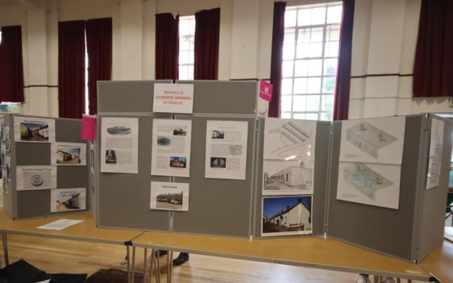
The display featuring Bentall’s workers’ housing in Heybridge, included details of the single storey Woodfield Cottages built of concrete and which are Listed Grade II. It was provided by Tim Howson of Maldon DC, with additional photos of other Bentall workers’ housing provided by Tony Crosby.
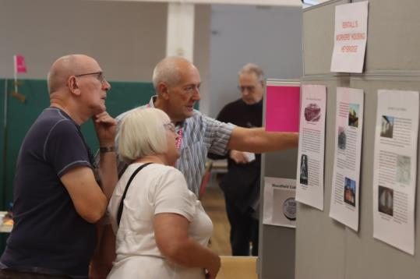

Visitors viewing and discussing the Bentall’s display.

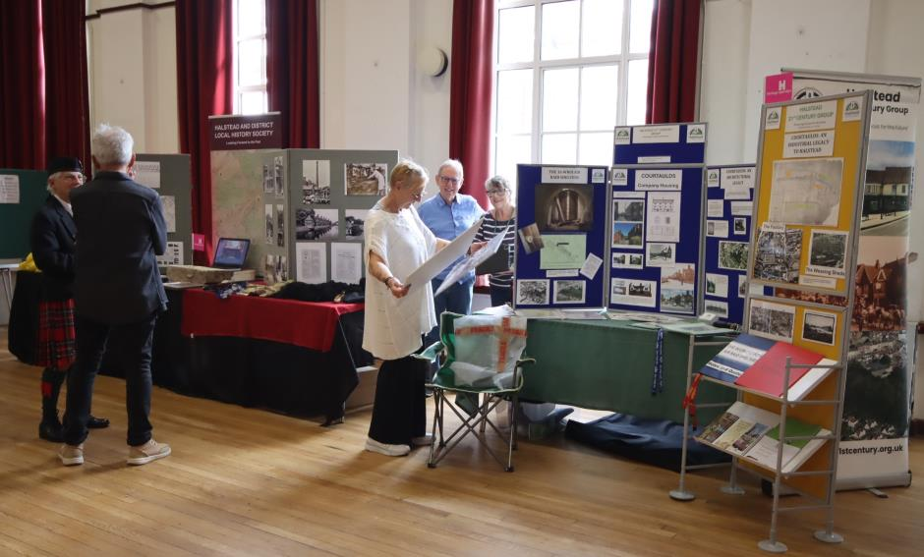
Above - The Halstead & District Local History Society exhibit (left) and the Halstead 21st Century Group’s display (right), both of which highlighted the impact of Courtauld’s on the urban environment in the town, the remains of their manufacturing sites, and the housing and community facilities provided for their workers.
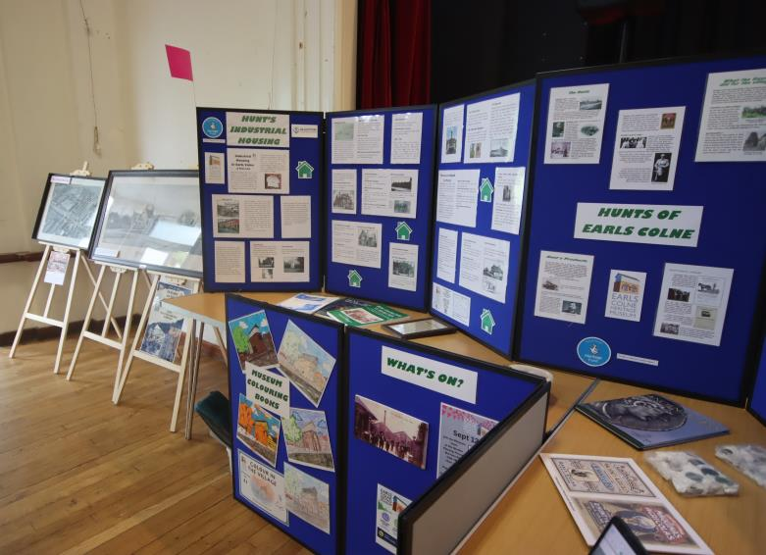

Above - The display by the Earls Colne Heritage Museum which is located in The Old Water Tower of the former Atlas Works, the R. Hunt agricultural machinery foundry, which was pivotal to the development of the village from a purely agricultural to an industrial village in the 19th & 20th centuries.
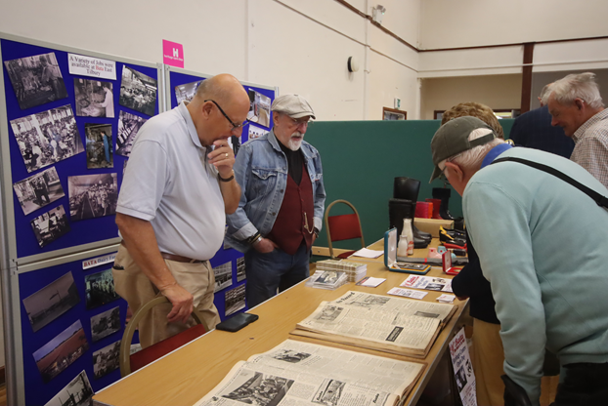

Above - Visitors studying the exhibits from the Bata Heritage Centre being presented and explained by Mike Tarbard (Chairman) and Mick Pinion.

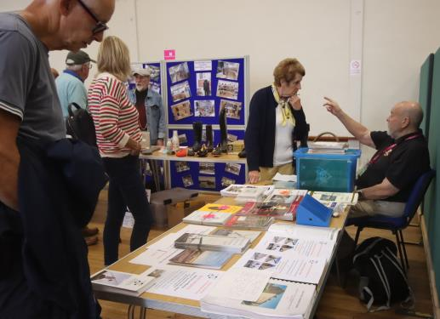

Left - EIAG sales table, with Bata Heritage Centre display in the background.

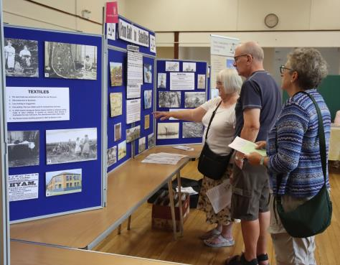
Below – visitors viewing the EIAG display.

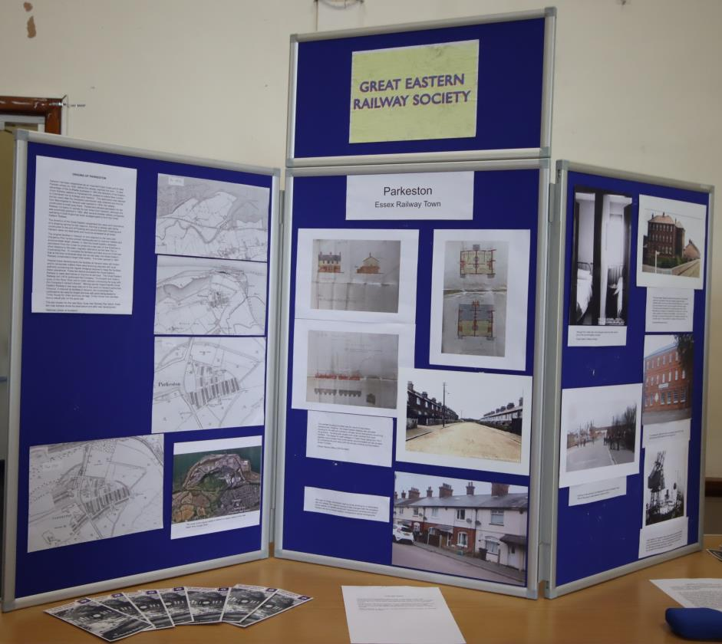
Above – The display by the Great Eastern Railway Society which featured the housing and other facilities developed for its staff at Parkeston.

Plus, of course, the Silver End Heritage Society (below)
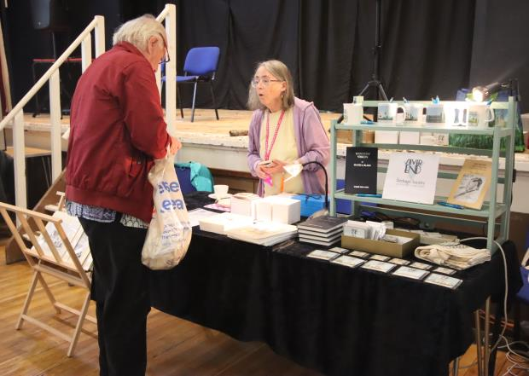

ECC Festival of Archaeology & History

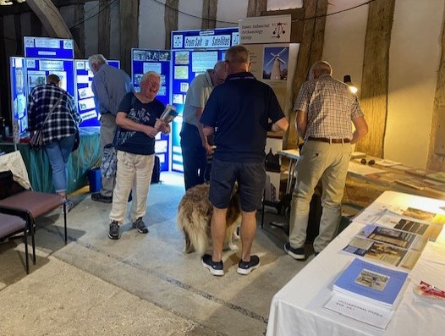
EIAG display in the Wheat Barn at the Festival at Cressing Temple Barns
Photo credit: Howard Brooks

EIAG were pleased to support the ECC Place Services’ Festival of Archaeology & History again this year, where we were able to promote the work of the Group and the County’s industrial history and heritage. It was also an excellent opportunity to network with our partner Societies which maintain, promote and interpret their sites for the public. ECC Place Services have reported that this year’s Festival was more successful than 2025 with an increase of nearly 20% in attendence by the public. They are already planning for a similar Festival in 2027.

ECC Place Services and ESAH Archaeology Conference

This Conference, held at the start of this month at the Essex Record Office, was the first such event since 2008 and focused on recent research and discoveries across a wide range of historic periods from the Pleistocene through the Iron Age, Roman and Saxon periods to the Medieval. EIAG was pleased to be invited to present research and discoveries focused on the County’s industrial archaeology and history.

EIAG Annual Meeting
Saturday 7th November 2026, 2:00pm
at the Essex Record Office
Wharf Rd, Chelmsford CM2 6YT
Our guest speaker this year is
Gary Armstrong
Trustee of the North Essex Heritage Trust
telling us about
Bringing Jumbo back to life: Restoration gets underway
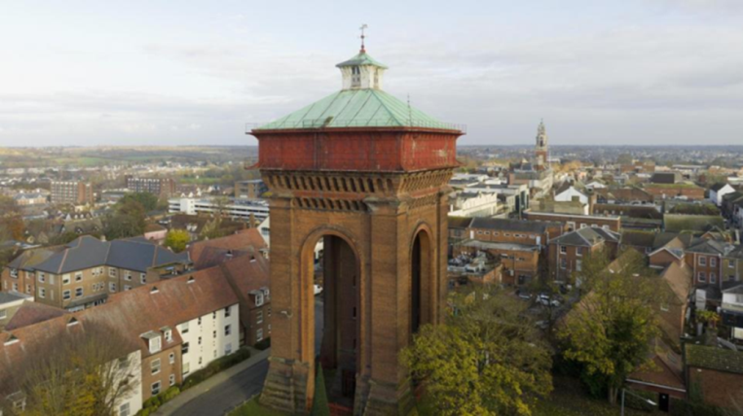
Please note – If you want to attend, please book your place by contacting Jane at jgiffould@aol.com. We need to know numbers in advance as there is a space limit to the room, but more importantly, so we can order sufficient refreshments!
The meeting will begin with the usual AGM business agenda.
Please note that the number, and therefore capacity to arrange events etc, of Committee members is decreasing so we are seeking new members. Please give serious consideration to putting yourself forward to help keep the Group actively researching and promoting Essex’s industrial past.
East of England Regional Industrial Archaeology Conference 2027

The region of EERIAC consists of Norfolk, Suffolk, Cambridgeshire and Essex, and the IA Societies of these counties rotate in hosting the annual conferences. Next year is Essex’s IA Group’s turn to host this event – as we did four years ago in Chlemsford. For the 2027 Conference we are partnering with the Halstead & District Local History Society to host the Conference in Halstead on:

SATURDAY 12TH JUNE 2027
Joint planning for the day’s programme of talks and visits will be starting over the winter so:
SAVE THE DATE and LOOK OUT FOR DETAILS OF THE PROGRAMME IN FUTURE EDITIONS OF THIS NEWSLETTER
*****************************************************

National Lottery Heritage Fund Grant for The Mills Archive

NLHF have recently made a grant to The Mills Achive Trust as part of their Archives Revealed initiative. This funded project focuses on preserving millwrighting heritage in order to save an endangered heritage craft skill.
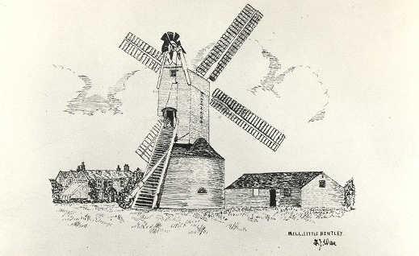
Four collections that record the historic craft of millwrighting – building and repairing windmills and watermills – are being catalogued by the Mills Archive Trust. The records, including technical drawings and photographs of historic mills in the UK and abroad, come from contemporary and 20th century millwrights and heritage specialists. The trust hopes these records can be useful teaching resources in caring for mills and helping pass on millwrighting, an industrial heritage skill classed as critically endangered by the Heritage Crafts Association. Around 1,000 technical drawings showing how historic mills were built and operated are being catalogued with this Archives Revealed grant.
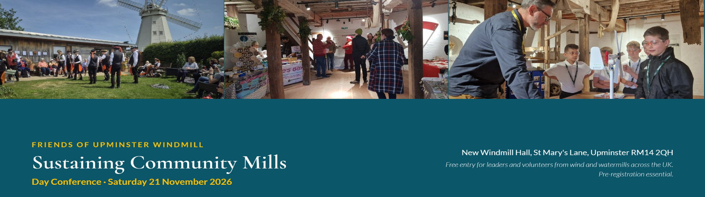
Upminster Windmill
The Friends of Upminster Windmill are delighted to invite trustees and volunteer leaders from wind and watermills across the UK to a conference-style event on the successful management of mills as community assets. Whether you're just starting out or have years of experience governing a mill trust, this is a chance to share ideas, swap practical experience, and build connections and collaboration with counterparts from other mills.
Morning — talks in the New Windmill Hall
- Luke Bonwick, Millwrighting Consultant: "Conservation and Communities"
- Andrew Brown, Director, Veolia Environmental Trust: "What Funders Want"
- Charles Pinchbeck, Chairman, Heckington Windmill Trust: "Running a community windmill – lessons from the past, lessons for the future"
Afternoon — at the Windmill and Visitor Centre
- Discuss – small-group sessions on grant & community fundraising, sustainable business models, health & safety, maintenance & mill operation, and education & youth
- Network – informal time to catch up with trustees and leaders from mills across the UK
- Visit – guided tours of Upminster Windmill, the archaeological site and community garden
When and where
10am–4pm, Saturday 21 November 2026
New Windmill Hall, St Mary's Lane, Upminster RM14 2QH
Entry
Entry is free of charge but pre-registration is essential so we can plan and cater accordingly. Tea, coffee and a finger buffet lunch provided.
To request places, please go to: https://www.upminsterwindmill.org/whatson/sustaining-community-mills.
This is the website of the Friends of Upminster Windmill (a Charitable Incorporated Organisation, registration no. 1162180). We manage the mill on behalf of the London Borough of Havering.
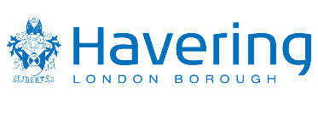
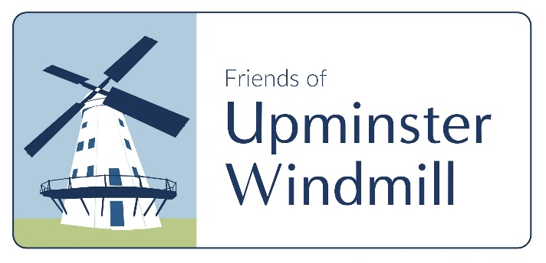
We are grateful to National Lottery Heritage Fund and Veolia Environmental Trust for their generous funding for the restoration of the windmill and development of the site as an educational and community resource.

