
Essex Industrial Archaeology Group

NEWSLETTER

Number 7 October 2015

Welcome …

… to this bumper edition of the Essex Industrial Archaeology Group’s (EIAG) Newsletter. The main item is a report on the Industrial Heritage Fair held earlier this month in Braintree, which was a great success. Other items include a report on the Braintree District Council Local Heritage List; links between Essex and Sussex industrial archaeology; and a look forward to our Annual Meeting and Lecture on 14th November.
If you have any comments on the Newsletter generally or specific items in it, or wish to make a contribution to the next Newsletter, please contact us via our email address - essexiag@gmail.com.

INDUSTRIAL HERITAGE FAIR
Report

We are honoured to have The Lord Petre, Patron of the Essex Society for Archaeology & History, attending to officially open the Industrial Heritage Fair held at Braintree District Museum on Saturday 10th October. The Fair, the first of its kind to be held in Essex, was deemed to be a success for such an innovative event. We had 19 local and national heritage organisations displaying information about their sites and work – unfortunately on the day a further two were unable to attend. As well as the people manning the stands we had around 100 members of the public visit the Fair, including the local MP James Cleverly. Five short talks were held over the mid-day period, each of which was attended by up to 20 plus people. It would have been better if we had had a larger space and had been able to keep all the stands in one room with more space per stand, but that is just one lesson to learn for future such events. There does seem to be demand for another Fair, in 2016 even, but your Committee at its last meeting decided to hold another in 2017, possibly in south Essex.

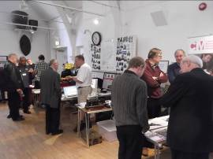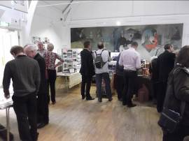

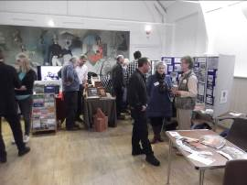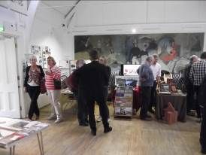

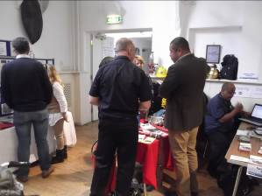

James Cleverly MP deep in conversation with the Essex Fire Museum folks

EIAG Annual Meeting and Lecture

Our next major event is the Annual Meeting and Lecture on Saturday 14th November at Chelmsford Museum, starting at 12:30 p.m. We will begin with a short business session, looking back over the last year and forward to 2016, plus electing the Committee for the coming year. This year’s lecture will be given by Keith Falconer, formerly Head of Industrial Archaeology at (the former) English Heritage and currently Chairman of the Association for Industrial Archaeology. His lecture is entitled:

The Association for Industrial Archaeology – a very British affair!

This talk will trace the pioneer development of industrial archaeology from its tentative beginnings in the late 1950, through its burgeoning in the 1960s, to the formation of the AIA itself in 1973 and the AIA’s involvement in the national and international scene thereafter.

Free to Members, £2 for non-members. Bookings can be made with Dr Graham Gould on 0208 556 1423 or email DrGEGould@aol.com

Essex and Sussex Connections

In early September half a dozen EIAG members, including your Chairman and Vice- Chairman, attended the Association for Industrial Archaeology’s annual conference which was held at the University of Sussex in Brighton. Amongst the very interesting lectures given were two which highlighted links between aspects of Essex and Sussex industrial and transport heritage.

Firstly, during the lecture on the history of the Volks Electric Railway, built along the Brighton sea front, we learned that in the immediate post-war period the railway was short of rolling stock. At the same time Southend Corporation were replacing the rolling stock on the Southend Pier Railway and had trailer cars, of a similar period to the existing Volk’s fleet, surplus to requirements. Two of these, cross-bench open control trailers built in 1899, were purchased, numbered as Cars 8 and 9, and fitted with motors before entering service in 1950 and 1953 respectively. By the 1990s they were in need of costly refurbishment and Car 8 was returned to Southend to form part of the Pier Museum collection, while Car 9 was moved to the South Downs Heritage Centre at Hassocks in West Sussex.

Chelmsford Museum has recently received initial support from the Heritage Lottery Fund for a major development project, part of which will involve the restoration a ‘toastrack’ railway carriage which used to run along Southend Pier, for display in a special outdoors glazed building at the museum. The Pier railway scheme was devised by Colonel Crompton who was Chelmsford’s foremost electrical engineer at the turn of the 19th and 20th century.

Further information on these two Cars can be found on the Volks Electric Railway website at:
http://volkselectricrailway.co.uk/history/the-car-fleet/numbers-8-9/

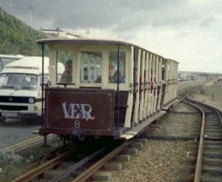

Car 8 on the Volks Electric Railway, Brighton

Secondly, one of the lectures was given by a representative of the Bluebell Railway and focused on their project to build a new London, Brighton and South Coast Railway (LBSCR) Atlantic (4-4-2) locomotive. The trigger which began this project was that a former Great Northern Railway (GNR) Atlantic boiler became available for sale and as LBSCR Atlantics were built to drawings modified from the GNR design, the boiler was correct for the new locomotive planned. The boiler was sold to the Bluebell Railway in 1987 by Boulton & Paul (formerly John Sadd & Sons Limited), timber merchants of Maldon where it had been used to produce power for the timber yard. (See below for a brief history of John Sadd & Sons Limited, builders and timber merchants of Maldon Essex.)

Further information on the project can be found on the Bluebell Railway website at:
http://www.bluebell-railway.co.uk/bluebell/locos/atlantic/background.html

On two of the visits during the Conference two further Essex – Sussex connections were noted, as follows:

In the storeroom of the Weald and Downland Open Air Museum was an early horse drawn plough made by E. H. Bentall & Co., of Heybridge near Maldon. The business was started by William Bentall, a farmer of Goldhanger who ceased farming in 1795 to concentrate on agricultural engineering. In 1805 the business moved to Heybridge and in 1836 Edward Hammond Bentall took over his father’s business, which he expanded. He patented new designs of agricultural machinery, including ploughs and the business continued until the 1980s.

In the signal box at Sheffield Park Railway Station on the Bluebell Railway, was a small tortoise stove made by Charles Portway and Son Limited of Halstead. They made several sizes of small combustion stoves under the name of “The Tortoise” throughout much of the nineteenth and twentieth centuries. They were used to heat all rooms from small cottages to very large churches and during the Second World War many were to be found in Nissan huts.

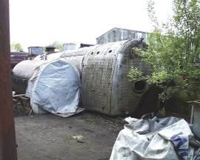

The Atlantic boiler at the Bluebell Railway following purchase

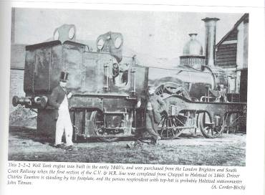

A 2-2-2 Well Tank engine built in the early 1840s and bought from the London Brighton & South Coast Railway when the first section of the Colne Valley & Halstead Railway was opened in 1860.
Boulton & Paul had bought the John Sadd & Sons timber merchants business in Maldon and a brief history of the John Sadd’s business written by Pam Corder-Birch follows.

A brief history of John Sadd & Sons Limited, builders and timber merchants of Maldon Essex.

During the 1720s a carpenter named Thomas Sadd had a business in Chelmsford which was later transferred to Maldon by his son John Sadd. The concern expanded and was passed from father to son through the generations, with the eldest son always being named John. In the 1820s when John F. Sadd concentrated on being a surveyor, builder and ship owner, his son John, took over the timber and building interests, and in 1831 took out a lease on premises and wharves in Maldon which allowed the Company to import soft woods from Canada, Finland, Norway and Russia, using their own ships and barges. John Granger Sadd with his bother Alfred Granger Sadd took over the running of the firm in 1851, and under John’s guidance the firm’s growth was phenomenal; he was a pioneer in the installation of power machinery for woodworking and continually reconstructed and modernised the business for over forty years. With further mechanisation the firm concentrated on the supply of sawn and planed timber to the building trade, which was easily transported with the rapidly developing railway system. There was also a large business in English hard woods, and company ships brought roof tiles from Wales to enhance their building trade. Also in 1871 the company purchased a steam traction engine for hauling trees to the works. In 1899 John Sadd & Sons was incorporated as a private limited company. John’s three sons, John Price, Harry William and Herbert Eustace joined the firm, and during their directorships installed two Crossley wood refuse gas plants, which were used to produce electricity, and by 1912 the Company generated enough electricity to supply the whole of Maldon and Heybridge! During the Second World War the Company worked for the war effort making motor torpedo boats, air sea rescue craft, pontoons, small assault craft and aircraft parts, flight cooking and messing boxes, as well as many other wooden products. The company worked day and night shifts and employed women in the joinery shops. In 1954 the Company acquired the adjoining Maldon Ironworks Limited, as a wholly owned subsidiary and part of the premises were used for the production of wireless and television cabinets, and later ‘flush’ doors. They continued to modernise the firm and built a new softwood mill in the 1960s. Eventually, like other family owned businesses, John Sadd & Sons Limited found it increasingly hard to compete against the large joinery companies who could produce goods at a cheaper prices and in October 1994 the ‘Boulton and Paul Group’ purchased John Sadd and Sons, (although they had been trading under this name for some time), and the entire Maldon site was demolished shortly afterwards.

Local Heritage Lists in Essex

Braintree District Council

‘Local heritage listing is a means for a community and a local authority to jointly identify heritage assets that are valued as distinctive elements of the local historic environment, especially buildings and structures which are not Listed Buildings. It provides clarity on the location of assets and what it is about them that is significant, guaranteeing that strategic local planning properly takes account of the desirability of their conservation.’
(Historic England’s Good Practice Guide for Local Heritage Listing, 2012).

https://historicengland.org.uk/images-books/publications/good-practice-local-heritage-listing/

Local heritage lists (LHL), therefore, play an important part in building and reinforcing a sense of local identity and distinctiveness in the historic environment, helping to conserve and enhance local character. The process of listing in this way provides an opportunity for communities, in partnership with local authorities, to identify valued heritage assets which they wish to protect at a local level, supporting both the National Heritage List (Listed Buildings) and enhancing the local Historic Environment Record (HER). LHLs provide additional protection alongside Listed Buildings, have no extra consent requirements but do help to influence planning decisions.

A number of local Councils in Essex have LHLs of varying detail and comprehensiveness, for example Castle Point, Chelmsford, Colchester, Epping, Maldon and Southend, while others are considering compiling one, such as Basildon. As reported in the last newsletter, Braintree District Council (BDC) launched their Local Heritage List on 19th August. Working in partnership with BDC, Braintree & Bocking Civic Society (BBCS) has created a nomination list of all buildings and structures in the District associated with the Courtauld family and business. All types of heritage assets can be considered for inclusion in an LHL and hence these nominated assets include not only buildings such factories, a workmen’s hall, village halls, a mechanics institute, schools, churches, Braintree Town Hall, hospitals, and dozens of staff houses across the District, but also public gardens, drinking fountains, and air raid shelters. (The full list can be viewed on the B&BCS website at: http://www.bbcivsoc.org.uk/pdfs/0-Courtauld-LHL-Version-6.pdf.)

BDC are currently consulting with the owners of those buildings and structures in Braintree and Bocking only, initially, as the first step towards compiling their LHL. The nominated assets will be checked to ensure they meet the criteria for inclusion on the LHL and after consultation the nominations will be reviewed by a Local List Selection Panel which is currently being established. This Panel will then make recommendations to the Planning Committee regarding which assets to include on the LHL and owners will be informed. The criteria for inclusion on the LHL are: Age & Integrity; Historic Associations & Social Value; Architectural & Aesthetic Value; and Group Value.

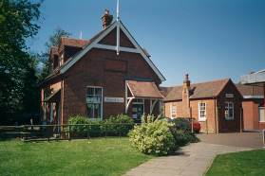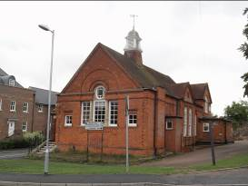

First Aid Building and Gatehouse, Halstead Workmen’s Hall, Church Street, Bocking

Chelmsford Industrial Heritage Trail
In the 1980s a Chelmsford Industrial Trail was produced as an A5 booklet by Stanley Wood for the Chelmsford Industrial Museums Society and for Essex Schools (at the request of Ian Mason of the Essex Record Office Schools Service). Copies of this informative and useful booklet are now difficult to obtain and there has been no subsequent publication to replace it. Therefore, it was interesting to note that in the programme for the 2015 Chelmsford Ideas Festival one of the events being offered was the opportunity to join a Chelmsford Industrial Walk. This was being repeated three times, I joined the walk held on the morning of 19th October.
The walk was led by Alan Pamphilon, a member of the Marconi Heritage Group, who does various walks around parts of the City dressed in clothes appropriate to the topic, on this occasion that of a Victorian businessman (see photo). He commenced the walk at the former silk factory in Hall Street, Old Moulsham, where Guglielmo Marconi established the world’s first wireless manufacturing and development factory in 1898 and ended it at the present e2v company site in Waterhouse Lane. In between stops were made at the former sites of Godfrey’s Rope Walk, on Moulsham Street (opened in 1839); at Colonel Crompton’s Anchor Street Arc Works (established in 1839); the Colman and Walton Iron Works Site on New London Road/New Writtle Street; the Eastern National Bus Depot in New Writtle Street, formally the Clarkson and Chapel Steam Car Company (opened 1902); and the Railway Viaduct over the River Cam which was built by the Great Eastern Railway in 1842 following the purchase of land from the former Mildmay estate (sold in 1839).
At each chosen location Alan told the story not only of the key industrial activity which had taken place there, but placed this into its longer site history. While the walk was confined to the area of Old Moulsham the later development of larger sites elsewhere in Chelmsford, and the innovations for which they were known, were also mentioned as appropriate. This included such enterprises as Christy’s on Broomfield Road, the Crompton Writtle Road site and the Marconi and Hoffman sites in New Street. In a short two hour tour a considerable amount of information about the industrial heritage of Chelmsford was provided. It was well worth the £5.00 which was being donated by Alan to support the Chelmsford Ideas Hub.
Note: The Chelmsford Ideas Hub was founded to stimulate community action and aims to celebrate and grow the culture, character and creativity of Chelmsford by advocating new ways to look at the City. It organises an annual Ideas Festival which this year has the theme “Connect”. This has the aim of encouraging new and lasting links between existing city communities which include connections between business, local authorities, schools, Anglia Ruskin University and Writtle College. The Industrial Heritage Walks were just one of numerous events organised between 19th October and 1st November.
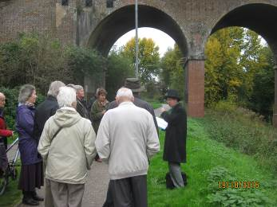
Dave Buckley
Thameside Explosives Industry

We hope you all read and enjoyed Michael Leach’s excellent piece in the summer edition of the ESAH newsletter on Hulks at Holehaven Creek and the Thameside Explosives Industry which gave a brief overview of the three main explosives manufacturers on the Thames estuary. If you have missed it, do have a look at pages 5 to 8.

