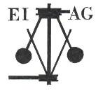
Essex Industrial Archaeology Group

NEWSLETTER

Number 8 January 2016

Happy New Year to all our members

Welcome to this edition of the Essex Industrial Archaeology Group’s (EIAG) Newsletter: the first in 2016, our third full year. As demand for new housing increases, threats to our industrial heritage also increase, as evidenced by recent and potential development proposals (see below). As so many small former industrial buildings are not protected as Listed Buildings, being in Conservation Areas or being on Local Heritage Lists, they are very vulnerable to unsympathetic re-development or demolition. EIAG tries to keep abreast of such developments, making comments to the relevant Planning Authority, and asking the Association for Industrial Archaeology to make representations. Individual members are also encouraged to comment on planning proposals and we would welcome members alerting us to similar proposals threatening our industrial heritage in their area.

If you have any comments on the Newsletter generally or specific items in it, or wish to make a contribution to the next Newsletter, please contact us via our email address - essexiag@gmail.com.

ESAH Industrial Visits 2016

The next visit of industrial interest is on Friday 26th February 2016 at Noon to the Martello Tower, Jaywick. Although a military defensive structure it is built of bricks made at Grays which were transported by barge to the site.

Other visits of industrial interest are:

* Saturday 16th April at 2pm to Great Dunmow Maltings and Museum. The Maltings is an outstanding survival of the early malting and brewing industry, the oldest parts dating from the 16th century.

* Thursday 12th May 10am to Marriages Chelmer Mill. A guided tour of the working flour mill built in 1899. (Max 15)
* Wednesday 3rd August to Essex Fire Museum, Grays.
* This year’s EIAG Annual Lecture will be on Saturday 12th November at Chelmsford Museum, and will be on the Lost Port of Gunfleet at Holland Haven.

Bookings can be made with Dr Graham Gould on 0208 556 1423 or email DrGEGould@aol.com
Braintree District Museum’s 2016 Spring Talk Programme

The former joinery company of Ripper’s Ltd., Sible Hedingham, is the focus for February. On Thursday 25 February at 2pm Adrian Corder-Birch, President of the Essex Society for Archaeology and History, and Vice Chairman of EIAG will speak on the history of the company.

On Tuesday 19 April at 2pm Valerie and Jeff Wise will be exploring the history and development of windmills, their many uses, how they work, how to mill grain and the dangers for millers. The speakers have gained hands-on experience through volunteering at Heckington Mill in Lincolnshire, and will also cover Bocking, Stock, Finchingfield, Thaxted and other Braintree mills. To add to the experience, attendees will get the chance to try some bread made with flour milled at the 13th Century Abbey Mill in Coggeshall.

Tickets for each talk are £3 and include light refreshments. To book a place on any of the talks, or for more information, please call the museum on 01376 328868 or email info@braintreemuseum.co.uk.

Industrial Air Raid Shelters

During the Second World War German bombers flew over Essex on their way to London and at times bombed various airfields and industries in Essex as well. For protection air raid shelters were constructed ranging from a box under the kitchen table through to more stable ones in the garden right up to very large ones for industry. It is those latter industrial ones in which we are interested. Essex, despite being a rural farming county, had quite a bit of industry with fairly large factories, for example Courtaulds with over 1000 workers in Halstead, Crittals in Silver End and Marconis in Chelmsford. It was essential that these factories provided protection for their workers. Courtaulds in Halstead, in anticipation of things to come, had built 16 air raid shelters in 1938. These were 15 partly submerged and one above ground which might have been used for First Aid and radio. All of these remain in reasonable to good condition. (Although current ‘developers’ feel that building poor quality housing on a boggy hillside would be better!) And so the question. What other industrial air raid shelters remain in Essex, and this refers to the Essex of 1939. These industrial air raid shelters are quietly removed by developers as mere mess of no value that is in the way. It is therefore important to locate all that remain and at least catalogue them before they are removed. Once they are gone then they are gone and cannot be replaced.

EIAG is working with H21C (Halstead 21st Century Group) to track down industrial air raid shelters over the whole of Essex, record them with as much detail as possible and if possible conserve some of them. To do this we need people with local knowledge who can alert us as to what is available. For full detail we need to know about Industrial Essex of 1939 – 45, the size and structure of the industries along with what air raid shelters were used. eg: I learnt that Cromptons in Chelmsford had below factory shelters which in later years were used for the First Aid room and blood donation.

We are working with as many people and groups as possible to gather information. eg: U3A Anglia Region has expressed interest in this as a shared learning project. The more who get involved the more we will learn about the importance of Industrial Archaeology along with what Essex has to offer.

With the information we then intend to write a booklet on Industrial Air Raid Shelters of Essex. The ERO has already asked for a copy!

Do contact me at: jgiffould@aol.com

Jane Giffould

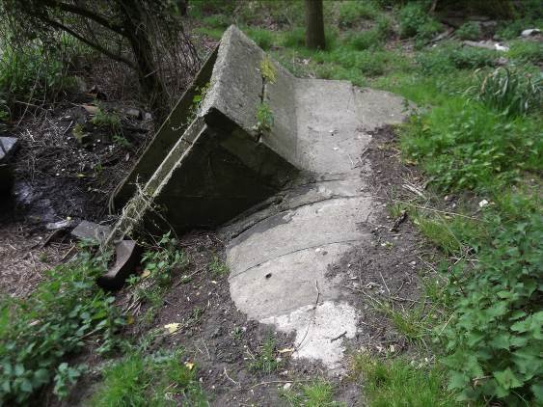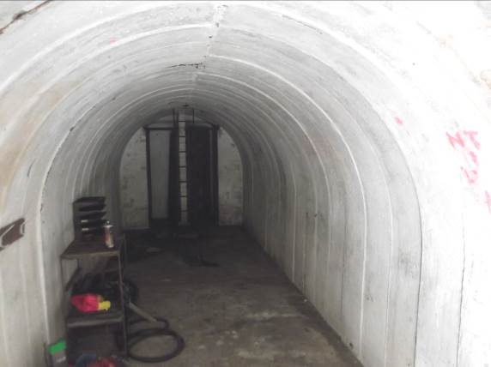

Courtauld air raid shelters, Halstead – external view (left) and internal (right).

Development proposals affecting former industrial buildings.

- Former Railway Buildings, Former EMD Works, Halstead
COLNE VALLEY AND HALSTEAD RAILWAY
In view of recent efforts to try and preserve three former railway buildings in Halstead, the Essex Industrial Archaeology Group has decided to expedite the compilation of Thematic Surveys especially of railways. Reports have already been published upon some former and existing railways in Essex as follows:
- The Flitch Way (the former Bishop’s Stortford, Dunmow and Braintree Branch Railway), 2003.
- The Saffron Walden Branch Railway Line, 2005.
- Elsenham and Thaxted Light Railway, 2010
- The Essex sections of the main Cambridge to Liverpool Street Line, 2013
In addition there has been some excellent publications by Peter Kay about railway heritage and surviving railway structures in Essex. EIAG is now giving priority to surveying, assessing, recording and photographing remaining railway structures. This will enable appropriate structures to be added to the Essex Historic Environment Record maintained by Essex County Council, which can include recommendations against demolition.

The three buildings under threat in Halstead were an office, water tank base and a trolley shed, which were all constructed by the former Colne Valley and Halstead Railway, circa 1890. They were located in the former Station and Goods Yard at Halstead just south of the Station. The office was constructed of red brick and slate roof. The bricks were supplied by Mark Gentry of Sible Hedingham and included lintels of gauged brickwork of a Georgian or flat arch design over the doors and windows with the key-brick of a sunflower motif. One of these key-bricks, (see photograph) in good condition, was rescued by members of Halstead and District Local History Society and is now preserved in Halstead Heritage Museum. (For further information see: ‘Bricks, Buildings and Transport – A History of Mark Gentry, the Hedingham red brick industry, buildings, road and rail transport’ by Adrian Corder-Birch, 2013). The office later became the Station Master’s Office and was sadly demolished in December 2015. It adjoined the water tank base of two arches constructed of white brick with blue engineering brick detail. Water was drawn from a well in the Station Master’s garden, which was situated behind the building. In 1916 a softening plant was installed immediately in front of the tank, comprising of a vertical cylindrical tower as shown in the accompanying photograph. This softening plant and the metal water tank were removed many years ago. Attached to the opposite side of the water tank base was a shed, also constructed of yellow brick and blue engineering brick detail, which was used as a Permanent Way Trolley Shed.

At the time of writing, the water tank base and trolley shed survive, although damaged and it is only the former Station Master’s Office, which has been demolished. Sometime following closure of the Halstead section of the former Colne Valley Railway in April 1965, a large factory was built in front of these buildings, which obscured them from public view. It was only upon the demolition of the EMD factory during December 2015 that the former railway buildings have once again become visible. Members of the Colne Valley Railway Preservation Society were immediately notified and put in contact with the developer, with a view to architectural rescue. The Society is very interested in these buildings and it is hoped that a rescue can be achieved and the buildings re-erected on the railway site at Castle Hedingham, when their future is secure. It was a condition of planning approval that a full record of these three buildings was made, but this did not prevent demolition. The survey was completed and includes a detailed history, maps, plans and photographs of these buildings. A report of all the remaining Colne Valley and Halstead Railway structures is in progress to hopefully avoid any future demolition.

ADRIAN CORDER-BIRCH

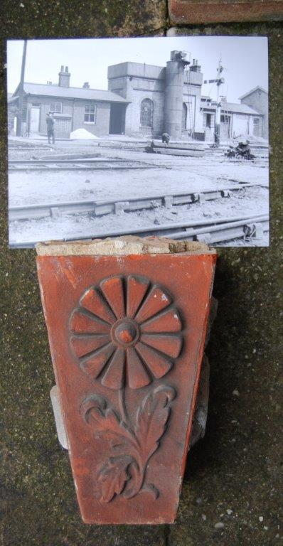

Stop Press:

At the time of publication of this newsletter the demolition of all the railway buildings has been completed.
JG

- Former Courtauld Boiler House, Halstead
In July last year a planning application was made for the change of use of the former Courtauld boiler house buildings to create 26 flats with associated car parking and landscaping. This Courtauld building was built as a Power House containing steam generation machinery with a smaller Boiler House that also had a very large external chimney that has been demolished. Although they appear as two buildings the original plans indicate they were designed as a unit, albeit with different design cues and massing. They were built to serve the enormous factories that were situated to the north and west until they too were demolished in the 1980’s. In 1985 Maycast-Nokes moved their pressure injection moulding shop into the Boiler House and a finishing shop into the first floor of the Power House. They left in 2009 and the building has been vacant ever since. The development proposal would have ensured the continued existence of this rare survivor of the former Courtauld factory complex in the middle of Halstead, albeit with new balconies attached to the riverside elevation.
Although not a Listed Building, nor within the Conservation Area, this building is on the proposed Local Heritage List for Braintree District Council, a decision about which will be made in the next month or so.
The application was withdrawn just before Christmas, but it is likely that further development proposals will come forward in the near future.
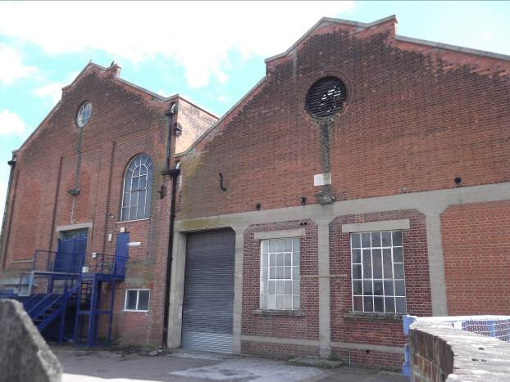

Courtauld Power House (left) and Boiler House (right), Halstead.

- Lawford Waterworks, Manningtree
Tendring Hundred Waterworks Co. originally operated from a site in Mistley, but in 1905 the company moved from Mistley to a new waterworks on a site in Mill Hill, Lawford. Further expansion took place during the 1920s and 1930s. This is an extensive site with a number of structures of various ages reflecting the stages of development, including a modern but sympathetic office block. At the entrance stands a red brick, tile roofed single-storey building with terracotta plaques moulded with the initials THWWCo and the date 1908. There are two large pump houses of yellow brick and slate roofs. These have the distinctive long round headed windows, the northern most being five bays by three, the other three bays by three. Both have clerestory roofs. The site contains other structures including a small building of similar style to the pump houses.
Apparently this site is due to be vacated and sold for redevelopment – more houses? When the Thematic Survey of the Public Water Supply in Essex was undertaken by Essex County Council in 1999, it was recommended that the historic buildings be listed at Grade II as the site was considered to be of “Regional / National Importance”, but this never happened! It is within the Manningtree / Mistley Conservation Area.

We will ‘watch this space’, but if anyone hears more about the future of this site, please let us know at essexiag@gmail.com.

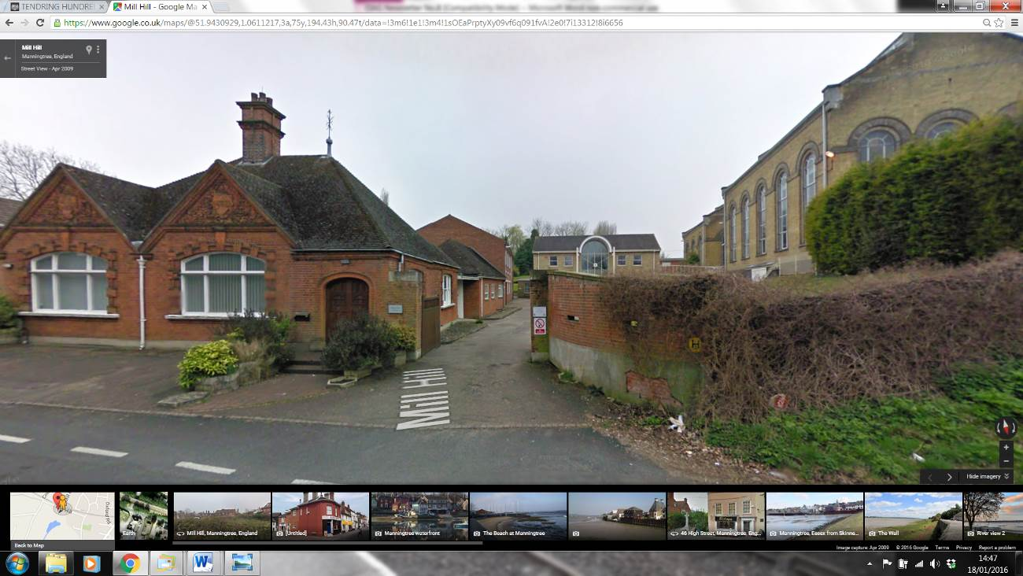

Lawford Waterworks, Mill Hill, Manningtree

On the Cliffs in Kent: A Marconi Connection
Members of EIAG with a particular interest in the development of radio by Guglielmo Marconi may be interested to know about archaeological excavations carried out by the Canterbury Archaeological Trust in July/August 2015 at the South Foreland lighthouse, Dover (reported in the Kent Archaeological Society Newsletter 102, Winter 2015, 20-21).
This iconic lighthouse was formerly run by Trinity House but since1988 has been in the ownership of the National Trust and is a popular visitor attraction/destination for walkers on the White Cliffs of Dover. The excavation of a series of fourteen small trenches within the grounds of the lighthouse was undertaken as part of the preparation of a Conservation Management Plan for the lighthouse and its immediate environs. They were designed to assess the extent and nature of any surviving archaeology, this related directly to the lighthouse, previous lighthouses, known historical activities at the site, or earlier features. A significant discovery was part of the concrete base for Marconi’s direction-finding radio emitter set up on the slope in front of the lighthouse in the early 1920s as part of a ground breaking experiment.

South Foreland was the site for a number of ground breaking experiments by Marconi. On 24th December 1898 he began the first tests of ship-to-ship communication between the Trinity lighthouse and the East Goodwin lightship. The value of these was reinforced on 28th April 1899 when the SS R.F. Mathews collided with the East Goodwin lightship and the first ship-to-shore distress message was received at the South Foreland lighthouse and relayed up the coast to the Walmer lifeboat. In 1899 the lighthouse was also used by Marconi to receive the first international transmission sent form Wimereux, three miles north of Boulogne in France. The Marconi Company used the South Foreland lighthouse again in September 1925 for an experimental transmission of a radio guidance system. The hut from which this transmission took place appears on photos held on the St Margaret’s village website, at http://catalogue.stmargaretshistory.org.uk/items/browse?search=marconi&submit_search=Search
They also show the Rotary Beam transmitter, installed in 1923, designed to assist ships to pinpoint their location. Although it was demolished in 1932 the base remained and was relocated in the recent excavations. It is understood that the National Trust has created a replica of the Marconi hut used for many of the experiments and will be filling it with historic radio equipment in an effort to tell the story of how radio developed.

Dave Buckley

MARCONI'S ROTATING BEAM TRANSMITTER, SOUTH FORELAND LIGHTHOUSE. c1930
