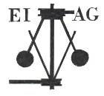**Essex Industrial Archaeology Group**

**(Incorporating The Essex Mills Group)**

**NEWSLETTER**

**Number 57 July 2025**

**Welcome to this edition of the Essex Industrial Archaeology Group’s (EIAG) Newsletter**

Firstly, many apologies for the lateness of your July 2025 Newsletter – as you will gather from the reports in this issue, it has been busy times and we wanted to ensure that we reported on recent events rather than waiting another three months!

In this edition we have reports on the visit to West Ham Engine House and the ECC Festival of Archaeology & Heritage, and there is the latest news regarding the EIAG Annual Meeting in October.

If you have any comments on the Newsletter generally or specific items in it, or wish to make a contribution to the next Newsletter, please contact us via our email address - [essexiag@gmail.com](mailto:essexiag@gmail.com).

Contributions for the Newsletter should be sent by the end of the month prior to publication (i.e. by end of March, June, September and December), please. Please submit text as a Word document and photos as separate files such as jpegs.

**Programme of ESAH / EIAG events 2025**

**EIAG Annual Meeting – Saturday 18th October 2025, 2:00 – 4:30pm**

**at the Essex Record Office**

**A short time of EIAG business will be followed by talks on the impact of the development of railways in Essex to mark the 200th Anniversary of the opening of the Stockton & Darlington Railway – full details below.**

 

**West Ham Engine House**

On Saturday 12th July the West Ham Engine House in Abbey Road, Stratford, was opened for invited guests and societies to see this historic pumping station which is not normally open to the public. A large number of enthusiasts gathered and were shown around in small groups starting in the engine house itself, followed by a walk around the outside of the whole building and finally a look at the cellars!

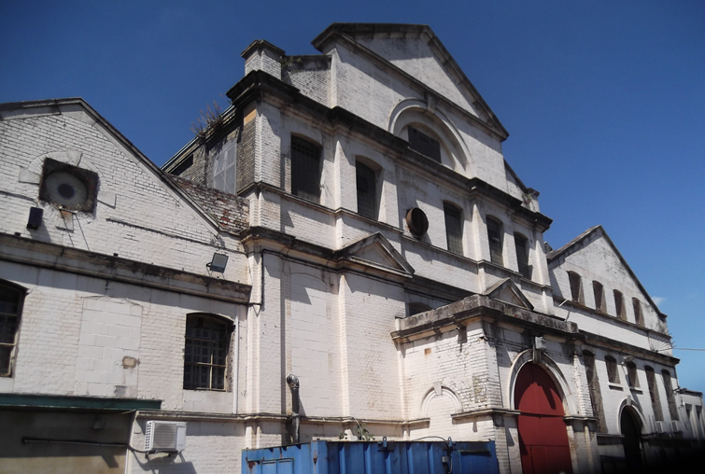West Ham Pumping Station was built to raise local sewage to the level of Joseph Bazalgette’s Northern Outfall Sewer of 1864, along which it then flowed under gravity to Beckton Treatment Works. Construction began in 1897 and it was completed c1900 as a combined pumping station and electric power station, the latter soon being replaced by a larger power station elsewhere.

*The Engine House*

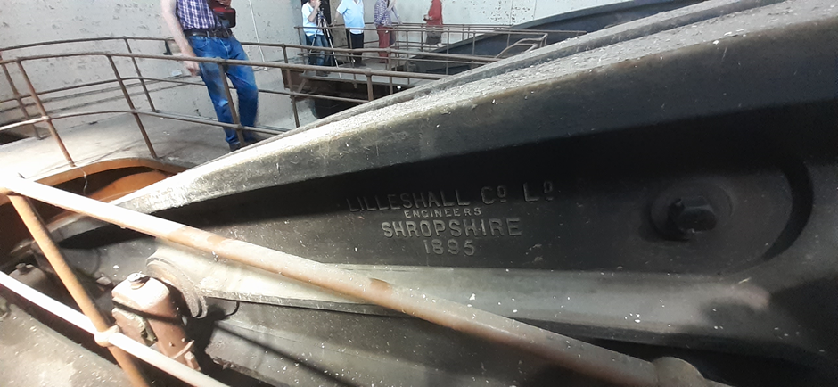

*One of the two beams showing the maker’s mark*

The two Woolf compound beam engines built by Lilleshall of Oakengates, Shropshire, in 1895 – 1900 operated well into the C20th, No. 2 engine ceasing operation at 12:00 noon on 10th January 1972. Both engines survive intact in the engine house, but the nine Lancashire boilers which created the steam have been removed, the boiler house now being used as a church, and the chimney has been demolished.

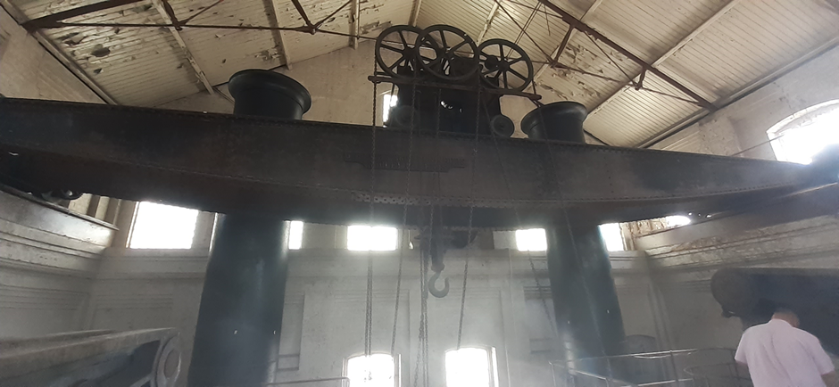

*The Gantry Crane made by J. Booth & Bros. Engineers of Leeds*

Also in the engine house survives the overhead gantry crane, which apparently can still be moved. It is unclear as for what the cellars were used – general storage or maybe for coal for the boilers? Also to be seen adjacent to the site is a wharf on Abbey Creek, part of the tidal Channelsea River, at which barges unloaded coal for the station and there was also a railway connection.

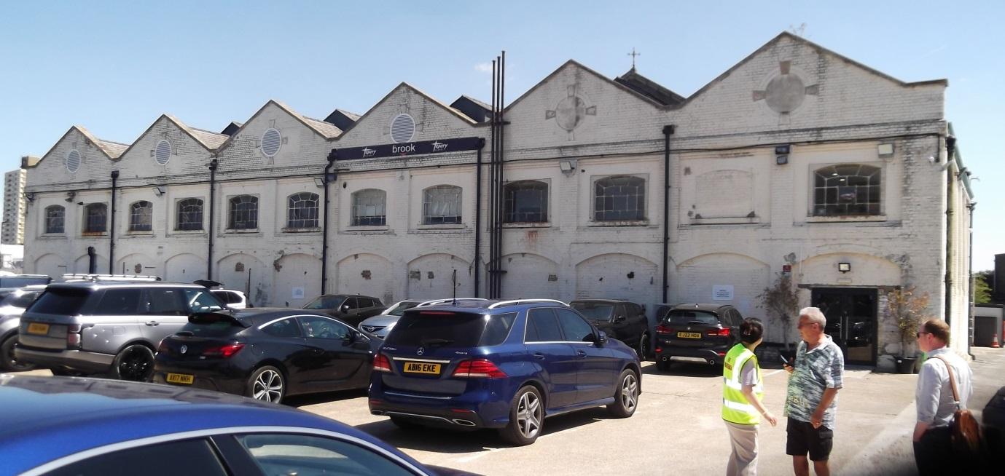

*The Boiler House, now used by a church.*

There were plans to remove the engines for preservation elsewhere, but the local community objected on the grounds that Newham would be loosing a valuable part of its industrial heritage. The site was unoccupied until 2002 when the engineering training facility which still operates there, took over the site and continues to preserve the engine house. The plan now is to form a Community Interest Organisation (CIO) to be called the Heritage Learning Engineering Trust to run the site as a combined engineering museum and training facility.

**Text and photos – Tony Crosby**

**SUCCESS FOR THE FIRST FESTIVAL OF ESSEX ARCHAEOLOGY AND HERITAGE**

This event, organised by Essex County Council's Place Services, was held on Thursday 24th July 2025 at Cressing Temple. This is the first such festival to be organised by Place Services, but can be seen as a successor to the Essex History Fairs which were held some years ago. Many heritage organisations from across the county were represented with stands and exhibitions distributed over the various buildings on the Cressing Temple site. It was also welcome to see several of the commercial archaeological units that are active in the county and who presented the results of recent excavations. About twenty talks were given during the day and most of these had sold out in advance, with large queues developing for spaces that became available on the day.

Most importantly of all, and despite the mixed weather, the event was a great success with about 1,100 people attending. Place Services reported good feedback from the public about the stands, exhibitions and talks. The knowledge and enthusiasm of the exhibitors was much appreciated.

The Essex Industrial Archaeology Group was represented by a stand in the Barley Barn, manned by members of the group, adjacent to a stand from our parent body, the Essex Society for Archaeology and History. Moreover, one of the talks was on an industrial theme, given by Peter Jones with the title 'From Salt to Satellites - An Introduction to Essex's Industrial Heritage'.

In the view of the success of the festival, including the good feedback, Place Services are keen to organise another festival in 2026. Hopefully, this will become a regular event in the county's calendar, providing a great avenue for the promotion of Essex's archaeology and history.

**Paul Gilman**

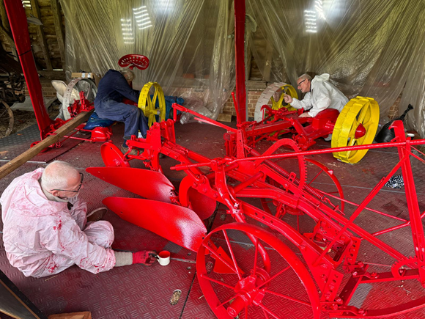Volunteers at Cressing Temple restoring vintage farm machinery for display.

Rear right is a Bamford No. 7 Mower.

Rear left is a Bentall No. 2 Mower from Marsh Farm, Woodham Ferrers.

Foreground is a two-furrow topsoil plough.

**Photo Courtesy David Andrews**

**Essex Industrial Archaeology Group (EIAG) Annual Meeting**

**Saturday 18th October 2025, 2:00 – 4:30pm**

**at the Essex Record Office, Wharf Rd, Chelmsford CM2 6YT**

**To mark the 200th Anniversary of the opening of the Stockton & Darlington Railway, this year’s EIAG Annual Meeting has been extended to allow for a series of short talks on the impact of the development of railways in Essex.**

**The provisional programme is as follows:**

**2:00 - EIAG business and introduction to the talks**

**2:30 - Peter Jones - Early Essex Railways**

**2:55 - Martin Rose - The Railway Through Audley End (TBC)**

**3:20 - Refreshment break**

**3:40 - Peter Wynn - Railway Engineers incl. Peter Bruff**

**4:05 - Alan White - The Impact of the Railway on the Development of Southend**

**4:30 – Close**

As the room at the Record Office has a seating limit and this event may attract more than the usual Annual Meeting attandance, **places must be booked in advance** so that we can manage the numbers attending. Note that this is free for members, for non-members the cost is £2.

**In order to book a place, please email Jane Giffould at** [**jgiffould@aol.com**](mailto:jgiffould@aol.com)

**Give your name and email address.**

If having booked a place you find you are unable to attend, please let Jane know as we will be maintaining a waiting list after all places are taken.

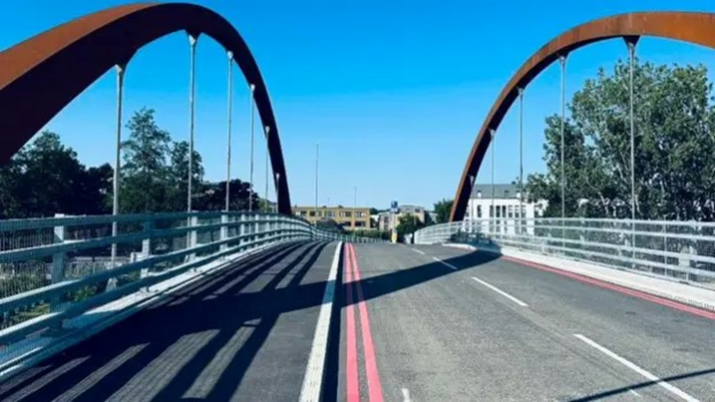

There is no parking at the Record Office apart from three disabled parking spaces. However, the new bridge across the Chelmer from the Baddow Road car park to the Record Office is now open, so Baddow Road is the nearest car park just a few minutes walk across the river.